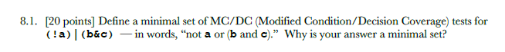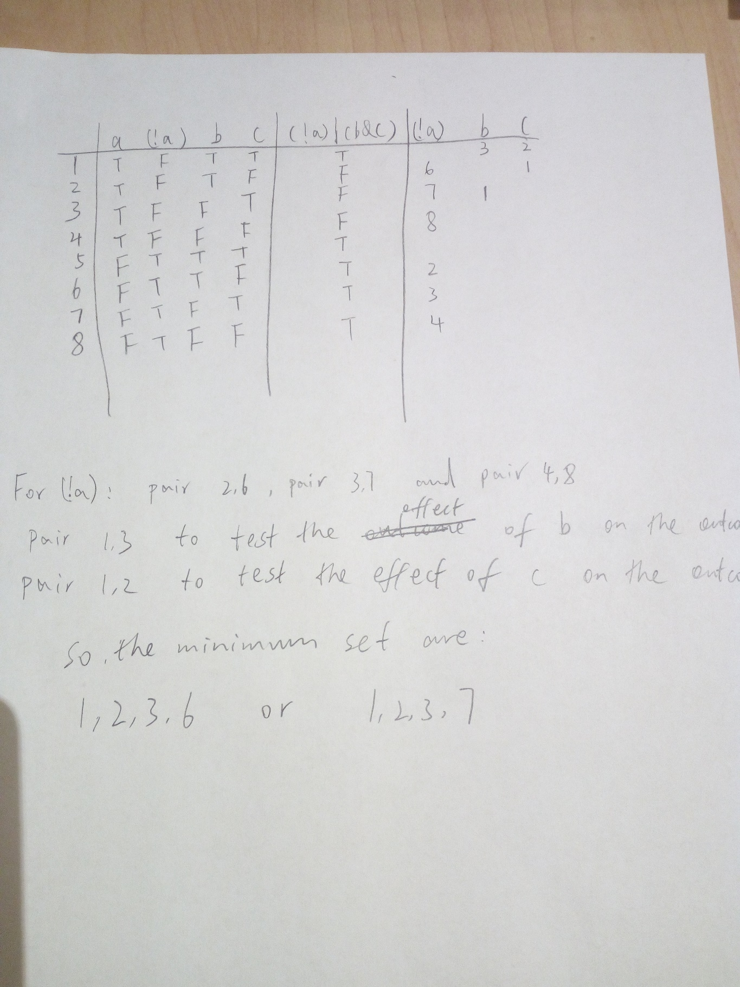

8.2

Parameter Testing

This corresponds to the **Unit tests** and **Functional tests**. Because this process focuses on each component.

Assembly Testing

This corresponds to the **Integration tests.** Because the description says the “system is gradually assembled and tested” which refers to the Integration tests (combinations of unit).

System Evaluation

This should be the **System tests** since as the description says, the system is to be tested as completed.

Shakedown

This corresponds to the **Acceptance tests**, since the completed system will be tested in its environment as the description says.