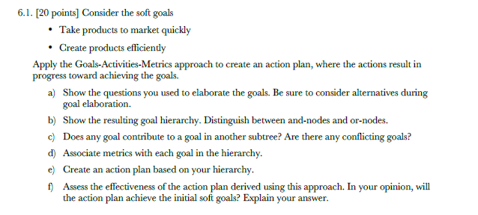

1. Take products to market quickly?

Goal: Take products to market quickly.

How? Reduce cost(time).

How else? Increase the speed of development.

Goal: Creating the products efficiently.

How? Reduce cost.

How else? Improve the quality.

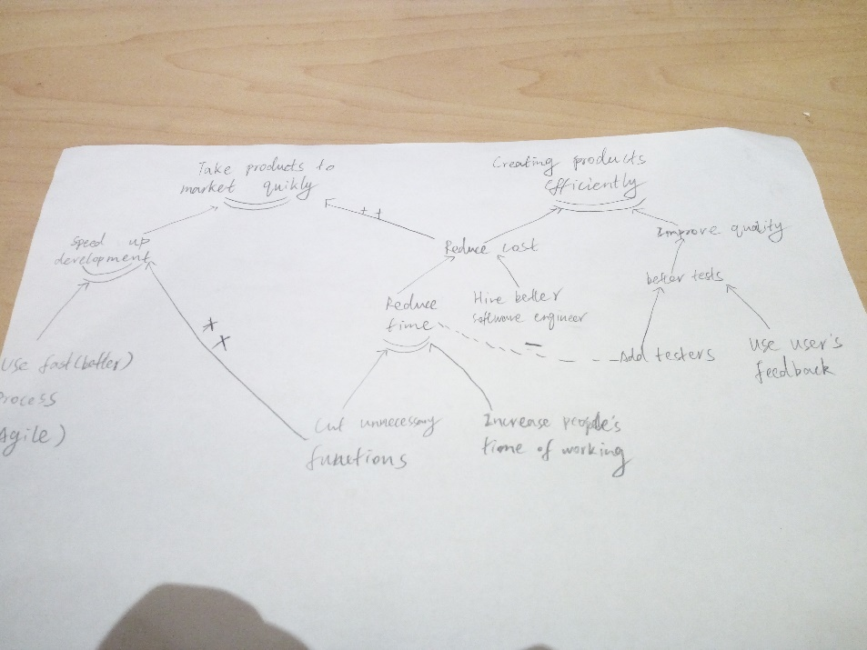

1. And c) are in above graph
2. Goal: Use faster process.

Activity: Optimize the currently using process or started using scrum.

Metrics: Iteration report.

Goal: To cut unnecessary functions of the product.

Activity: Based on the user’s feedback and developer’s suggestions, vote for the function to give up.

Metrics: Later user’s feedbacks.

Goal: Improve quality.

Activity: Write more tests to check.

Metrics: Reports generated from tests.

e)

Action: Objective:

Speed up the development Take product to market quickly

Reduce development time Take product to market quickly and create it efficiently

Improve product’s quality Creating the product efficiently

f)

There may be a problem that increasing the quality would conflict with speeding up the development.

Since more tests will be used to make a better product, this increased the time and also need more people at that time.

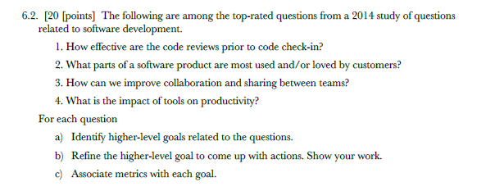

1.

a)

Increase the correctness of the source code.

b)

Adding more system tests to increase the correctness and quality of the product.

c)

Code pass the tests before pushing into the project

2.

a)

Find the taste of customer of the product.

b)

Ask feedbacks from customers who purchase the product.

c)

Surveys are filled by customers who used the product.

3.

a)

Increase the working efficiency between teams.

b)

Have meetings with developers from different teams.

c)

People give out advice and feedbacks from different teams.

4.

a)

Knowing the importance of tools during the development.

b)

Testing tools’ impact with smaller development samples.

c)

Reporters of the tests (examination) shows how important each tool is on productivity.