Class: CS436 Fall2017

Assignment: HW2

Due time: Sep 14, 2017 11:30 PM

Student: Dong Liang

Professor: Ravi Sethi

TA/Graders: Jacob Combs

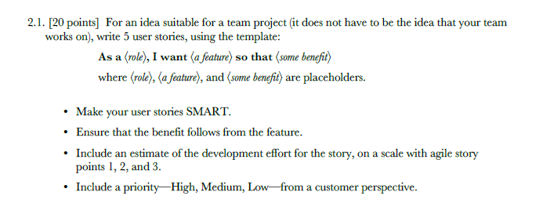

1. As a fan of sports, I want to read the sports news so that I won’t miss a match which I’d love to watch.

Medium Priority; 1 point(s)

1. As a student go to campus for class every day, I want to share bicycles with other students so that I could get to the classrooms faster and don’t need to purchase a bicycle myself.

Low Priority; 3 point(s)

1. As a game player, I want to know from a website what performance my PC need to run the game and the price of the proper PC so that I don’t have to go to a BestBuy and save my own time.

High Priority; 2 point(s)

1. As a student who eat lunch at school, I want to know if the food place is busy or not so that I don’t need to wait in line.

High Priority; 3 point(s)

1. As a driver need to park at school, I want to know if a garage is already full or not so that I don’t need to spend time on finding a spot and be late.

High Priority; 3 point(s)



They are specific or independent: most of them are created for student of uofa.

They are valuable: some of them got a chance to earn some money and the other can benefit the customers a lot (saving their time and etc.).

They are time related.

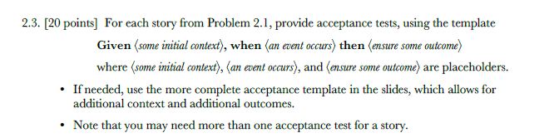

1. Given there is a match tomorrow

and the customer’s phone is working well and connected with wifi

When the news or reports about this match are out

Then ensure the news will be sent to the phone of the user

and the link of the news is working fine

1. Case 1: The student is enrolled

Given an id of a student

and the student id is valid

When the student finished login in and check process

Then the lock of the bike is open

and ensured the bike is locked sooner

Case 2: The student is not enrolled

Given an id of a student

and the student id is valid

When the student finished login in and check process

Then present a rejection message

and ensured the bike is locked

1. Given a game

and the game is found in the database

When the user asked about this game

Then find the proper choices of PCs

and give information of these PC to the user

and give the suggestion (best deal)

1. Case 1: The food court is busy

Given a system that keep track the dynamic population of food place

and the student’s is login

When the student opens the app

Then the population information is sent

and send the conclusion (“the food court is busy now”)

Case 1: The food port is not packed

Given a system that keep track the dynamic population of food place

and the student’s is login

When the student opens the app

Then the population information is sent

and send the conclusion (“the food place is not packed now”)

1. Case 1: The garage is full

Given a system that keeps track the situation of the garage

and the system can send information to user’s devices

When the driver searched for the garage

Then find the garage from the system

and tell the user this garage is already full

Case 2 The garage is not full

Given a system that keeps track the situation of the garage

and the system can send information to user’s devices

When the driver searched for the garage

Then find the garage from the system

and tell the user there is still a spot





Product: IDE on smart phone

Reason: It would be needed and used if someone doesn’t have a PC and this person need to program. So, it is useful.

However, most programmer would not consider coding on a smartphone. Thus, it is not desirable.

Also, coding on smartphone won’t as efficient as doing it on a PC. For example, the tiny screen does hurt. So, it is not usable.



Product: Top video/graphic card (let’s say [Nvidia](http://gpu.userbenchmark.com/Search?searchTerm=Brand:%22Nvidia%22) Titan X)

Reason: This video card works perfect for almost all games and would support any high performance if you want. And no one would have a problem to have it in PC if it is free. So, this product is definitely usable.

However, based on the price, only limited could afford it. Also, it is hard to find some game can only run by this graphic card. In other words, gamers won’t need such an experience product while other cheaper products could do the same work, So, it is not desirable nor useful.



Product: souvenir soccer balls

Reason: For soccer fans, a souvenir soccer ball would be the best birthday gift. Also, the souvenir soccer balls for world cups are very variable and precious for soccer fans. So, it is desirable.

But nobody would use them to play a soccer match with friends. So, they are not useful.

Also, a lot of souvenir soccer ball are desired not for playing. That means most of them are less comfortable to play compare to normal soccer balls. So, they are not usable.



Product: Management App for Android

Reason: Most of them works fine to protect your android system and clean your phone to keep it efficient. So, they are useful and usable.

However, sometimes, people may not want several similar app on one phone. And for people like me, for example, I don’t really need those app since I do all the work by hand. So, those app may not be desirable.



Uaccess….



Product: VR devices

Reason: A pair of VR glasses would be cool and fun to play around. No doubt that people would like to get their VR devices. So, they are desirable.

Watching a movie through VR devices is awesome and most VR devices to day is convenient to use. So, they are Usable.

But they are not necessary and widely used today. Thus, they are not useful.



Product: Uber, Lyft….

Reason: Those products are wanted by both riders and drivers ---Desirable

People who don’t have a car need to use them and most people who don’t own a car has at least one uber or lyft on their smartphones ---Useful

They are easy to use. And the payment is efficient and convenient.

--- Usable