Class: CS436 Fall2017

Assignment: HW3

Due time: Sep 21, 2017 11:30 PM

Student: Dong Liang

Professor: Ravi Sethi

TA/Graders: Jacob Combs

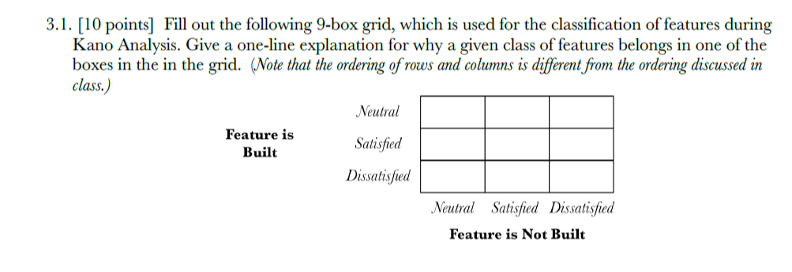

|  |  |  |  |
| --- | --- | --- | --- |
| Neutral | Indifferent | Reverse | Must Have |
| Satisfied | Attractor |  | Key |
| Dissatisfied | Reverse | Reverse |  |
|  | Neutral | Satisfied | Dissatisfied |

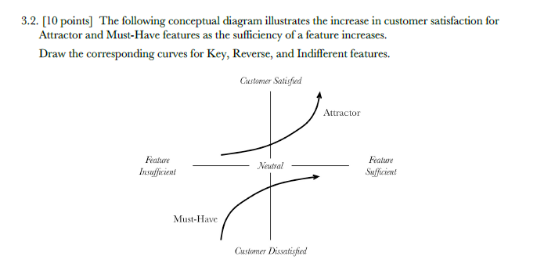

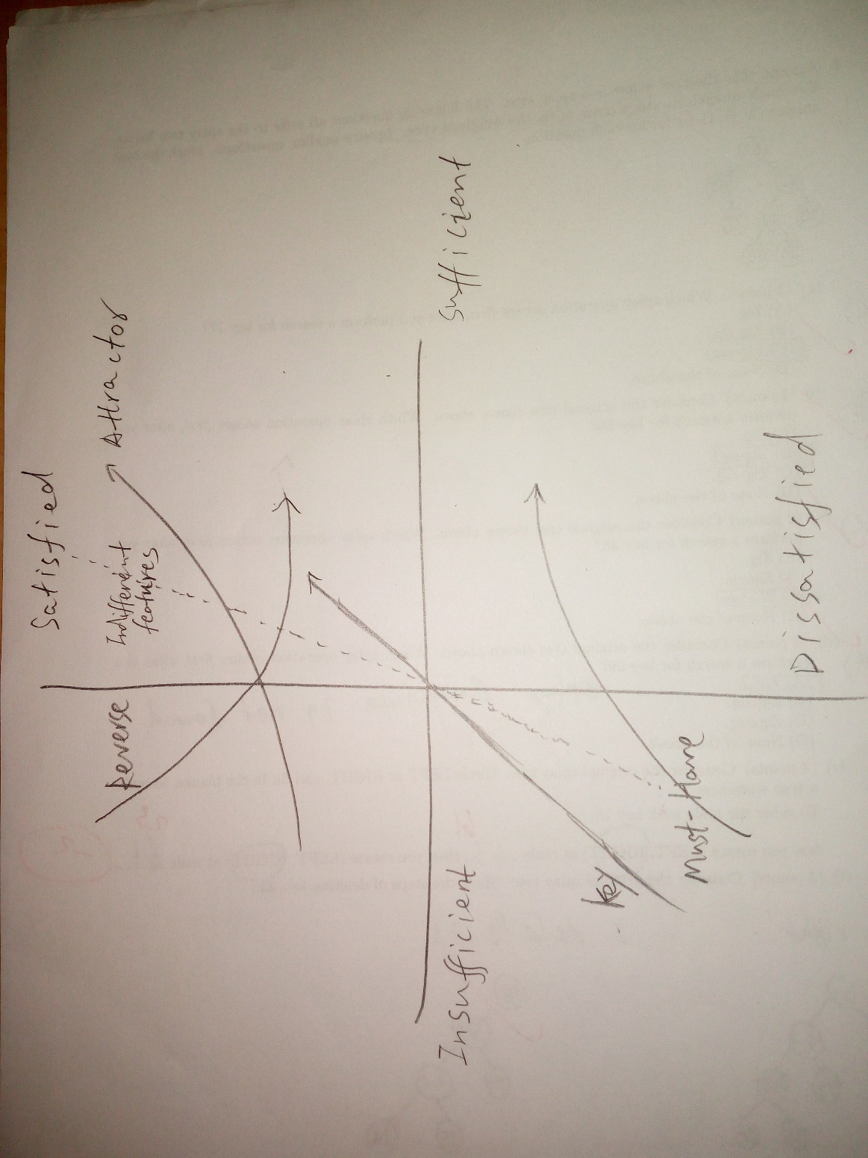

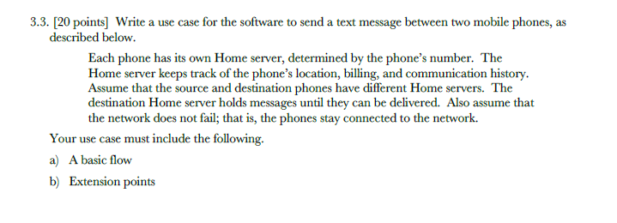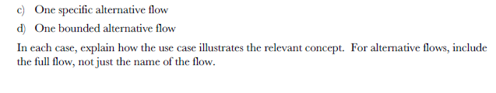

1. Basic flow:
2. User 1 wrote a text on his/her phone for user 2.
3. User 1 selected the destination user (user 2).
4. User 1 hit the “send” bottom and send the text to his/her number’s server.
5. The server identified the user 1’s number and the destination number.
6. The server sends only the text message from user 1 to the destination server and send the number of user 1.
7. The destination server holds this message.
8. The destination server checked the text message and send it to the destination number.
9. The user 2 gets the message.
10. Extension points

{compose text}

1.User 1 wrote a text on his/her phone for user 2.

2.User 1 selected the destination user (user 2).

3.User 1 hit the “send” bottom and send the text to his/her number’s server.

{send text}

4.The server identified the user 1’s number and the destination number.

5.The server sends only the text message from user 1 to the destination server and send the number of user 1.

{check text}

6.The destination server holds this message.

7. The destination server checked the text message

{deliver text}

8. The destination server sends it to the destination number also send a confirm information to the first server.

9. The user 2 gets the message.

1. One specific alternative flow: the destination server blocks the message

1.User 1 wrote a text on his/her phone for user 2.

2.User 1 selected the destination user (user 2).

3.User 1 hit the “send” bottom and send the text to his/her number’s server.

4.The server identified the user 1’s number and the destination number.

5.The server sends only the text message from user 1 to the destination server and send the number of user 1.

6.The destination server holds this message.

7.The destination server checks the text message and decides to send it back.

8.The first server gets the return text and send a message to user 1 that the text was failed to send.

1. Bounded alternative flow: Note destination server is down”

At any point between {check text}and {deliver text} if the destination server is down, then the first sever will not get the confirm information

Server will show user 1 “Something is wrong please send the text again”.

Resume the basic flow at { compose text }