Class: CS436 Fall2017

Assignment: HW4

Due time: Sep 28, 2017 11:30 PM

Student: Dong Liang

Professor: Ravi Sethi

TA/Graders: Jacob Combs

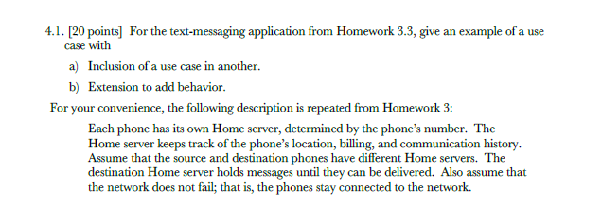

**Description:**

Process for a user to use a phone and its server for sending out a text message.

**Actors:**

The user and the receiver (user 2).

**Basic Flow:**

1. User 1 wrote a text on his/her phone for user 2.
2. User 1 selected the destination user (user 2).
3. For a message going to be sent. (extension)
   1. The phone may ask if sending the text with a photo.
   2. The phone will ask if sending the message also to the email of user 2.
   3. User 1 only hit the “send” bottom and send the text to his/her number’s server
4. The server identified the user 1’s number and the destination number.
5. The server sends only the text message from user 1 to the destination server and send the number of user 1.
6. The destination server holds this message.
7. The destination server checked the text message and send it to the destination number.
8. The user 2 gets the message.

**Alternative Flow:**

Server connection fails.

The user 2 shut down his/her phone. (cannot connect to user 2)

The server is busy.

1. User 1 decides to wait.
2. User 1 decides to resend the text.
3. User 1 decides to cancel the sending.

4.2

a) The expected overall planning effort is less with advance planning than with adaptive

planning.

**False – Advance planning is before the design and will affect the entire product while adaptive planning is spread evenly across iterations. So, the description is opposite.**

b) The Adaptive Iron Triangle fixes time and scope and lets costs vary.

**True – but only pick 2 of them each time.**

c) Anchoring is the human tendency to stick to a position, once taken.

**True – “People make estimates by starting from an initial value that is adjusted to yield the final” is called anchoring.**

d) The shorter the planning horizon, the lower the uncertainty.

**True – This is the original note from the lecture slides.**

e) Anchoring reduces uncertainty during planning.

**False – Anchoring can lead to bias. This increases the uncertainty.**

f) Planning Poker involves successive rounds of individual estimation and group discussion.

**False – It involves only group discussion.**

g) Relative estimates are more accurate than absolute estimates.

**False – The relative estimates beat absolute estimates in time unit but it takes less accuracy than absolute estimates.**

h) Three-Point Estimation is given by estimate = (best + 2×median + worst)/4

**False – The correct fomula is estimate = (best +4*median+worst)/6**

i) Wideband Delphi avoids cognitive bias by keeping group members apart and anonymous.

**True – As the slides described.**

j) Estimators tend to underestimate effort needed.

**False – Without any influence from outside, the estimators may either underestimate or overestimate effort needed.**