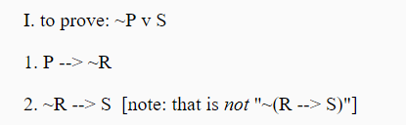

Because P→~R and ~R→S, we can get P→S.

And P→S is equivalent to (~P v S) by material implication.

The proof is done.

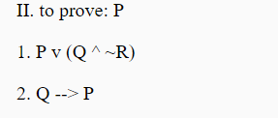

Prove by conditions:

Based on premise 1, P v(Q^~R) is true. So, P or (Q^~R) is true.

If Q is true, then P is true and P v(Q^~R) is still true by premise 2.

If Q is not true, to keep P v(Q^~R) still true, P must be true.

The proof is done.

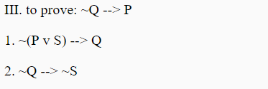

Premise 1 is ~ (P v S) → Q and this is equivalent to ~Q→(P v S).

Since premise 2 gives us ~Q→~S, so when we have ~Q and will get (P v S) and ~S, then P must be true.

So, the entire process is just: ~Q → P. The proof is done.

C:\Users\DONGLI~1\AppData\Local\Temp\1510876327(1).png

(P→~P) is equivalent to (~P→P).

And this is just (P→~P) → (~P→P) which is equivalent to (P→~P) v (~P→P).

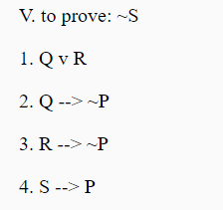

By premise 1, Q or R must be true.

Since either Q or R is true, and by premises 2 and 3, we will get ~P.

The premise 4 is S→P which is equivalent to ~P → ~S.

We’ve got ~P, so now we get ~S. And the proof is done.