homework #9

Write up 12.1-12.3 (p. 336) and 13.20-13.22 (pp. 367-368).

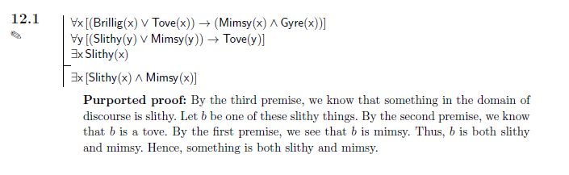

12.1 Answer:

The argument is valid, and this proof is fine.

The proof would be better if it includes the rule used to prove. For example, as saying that b is a tove the proof can claim this conclusion is by using the ∀ Elim, ∨ Intro and → Elim.

13.20：

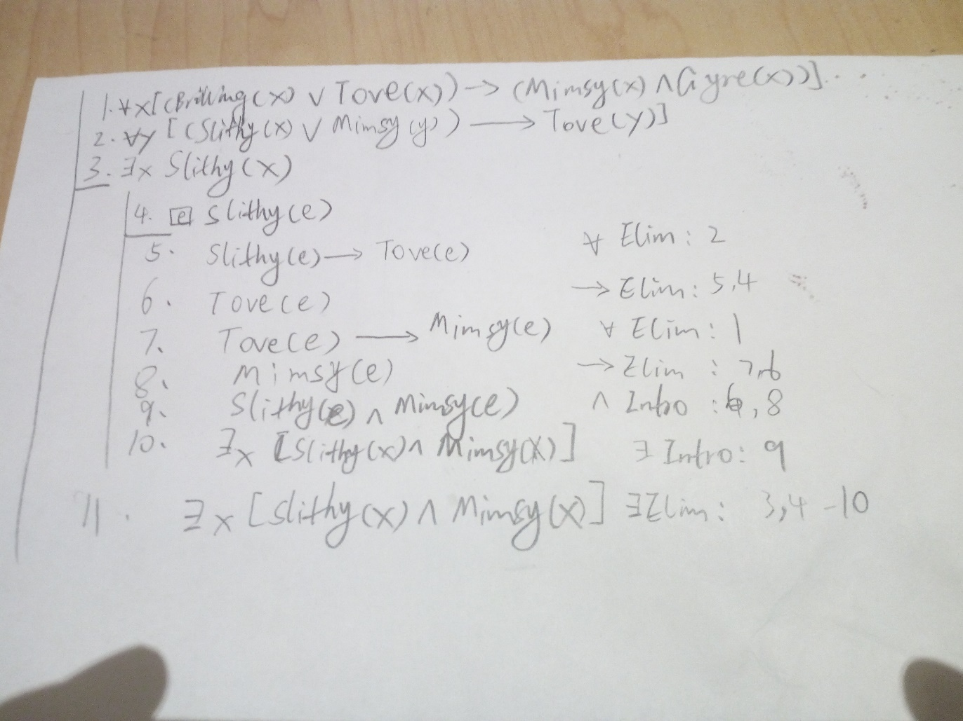

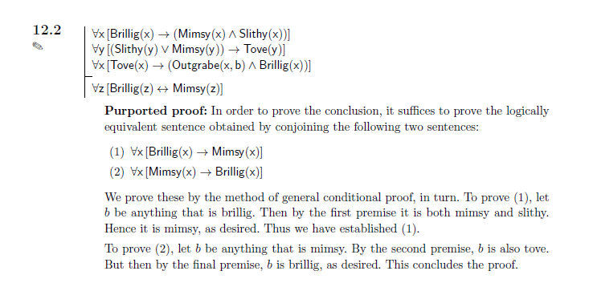

12.2 Answer:

The argument is valid, and this proof is logically correct.

We can optimize the proof by adding a statement says since b is an arbitrary object in the domain, we can conclude (for both (1) and (2)) the conclusion by universal generalization.

13.21：

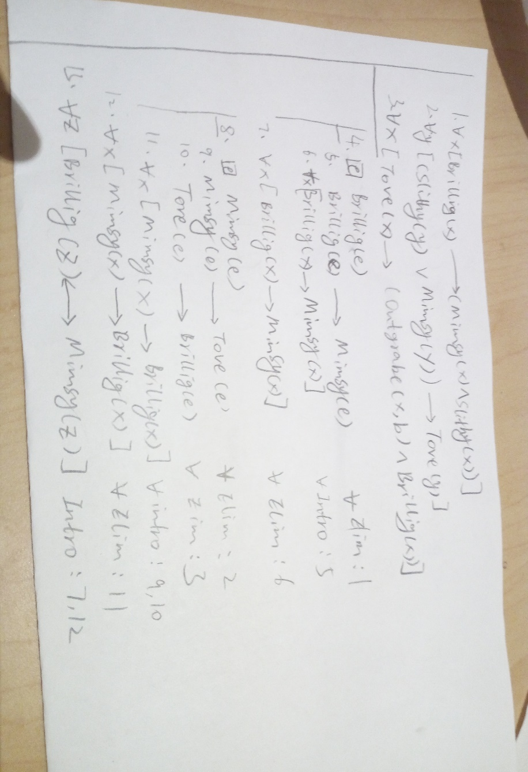

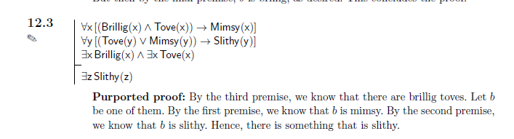

12.3 Answer:

The statement is valid and so the proof is fine.

13.22：

