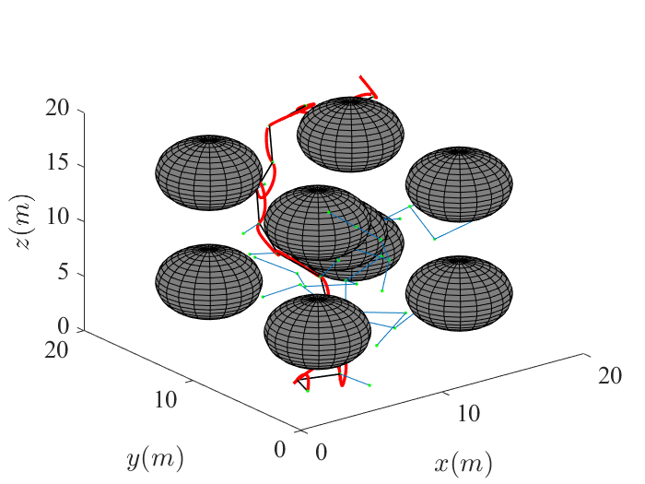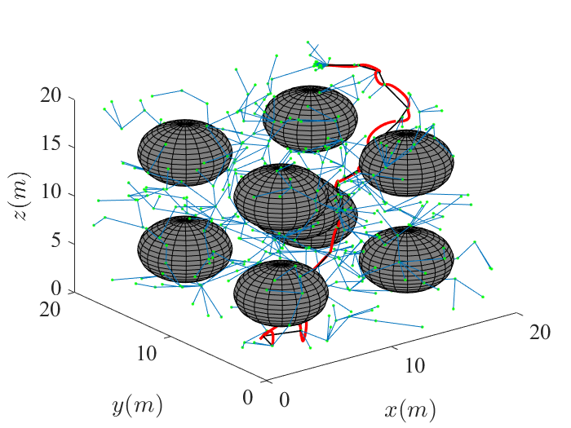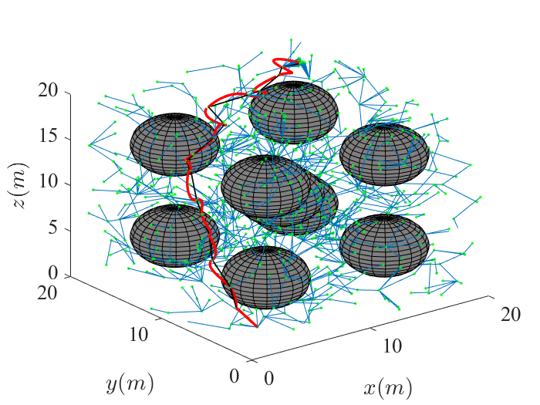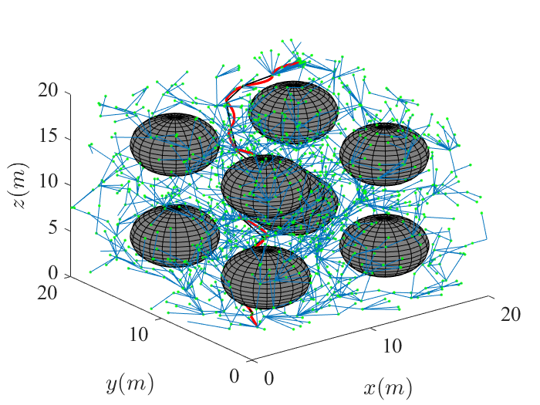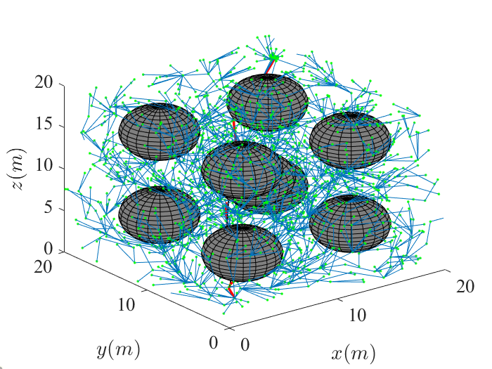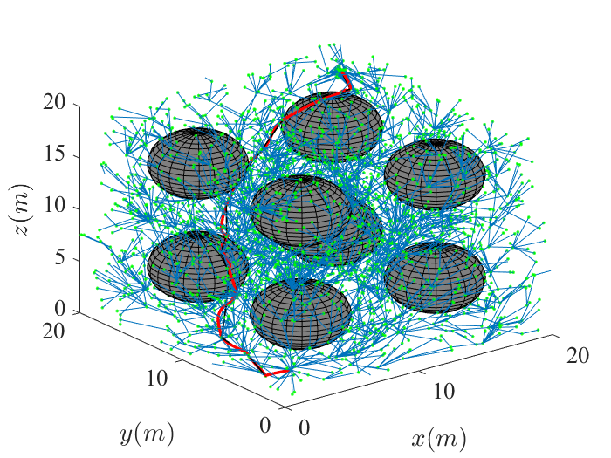

Nodes = 52 500 1000 1500 2000 3000

time = 0.3920 4.4600 15.2000 29.0440 43.9350 59.8260 76.6880

cost = 108.2929 104.5237 95.3835 74.2641 66.7579 61.9246

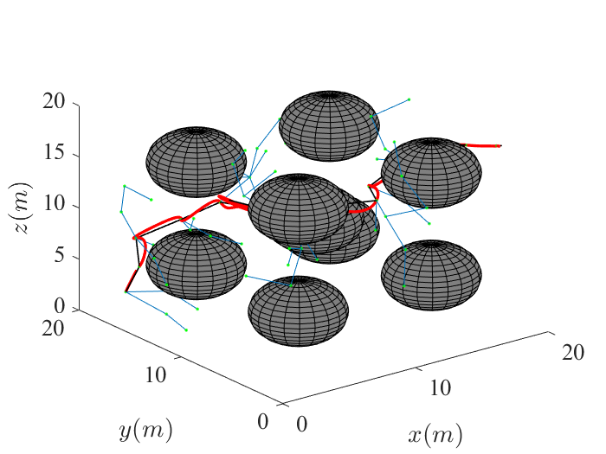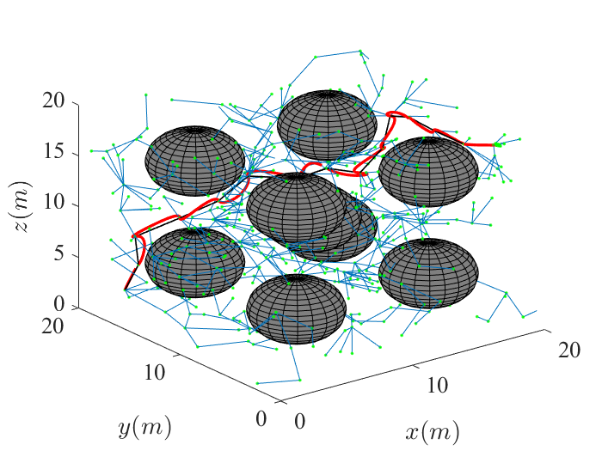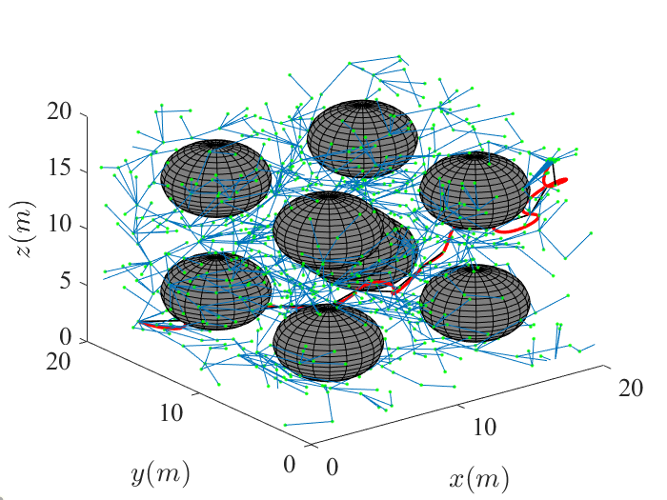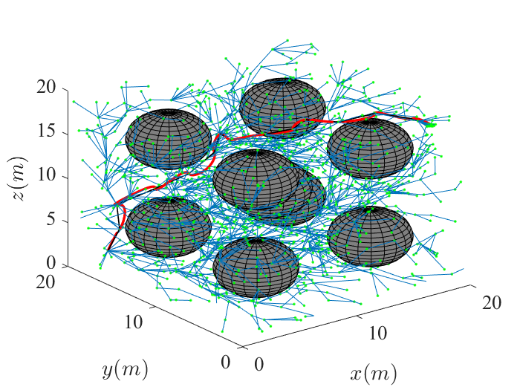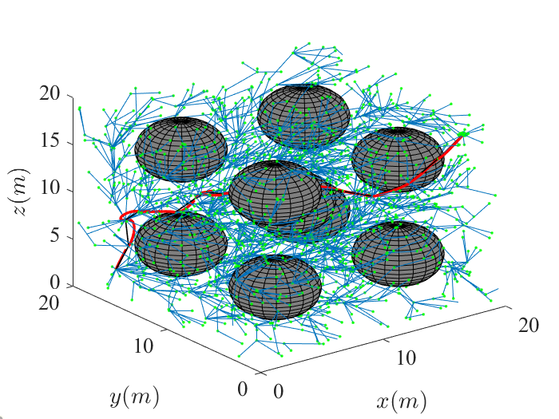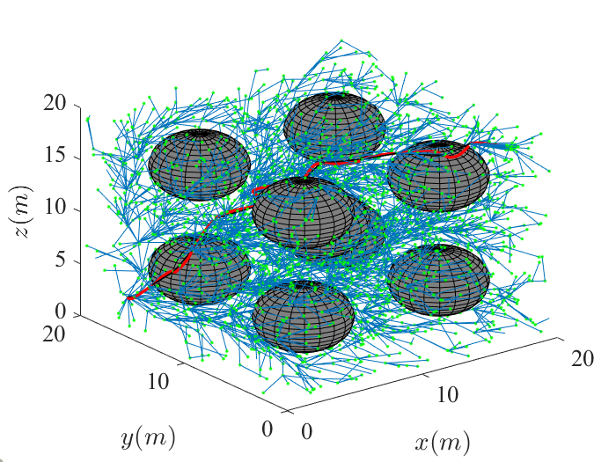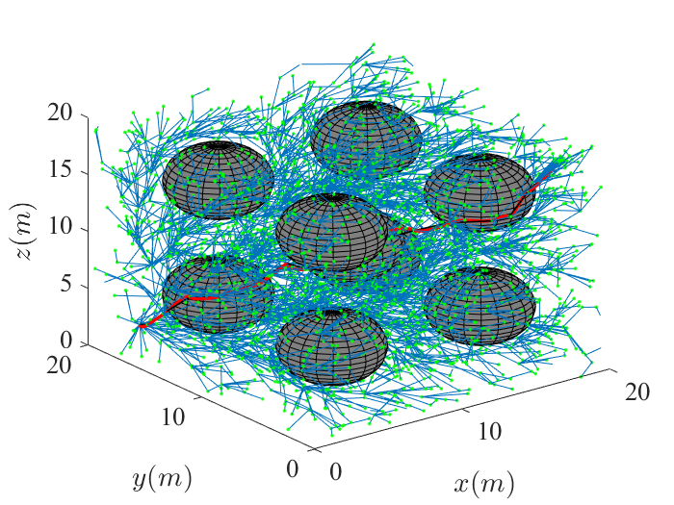

Nodes = 64 500 1000 1500 2000 3000 4000

time = 0.2760 2.9840 8.9060 15.7030 23.9860 (33.4650) 42.1900 (51.6540)

Cost = 96.1304 90.2914 68.1659 66.7950 61.8063 58.0927 55.8769