19Fall Weekly Report 12  
Dongliang Zheng  
2019/11/13

Introduce a biased state space sampling strategy to obtain *better first solution*.

If we uniformly sampling the state space, the first solution always look like this:



If we treat the position space sampling and velocity space sampling separately. The cost of first found path can be reduced.

Use the sampled position to bias the sampling of velocity, such that the velocity vector has the same direction as line $AB$.

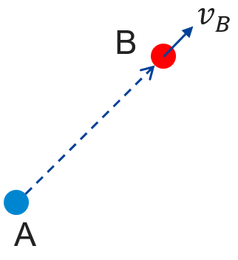

Figure 1. Simple biased state space sampling strategy. $A$ is a node already in the tree, $B$ is the new sampled point. And we want to connect $A B$. Instead of uniformly sample the velocity space, restrict $v_{B}$ to has the same direction as line $AB$, (magnitude still random).

The first solutions obtained with this bias sampling is shown in Figure 2. For comparison, the uniform velocity space sampling results are shown in Figure 3.

    

Figure 2. First solutions obtained using the proposed bias sampling



Figure 3. First solutions obtained using uniform sampling

It is easy to see that the first solutions found using the proposed bias sampling have low cost than uniform sampling.

More details can be found in the two table below.

|  |  |  |  |  |  |  |  |  |  |
| --- | --- | --- | --- | --- | --- | --- | --- | --- | --- |
| Biased sampling | 1 | 2 | 3 | 4 | 5 | 6 | 7 | 8 | 9 |
| Cost | 56.8948 | 77.5854 | 64.8455 | 67.8530 | 68.5137 | 66.3661 | 55.3872 | 64.8565 | 68.2505 |
| Time (s) | 0.2110 | 0.3380 | 0.3860 | 0.3820 | 0.2590 | 0.2880 | 0.2170 | 0.3470 | 0.4290 |
| Nodes | 37 | 50 | 41 | 51 | 31 | 48 | 30 | 47 | 60 |

|  |  |  |  |  |  |  |  |  |  |
| --- | --- | --- | --- | --- | --- | --- | --- | --- | --- |
| uniform sampling | 1 | 2 | 3 | 4 | 5 | 6 | 7 | 8 | 9 |
| Cost | 96.1179 | 99.6349 | 86.1428 | 91.6261 | 95.1564 | 101.3887 | 90.8037 | 114.5942 | 82.3886 |
| Time (s) | 0.3420 | 0.4800 | 0.4000 | 0.2950 | 0.3140 | 0.2990 | 0.3580 | 0.4870 | 0.1520 |
| Nodes | 40 | 51 | 50 | 41 | 46 | 30 | 47 | 61 | 16 |

Conclusion:

This simple sampling strategy for state space sampling is effective. It is accord with our intuition of how the ‘good’ trajectory should look like.

It will provide better first solution (in term of trajectory cost), with no additional computation. This better first solution is then combined with informed sample methods to accelerate convergence.