ACE-LoRA: Graph-Attentive Context Enhancement for Parameter-Efficient Adaptation of Medical Vision-Language Models
M. Arda Aydın, Melih B. Yilmaz, Aykut Koç, Tolga Çukur
https://arxiv.org/abs/2603.17079

Research Questions
- How can we bridge the specialization-generalization trade-off in medical vision-language models to capture fine-grained diagnostic cues while maintaining robust zero-shot generalization?
- How can hypergraph neural networks capture higher-order contextual interactions beyond pairwise attention to improve medical image-text alignment?
- How can we mitigate false negatives in medical contrastive learning where distinct samples may share identical clinical semantics?

Core Idea
Medical VLMs face a fundamental trade-off: specialist models capture diagnostic details but generalize poorly, while generalist models retain broad semantics but lose fine-grained cues. ACE-LoRA addresses this by parameter-efficiently adapting generalist models using LoRA plus a novel hypergraph module (ACE-HGNN) that captures higher-order interactions among image patches and text tokens beyond simple pairwise attention. The key insight is that medical diagnosis requires understanding structured relationships among groups of visual/textual elements, not just global features. A label-guided InfoNCE loss prevents the model from pushing apart semantically similar medical samples during contrastive learning.

Key Formula
Hypergraph incidence matrix construction
$H_{i,j}=\left\{\begin{matrix}1 & \text{if }i=j \\ \frac{exp(S_{i,j})}{\sum_{k∈Ω_{i}}{exp(S_{i,k})}} & \text{if }j∈Ω_{i}\text{ and }i≠j \\ 0 & \text{otherwise}\end{matrix}\right.$
H is the incidence matrix, S is the raw affinity matrix, Ω_i is the top-k neighbors for node i. This constructs hyperedges by selecting top-k similar tokens and applying softmax normalization while preserving self-connections. Critical for capturing higher-order token relationships in medical images.
Label-guided InfoNCE loss
$ℒ=−\frac{1}{2B}\left(\sum_{i=1}^{B}{log\frac{exp(⟨v_{0}^{′(i)},t_{0}^{′(i)}⟩/τ)}{\sum_{k=1}^{B}{1_{i,k}exp(⟨v_{0}^{′(i)},t_{0}^{′(k)}⟩/τ)}}+\sum_{i=1}^{B}{log\frac{exp(⟨t_{0}^{′(i)},v_{0}^{′(i)}⟩/τ)}{\sum_{k=1}^{B}{1_{i,k}exp(⟨t_{0}^{′(i)},v_{0}^{′(k)}⟩/τ)}}}}\right)$
v'_0 and t'_0 are refined global embeddings, τ is temperature, 𝟙_{i,k} is indicator function that equals 1 when disease labels differ or i=k, 0 otherwise. This prevents falsely pushing apart semantically similar medical samples during contrastive learning by excluding same-label pairs from negative samples.

Key Figure
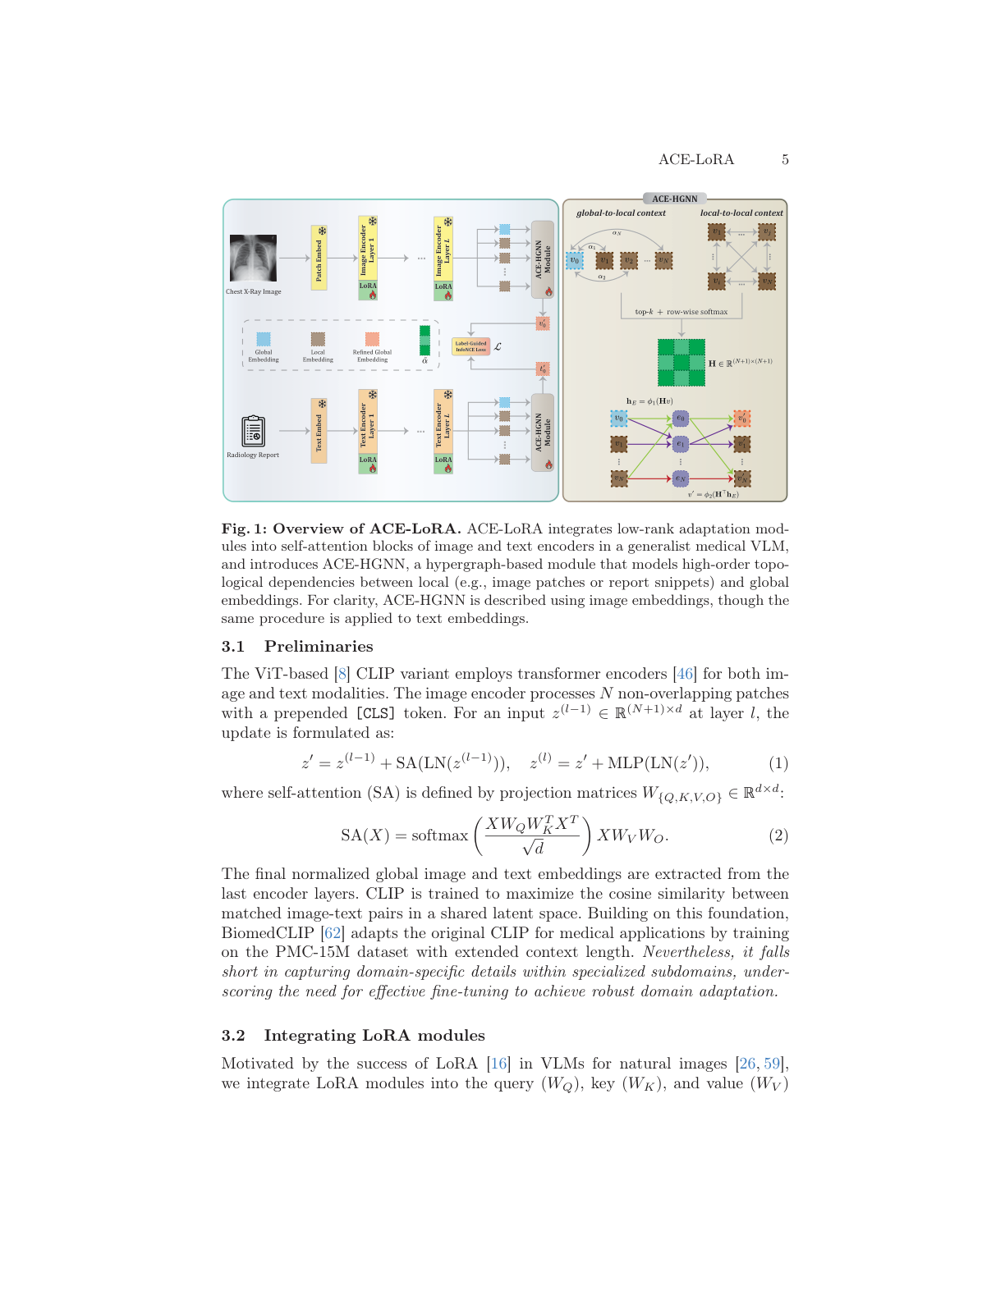
Figure 1: Shows the complete ACE-LoRA architecture with LoRA integration, ACE-HGNN hypergraph construction for local-global context modeling, and label-guided InfoNCE loss.

Limitations
- Relies on CheXpert labeler for extracting disease labels, limiting applicability to domains without standardized label extraction tools
- ACE-HGNN module adds computational overhead during inference, though minimal compared to full fine-tuning
- Evaluated primarily on radiology and histopathology; generalization to other medical domains unclear
- Hypergraph construction uses fixed top-k selection which may not be optimal across all medical imaging modalities

