Complementary Reinforcement Learning
Dilxat Muhtar, Jiashun Liu, Wei Gao, Weixun Wang, Shaopan Xiong, Ju Huang et al. | alibaba-inc
https://arxiv.org/abs/2603.17621

Research Questions
- How can policy actors and experience extractors co-evolve together during RL training to maintain alignment as capabilities improve?
- What training framework enables efficient asynchronous coordination between actor training and experience distillation at scale?
- How does co-evolutionary experience management compare to static experience approaches in multi-task RL settings?

Core Idea
Existing RL approaches for LLM agents suffer from static experience management - the experience distilled from historical trajectories becomes stale as the actor improves, creating misalignment. The key insight is to co-evolve both the policy actor and experience extractor: the actor optimizes on outcome rewards while the experience extractor optimizes based on whether its distilled experiences actually help the actor succeed. This creates a mutually reinforcing loop where better policies generate higher-quality trajectories that refine the experience bank, which in turn provides more effective guidance for policy optimization.

Key Formula
Split GRPO Objective
$J_{GRPO}^{split}(θ)=E\left[\frac{1}{2}\sum_{c∈\{m,∅\}}{\frac{1}{K_{c}}\sum_{k=1}^{K_{c}}{L_{clip}(ρ_{c},{\overset{^}{A}}_{c})}}\right]$
Novel modification to GRPO that computes advantages \hat{A}_c within each subgroup c (experience-guided m vs experience-free ∅) using subgroup-specific means and standard deviations. This prevents bias from differing reward scales between conditions and enables balanced gradient contributions from both subgroups.
CISPO Experience Extractor Objective
$J_{CISPO}(ϕ)=E\left[\frac{\sum_{i=1}^{O}{\sum_{t=1}^{|m_{i}|}{sg([ρ_{i,t}]_{1−ϵ_{low}^{IS}}^{1+ϵ_{high}^{IS}}){\overset{^}{A}}_{i}logπ_{ϕ}(m_{i,t}|g_{i},τ_{i},m_{i,<t})}}}{\sum_{i=1}^{B}{|m_{i}|}}\right]$
Optimizes experience extractor π_φ using clipped importance sampling ratios ρ_{i,t} and batch-level advantages \hat{A}_i = r(m_i) - \bar{r} where r(m_i) ∈ {-1,+1} indicates whether experience m_i helped actor succeed. The clipping mechanism prevents abrupt distribution shifts during co-evolution.

Key Figure
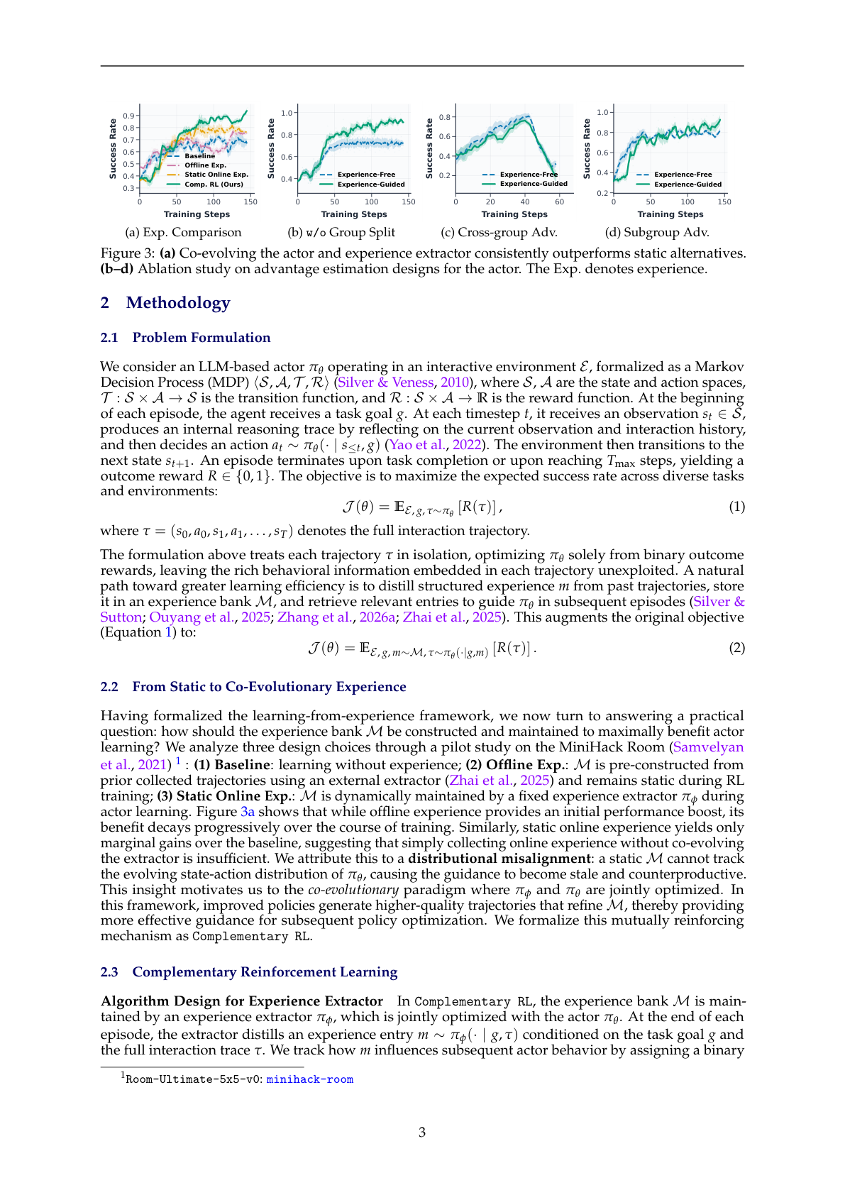
Figure 3: Demonstrates that co-evolving actor and experience extractor consistently outperforms static alternatives, and shows the critical importance of split advantage estimation for stable training.

Limitations
- Requires separate parameter sets for actor and experience extractor, increasing computational overhead
- Performance depends on quality of experience distillation, which may be unreliable for weak base models or complex tasks
- Asynchronous training framework adds implementation complexity compared to standard RL approaches
- Limited evaluation on tasks beyond the four environments tested (MiniHack, WebShop, ALFWorld, SWE-Bench)

