EVA: Aligning Video World Models with Executable Robot Actions via Inverse Dynamics Rewards
Wang, Ruixiang, Liu, Qingming, Deng, Yueci, Liu, Guiliang, Liu, Zhen, Jia, Kui | cs.RO
https://arxiv.org/abs/2603.17808

Research Questions
- How can video world models for robotics be aligned to generate physically executable trajectories that respect kinematic constraints?
- Can an inverse dynamics model (IDM) be repurposed as a reward model to penalize executability violations during video generation training?
- What is the impact of IDM-based reward alignment on downstream robotic task execution success rates?

Core Idea
The paper addresses the "executability gap" in video world models for robotics: while generated videos may look visually plausible, they often contain kinematic violations (arm deformations, impossible joint movements) that produce unstable robot actions when decoded by inverse dynamics models. The key insight is to train an IDM on real robot data and repurpose it as a reward model that evaluates generated videos through their implied action sequences, penalizing non-smooth motions and embodiment constraint violations. This creates a dense training signal that aligns video generation with physical feasibility without requiring expensive rejection sampling at inference time.

Key Formula
IDM-based Penalty Function
$𝒫(A)=λ_{j}𝒫_{j}+λ_{α}𝒫_{α}+λ_{v\text{-lim}}𝒫_{\text{vel}}+λ_{a\text{-lim}}𝒫_{\text{acc}}$
Total penalty P(A) combines jerk penalty P_j, acceleration penalty P_α, velocity limit violations P_vel, and acceleration limit violations P_acc, each weighted by lambda coefficients. This penalty is computed from IDM-predicted action sequences and captures kinematic implausibility.
Executability Reward
$R(V)={\left(1+\frac{𝒫(A)}{P_{0}}\right)}^{−γ}$
Reward R(V) for video V is computed by mapping penalty P(A) into bounded reward using scale P_0 and decay rate γ. Higher penalties (more kinematic violations) result in lower rewards, providing training signal for GRPO alignment.

Key Figure
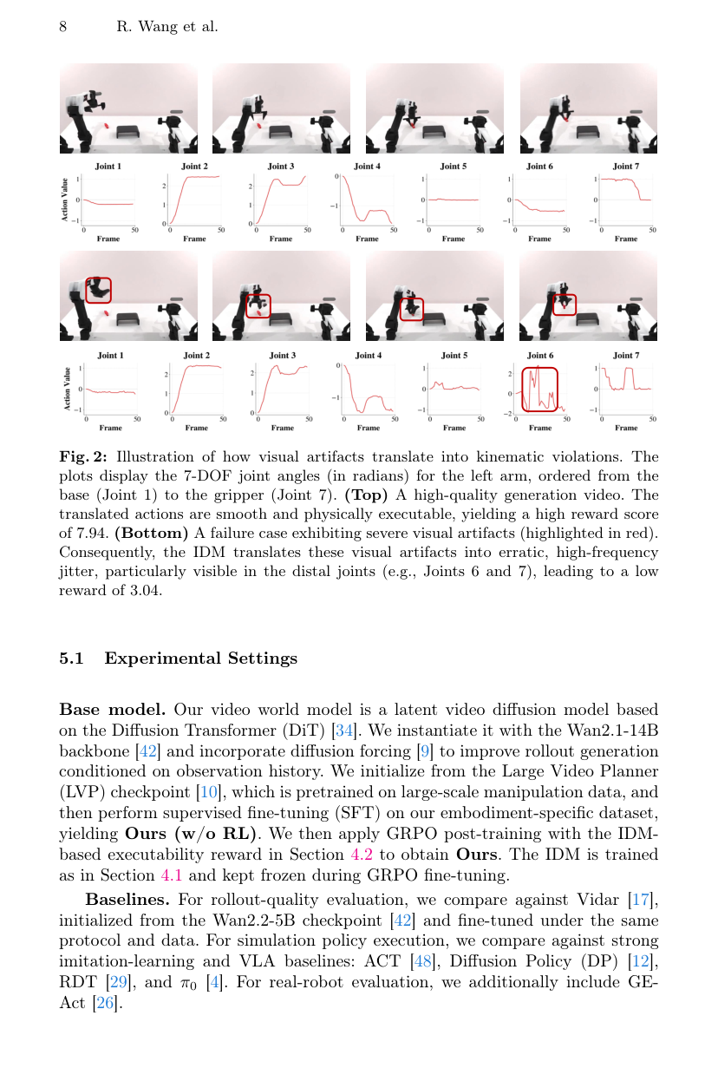
Figure 2: Shows how visual artifacts in generated videos directly translate into erratic, high-frequency joint trajectories when decoded by the IDM, demonstrating the executability gap with concrete joint angle plots.

Limitations
- Reward focuses only on kinematic feasibility and smoothness, not contact dynamics like forces, friction, or torques critical for precision manipulation
- Diffusion-based video generation is computationally expensive, limiting applicability to high-frequency reactive control
- May exhibit reward hacking behaviors during prolonged GRPO training, requiring careful checkpoint selection and early stopping
- IDM spatial softmax architecture is crucial but may not generalize to all robot morphologies or action spaces

