GigaWorld-Policy: An Efficient Action-Centered World--Action Model
Angen Ye, Boyuan Wang, Chaojun Ni, Guan Huang, Guosheng Zhao, Hao Li et al. | GigaAI
https://arxiv.org/abs/2603.17240

Research Questions
- How can World-Action Models (WAMs) be made more inference-efficient while maintaining or improving policy learning performance?
- How can future visual dynamics supervision be leveraged without requiring expensive video generation at inference time?
- What training paradigm can effectively adapt video generation models for action-centered robot policy learning?

Core Idea
Existing World-Action Models jointly predict actions and future videos, but this creates two problems: expensive inference requiring video generation at every step, and action prediction being dependent on potentially noisy video forecasts. GigaWorld-Policy solves this with a clever causal masking design that trains the model to predict both actions and future videos jointly (providing dense supervision), but prevents future video tokens from influencing action tokens. This allows the model to skip video generation entirely at inference time while still benefiting from the richer training signal during learning.

Key Formula
Joint Training Loss
$ℒ_{all}=λ_{video}ℒ_{video}+λ_{action}ℒ_{action}$
Combined loss function where λ_video and λ_action are scalar weights balancing video prediction loss ℒ_video and action prediction loss ℒ_action. This enables joint supervision from both modalities during training while allowing action-only inference.
Action Flow Integration
$\frac{da^{(s)}}{ds}=g_{Θ}(a^{(s)},s|w_{t}),s∈[0,1]$
Flow matching integration for action generation where a^(s) is the action at flow time s, g_Θ is the learned velocity field, and w_t is the context (language, state, observation). This generates actions without requiring video token instantiation.

Key Figure
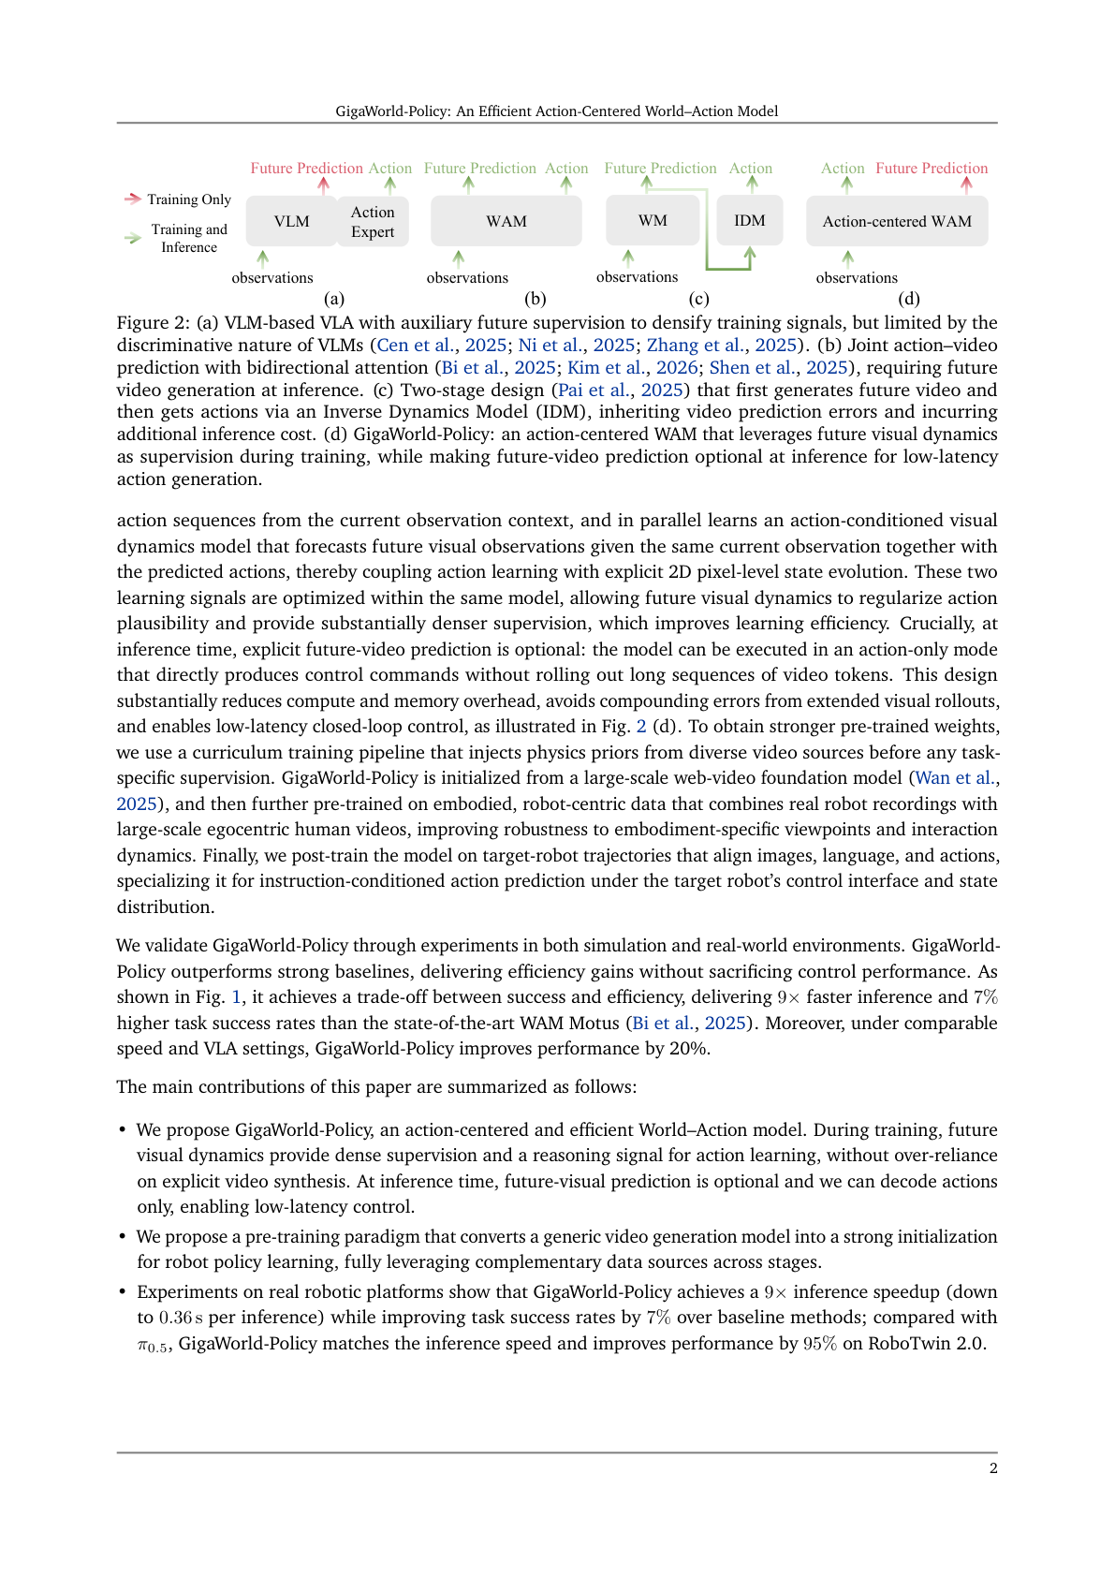
Figure 2: Shows the key architectural difference: GigaWorld-Policy uses causal masking to make future video prediction optional at inference, unlike existing WAMs that require video generation.

Limitations
- Requires careful tuning of loss weights λ_video and λ_action to balance supervision signals effectively
- Still depends on accurate current observation encoding - errors in visual perception can propagate to action prediction
- Causal masking design may limit the model's ability to leverage full bidirectional reasoning between action and video modalities
- Performance gains may diminish for very long-horizon tasks where video prediction errors would compound anyway

