LoST: Level of Semantics Tokenization for 3D Shapes
Niladri Shekhar Dutt, Zifan Shi, Paul Guerrero, Chun-Hao Paul Huang, Duygu Ceylan, Niloy J. Mitra et al. | Adobe
https://arxiv.org/abs/2603.17995

Research Questions
- How can 3D shapes be tokenized by semantic salience rather than geometric level-of-detail to enable efficient autoregressive generation?
- How can semantic supervision be provided for 3D shape tokenization without direct access to semantic labels?
- Can semantically-ordered tokens enable high-quality 3D generation with dramatically fewer tokens than geometric hierarchies?

Core Idea
Current 3D tokenization methods use geometric level-of-detail (LoD) hierarchies that require many tokens to represent basic shapes and produce unusable early prefixes. This paper proposes ordering tokens by semantic salience instead - early tokens capture the core semantic identity (e.g., 'chair') while later tokens add instance-specific details. The key insight is using Relational Inter-Distance Alignment (RIDA) to train a semantic extractor that aligns 3D shape relationships with DINO image feature relationships, providing semantic supervision without needing explicit 3D semantic labels.

Key Formula
Inter-Instance Rank Distillation Loss
$L_{rank}:=E_{z_{i}∈B}[||{\overset{\sim }{c}}_{i}^{s}−{\overset{\sim }{c}}_{i}^{t}||_{2}^{2}]$
Aligns relative similarity rankings between student (3D) and teacher (DINO) spaces. \tilde{c}_i^s and \tilde{c}_i^t are z-scored cosine similarity vectors that remove modality-specific means/scales, making the loss invariant to absolute similarity values while preserving neighborhood rankings.
RIDA Combined Loss
$L_{RIDA}:=λ_{g}L_{global}+λ_{r}L_{rank}+λ_{s}L_{spatial}$
Total semantic alignment objective combining global contrastive loss (L_global), inter-instance rank distillation (L_rank), and spatial structure distillation (L_spatial). Used to train the semantic extractor that maps 3D triplanes to semantically-structured features aligned with DINO space.

Key Figure
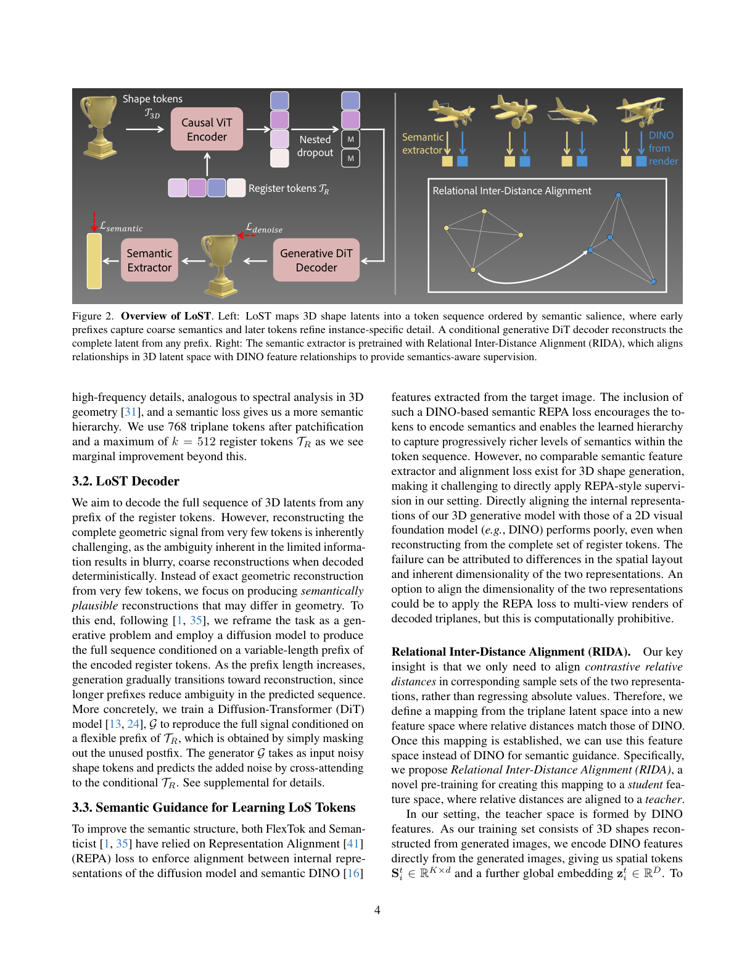
Figure 2: Shows the complete LoST architecture with causal ViT encoder, nested dropout, generative DiT decoder, and RIDA semantic alignment training pipeline.

Limitations
- Relies on VAE triplane representation, limiting extension to other 3D formats without adaptation
- Uses diffusion decoder which increases computational cost compared to pure autoregressive decoding
- Few-token regime still exhibits artifacts compared to full-length decodes
- AR generator uses fixed target length rather than variable-length with EOS tokens for complexity-aware stopping

