MosaicMem: Hybrid Spatial Memory for Controllable Video World Models
Wei Yu, Runjia Qian, Yumeng Li, Liquan Wang, Songheng Yin, Sri Siddarth Chakaravarthy P et al. | Georgia Institute of Technology
https://arxiv.org/abs/2603.17117

Research Questions
- How can spatial memory mechanisms for video world models combine the geometric consistency of explicit 3D memory with the dynamic flexibility of implicit memory?
- Can patch-level spatial memory with 3D lifting and implicit conditioning achieve better camera control and dynamic object modeling than existing paradigms?
- How can warped positional encoding and latent alignment improve memory retrieval accuracy in video diffusion models?

Core Idea
Existing spatial memory approaches for video world models face a fundamental tradeoff: explicit 3D memory (point clouds, 3D Gaussians) provides geometric consistency but struggles with dynamic objects, while implicit memory (posed frames) handles dynamics but suffers from camera drift and redundancy. MosaicMem bridges this gap by using patches as memory units - lifting them into 3D for reliable localization (like explicit methods) but conditioning generation through attention mechanisms (like implicit methods). The key insight is that patches offer the right granularity: more structured than implicit frames for geometric alignment, yet more flexible than explicit point clouds for dynamic scenes.

Key Formula
Warped RoPE Reprojection
$(u^{′},v^{′})=Π\left(K_{j}T_{j}T_{i}^{−1}K_{i}^{−1}(u,v,D)\right)$
Projects patch coordinates (u,v) with depth D from source camera (Ki, Ti) to target camera (Kj, Tj). Π denotes perspective projection. This enables geometric correspondence for aligning memory patches across viewpoints, addressing the core challenge of patch-level spatial consistency.

Key Figure
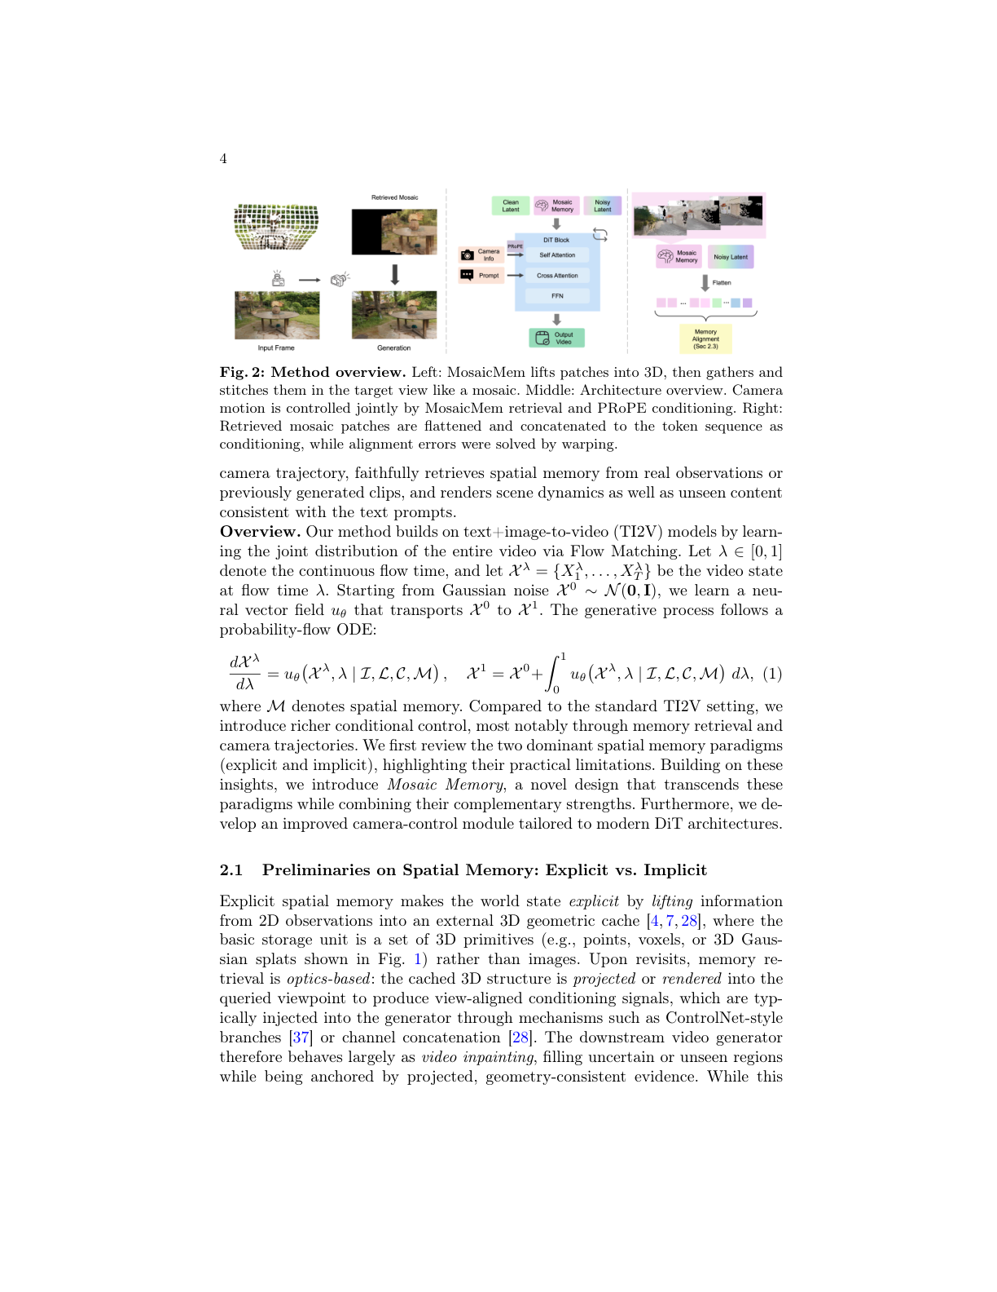
Figure 2: Shows the complete MosaicMem pipeline: patch lifting into 3D, mosaic composition in target view, and architecture with PRoPE conditioning and warping mechanisms.

Limitations
- Relies on off-the-shelf 3D estimators (Depth Anything V3, VIPE) whose accuracy affects memory quality
- Warped RoPE can cause object repetition at image boundaries in extreme scenarios like very slow camera motion
- Limited to patch-level granularity which may miss fine-grained spatial details within patches
- Memory alignment through warping introduces computational overhead compared to direct frame-based approaches

