Qianfan-OCR: A Unified End-to-End Model for Document Intelligence
Daxiang Dong, Mingming Zheng, Dong Xu, Chunhua Luo, Bairong Zhuang, Yuxuan Li et al. | BAIDU
https://arxiv.org/abs/2603.13398

Research Questions
- How can end-to-end vision-language models achieve OCR performance competitive with specialized multi-stage pipeline systems?
- How can explicit layout analysis capabilities be recovered in end-to-end OCR models that typically lose spatial structure information?
- What are the performance trade-offs between unified end-to-end models versus traditional OCR-then-LLM pipeline approaches for document understanding tasks?

Core Idea
Traditional OCR systems use multi-stage pipelines (detection → recognition → understanding) that suffer from error propagation and lose visual context during text extraction. End-to-end models avoid these issues but sacrifice explicit layout analysis that users need for spatial grounding. Qianfan-OCR introduces "Layout-as-Thought" - an optional reasoning phase triggered by <think> tokens where the model first generates structured layout representations (bounding boxes, element types, reading order) before producing final outputs. This recovers layout capabilities while maintaining end-to-end optimization and improving accuracy on complex documents where structural priors help resolve ambiguities.

Key Figure
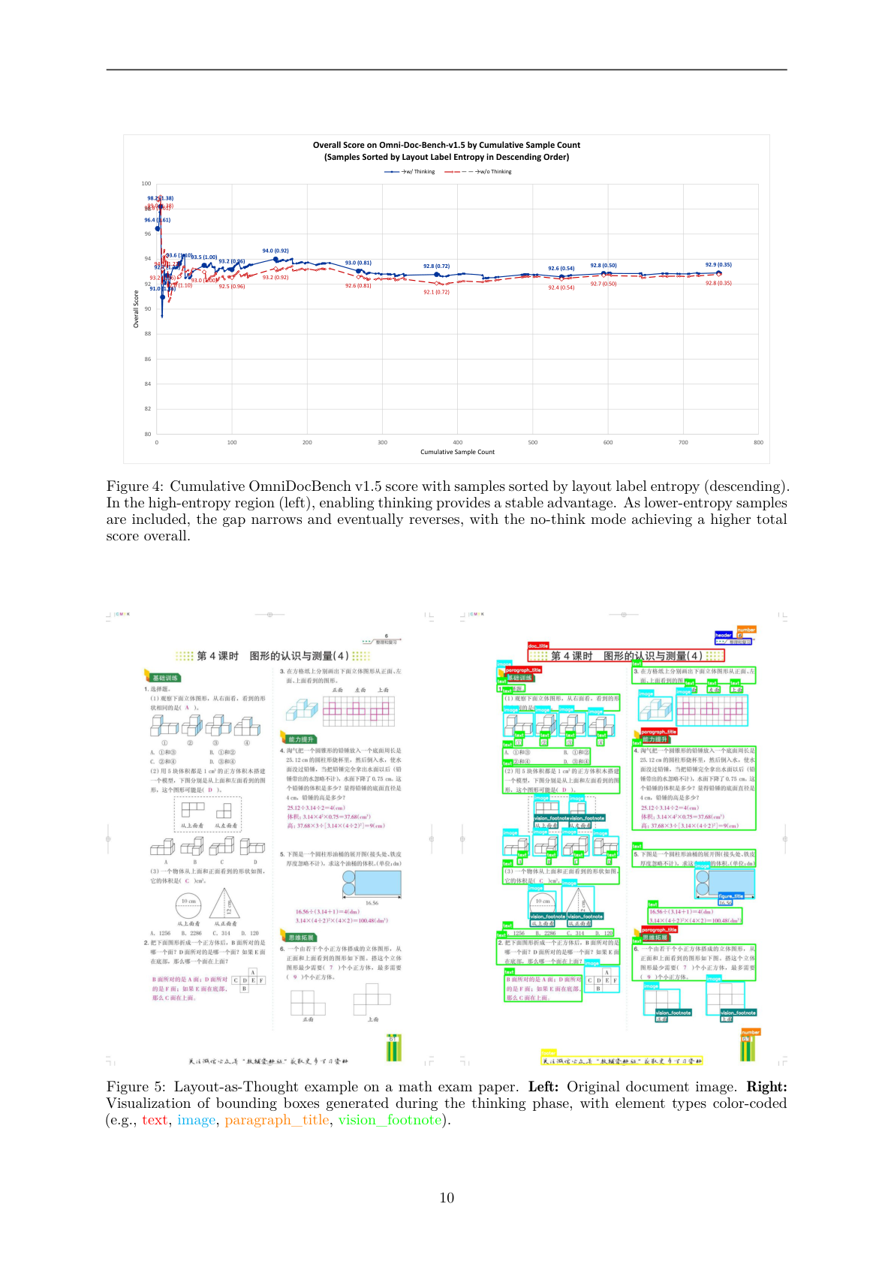
Figure 4: Shows Layout-as-Thought provides targeted benefits on structurally complex documents (high layout entropy) but can hurt performance on simple documents, validating the mechanism's selective effectiveness

Limitations
- Layout-as-Thought only validated on document parsing tasks, effectiveness on KIE, chart understanding, and document QA remains unexplored
- 4B parameter footprint limits deployment in resource-constrained environments like edge devices and CPU-only servers
- Performance ceiling of purely end-to-end architectures versus heavily optimized pipeline systems remains unclear
- Current Layout-as-Thought generates rigid format layout dumps rather than flexible task-adaptive spatial reasoning

