Temporal Gains, Spatial Costs: Revisiting Video Fine-Tuning in Multimodal Large Language Models
Linghao Zhang, Jungang Li, Yonghua Hei, Sicheng Tao, Song Dai, Yibo Yan et al.
https://arxiv.org/abs/2603.17541

Research Questions
- How does Video-SFT (video-based supervised fine-tuning) affect the balance between spatial and temporal understanding capabilities in MLLMs?
- What is the relationship between temporal budget (number of frames) and the image-video performance trade-off?
- Can adaptive frame allocation strategies mitigate the conflict between image and video understanding in unified MLLM training?

Core Idea
This paper reveals a fundamental conflict in multimodal large language models: video fine-tuning consistently improves video understanding but degrades image understanding, termed the "temporal trap". The key insight is that shared parameters create competing gradients - video-oriented updates with temporal specialization interfere with spatial capability preservation. The authors show this trade-off intensifies with more training frames and propose an adaptive frame allocation strategy that assigns different frame counts based on instruction complexity to partially mitigate the conflict.

Key Formula
Image loss change under video update
$L_{img}(θ^{+})=L_{img}(θ)−η⟨g_{img},g_{vid}^{(m)}⟩+\frac{η^{2}}{2}(g_{vid}^{(m)})^{⊤}H_{img}({\overset{\sim }{θ}}_{img})g_{vid}^{(m)}$
Shows how image loss L_img changes when parameters θ are updated by video gradient g^(m)_vid. The key term ⟨g_img, g^(m)_vid⟩ represents gradient alignment - negative alignment leads to image degradation. This formalizes when video updates harm image performance.
Video gradient decomposition
$g_{vid}^{(m)}=g_{sh}+α^{(m)}g_{tmp}+ϵ^{(m)}$
Decomposes video gradient into shared component g_sh (useful for both modalities), temporal component g_tmp (video-specific), and residual ε^(m). Coefficient α^(m) increases with frame count m, explaining why more frames intensify the conflict.

Key Figure
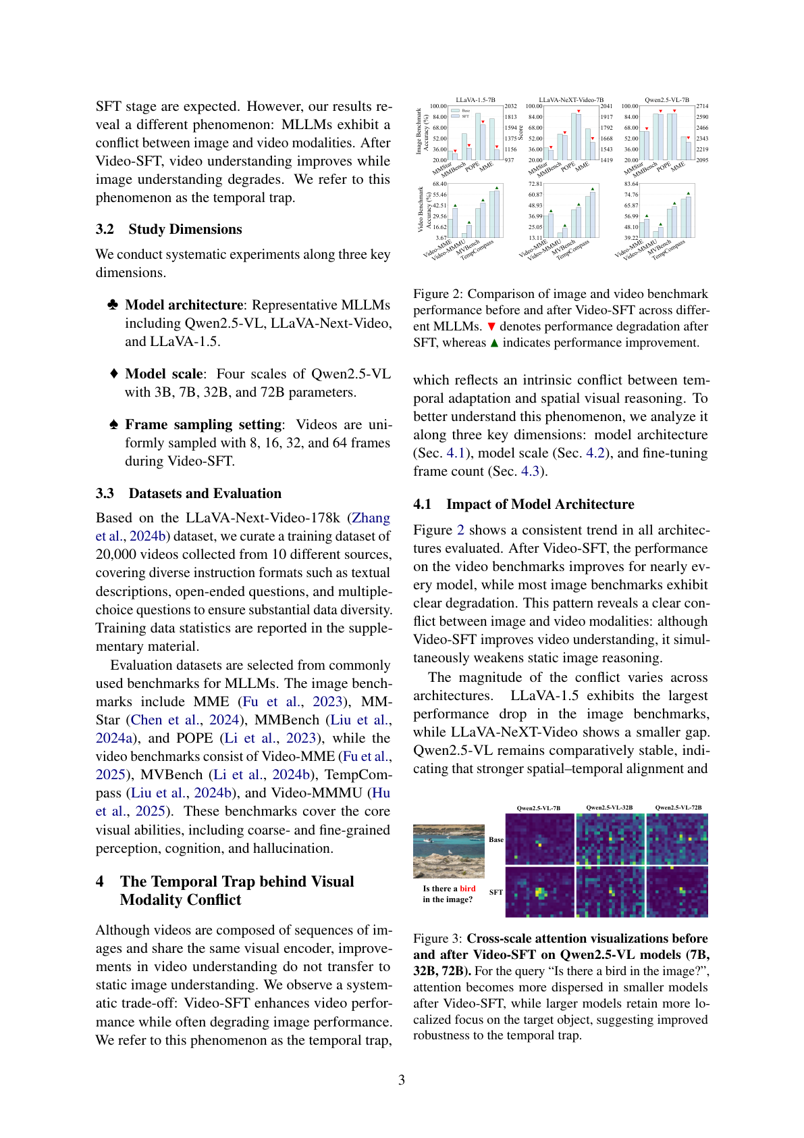
Figure 2: Shows consistent performance degradation on image benchmarks (MME, MMStar, MMBench, POPE) while video benchmarks improve across different MLLM architectures after Video-SFT, directly demonstrating the temporal trap phenomenon.

Limitations
- Hybrid-Frame Strategy relies on predefined discrete frame counts (8, 16, 32, 64) rather than continuous optimization
- Current approach only uses textual instruction analysis, ignoring actual visual content dynamics of videos
- Theoretical analysis provides local sufficient conditions but not complete characterization of the trade-off mechanism
- Evaluation limited to standard benchmarks, excluding streaming video and interactive scenarios

