When AI Navigates the Fog of War
Ming Li, Xirui Li, Tianyi Zhou | Tianyi Lab
https://arxiv.org/abs/2603.16642

Research Questions
- Can large language models reason coherently about an unfolding geopolitical crisis when armed only with partial, noisy information available at each temporal moment?
- How do LLM strategic reasoning capabilities vary across different domains (economic vs. political vs. military) during real-time geopolitical analysis?
- How do model narratives and predictions evolve as new information becomes available during an ongoing conflict?

Core Idea
The core problem is that evaluating LLM geopolitical reasoning on historical events is fundamentally flawed due to training data leakage - models may have memorized outcomes rather than genuinely reasoning. The key insight is to study an ongoing conflict (2026 Middle East crisis) that occurred entirely after model training cutoffs, creating a natural experiment where models must rely on reasoning rather than memorization. The approach works by constructing 11 temporal nodes with strict information constraints, forcing models to reason from only publicly available information at each moment, thus eliminating hindsight bias and data contamination.

Key Formula
Calibration Consistency Score
$\text{Calibration Score}=1−\text{MAE},\text{ where }\text{MAE}=\frac{1}{N}\sum_{k=1}^{N}{|p_{k}−y_{k}|}$
p_k is the probability estimate from model response, y_k ∈ {0,1} is ground truth outcome, N is number of questions. Measures how well model probability estimates align with observed outcomes, with higher values indicating better calibration. Important because it quantifies model reasoning quality under uncertainty.

Key Figure
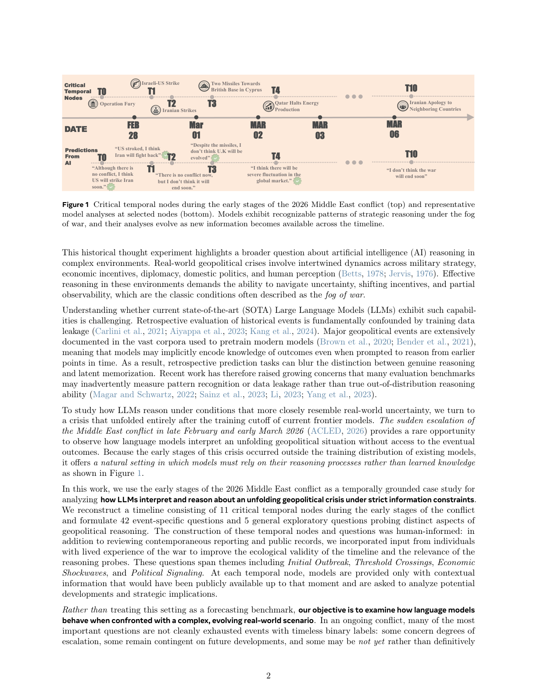
Figure 1: Shows the temporal timeline of 11 critical nodes (T0-T10) with representative AI predictions, demonstrating how models evolve their strategic reasoning as the conflict unfolds from pre-conflict to active warfare.

Limitations
- Single conflict case study limits generalizability to other geopolitical scenarios or time periods
- Manual extraction of probability estimates from model responses introduces potential researcher bias
- One-week resolution window for 'verifiable' questions is somewhat arbitrary and may not capture longer-term developments
- Ongoing nature of conflict means some ground truth labels may change with longer observation periods

