HAM10000 Skin Lesion Classification and Segmentation
Final Project Report
All reported measurements were loaded from saved experiment outputs. Existing classification checkpoints were not retrained for this report.

Abstract
This project investigates automated skin-lesion analysis using 10,015 HAM10000 dermoscopic images across seven diagnostic classes. Five established convolutional architectures and a custom CNN were evaluated on one canonical lesion-level validation split using Apple MPS. EfficientNetB0 achieved the highest classification accuracy (87.70%) and macro F1 (0.8075). A compact U-Net trained with 10,015 genuine lesion masks achieved Dice 0.9176 and IoU 0.8613. The results show that efficient transfer-learning architectures provide strong classification performance while pixel-level segmentation can accurately localize lesion regions.

1. Introduction
Skin cancer screening benefits from consistent analysis of dermoscopic images, but visual similarity among lesion types and severe class imbalance make automated diagnosis challenging. Deep convolutional networks can learn discriminative features, while segmentation separates the lesion from surrounding skin. This project combines both tasks in one reproducible PyTorch pipeline.

2. Related Work
HAM10000 was introduced as a multi-source dermatoscopic benchmark [1]. Residual connections [4], dense connectivity [5], very deep VGG networks [6], and compound EfficientNet scaling [3] provide complementary approaches to image classification. U-Net introduced an encoder–decoder architecture with skip connections for biomedical segmentation [7]. PyTorch supplies the training and MPS execution framework [2]. The course-referenced HealthFed study illustrates broader privacy and collaboration concerns for healthcare AI [8].

3. Dataset
The project uses all 10,015 HAM10000 RGB images and all 10,015 corresponding genuine lesion masks. The seven labels are akiec, bcc, bkl, df, mel, nv, and vasc. The data are highly imbalanced, with melanocytic nevi forming the majority. No synthetic ground-truth mask was created.

4. Methods
Classification images were resized to 224×224 and normalized using ImageNet statistics. Training augmentation included flips, rotations, and mild color jitter. Final evaluation used deterministic preprocessing. The canonical 80/20 split was grouped by lesion_id with seed 42, producing 7,967 training and 2,048 validation images. Grouping prevents different images of the same lesion from crossing the split.

5. Classification
The evaluated models were ResNet50, VGG16, VGG19, DenseNet121, EfficientNet-B0, and a four-block custom CNN. Saved checkpoints were loaded without retraining and inferred on the exact same validation image IDs. Accuracy, per-class precision/recall/F1, macro averages, weighted averages, confusion matrices, and parameter counts were recorded.

6. Segmentation
A compact U-Net used four encoder and decoder levels with skip connections. Images and masks were jointly resized to 128×128 and augmented with synchronized flips and rotations. The objective combined binary cross-entropy and soft Dice loss. Training used five epochs, batch size 32, Adam optimization, lesion-level splitting, and Apple MPS.

7. Experiments
All completed final classifier inference ran on Apple MPS. The six checkpoints were evaluated on 2,048 canonical validation images. Segmentation used 7,967 training and 2,048 validation pairs. Existing classifier histories were retained for training-curve analysis; the custom CNN lacks a genuine epoch-level history, so no curve was fabricated.
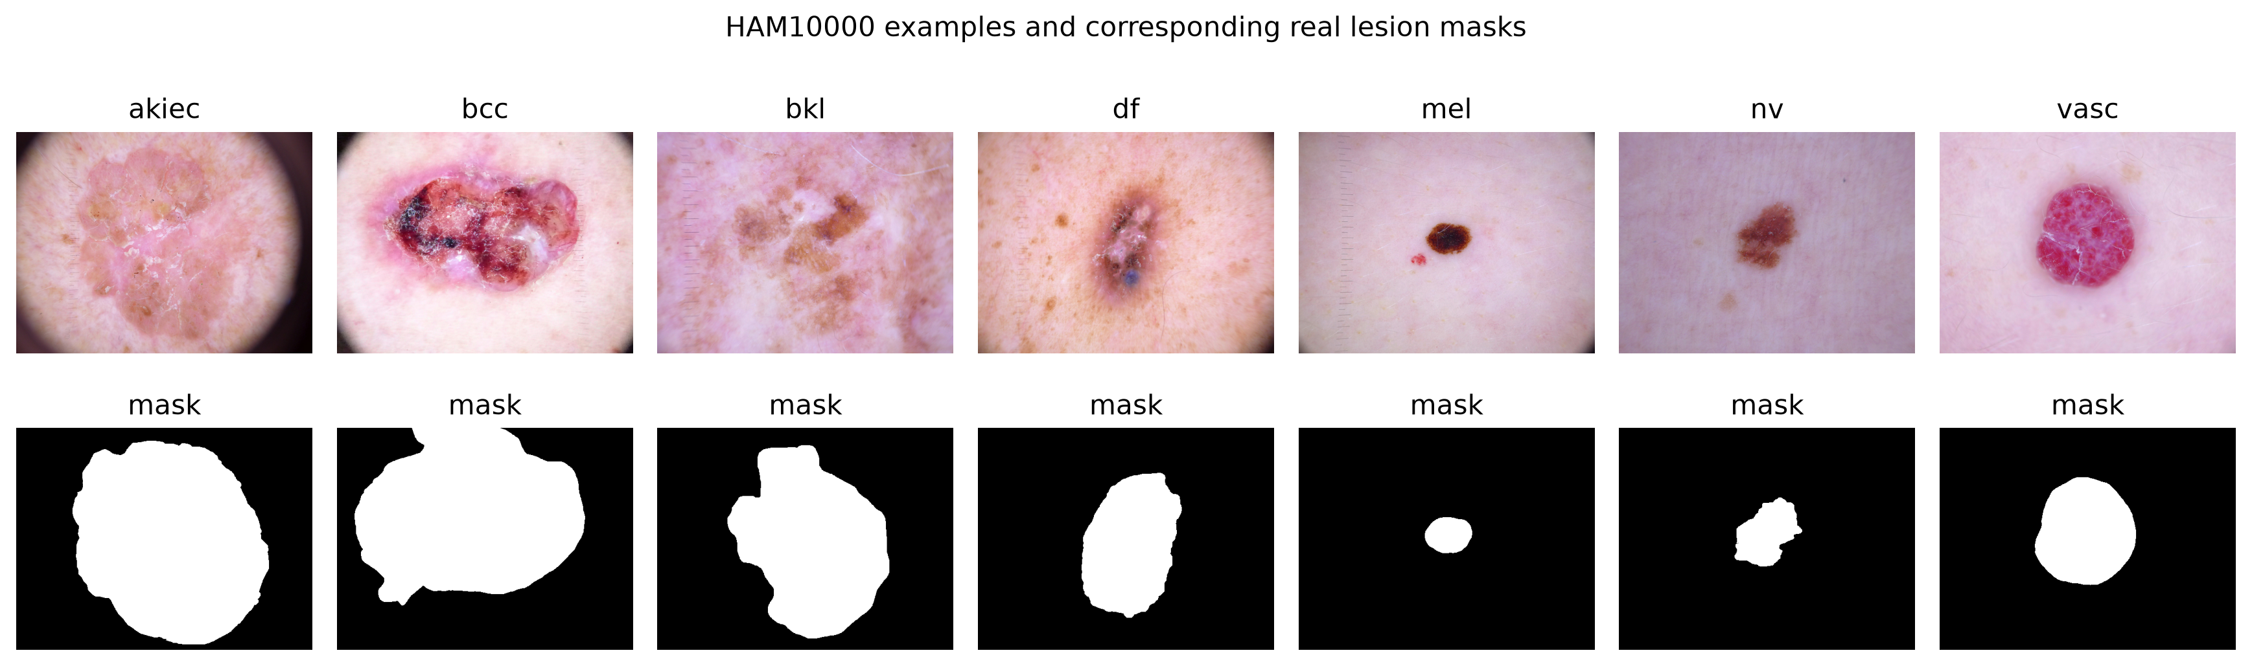

8. Results
Model | Accuracy | Macro Precision | Macro Recall | Macro F1 | Weighted F1 | Parameters
EfficientNetB0 | 0.8770 | 0.8152 | 0.8137 | 0.8075 | 0.8741 | 4,016,515
DenseNet121 | 0.7749 | 0.6291 | 0.5006 | 0.5345 | 0.7626 | 6,961,031
VGG16 | 0.7739 | 0.7096 | 0.6421 | 0.6489 | 0.7774 | 27,563,847
VGG19 | 0.7202 | 0.7154 | 0.8853 | 0.7659 | 0.7394 | 32,873,543
ResNet50 | 0.6812 | 0.5029 | 0.6537 | 0.5435 | 0.7058 | 23,522,375
CNN | 0.4829 | 0.3403 | 0.4177 | 0.3376 | 0.5309 | 423,175
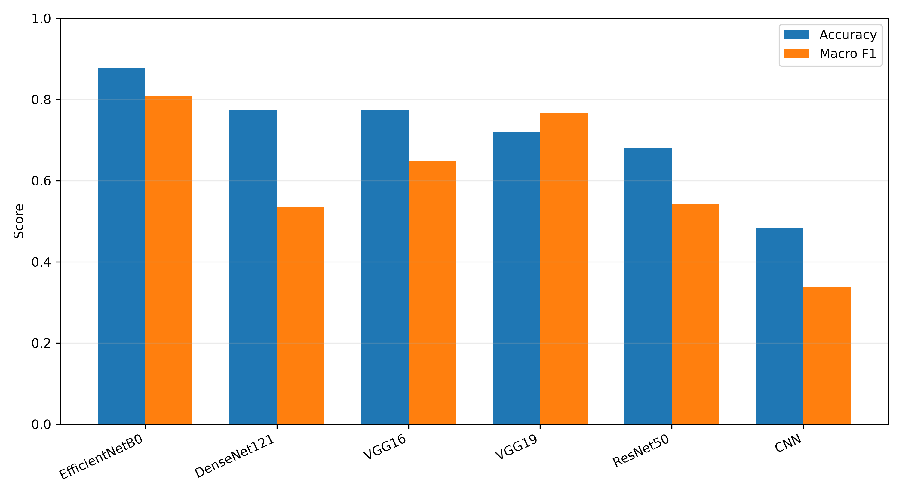
Segmentation results: Dice 0.9176, IoU 0.8613, precision 0.9582, recall 0.8983, and combined loss 0.2321.
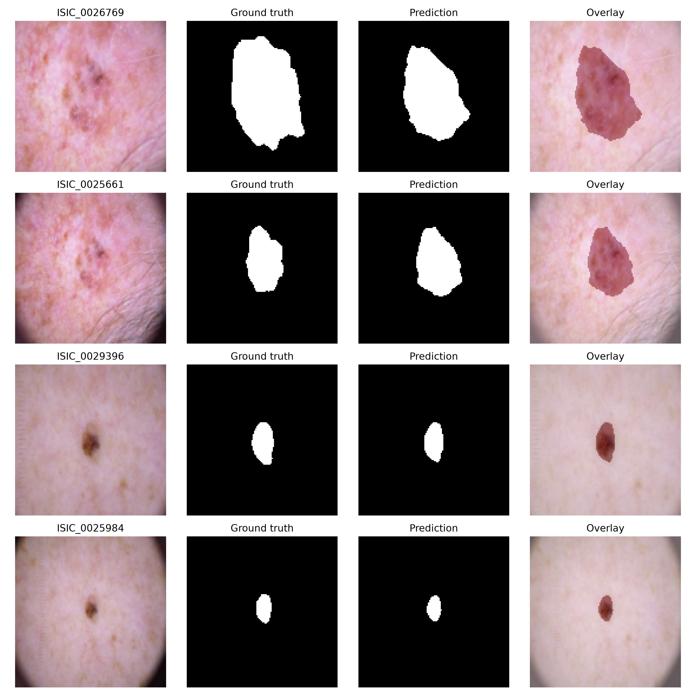

9. Discussion
EfficientNetB0 provided the strongest balance of accuracy and macro F1 with only 4,016,515 parameters. Its accuracy exceeds macro F1, showing that performance on the dominant nv class is stronger than balanced performance across diagnoses. VGG19 has lower accuracy but high macro recall, consistent with more minority-class predictions. The compact CNN is computationally small but underfits the classification task. Segmentation scores indicate strong region overlap, although the experiment uses an internal validation split rather than an external cohort.

10. Limitations
The original classifiers were trained under different historical split strategies and hyperparameters. Canonical inference makes final evaluation samples identical, but it cannot remove differences in training exposure. There is no independent external test set, clinical calibration analysis, or prospective validation. HAM10000 is imbalanced, and diagnostic labels do not replace histopathological confirmation. Segmentation was trained at 128×128 for efficiency. The custom CNN training history is unavailable.

11. Future Work
Future work should define one lesion-level train/validation/test split before training, use imbalance-aware losses or sampling, assess calibration and uncertainty, evaluate on external datasets, increase segmentation resolution, explore joint classification–segmentation learning, and investigate privacy-aware multi-institutional training.

12. Conclusion
A complete classification and segmentation pipeline was developed for HAM10000. On the shared validation split, EfficientNetB0 achieved 87.70% accuracy and macro F1 0.8075. The U-Net achieved Dice 0.9176. Reporting macro metrics, confusion matrices, and methodological limitations provides a more reliable interpretation than accuracy alone.

References
[1] P. Tschandl, C. Rosendahl, and H. Kittler, “The HAM10000 dataset, a large collection of multi-source dermatoscopic images of common pigmented skin lesions,” Scientific Data, vol. 5, Art. no. 180161, 2018, doi: 10.1038/sdata.2018.161.
[2] A. Paszke et al., “PyTorch: An imperative style, high-performance deep learning library,” in Advances in Neural Information Processing Systems 32, 2019, pp. 8024–8035.
[3] M. Tan and Q. V. Le, “EfficientNet: Rethinking model scaling for convolutional neural networks,” in Proc. ICML, 2019, pp. 6105–6114.
[4] K. He, X. Zhang, S. Ren, and J. Sun, “Deep residual learning for image recognition,” in Proc. IEEE CVPR, 2016, pp. 770–778, doi: 10.1109/CVPR.2016.90.
[5] G. Huang, Z. Liu, L. van der Maaten, and K. Q. Weinberger, “Densely connected convolutional networks,” in Proc. IEEE CVPR, 2017, pp. 4700–4708, doi: 10.1109/CVPR.2017.243.
[6] K. Simonyan and A. Zisserman, “Very deep convolutional networks for large-scale image recognition,” in Proc. ICLR, 2015, arXiv:1409.1556.
[7] O. Ronneberger, P. Fischer, and T. Brox, “U-Net: Convolutional networks for biomedical image segmentation,” in MICCAI, 2015, pp. 234–241, doi: 10.1007/978-3-319-24574-4_28.
[8] Z. Abou El Houda, A. S. Hafid, L. Khoukhi, and B. Brik, “When collaborative federated learning meets blockchain to preserve privacy in healthcare,” IEEE Trans. Network Science and Engineering, vol. 10, no. 5, pp. 2455–2465, 2023, doi: 10.1109/TNSE.2022.3211192.

