- Introduction
object class: numeric, integer, character, logical, complex.
class | create | index | function
objects | #class()  #is.numeric()  #as.numeric() |  | + - * / ^
sqrt() abs() pi
sin() cos() tan()
exp() log() log10()
factorial() choose()
vector | #c()  #start:stop  #seq(start,stop,step)  #rep(number,times) | x[n]  x[-n]  x[c(n1,n2,n3)]  x[x<n] | length()  sum() cumsum()  prod() cumprod()
matrix | #matrix(c(),nrow,ncol,byrow)  #rbind()  #cbind()  #matrix(scan(),nrow) | x[n1,n2]  x[c(n1,n2),c(n3,n4)] | dim() %*%  t() det() solve()
data frame | #str()  #data.frame()/tibble()  #fix()  #as.data.frame()/as_tibble() | x$col  x[[n]]  x[n1,n2]  attach() | names()  rownames()  colnames()  rename(old=new)
list | #list(a,b,c) | x[n]  x[[n]]  x$col
- Exploration
Input and export:
#read.csv(file.choose(),header=T) | #write.csv(var,file=,col.names=T)
#read.table(‘clipboard’,sep=’’,header=T) | #write.table(var,file=’clipboard’)
#readxl::read_excel(file.choose(),sheet=) | #writexl::write_xlsx(var,path=’’)
Numeric data describing:
Central tendency | Arithmetic mean | #mean() rowMeans() colMeans()
 | Median | #median()
 | Mode | #te<-table(x)  #names(te)[te==max(te)]  #DescTools::Mode()
Quartiles | quartiles | #quantile(), summary()
Variation | Range | #max()-min()/range()
 | Interquartile range | #IQR()
 | Variance | #var()
 | Standard deviation | #sd()
 | Coefficient of variation | #sd()/mean()*100
Shape | Skewness | #e1071::skewness()
 | Kurtosis | #e1071::kurtosis()
Data wrangling:
#head(),tail() | First rows | #which(condition) | Select row data
#subset(data,con,select) | Find a subset | #sort(,decreasing=T) | Order the data
#order(col1,-col2) | Order the data | #merge(d1,d2,by=) | Merge two data
#factor() | Create factor | #table() | Frequency
#cut(x,breaks=,labels=) | Cut a sequence | #interaction(,drop=T | Double-factor
#lapply(data,FUN=) | Return list | #sapply(data,FUN=) | Return vector
#apply(data,MARGIN,FUN) | By row/col | #do.call(function,list) | Fun one time
#is.na() | Missing value | #na.omit() | Clear the missing
#paste(c(‘a’,’b’,’c’),1:3,sep=’,’,collapse=’!’) |  | “a,1!b,2!c,3”
#dplyr::select, arrange, filter, mutate, rename, pull(data,-1), group_by, summarise
- Visualization
Basic arguments:
title | #mian=, sub=, xlab=, ylab=
font size | #cex=, cex.main=, cex.sub=, cex.axis=, cex.lab=
color | #col=, col.main=, col.sub= ,col.axis=, col.lab=
range | #ylim=, xlim=
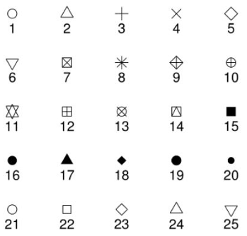  pch: |  | 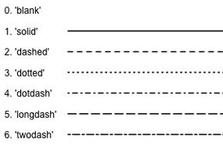  lty: | 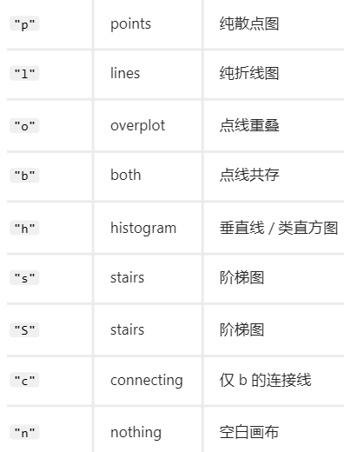  type:
Basic figure:
Figure function | addition
#plot(y~x,data) | #par(mfrow=c(nrow,ncol))
#hist(x,breaks=10) | #layout(matrix(c(1,1,2,3),nrow=2,byrow=T))
#pie(table(x),label=c()) | #text(x,value,pos=1:4)
#barplot(t,add=,names.arg=c(),space()) | #points(x)
#boxplot(y~x)/boxplot(a,b,c,names=c()) | #lines(x)
#stripchart(y~x,horizontal/vertical) | #legend(px,py,col=,pch=,c())
 | #abline(v=/h=/lm)
 | #curve(sin(x),from=,to=)
- Analysis
Hypothesis analysis:
H0:μ=mu  sd kown | #library(TeachingDemos)  #z.test(x,mu,sd,alternative=’two.sided’/’less’/’greater’,conf.level)
H0:μ=mu | #t.test(x,mu,alternative=’two.sided’/’less’/’greater’,conf.level)
H0:μ1-μ2=mu | #t.test(x,y,mu,alternative=,conf.level=0.95,var.equal=F,paired=T)
H0:μ1=μ2=μ3 | #aov(y~x,data), summary()
 | #aov(y~x1+x2+x3,data), summary()
 | #aov(y~x1*x2*x3,data), summary()>>interaction effect
H0:pi=p | #prop.test(x=sucess,n=total,p,alternative=,conf.level=,correct=F)
H0:pi1-pi2=p | #prop.test(x=c(),n=c(),p,alternative=,conf.level=,correct=F)
H0:σ^2=si^2 | #library(EnvStats)  #varTest(x,sigma.squared,alternative=,conf.level=)
H0:σ1^2/σ2^2=r | #var.test(x,y,ratio,altenative=,conf.level=)
Regression:
#lm(y~x,data) | Create a linear regression
#summary()  #plot(y~x,data), abline(model) | Show the result
#pairs(~x1+x2+x3,data) | Plot a scatterplot matrix
#lm(y~x1,x2,x3,data) | Create a multiple linear regression
#as.factor(x1),lm(y~x1) | Fit a dummy variable model
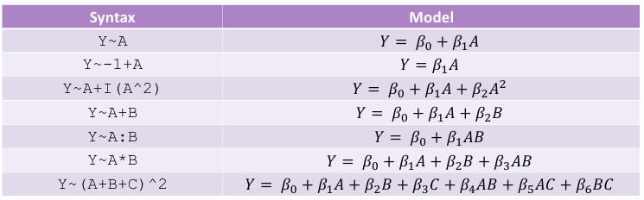

Residual analysis:
#plot(fitted(model),residuals(model)),  #abline(h=0) | Detect non-linearity and non-constant variance.  The plot should random.
#hist(residuals(model))  #qqnorm(residuals(model))  #qqline(residuals(model)) | Detect non-normality
#rstandard(model)  #rstudent(model) | Abs(residuals)>2 >>>possible outlier  Abs(residuals)>3 >>>strong outlier
#hatvalues(model) | hatvalues>2(p/n) >>>high leverage points.  Leverage: Measures how far an observation’s predictors (x-values) are from the mean.  should examine the corresponding observation.
#dffits(model) | Abs(value)>2*sqrt(p/n) >>>influential observation  DFFITS: Measures influence of each observation on fitted values.
#cooks.distance(model) | Value>1 >>>potentially influence  Value>4/n >>>worth investigating  Cook’s Distance: Measures the overall influence of an observation on the fitted regression model.
- Programming
#if (condition) {processing} | If-else branches
#if (condition) {processing}
#else {processing2}
#if (condition) {processing}
#else if {processing2}
#else {processing3}
#ifelse(condition,true,false)
#switch(number,re1,re2,re3)
#for (val in sequence) {processing} | Loop  #breaks>>finish the loop  #next>>skip this turn
#while (condition) {processing}
#function(ar1,ar2) {processing return()} | Function
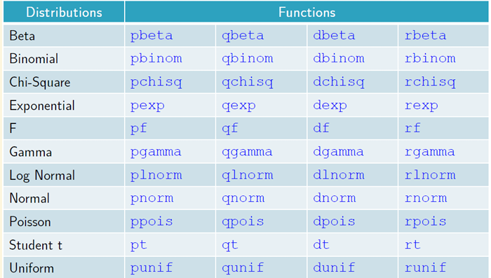
- Monte carlo simulation
Distribution is known | d>>density | Probability density
 | p>>probability | Smallest probability
 | q>>quantile | Quantile
 | r>>random | Generate random number
Convert into longer data:
tidyr::pivot_longer(data,cols=everything(),names_to=,values_to=)

