网页框架：

Hydrometeorology, Atmosphere and Climate

HydroMet Group @ HKUST

* Meet us
* Projects
* Team
* Latest Tweets
* Collaborators
* Contact us

各部分内容：

* Meet us:

The *HydroMet* Group is a research team led by Prof. Mengqian Lu at the Department of Civil and Environmental Engineering, the Hong Kong University of Science and Technology (HKUST). The team currently consists of six research graduate students, one postdoctoral research fellow. From time to time, we will have visiting students and scholars coming to UST and work with us. You can find their research interests and news in the Team & Latest News sessions. At the moment, our team is expanding, if you are interested in joining us, please contact Prof. Mengqian Lu ([mengqian.lu@ust.hk](mailto:mengqian.lu@ust.hk)) with your CV and some description of your research pursuit. We have opening positions for graduate students (both Master of Philosophy and Doctor of Philosophy) and postdoctoral researchers.

We want to provide a platform for anyone who might be interested in the same research area and/or our group, to know us and learn our current research findings. Our research interests lie in water resource, data science, climate dynamics and risk management. We are motivated by emerging questions at the intersection of water resources, severe weather event and climate change with a focus on hydroclimate extremes prediction and associated risk management given their close relevance to societal outcomes or to the advancement of science towards innovative application. Our ongoing research covers spatiotemporal statistics and prediction of extreme hydrometerological events and the mechanisms and impacts of *Atmospheric Rivers*, changes in their frequency-of-occurrence subjected to climate variability and climate changes, and their impacts on natural resources management schemes and risk mitigation. Our education background and research experiences in water resources engineering, atmospheric science, climate and data science enable us assimilate the understanding of the physical systems with 'big data' approaches to develop a framework for the hydrometeorological study. Everyone in my group has their own research focus, which you can find out from their own page (linked provided below) in details.

以及后面的视频（插入视频，格式为SWF/MOV/MP3/MP4/WMV/AVI/RMTB等，也可以插入flash动画）

* Projects:
  1. Project Title: Identification and diagnosis of spatiotemporal hydrometeorological structure of heavy precipitation induced floods in Southeast Asia

PI: Prof. Mengqian LU

Research students: Lun DAI; Mengxin PAN; Tat Fan CHENG

Funding Agency & Scheme: General Research Fund, Research Grants Council ( RGC) of Hong Kong

Project period: 2018/01 – 2020/12

Outputs:

* + 1. Mengxin Pan and Mengqian Lu, “*An Algorithm for Atmospheric Rivers (ARs) Trajectory Identification in the East Asia: An Application for Flood-triggering* *Heavy Precipitation in the Yangtze River Basin (YRB)*”, Water Resources Research, (to be submitted)
    2. Lun Dai, Mengqian Lu and Tat Fan Cheng, “*The Spatiotemporal Characteristics of Summer Rainfall in the Southeast China Coast and hydrometeorological diagnosis of its predictability*”. AGU 2018 (submitted)
    3. Mengxin Pan and Mengqing Lu “*A new algorithm for Atmospheric Rivers detection in the East Asia – a pilot application for flood-triggering Heavy Precipitation in the Yangtze River Basin (YRB)”*, AGU 2018 (submitted)
  1. Project Title: 中国东南沿海极端降水灾害时空变异的天河水汽输送机制The Atmospheric River moisture transport mechanism for the spatiotemporal variations of the extreme precipitation in Southeast China coast

PI: Prof. Mengqian LU

Research students: Mengxin PAN; Tat Fan CHENG; Lun DAI;

Funding Agency & Scheme: 国家自然科学基金 青年科学基金项目 National Natural Science Foundation of China, Young Scientists Fund

Project period: 2018/01 – 2020/12

Outputs:

1. Tat Fan Cheng, Mengqian Lu and Lun Dai (2018) *“The Zonal Oscillation and the Driving Mechanisms of the Extreme western North Pacific Subtropical High and its impacts on East Asia Summer Precipitation”*, Journal of Climate, (under 2nd review)
2. Mengxin Pan and Mengqing Lu “*A new algorithm for Atmospheric Rivers detection in the East Asia – a pilot application for flood-triggering Heavy Precipitation in the Yangtze River Basin (YRB)”*, AGU 2018 (submitted)
3. Mengxin Pan and Mengqian Lu, “*An Algorithm for Atmospheric Rivers (ARs) Trajectory Identification in the East Asia: An Application for Flood-triggering Heavy Precipitation in the Yangtze River Basin (YRB)*”, Water Resources Research, (to be submitted)
4. Lun Dai, Mengqian Lu and Tat Fan Cheng, “*The Spatiotemporal Characteristics of Summer Rainfall in the Southeast China Coast and hydrometeorological diagnosis of its predictability*”. AGU 2018 (submitted)
   1. Project title: The role of atmospheric moisture transport and associated circulation patterns on extreme precipitation events at the mesoscale: a strategic scheme for the Sky-River initiative in China

PI: Prof. Mengqian Lu

Researcher: Dr. Yingzhao Ma

Research student: Mengxin Pan

Funding Agency & Scheme: HKUST

Project period: 2018/10 – 2020/10

Outputs:

* + - 1. Ma Y., **Lu Mengqian**, Chen H., Pan M. and Hong Y. (2018). “*Atmospheric moisture transport versus precipitation across the Tibetan Plateau: a mini-review and current challenges*”, ***Atmospheric Research***. 209, 50-58, doi:10.1016/j.atmosres.2018.03.015
      2. *Paper in progress*
  1. Project title: Revolutionizing Future Hydrometeorological Extreme Induced Multi-hazard Risk Mapping by Adapting Big Data Analytics on the Composition of Multi-source Information

PI: Prof. Mengqian LU & Prof. Limin ZHANG

Research students: Lun DAI; Liang GAO; Yejia QIANG; Shengyang ZHOU

Funding Agency & Scheme: HKUST

Project period: 2017 – 2019

Outputs:

1. Gao, L., L. Zhang, and Mengqian Lu (2017), “*Characterizing the spatial variations and correlations of large rainstorms for landslide study”*, *Hydrology and Earth System Sciences*, 21(9), 4573–4589, doi:10.5194/hess-21-4573-2017.
2. Zhou, S.Y., Zhang, L., Gao, L., and Lu, M. (2018). Scenarios of Large-Scale Landslides and Debris Flows under Extreme Rainstorms. Proc. 6th International Symposium on Reliability Engineering and Risk Management (6ISRERM), 31 May-01 Jun 2018, Singapore. Qian, X.D., Pang, S. D & Phoon, K. K. (editors)
   1. Project title: The Causal Dynamics of Atmospheric Moisture Transport – Convergence – Release for Flood-triggering Precipitation Sequences on the Southeast China coast

PI: Prof. Mengqian LU

Research students: Tat Fan CHENG; Mengxin PAN; Lun DAI;

Funding Agency & Scheme: General Research Fund, Research Grants Council ( RGC) of Hong Kong

Project period: 2019/01 – 2021/12

Outputs:

* Team:

Prof. Mengqian Lu

My Bachelor's degree in Civil and Environmental Engineering and graduate studies in both engineering and applied statistics paved the road for my dedicated pursuit of doctorate study in hydroclimatic extremes and water resources in the Earth and Environmental Engineering and Columbia Water Center at Columbia University (2009 - 2014). My postdoctoral residency in Applied Physics and Applied Math (2014-2015) further strengthened my understanding of the dynamics, nonstationarity and nonlinearity of the climate system with a focus on the spatiotemporal statistics and modeling of extremes under climate changes and human impacts. I taught multivariate statistical inference and exploratory data analysis and visualization at the Department of Statistics and Data Science Institute at Columbia University (2015-2016) prior to my joining in HKUST. Currently I am teaching the *Hydrosystems Engineering (Fall)* and *Hydroclimate Data Analysis and Modeling (Spring)* at HKUST.

其他两位同学的照片；

每位的link

* Latest Tweets
* Collaborators

1. Columbia Water Center <http://water.columbia.edu/research-themes/cwc-china-water-initiative/>
2. Dr. Naresh Devineni, City University of New York <http://nareshdevineni.com/about-3/>
3. Dr. Upmanu Lall, Columbia University <http://www.columbia.edu/~ula2/>
4. Dr. Kwon Hyun-Han, Chonbuk National University <http://www.ahrl.re.kr/1m3.html>
5. Dr. Vipin Kumar, University of Minnesota, Minneapolis <https://www-users.cs.umn.edu/~kumar001/>
6. Dr. Lai-yung Ruby Leung, Pacific Northwest National Laboratory <https://www.pnnl.gov/science/staff/staff_info.asp?staff_num=5661>
7. Dr. Yang Hong, Tsinghua University <http://www.civil.tsinghua.edu.cn/en/he/essay/543/2545.html>
8. Dr. Yi Zheng, Southern University of Science and Technology <http://www.sustc.edu.cn/en/faculty_58/f/Zheng_Yi>
9. Dr. Dechun Huang, Hohai University
10. Dr. Changzheng Zhang Hohai University

* Contact us

邮箱名：hydrometust@gmai.com

密码：hydromet135246

具体绑定手机号为代伦的，

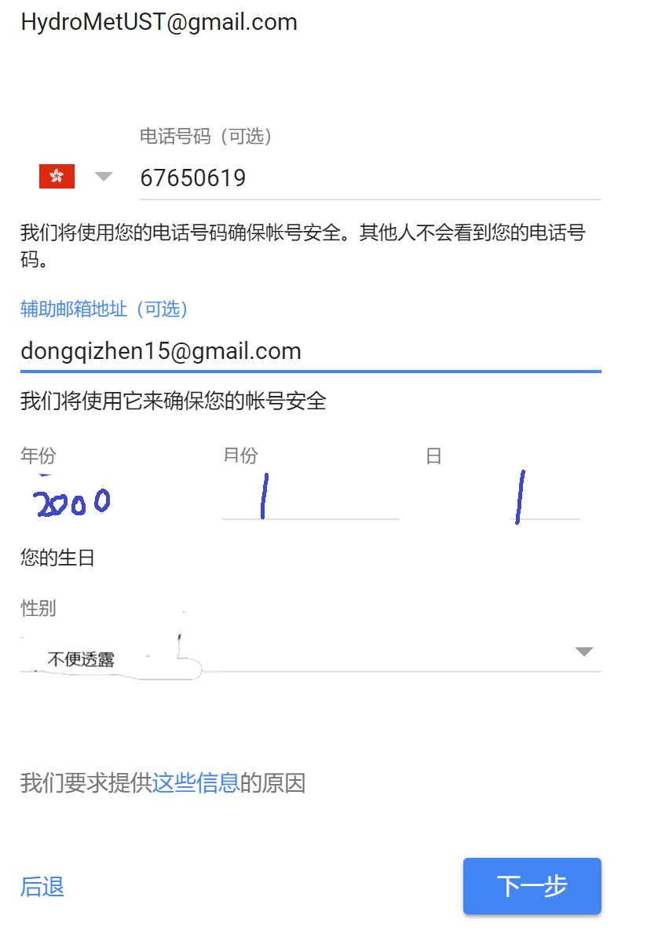

GitHub账号：用户名HydroMetUST，邮箱hydrometust@gmail.com，密码hydromet135246