1. 아래와 같이 EMP Table을 사용하여 부서별 MAX SAL,MIN SAL,AVG SAL(소수점 절삭),건수 그리고 전체 MAX SAL,MIN SAL,AVG SAL(소수점 절삭),건수를 구하시요.

( 1개는 Inline View를 통해 작성하고 1개는 Analytic Function을 사용하여 EMP Table 한번만 조회하도록 작성)

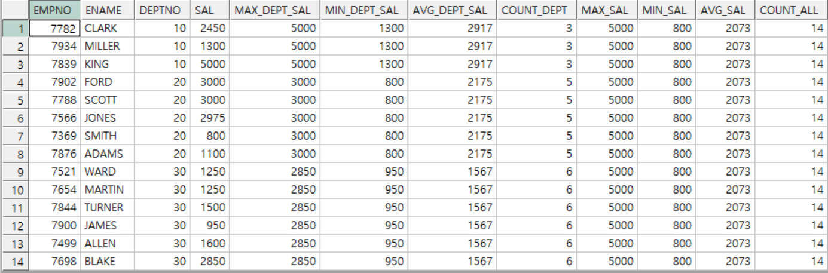  
**SQL Inline View :**

SELECT A.EMPNO,

A.ENAME,

A.DEPTNO,

A.SAL,

B_1.MAX_DEPT_SAL,

B_1.MIN_DEPT_SAL,

B_1.AVG_DEPT_SAL,

C_1.MAX_SAL,

C_1.MIN_SAL,

C_1.AVG_SAL,

C_1.COUNT_ALL

FROM EMP A,

(SELECT DEPTNO,

MAX(SAL) MAX_DEPT_SAL,

MIN(SAL) MIN_DEPT_SAL,

ROUND(AVG(SAL),0) AVG_DEPT_SAL

FROM EMP B

GROUP BY DEPTNO) B_1,

(SELECT MAX(SAL) MAX_SAL,

MIN(SAL) MIN_SAL,

ROUND(AVG(SAL),0) AVG_SAL,

COUNT(*) COUNT_ALL

FROM EMP C) C_1

WHERE A.DEPTNO = B_1.DEPTNO

ORDER BY DEPTNO ASC;

**SQL analytic function :**

SELECT EMPNO,

ENAME,

DEPTNO,

SAL,

TO_CHAR(HIREDATE, 'YYYY/MM/DD') HIREDATE,

ROW_NUMBER() OVER(PARTITION BY DEPTNO

ORDER BY SAL, HIREDATE) NUM_SAL,

SUM(SAL) OVER(PARTITION BY DEPTNO

ORDER BY SAL, HIREDATE) COMM_SAL

FROM EMP

GROUP BY EMPNO,

ENAME,

DEPTNO,

SAL,

HIREDATE

ORDER BY DEPTNO;

3. 아래와 같이 2번 SQL을 참조하여 부서별로 SAL,HIREDATE 순으로 ENAME을 나열하는 SQL을 작성하시요.

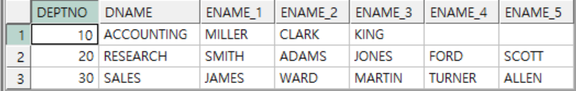

2번째 함수 이용

**SQL :**

SELECT B.DEPTNO, A.DNAME,

MAX(DECODE(TEMP_ENAME, 1, ENAME)) ENAME_1,

MAX(DECODE(TEMP_ENAME, 2, ENAME)) ENAME_2,

MAX(DECODE(TEMP_ENAME, 3, ENAME)) ENAME_3,

MAX(DECODE(TEMP_ENAME, 4, ENAME)) ENAME_4,

MAX(DECODE(TEMP_ENAME, 5, ENAME)) ENAME_5,

MAX(DECODE(TEMP_ENAME, 6, ENAME)) ENAME_6

FROM DEPT A,

( SELECT DEPTNO,

ROW_NUMBER() OVER(PARTITION BY DEPTNO ORDER BY SAL, HIREDATE) TEMP_ENAME,

ENAME

FROM EMP ) B

WHERE A.DEPTNO = B.DEPTNO

GROUP BY B.DEPTNO, A.DNAME;