1. 아래와 같이 EMP Table을 사용하여 부서별 MAX SAL,MIN SAL,AVG SAL(소수점 절삭),건수 그리고 전체 MAX SAL,MIN SAL,AVG SAL(소수점 절삭),건수를 구하시요.

( 1개는 Inline View를 통해 작성하고 1개는 Analytic Function을 사용하여 EMP Table 한번만 조회하도록 작성)

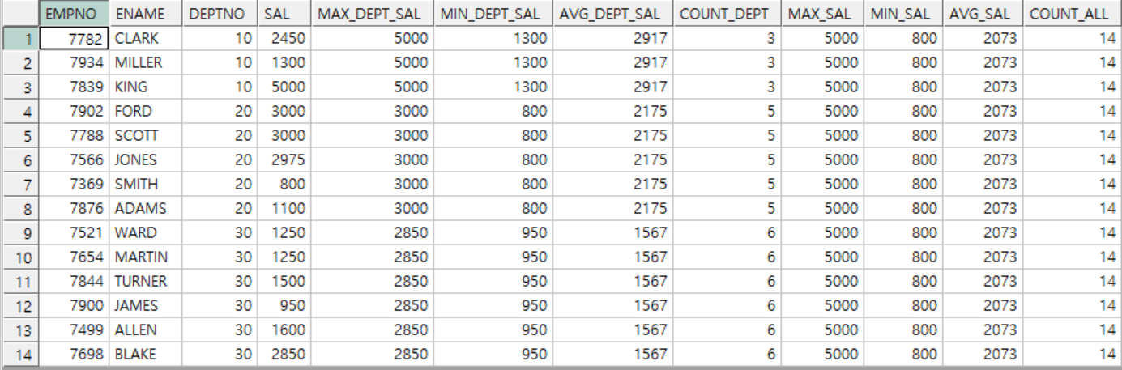  
**SQL Inline View :**

SELECT EMPNO ,

ENAME ,

A.DEPTNO ,

SAL ,

MAX_DEPT_SAL ,

MIN_DEPT_SAL ,

AVG_DEPT_SAL ,

COUNT_DEPT ,

MAX_SAL ,

MIN_SAL ,

AVG_SAL ,

COUNT_ALL

FROM EMP A,

(SELECT DEPTNO,

MAX(SAL) MAX_DEPT_SAL,

MIN(SAL) MIN_DEPT_SAL,

ROUND(AVG(SAL), 0) AVG_DEPT_SAL ,

COUNT(*) COUNT_DEPT

FROM EMP B

GROUP BY DEPTNO) B,

(SELECT MAX(SAL) MAX_SAL ,

MIN(SAL) MIN_SAL ,

ROUND(AVG(SAL), 0) AVG_SAL ,

COUNT(*) COUNT_ALL

FROM EMP C)

WHERE A.DEPTNO = B.DEPTNO

ORDER BY DEPTNO;

**SQL analytic function :**

SELECT EMPNO ,

ENAME ,

DEPTNO ,

SAL ,

MAX(SAL) OVER(PARTITION BY DEPTNO) MAX_DEPT_SAL ,

MIN(SAL) OVER(PARTITION BY DEPTNO) MIN_DEPT_SAL ,

ROUND(AVG(SAL) OVER(PARTITION BY DEPTNO), 0) AVG_DEPT_SAL ,

COUNT(*) OVER(PARTITION BY DEPTNO) ,

MAX(SAL) OVER() MAX_SAL ,

MIN(SAL) OVER() MIN_SAL ,

ROUND(AVG(SAL) OVER() , 0) AVG_SAL ,

COUNT(*) OVER() COUNT_ALL

FROM EMP;

2. 아래와 같이 EMP Table을 사용하여 부서별 SAL,HIREDATE 순 Numbering, 누적 SAL을 Analytic Function을 사용하여 구하시요.

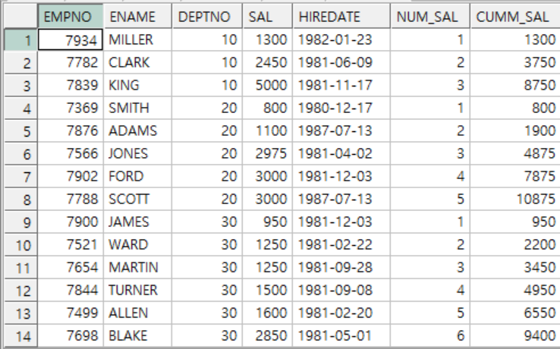

Cumm_sal : 누적 sal

**SQL :**

SELECT EMPNO ,

ENAME ,

DEPTNO ,

SAL ,

TO_CHAR(HIREDATE , 'YYYY-MM-DD') HIREDATE,

ROW_NUMBER() OVER(PARTITION BY DEPTNO

ORDER BY SAL, HIREDATE) NUM_SAL,

SUM(SAL) OVER(PARTITION BY DEPTNO

ORDER BY SAL, HIREDATE) COMM_SAL

FROM EMP

ORDER BY DEPTNO;

3. 아래와 같이 2번 SQL을 참조하여 부서별로 SAL,HIREDATE 순으로 ENAME을 나열하는 SQL을 작성하시요.

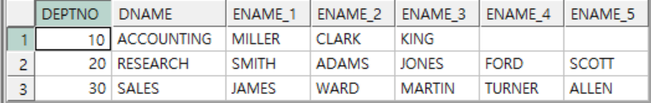

2번째 함수 이용

**SQL :**

SELECT B.DEPTNO,

DNAME,

MAX(DECODE(NUM, 1, B.ENAME)) ENAME_1,

MAX(DECODE(NUM, 2, B.ENAME)) ENAME_2,

MAX(DECODE(NUM, 3, B.ENAME)) ENAME_3,

MAX(DECODE(NUM, 4, B.ENAME)) ENAME_4,

MAX(DECODE(NUM, 5, B.ENAME)) ENAME_5,

MAX(DECODE(NUM, 6, B.ENAME)) ENAME_6

FROM DEPT A,

(SELECT DEPTNO,

ROW_NUMBER() OVER(PARTITION BY DEPTNO

ORDER BY SAL, HIREDATE) NUM,

ENAME

FROM EMP) B

WHERE A.DEPTNO = B.DEPTNO

GROUP BY B.DEPTNO,

DNAME;