1. 아래와 같이 각 empno 당 2개씩 row가 생성되도록 만든 후 각 empno 당 1건만 남기고 삭제시키는 문을 작성하시요.

(최소 2개 이상)

create table emp_dup

as

select a.*

from emp a,

(select 1 from emp where rownum <= 2) b;

**SQL 1번 :**

DELETE

FROM EMP_DUP A

WHERE ROWID > (SELECT MIN(ROWID)

FROM EMP_DUP B

WHERE A.EMPNO = B.EMPNO);

**SQL 2번 :**

DELETE

FROM EMP_DUP B

WHERE B.ROWID IN (SELECT A.RID

FROM (SELECT ROWID RID,

ROW_NUMBER() OVER(PARTITION BY EMPNO

ORDER BY EMPNO) RN

FROM EMP_DUP) A

WHERE A.RN >1) ;

2. 아래와 같이 SAL_HIST Table을 생성한 후 아래와 같이 기간이 조회되도록 하시요.

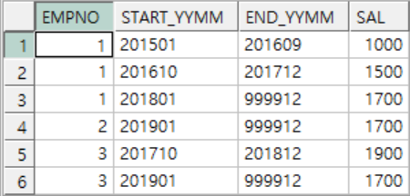

CREATE TABLE SAL_HIST

(

EMPNO NUMBER (4) NOT NULL,

START_YYMM CHAR(6),

SAL NUMBER (7,2)

);

INSERT INTO SAL_HIST VALUES (1,'201501',1000);

INSERT INTO SAL_HIST VALUES (1,'201610',1500);

INSERT INTO SAL_HIST VALUES (1,'201801',1700);

INSERT INTO SAL_HIST VALUES (2,'201901',1700);

INSERT INTO SAL_HIST VALUES (3,'201710',1900);

INSERT INTO SAL_HIST VALUES (3,'201901',1700);

commit;

**SQL :**

SELECT EMPNO,

START_YYMM,

DECODE(EMPNO, LEAD(EMPNO) OVER(

ORDER BY EMPNO), TO_CHAR(ADD_MONTHS(TO_DATE(LEAD(START_YYMM) OVER(PARTITION BY EMPNO

ORDER BY START_YYMM), 'YYYYMM'), -1), 'YYYYMM'), 999912) DA,

SAL

FROM SAL_HIST;

3. 아래와 같이 EMP Table을 참조하여 부서별,기간별 소속된 직원수를 구하는 SQL을 작성하시요.

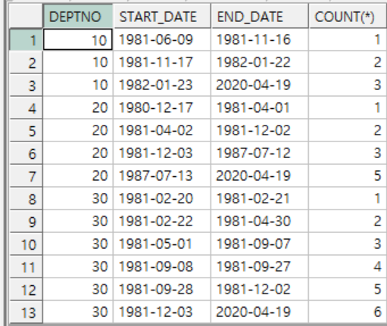

**SQL :**

SELECT A.DEPTNO,

START_DATE,

END_DATE,

COUNT(*)

FROM EMP A,

(SELECT DEPTNO,

HIREDATE,

TO_CHAR(HIREDATE, 'YYYY-MM-DD') START_DATE,

DECODE(DEPTNO, LEAD(DEPTNO) OVER(

ORDER BY DEPTNO), TO_CHAR((TO_DATE(LEAD(TO_CHAR(HIREDATE, 'YYYY-MM-DD')) OVER(PARTITION BY DEPTNO

ORDER BY HIREDATE), 'YYYY-MM-DD'))-1, 'YYYY-MM-DD'), TO_CHAR(SYSDATE, 'YYYY-MM-DD')) END_DATE

FROM EMP

GROUP BY DEPTNO, HIREDATE

ORDER BY DEPTNO ) B

WHERE A.HIREDATE < END_DATE

GROUP BY A.DEPTNO,

B.DEPTNO,

START_DATE,

END_DATE

HAVING A.DEPTNO = B.DEPTNO

ORDER BY DEPTNO, START_DATE;