**7차 2번 SQL 보강 ( 피드백 : 정말 길다. 집합 단위로 단순화 시켜봐 )**

**4건의 이순신 Data 추가**

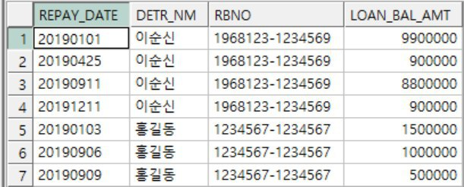

**Binding 값으로 20190102, 20190105 입력하면 아래와 같이 조회되도록**

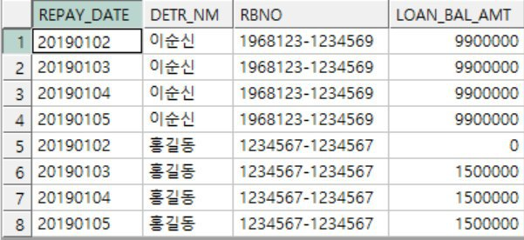

**SQL :**

SELECT B.REPAY_DATE,

DETR_NM,

RBNO,

CASE

WHEN B.REPAY_DATE < ST_REPAY_DATE THEN 0

ELSE LOAN_BAL_AMT

END LOAN_BAL_AMT

FROM (SELECT TO_CHAR(:1 -1 +LEVEL, 'YYYYMMDD') REPAY_DATE

FROM DUAL CONNECT BY LEVEL <=(:2 - :1)+1) B,

(SELECT TO_CHAR(REPAY_DATE, 'YYYYMMDD') REPAY_DATE,

DETR_NM,

RBNO,

LOAN_BAL_AMT,

TO_CHAR(

CASE

WHEN REPAY_DATE > MIN(REPAY_DATE) OVER(PARTITION BY RBNO) THEN REPAY_DATE

WHEN MIN(REPAY_DATE) OVER(PARTITION BY RBNO) > :1 THEN :1

ELSE REPAY_DATE

END , 'YYYYMMDD') SD,

TO_CHAR(LEAD(REPAY_DATE, 1 , '99991231') OVER(PARTITION BY RBNO

ORDER BY REPAY_DATE)-1, 'YYYYMMDD') ED,

MIN(REPAY_DATE) OVER(PARTITION BY RBNO) ST_REPAY_DATE

FROM REPAY_TEST ) A

WHERE B.REPAY_DATE BETWEEN SD AND ED

ORDER BY DETR_NM,

B.REPAY_DATE;

2차

SELECT A.*,

B.DETR_NM,

B.RBNO,

CASE

WHEN A.REPAY_DATE < B.REPAY_DATE THEN 0

ELSE LOAN_BAL_AMT

END LOAN_BAL_AMT

FROM (SELECT TO_CHAR(:1 -1 +LEVEL, 'YYYYMMDD') REPAY_DATE

FROM DUAL CONNECT BY LEVEL <=(:2 - :1)+1) A,

(SELECT REPAY_DATE,

DETR_NM,

RBNO,

LOAN_BAL_AMT,

CASE

WHEN REPAY_DATE > MIN(REPAY_DATE) OVER(PARTITION BY RBNO) THEN REPAY_DATE

WHEN MIN(REPAY_DATE) OVER(PARTITION BY RBNO) > :1 THEN :1

ELSE REPAY_DATE

END SD

FROM REPAY_TEST

ORDER BY DETR_NM,

REPAY_DATE) B

WHERE A.REPAY_DATE BETWEEN SD AND :2

ORDER BY DETR_NM,

A.REPAY_DATE,

B.REPAY_DATE ;