What are We Thinking When We Talk about Fleeing Beijing,Shanghai and Guangzhou?

Background

Because of the soaring housing prices and increasing life pressure, a fresh social phenomenon boomed among white-collar workers in the metropolitan--"Fleeing Beijing,Shanghai and Guangzhou",that is,people tend to escape from these first-tier cities to other cities. To be or not to be,that is a question.Whether spending quality time in the first-tier, second-tier or third-tier cities,it all depends on each person's personality and specific circumstances.

In 2006, the internet marketing case "Fleeing Beijing,Shanghai and Guangzhou within 4 hours" triggered a sensation in mass media.Last year,internet media sparked a lively discussion again.

Our group

Thus,our group conducted a related research based on Python.We will tell you the true essence through data analysis and visualization from three dimensions of Beijing's air quality, employment pressure and life pressure.

Our group consists of there members in different majors.Dong Wenwei,from computer major,has completed data processing and website construction carefully.Zheng Baoying and Kuang Yanfang,both from linguistics major,the former is responsible for writing the document,the later finished on-spot reply and document translation.

Technology Route

Here for you on technology route about our research.According to breadth-first rule, we made use of Scrapy package of Python to crawl data from these 6 pages:

1. [www.tianqihoubao.com](http://www.tianqihoubao.com),*Beijing historical weather*
2. Beijing Municipal Education Commission,*2017 Annual Report on Job Quality of College Graduates in Beijing*
3. Tencent & Penguin Think Tank,*City Travel Radius Big Data Report*
4. Zhuge Zhaofang Data Research Center,*Beijing Sets Rent &Flat Rent situation*
5. High German map,*2017 Major Urban Traffic Analysis Report in China*
6. China Industrial Information Network,50 Cities in 2017 Rental Income Ratio Report

And then we use regular expressions to parse the page structure for useful information.

In addition,we recorded the frequency of the words related to “haze” “Beijing Floater” on Baidu Encyclopedia networking,and then generate two word clouds using jieba participle.Finally we display all of our work on the website through the flask together with echarts .Web address, please check the compressed package.

<**WebPython/templates/index.html**>

Project Content

Weather Quality

As for specific steps,first of all, we crawl Beijing daily weather data from 2011 to 2017, and shows the changes in Beijing haze days in recent years through the line chart statistics.

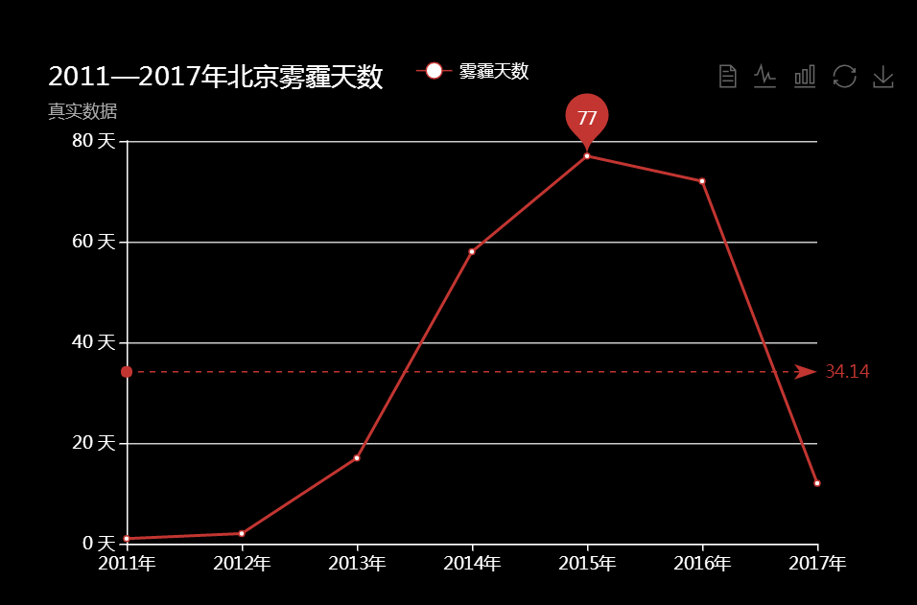

After a preliminary analysis, we found that haze was more serious in 2015 and 2016.Thus,we take 2016 as an example to observe the changes of Beijing haze every month.

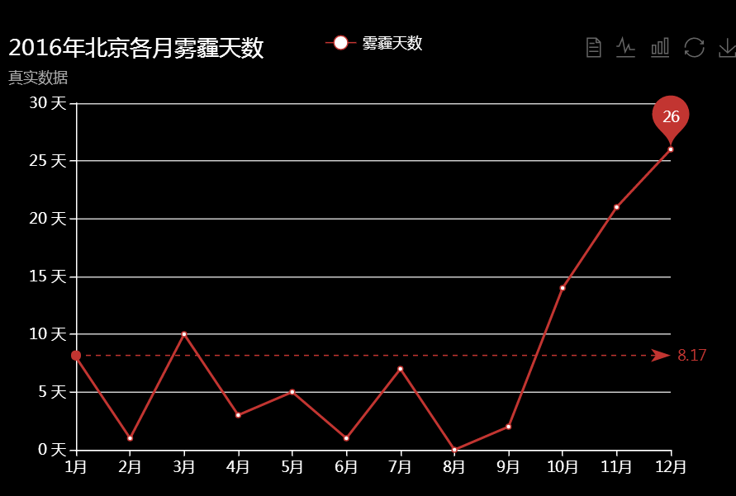

From the table above, we see the plume of haze dropped sharply on February. The potential reasons may be：

1. Around the Spring Festival, with the greatly enhanced management and publicity efforts, "Spending a joyful Spring Festival in eco-friendly way" gets deeper into the hearts of the people.
2. February is college winter vacation, a considerable number of people depart from Beijing to their hometown.During the Spring Festival,Beijing has almost become an empty city.
3. In addition, several meetings were held domestically in February 2016, which may also control the emission and reduce the haze weather.

At the same time,we draw a map about the severity of the haze weather of each

provinces,to visualize the national air quality. The more redder the dots, the heavier the haze weather.

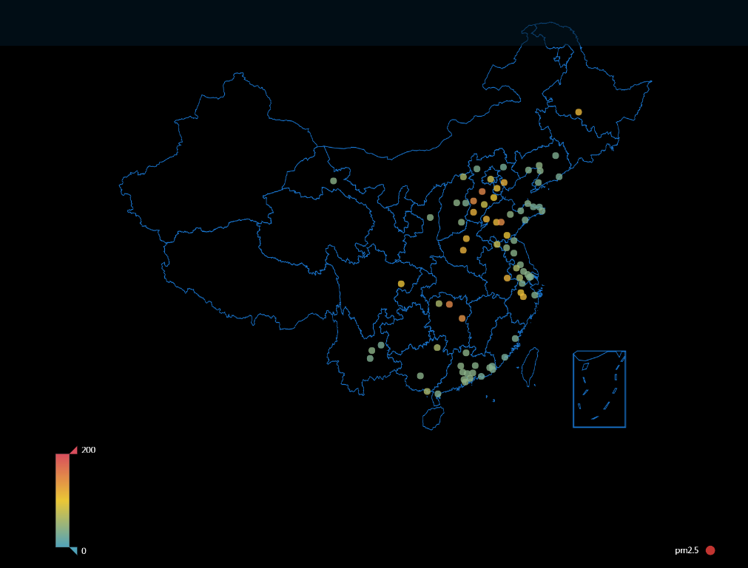

In the short term, haze will directly affect vulnerable groups,like elderly, children, and pregnant women.But by and large,it will affect we younger generation in the future. Living in first-tier cities with haze pollution is equal to chronic suicide.

Employment Pressure

Based on *2017 Annual Report on Job Quality of College Graduates In Beijing*,we

made a rough analysis of “Beijing Floater” about their employment pressure.

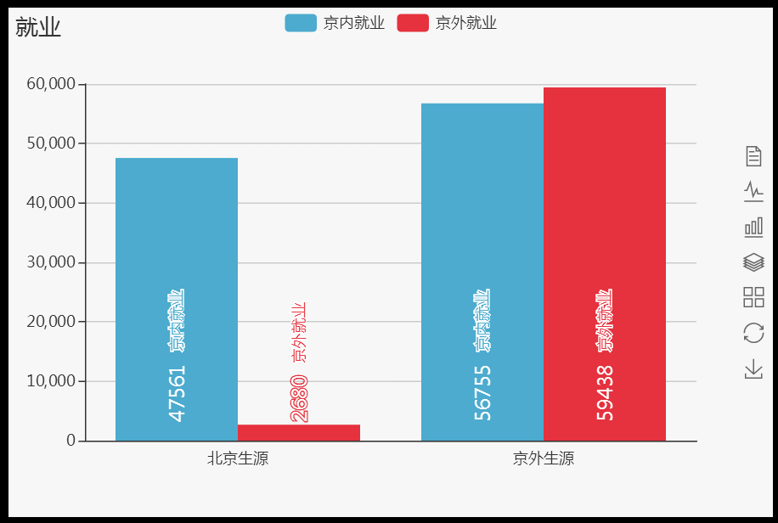

First of all, according to the survey data, there are 230,000 college graduates in Beijing and the employment rate is over 90%. That is a very encouraging news.However, when conducting a survey and analysis of graduates' employment areas, the following conclusions can be drawn: The college graduates of Beijing native, 47,561 were employed in Beijing, accounting for 94.67%; 2,680 were employed outside Beijing, accounting for 5.33%; the college graduates of strangers, 56,755 of them were employed in Beijing, accounting for 48.85%; and 59,438 were employed outside Beijing, accounting for 51.15%.

Life Pressure

Thirdly,from the rent income ratio, commuting time, urban congestion and other dimensions,we made a comprehensive analysis of “Beijing Floater”about their life pressure.

1. Commuting Time

With the rapid urbanization, the influx of population into first-tier cities, the issue of pressure on commuting rose.Compared to Shanghai,Guangzhou and Shenzhen,the average commuting distance of Beijing on working days is 9.3 kilometers and the commuters in Beijing occupy the first place.

In these international metropolis lead to frequent migration.Residents in Beijing, Guangzhou and Shenzhen prefer trips outside the city, while Shanghai residents prefer to travel within the city. Big data points out that at least half of the people left the cities in which they live during the Spring Festival, of which Shenzhen has an empty city rate of 69%, the highest in these four cities, making it a veritable "empty city." In Beijing and Shanghai,half of the residents left.

What’s more, it has been found that the separation of occupations and residences lead to the heavy traffic of first-tier cities. Solving this problem has become an important measure to improve residents’ happiness index and reduce the operating costs of the city.

1. Rent Income Ratio

From the aspect of rent per square meter, there are a huge gap between the inner city of six districts and suburbs, whose the largest gap up to 6 times.

Financial Street is located in central area,Xicheng District,with its financial, cultural and consumer, three major advantages,rental price per square meter topped the list.Line 2 and Line 10, as the only two inner ring road in Beijing, its rent are ahead of other subway lines definitely.

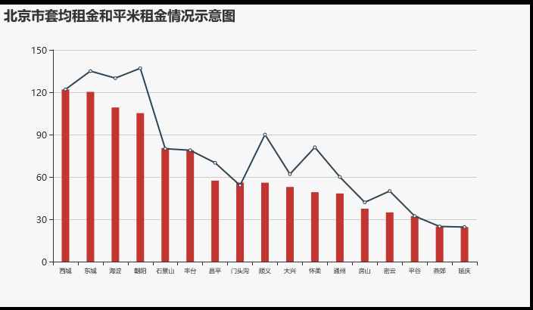

For example, if we rent a bedroom of 50 square meters, we will spend 9000 yuan nearby Guanyuan,while we just spend 2000 yuan nearby Liangxiang University.

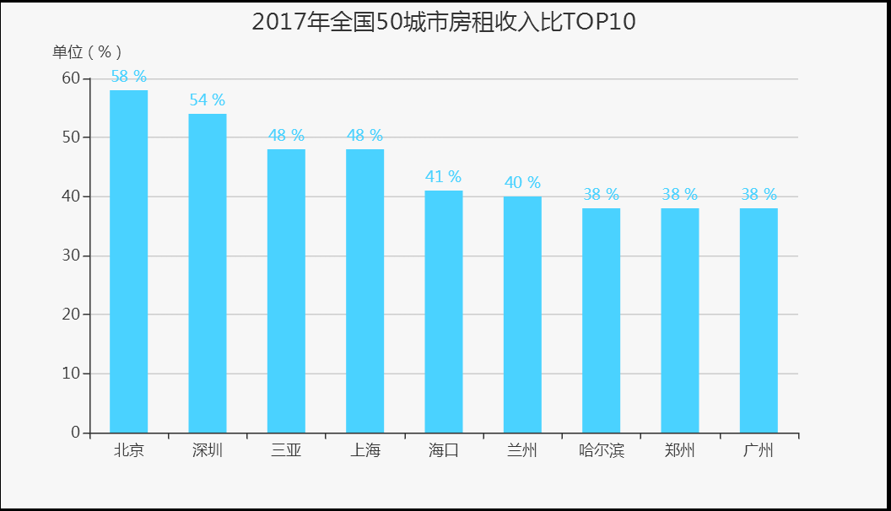

According to the statistics, Beijing's rent fees accounts for as much as 58% of its total revenue. That is, the youngster workers spend most of their salary on rent fees every month. Shanghai and Guangzhou are slightly lower but still larger in value,which are 48% and 38% respectively.Thus,the youngster generation are almost unlucky “moonlight clan”.

1. Urban Congestion

The report shows that 26% of cities across the country in commuting are in a state of congestion and 55% of cities in rush hours are in a state of slowdown.Among the cities, the urban congestion in Beijing, Shanghai and Guangzhou ranked the top 10 in the country, with annual congestion costs per individual being 268h, 249h and 247h respectively.In terms of numbers, the time spent in rush hours in Beijing is twice than the normal state, which indicating that salaried people have high time costs.

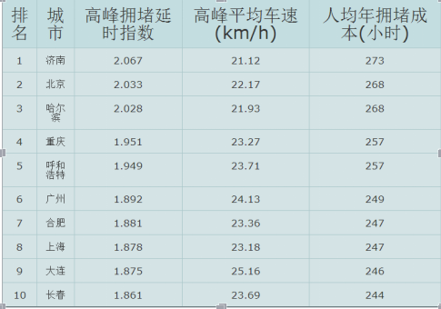

Project conclusion

To sum up, by analyzing the employment rate of college graduates in Beijing, rent-to-income ratio, commuting time and urban congestion, we find that the employment pressure and life pressure of “Beijing Floater” are much higher than that of other first-tier cities.In order not to waste their quality time on the mortgage, working commuting, “Beijing Floater” may have no choice but escape to the second or third-tier cities to work and live.