Conditional Value of Borrower Narratives in Credit Risk Prediction: Evidence from a Korean P2P Platform

Dongwoo Kim*

*Baekseok University, 76 Munam-ro, Dongnam-gu, Cheonan-si, Chungcheongnam-do, Republic of Korea
Corresponding author: Dongwoo Kim, Tel: +82-10-3936-6650, Email: dongwoo.kim@bu.ac.kr

Highlights

• Structured variables alone deliver the best average default risk ranking.
• Narrative text adds value mainly for uncertain cases with predicted risk 0.3 to 0.7.
• Text features reduce costly false negative errors missed by structured models.
• Gains concentrate in longer narratives; short narratives can reduce performance.
• Results support selective, decision-aware use of text in credit screening.

Keywords: Machine learning in OR; Risk analysis; Decision support systems; Credit scoring; Text analytics

JEL Classification: G21, G23, C45, C53

Abstract
We examine whether borrower narratives add predictive value to default-risk assessment in an early Korean peer-to-peer lending platform (6,057 loan applications, 2006–2016). We compare models using structured variables only, text only, and combined structured-and-text inputs, and then diagnose where text contributes beyond average performance. A structured-only gradient boosting benchmark achieves strong ranking performance on a fixed holdout test set (area under the receiver operating characteristic curve 0.812). Text-only models perform near random ranking. Adding text does not improve average ranking beyond the strong structured benchmark, even after additional optimization and model combination.
Despite limited average gains, text provides clear conditional value. For borderline cases with predicted risk between 0.3 and 0.7 (about 14% of the test set), adding text yields large local improvements in ranking and classification balance. Error-focused diagnostics show that combined models recover a meaningful share of missed defaults, especially in the high-risk tier. Threshold-sensitivity analysis further indicates that text helps concentrate detection within high-risk borrowers as decision thresholds become more conservative. Finally, the contribution of text depends on information richness: longer narratives benefit modestly, whereas short narratives can reduce performance.
Overall, borrower narratives are most useful when applied selectively to decision-relevant regions rather than uniformly across all applicants.

1. Introduction
1.1 Background

Online peer-to-peer (P2P) lending connects borrowers and investors directly through digital platforms and improves the efficiency of loan screening and funding. However, lending decisions are typically made under substantial information asymmetry, as investors observe only limited structured indicators such as credit scores, income, and debt. Relying solely on these formal variables can result in the misclassification of high-risk borrowers or the unnecessary rejection of creditworthy applicants (Fitzpatrick & Mues, 2021).

In this context, borrower narratives voluntarily provided during the application process—such as loan purpose, repayment plans, and personal statements—may contain soft information that is not captured by traditional credit variables. Prior studies show that textual and linguistic characteristics are associated with both funding outcomes and loan performance, suggesting that narrative content can serve as complementary signals for risk assessment rather than merely supplementary information (Dorfleitner et al., 2016; Pengnate & Riggins, 2020).

This study systematically evaluates the incremental value of integrating narrative text with structured variables for credit-risk prediction using long-term operational data (2006–2016) from a Korean P2P platform. Rather than assuming that text uniformly improves average predictive accuracy, we examine the operational conditions under which text provides value. Specifically, we test whether the contribution of text is amplified in high-risk segments, in borderline cases with uncertain default probabilities, and in error-sensitive situations such as false negatives where misclassification costs are high. By focusing on these conditional settings, we delineate when and how text functions as a complementary decision signal within credit scoring models.

1.2 Related Work
Research on P2P lending highlights the role of unstructured information in mitigating information asymmetry. Borrower narratives may convey soft signals that are not captured by conventional credit variables, and textual features have been shown to correlate with both funding outcomes and loan performance (Dorfleitner et al., 2016). Sentiment-based studies further suggest that linguistic and emotional cues influence investor decisions, indicating that narrative content can function as complementary risk signals rather than merely descriptive information (Pengnate & Riggins, 2020). Model effectiveness has also been shown to depend on the prediction objective and the structure of available inputs (Fitzpatrick & Mues, 2021).
In parallel, credit-risk modeling has evolved from linear scorecards to nonlinear machine learning approaches—particularly tree-based ensembles—which often deliver strong predictive performance on structured credit data (e.g., Hand, 2009; Lessmann et al., 2015). More recently, text representations—from term-frequency statistics to Transformer-based embeddings—have been combined with structured variables to capture soft information (e.g., Devlin et al., 2019; Dastile et al., 2020). Evidence on their incremental value remains mixed: while some studies report gains, improvements are frequently modest and highly context-dependent (e.g., Dorfleitner et al., 2016; Pengnate & Riggins, 2020; Zhang et al., 2019; Kriebel & Stitz, 2022).
Beyond average accuracy, responsible credit assessment increasingly emphasizes operational considerations such as explainability, threshold selection, and subgroup risk management. Cost-sensitive evaluation and interpretable modeling frameworks show that model quality should be assessed not only by aggregate metrics but also by error-type costs, uncertainty regions, and performance heterogeneity across risk groups (Bahnsen et al., 2014; Ariza-Garzón et al., 2020).
Despite these advances, systematic evidence remains limited on when text integration is operationally beneficial—that is, under which conditions text improves decisions rather than merely average scores. To address this gap, we develop a conditional effect–centered evaluation framework that examines text contributions across uncertainty intervals, false-negative recovery, threshold sensitivity, and information richness using long-term Korean P2P data.
1.3 Research Questions
This study addresses three questions.
RQ1: How well do structured variables alone rank credit risk in Korean P2P lending?
RQ2: Does integrating borrower narratives, and the sophistication of their representation, improve predictive performance?
RQ3: Are the gains from text integration uniform on average, or concentrated under specific operational conditions such as uncertainty regions, high-risk tiers, false negatives, threshold choices, and information richness?
1.4 Overview of Approach and Research Design
We adopt a staged experimental design on long-term Korean P2P data (2006–2016).
Phase 0 establishes a structured-only benchmark. Phases 1–2 benchmark four text-representation stages—Stage 1 (TF–IDF), Stage 2 (subword-based features), Stage 3 (MiniLM sentence embeddings), and Stage 4 (KoSimCSE sentence embeddings)—under two feature settings: text-only models (Phase 1) and structured + text models (Phase 2). Phase 3 then conducts hyperparameter tuning for the selected model–representation combinations, and Phase 4 applies ensemble strategies (e.g., hard/weighted voting, blending, stacking) to quantify average performance effects. Fixing the best structured benchmark, Phase 5 then conducts conditional diagnostics to isolate where text integration adds value, examining uncertainty intervals, risk tiers, false-negative recovery, threshold sensitivity, and text length.
Figure 1-1 summarizes the overall framework and Stage–Phase pipeline
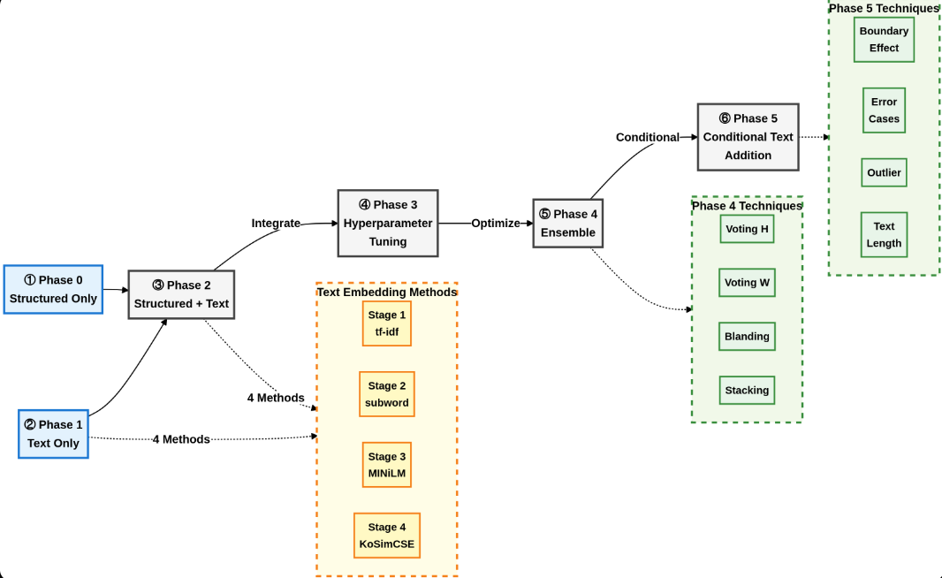
Figure 1-1 Overall research framework and experimental pipeline (including Stage/Phase flow)
Note: Stage indicates text representation levels, and Phase indicates experimental steps from the structured-only benchmark to text integration, tuning, ensembling, and conditional-effect analysis.
1.5 Contributions
This study makes four contributions.
First, it proposes a conditional-effect evaluation framework that assesses text integration beyond average metrics across uncertainty, risk tiers, error types, thresholds, and information richness.
Second, it introduces the false-negative recovery rate to quantify reductions in costly approval errors.
Third, it provides long-horizon operational evidence from an under-studied Korean P2P market characterized by high information asymmetry.
Fourth, it systematically compares sparse and embedding-based text representations to identify the operating range where narrative signals are most valuable.
2. Data
2.1 Data Source and Target

We use operational data from a Korean P2P platform covering 6,057 loans originated between 2006 and 2016, each with structured variables (demographics, credit, income, loan terms) and borrower-provided narratives (title, purpose, repayment plan). The dependent variable is binary: defaults are coded as 1 and repayment outcomes as 0.

Table 2-1. Distribution of Repayment Outcomes (2-Class) and Binary Target Composition
Repayment Outcome | Number | Ratio (%) | y(target)
Default | 3,352 | 55.34 | 1
Repayment | 2,705 | 44.66 | 0
Total | 6,057 | 100.00
Note: Distribution of the binary target (default = 1, repaid = 0).
2.2 Structured Variables
The number of structured variables used as model inputs is fixed at 11 to ensure comparability. Continuous variables are scaled, using standardization or normalization, to account for differences in scale, while binary variables retain their 0/1 encoding.

Table 2-2. Structured Variables (11) and Descriptive Statistics
Variable | Mean | Standard Deviation | Median | Q1 | Q3 | Min | Max
Gender | 0.33 | 0.47 | 0 | 0 | 1 | 0 | 1
Region | 0.52 | 0.50 | 1 | 0 | 1 | 0 | 1
Age | 36 | 6.41 | 35 | 32 | 40 | 21 | 68
Credit Score | 629 | 129.4 | 638 | 577 | 706 | 0 | 950
Monthly Income | 261 | 228.9 | 200 | 160 | 300 | 0 | 6000
Loan Amount | 413 | 292.4 | 300 | 200 | 500 | 100 | 5000
Loan Interest Rate | 0.32 | 0.05 | 0.30 | 0.29 | 0.35 | 0.05 | 0.59
Monthly DTI | 0.37 | 0.37 | 0.30 | 0.15 | 0.51 | 0.00 | 5.00
Loan Term | 19.6 | 7.3 | 24 | 12 | 24 | 6 | 36
Months of Service | 29.0 | 42.8 | 13 | 4 | 36 | 0 | 491
Number of Investors | 34.5 | 23.1 | 30 | 17 | 48 | 0 | 164
Note. Table 2-2 reports descriptive statistics (mean, standard deviation, quartiles, and minimum–maximum values) for the 11 structured explanatory variables used in this study, including gender, region, credit score, income/debt indicators, and loan terms. Gender and region are binary indicators dummy-coded as male = 0 and female = 1, and metropolitan area = 0 and non-metropolitan area = 1, respectively. Age is measured in years and months of service in months. Monetary variables (e.g., monthly income and loan amount) are expressed in units of 10,000 KRW. Credit score is a point-scale measure ranging from 0 to 1,000, and the number of investors is a count variable. The interest rate and monthly DTI are unitless ratio variables. For reporting precision, the means and standard deviations of binary variables are shown to two decimal places; the standard deviations of credit score, monthly income, and loan amount are reported to one decimal place; all statistics for interest rate and monthly DTI are reported to two decimal places; the means and standard deviations of loan term, months of service, and number of investors are reported to one decimal place; and all remaining statistics are reported as integers.
2.3 Text Data
The text data comprises three fields—title, loan purpose , and repayment plan—which are concatenated into a single narrative. Preprocessing includes normalization, tokenization, stopword removal, and rare-token filtering, applied consistently across stages to ensure comparable and stable inputs.
Table 2-4. Descriptive Statistics for Text Length (Number of Characters)
Field | Mean | Standard Deviation | Median | Q1 | Q3 | Min | Max
Title | 15.7 | 7.4 | 14.0 | 10.0 | 20.0 | 0 | 76
Loan Purpose | 213.3 | 217.4 | 152.0 | 75.0 | 272.0 | 0 | 2433
Repayment Plan | 225.6 | 218.1 | 175.0 | 83.0 | 302.0 | 0 | 3357
Total (Title + Purpose + Plan) | 454.5 | 350.9 | 370.0 | 221.0 | 585.0 | 7 | 3946
Note. Table 2-4 reports descriptive statistics (mean, standard deviation, selected quantiles, minimum, maximum) for the lengths (in characters) of the title, loan purpose, repayment plan, and their combined narrative. It summarizes the basic scale and variability of the textual information used in this study.
2.4 Definition of Risk Groups
For conditional analyses, we define high- and low-risk tiers using credit-score quantiles: the bottom 30% (≤ Q30) forms the high-risk group and the top 30% (≥ Q70) the low-risk group (Verbraken et al., 2013). This split is used later to compare subgroup performance and threshold sensitivity.
Table 2-3. Risk Group Definition and Default Rate Based on Credit Score Percentile
Interval | Criterion (Credit Score) | Sample Size | Default Rate (%)
Bottom 30% (High Risk) | ≤ 596 | 1,844 | 68.55
Top 30% (Low Risk) | ≥ 691 | 1,829 | 41.12
Note. Table 2-3 defines the high- and low-risk tiers using credit-score quantiles (bottom 30% vs top 30%) and reports the sample size and default rate for each tier. This table provides the reference split for subsequent subgroup performance comparisons.
2.5 Train–test split
All experiments were conducted using an 80% training and 20% test split, with stratified sampling to preserve target class proportions. To ensure reproducibility across stages and phases, the same data split and random seed were maintained for all experiments.
3 Methodology
3.1 Text Representation Methods (Stage 1–Stage 4)
The text representation method is organized into four stages (Stages 1–4) to increase complexity and contextual depth. Stages 1 and 2 utilize sparse vectors (TF-IDF series), while Stages 3 and 4 employ sentence embeddings (dense vectors) such as MiniLM and KoSimCSE (Wang et al., 2020; Kim et al., 2021). At each stage, both Text-only and Merged (combining structured data and text) models are evaluated to distinguish the standalone predictive power of text from its incremental contribution relative to structured data.
3.2 Classification Models
This study compares eight classification models: Logistic Regression (LR), Support Vector Machine (SVM), k-Nearest Neighbors (KNN), Decision Tree (DT), Naive Bayes (NB), Random Forest (RF), Gradient Boosting (GB), and Extreme Gradient Boosting (XGB). Hereafter, abbreviations (LR, SVM, KNN, DT, NB, RF, GB, XGB) are used in the main text and tables.
3.3 Hyperparameter Tuning and Ensemble
To explore potential performance gains beyond the baseline classification model settings, this study sequentially applied hyperparameter tuning (Phase 3) and ensemble strategies (Phase 4). These two phases follow the text representation (Stages 1–4) and structured–text integration experiments. They were designed as extension experiments to evaluate how much tuning and ensemble further improve average performance and prediction stability compared to the baseline model (Valdrighi et al., 2025; Zhang et al., 2024).
3.3.1 Hyperparameter Tuning (Phase 3)

In Phase 3, we perform grid-search cross-validation for RF, GB, and XGB to assess whether tuning can improve average performance with the same inputs. We vary key hyperparameters such as the number of trees, maximum depth, learning rate, and minimum split size, using only the training data and keeping the train–test split and random seed fixed for comparability.
3.3.2 Ensemble Model Application (Phase 4)

In Phase 4, we apply a set of ensemble strategies to the structured+text models to mitigate the limitations of single learners and to test whether combining base models yields additional improvements in average performance and prediction stability. The considered ensembles are: Hard Voting (Voting-H), which aggregates the binary predictions of base models via majority vote; Soft Voting (Voting-S), which averages predicted probabilities to produce the final probability; Weighted Voting (Voting-W), which combines predicted probabilities using weights determined by validation performance; Blending (BLD), which fits a validation-based weighted combination of predicted probabilities; and Stacking (STK), which uses base-model predicted probabilities as input features and trains an XGBoost meta-learner to generate the final prediction. These ensemble experiments are designed as an extension to evaluate the potential for further gains in ROC–AUC and F1-score, as well as enhanced prediction stability, beyond the best single structured+text models.
3.4 Evaluation Metrics
The primary performance metrics of this study are ROC-AUC, Recall, and F1-score. ROC-AUC serves as the primary metric because it provides threshold-independent ranking performance, while Recall is important from the perspective of controlling for false negatives (FN). The F1-score summarizes the balanced performance of Precision and Recall (Dastile et al., 2020; Valdrighi et al., 2025).
3.5 Conditional Effect Analysis
We evaluate whether the effect of text integration varies across risk level, uncertainty, error type, and information richness. This analysis is performed with the benchmark model selected based on ROC-AUC in Phase 0 fixed, to minimize variation in model structure during conditional comparisons. Furthermore, the definition of the risk level axis (high risk/low risk) follows Section 2.4 (Table 2-3), and this classification is used to evaluate intergroup differences in error case analysis and threshold sensitivity analysis.
3.5.1 Uncertainty Analysis
Cases where the prediction probability generated by the structured standalone model for the test set falls within the 0.3–0.7 range are defined as marginal cases, while others are defined as clear cases. The marginal/clear intervals are each divided into subsamples to compare key performance metrics—ROC-AUC, Recall, F1—between the structured standalone model and the structured+text combined model. We compare performance within marginal and clear subsets.
3.5.2 Error Case Analysis
The FN Recovery Rate measures the proportion of baseline false negatives that are reclassified as true positives after text integration. To evaluate both recovery and overall error changes, we additionally report the net changes in FN, TP, and FP derived from the confusion matrices before and after integration. For transparency, both the absolute FN change and the FN reduction rate (FN change ÷ baseline FN × 100) are presented.
To examine heterogeneity across risk tiers, the baseline FN set is further divided by credit-score percentiles into high-risk (bottom 30%) and low-risk (top 30%) groups, and recovery rates are computed separately for each group.
3.5.3 Threshold Sensitivity Analysis
This analysis examines how classification performance varies with the decision threshold and across predefined credit-risk tiers. Let p̂ denote the predicted probability of default and τ the classification threshold. A borrower is classified as default (positive) if p̂ ≥ τ and as non-default (negative) otherwise. Increasing τ results in a stricter decision rule and fewer positive classifications.

Risk tiers are defined using credit-score percentiles as described in Section 2.3 (Table 2-3). Borrowers in the bottom 30% of credit scores are classified as the high-risk group, and those in the top 30% as the low-risk group.

For each threshold τ ∈ {0.3, 0.4, 0.5, 0.6}, performance metrics (Recall, F1-score) are computed separately for the high- and low-risk groups. To quantify between-tier differences, the relative performance gap is defined as Gap(%) = (M_high − M_low) / M_low × 100, where M denotes the corresponding metric. Gap patterns are then compared across thresholds and models to evaluate changes in subgroup discrimination as τ varies.
3.5.4 Text Length/Richness Interaction Analysis
We treat narrative length as a proxy for information richness rather than a causal determinant of default risk. This section evaluates three diagnostics: (i) how observed default rates vary across length groups at an aggregated level, (ii) whether the model’s predicted risk scores respond excessively to text length. Specifically, even when the association between text length and observed default at the individual level is weak, we test whether the model nonetheless treats length as an unduly strong signal in producing predictions (i.e., length sensitivity), and (iii) whether the incremental contribution of text integration differs by information richness.
3.5.4.1Actual Default Rate Patterns by Length Quantile
To describe baseline risk variation by information richness, we define length-based groups using total narrative length. Let $L_{i}$denote the total narrative length (in characters) for borrower $i$, computed as the character count of the concatenated text fields (title + purpose + repayment plan). Borrowers are partitioned into ten mutually exclusive deciles based on $L_{i}$. For each decile $d∈\{1,…,10\}$, we compute (a) the mean length ${\overset{ˉ}{L}}_{d}$and (b) the observed default rate,
$$DR_{d}=\frac{1}{n_{d}}\sum_{i∈d}{y_{i}},$$where $y_{i}∈\{0,1\}$is the default indicator and $n_{d}$is the number of observations in decile $d$. These summaries provide a descriptive profile of how baseline default risk varies across length-defined information groups.
3.5.4.2 Length Sensitivity: Correlation in Actual Outcomes vs. Model Scores
To assess whether model outputs exhibit length sensitivity beyond what is supported by the outcome, we compare the linear association between narrative length and (i) actual default, (ii) structured-only predicted probabilities, and (iii) text-integrated predicted probabilities.
Let ${\hat{p}}_{i}^{S}$denote the predicted default probability from the structured-only benchmark and ${\hat{p}}_{i}^{T}$denote the predicted default probability from the corresponding text-integrated model. We compute Pearson correlation coefficients:
$$r(L,y),r(L,{\hat{p}}^{S}),r(L,{\hat{p}}^{T}).$$Comparing $r(L,{\hat{p}}^{S})$and $r(L,{\hat{p}}^{T})$against $r(L,y)$provides a diagnostic of whether predicted scores depend on length more strongly than actual default outcomes do.
3.5.4.3 Conditional Effect by Information Richness: Long vs. Short
To test whether the incremental contribution of text depends on information richness, we split the sample into two groups using the median narrative length computed on the relevant evaluation set. Let $m$denote the median of $L_{i}$. We define:
- Long group: $L_{i}≥m$
- Short group: $L_{i}<m$
Within each group $g∈\{\text{Long},\text{Short}\}$, we report: (i) the observed default rate $DR_{g}$; (ii) classification performance of the structured-only model and the text-integrated model at the operating point used in the main evaluation (ROC–AUC, Recall, F1-score); and (iii) the incremental change from adding text, computed for each metric $M$as:
$$Δ_{M}=M(\text{Text-integrated})-M(\text{Structured-only}).$$Because this comparison is intended to reflect a single-threshold operational classification setting, F1-score is emphasized as the primary summary statistic.
4. Research Results
This chapter presents and interprets the experimental results step by step, following the evaluation-metric framework defined in Chapter 3. The results are interpreted along three metrics: (i) ROC–AUC, a threshold-independent measure of discrimination that evaluates how well predicted scores rank borrowers by default risk; (ii) Recall, the proportion of actual defaults correctly identified, which directly captures the ability to control costly false negative (FN) errors; and (iii) F1-score, the harmonic mean of Recall and Precision, which summarizes overall classification effectiveness as a single balanced metric, particularly informative under class imbalance.
All performance metrics were calculated using the same test dataset (20% of the total, stratified sampling). The same training– test split and random seed were maintained across all stages and phases to isolate the effects of methodological differences. The analysis proceeds as follows: (1) the aggregate effect of text integration is first confirmed; (2) subsequently, an in-depth examination is conducted to determine whether the limited improvement observed in average performance exhibits heterogeneity under specific conditions (e.g., risk groups, uncertainty intervals, information content).
4.1 Structured-Only Models (Phase 0) Performance
Table 4-1 shows that GB achieved the highest performance based on ROC-AUC (0.812), followed by RF (0.799) and XGB (0.794). This finding suggests that even using only structured variables provides a practical level of discriminatory power for risk ranking (ROC-AUC). Accordingly, in subsequent stages, the highest-performing GB model is fixed as the benchmark. This approach allows for a comparison of whether performance changes from text integration are attributable to model selection or to the incremental contribution of textual information.
Table 4-1. Performance Comparison of Structured-Only Models (Phase 0)
Model | ROC-AUC | Recall | F1-score
LR | 0.762 | 0.778 | 0.732
GB | 0.812 | 0.794 | 0.772
RF | 0.799 | 0.790 | 0.775
XGB | 0.794 | 0.763 | 0.752
SVM | 0.638 | 0.833 | 0.698
DT | 0.655 | 0.696 | 0.693
KNN | 0.642 | 0.703 | 0.666
NB | 0.718 | 0.820 | 0.720
Table 4-1 serves as the structured-only benchmark for subsequent comparisons on text integration
4.2 Text-only Model Performance (Stages 1–4)
Table 4-2 reports stage-wise average performance for text-only models. Discrimination remains near chance across representations (ROC–AUC ≈ 0.49–0.50; range 0.46–0.52), with no systematic improvement from TF–IDF to embeddings. Occasionally high Recall likely reflects aggressive positive predictions rather than improved ranking.
Table 4-2. Stage-wise Performance Summary of Text-only
Stage | ROC-AUC (mean) | ROC-AUC (range) | Recall (mean) | F1-score (mean)
Stage 1 (TF-IDF) | 0.50 | 0.49–0.51 | 0.96 | 0.70
Stage 2 (Subword) | 0.50 | 0.48–0.52 | 0.95 | 0.70
Stage 3 (MiniLM) | 0.50 | 0.49–0.51 | 0.87 | 0.64
Stage 4 (KoSimCSE) | 0.49 | 0.46–0.52 | 0.83 | 0.61

Note. Table 4-2 summarizes stage-wise average test-set performance for text-only models using narrative text only.
4.3 Merged Model Performance (Phase 2)
Table 4-3 compares merged model performance against LR (weak baseline) and GB (strong benchmark). Relative to LR (0.762), merged models improve substantially (+6.5%p ROC-AUC), but relative to GB (0.812), they show no gain: ROC-AUC ranges from 0.811 (Stage 1) to 0.796 (Stage 4), with F1 unchanged at 0.772. This indicates text provides limited average value when structured variables already achieve strong discrimination, and richer text representations do not improve performance.
Table 4-3. Stage-by-Stage Best Performance Comparison Against Baseline Model
Baseline Model | Metric | Stage 0 | Stage 1 | Stage 2 | Stage 3 | Stage 4 | Δ
LR | ROC-AUC | 0.762 | 0.811 (GB) | 0.808 (GB) | 0.802 (GB) | 0.796 (GB) | +6.5%p
LR | Recall | 0.778 | 0.833 (RF) | 0.833 (RF) | 0.833 (RF) | 0.832 (SVM) | +7.1%p
LR | F1-score | 0.732 | 0.772 (GB) | 0.772 (GB) | 0.771 (GB) | 0.770 (GB) | +5.5%p
GB | ROC-AUC | 0.812 | 0.811 (GB) | 0.808 (GB) | 0.802 (GB) | 0.796 (GB) | -1.9%p
GB | Recall | 0.794 | 0.809 (GB) | 0.809 (GB) | 0.833 (RF) | 0.832 (SVM) | +4.9%p
GB | F1-score | 0.772 | 0.772 (GB) | 0.772 (GB) | 0.771 (GB) | 0.770 (GB) | ≈0
Note: Table 4-3 summarizes the changes in the highest performance observed at each Stage, rather than changes within the same model across Stages. Parentheses indicate the model name achieving the highest value for that metric at each Stage. Δ represents the maximum change (increase or decrease) relative to Stage 0.
4.4 Hyperparameter Tuning Results (Phase 3)
Table 4-4 compares the performance of key models before and after hyperparameter tuning, focusing on those that exhibited relatively high performance during the text integration stage. The baseline ('Before') represents the highest performance value, observed for each metric in Phases 1–2, while 'After' presents the results following hyperparameter tuning(Phase 3) for the same model.
Table 4-4 shows that, for XGB, ROC-AUC decreased by 0.018 (from 0.811 to 0.793), and for RF, Recall decreased by 0.008 (from 0.833 to 0.826). The F1-score for XGB also declined by 0.008 (from 0.772 to 0.764). Thus, even after hyperparameter tuning, performance improvement was limited, with overall stability or slight declines observed.

Table 4-4. Comparison of Key Performance Metrics Before and After Hyperparameter Tuning
Metric | Tuned model | Before (reference) | After (tuned) | Δ
ROC-AUC | XGB | 0.811 (Stage 1 best) | 0.793 | -0.018
Recall | RF | 0.833 (Stage 3 best) | 0.826 | -0.008
F1-score | XGB | 0.772 (Stage 1 best) | 0.764 | -0.008
Note: Before (reference) denotes the highest performance value of the respective metric observed in Phases 1–2, while After (tuned) represents the result after applying hyperparameter tuning(Phase 3) to the same model.
4.5 Ensemble Model Performance (Phase 4)
Table 4-5 compares the performance of text-merged single models (GB, XGB, RF) with ensemble strategies (Voting, Blending, Stacking). Based on ROC-AUC, STK (0.796) achieved the highest performance among the ensembles, followed closely by Voting-W (0.795) and Voting-S (0.794). However, these ensemble performances did not surpass the ROC-AUC of GB (0.812), which recorded the highest performance in the structured standalone phase (Phase 0). From the F1-score perspective, Voting-S (0.766) showed the highest value, with no significant difference observed compared to STK (0.764), Voting-H (0.765), and Voting-W (0.765). Therefore, even after applying ensemble methods following text integration, additional improvements in average ranking performance (ROC-AUC) were limited, and classification balance performance (F1-score) also fluctuated within a narrow range.
In summary, applying tuning and ensemble methods after text concatenation yielded only limited additional improvement in overall average performance, particularly in terms of ROC-AUC.

Table 4-5. Performance Comparison: Single Model vs. Ensemble Model
Category | Model | ROC-AUC | Recall | F1-score
Single | GB | 0.788 | 0.808 | 0.761
Single | XGB | 0.793 | 0.794 | 0.764
Single | RF | 0.740 | 0.826 | 0.746
Ensemble | Voting-H | 0.711 | 0.817 | 0.765
Ensemble | Voting-S | 0.794 | 0.820 | 0.766
Ensemble | Voting-W | 0.795 | 0.814 | 0.765
Ensemble | BLD | 0.782 | 0.763 | 0.751
Ensemble | STK | 0.796 | 0.808 | 0.764

Note. Table 4-5 reports test-set performance for models trained on the merged structured+text feature set. “Single” (GB, XGB, RF) therefore denotes single learners in the merged setting (not the structured-only Phase 0 benchmark). Voting-H/S/W, BLD, and STK are Phase 4 ensemble strategies. ROC–AUC measures threshold-independent ranking performance; Recall and F1-score summarize default-detection and balanced classification performance.
4.6 In-depth Analysis of the Conditional Effect of Text Information
As demonstrated by the stepwise results in Sections 4.1–4.5, text integration did not consistently improve average performance (ROC-AUC, F1-score) across the entire sample. Therefore, this section evaluates whether performance differences emerge under specific conditions that are not reflected in overall averages. To this end, we fixed the GB model (ROC-AUC = 0.812), which achieved the highest ROC-AUC in the structured-only experiment, as the baseline model. We then compared the incremental contribution of text integration across four condition axes. Specifically, we sequentially analyze: (i) performance changes in borderline cases with high uncertainty in the structured model; (ii) the effect of compensating for missed risks via FN-related metrics under standard thresholds; (iii) trends in the gap (sensitivity) between high- and low-risk groups as thresholds change; and (iv) whether the combined effect strengthens with increasing text length (information content). The primary metrics are ROC–AUC, Recall, and F1-score.

Figure 4-1 Four axes and detailed analysis techniques for Phase 5 conditional effect analysis
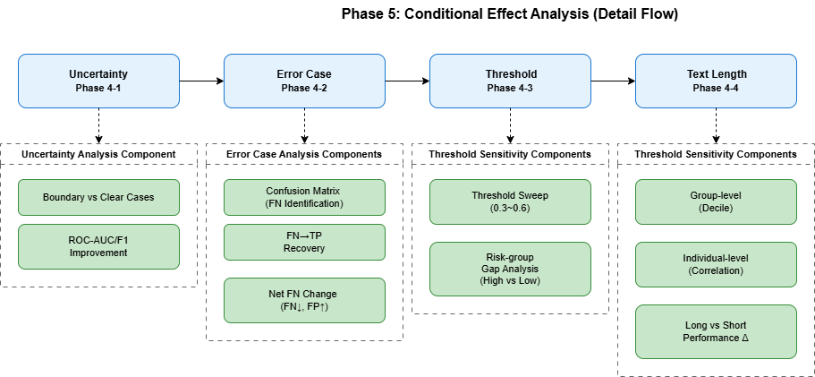

Figure 4-1 summarizes the conditional-diagnostic framework; axes are evaluated independently while holding the baseline model fixed.
4.6.1 Uncertainty-Based Marginal Case Analysis
Tables 4-6 and 4-7 compare text-integrated models with the structured-only benchmark for marginal and clear cases . ROC–AUC is used for ranking performance, and Recall/F1 for detection performance; Recall and F1 are computed using a common default threshold (τ = 0.5) across models. In marginal cases , GB+Text improves ROC–AUC from 0.547 to 0.598 (+9.32%) and F1 from 0.532 to 0.600 (+12.78%). In clear cases , where the structured-only model already performs strongly (ROC–AUC = 0.856; F1 = 0.868), text integration yields no additional improvement and slightly reduces performance (GB+Text: ROC–AUC −1.87%; F1 −0.35%). Figure 4-2 summarizes that gains are concentrated in marginal cases.
Table 4-6. Performance Comparison for Marginal Borrowers
Model | ROC-AUC | Recall | F1-score | ROC-AUC  Change Rate (%) | F1  Change Rate (%)
Structured Only | 0.547 | 0.523 | 0.532 | - | -
RF + Text | 0.504 | 0.659 | 0.595 | -7.87 | 11.84
GB + Text | 0.598 | 0.614 | 0.600 | 9.32 | 12.78

Note. Table 4-6 reports performance for marginal cases with baseline (structured-only) predicted probabilities p̂ in [0.3, 0.7]. Percentage changes are computed relative to the structured-only benchmark as Δ(%) = (M_Text − M_Struct)/M_Struct × 100, where M is the corresponding metric.

$$Δ(\%)=\frac{M_{\text{Text}}-M_{\text{Struct}}}{M_{\text{Struct}}}×100,$$where $M$denotes the corresponding metric (e.g., ROC–AUC, Recall, F1).

Table 4-7. Performance Comparison for Clear Cases
Model | ROC-AUC | Recall | F1-score | ROC-AUC  Change Rate (%) | F1  Change Rate (%)
Structured Only | 0.856 | 0.897 | 0.868 | - | -
RF + Text | 0.820 | 0.907 | 0.866 | -4.21 | -0.23
GB + Text | 0.840 | 0.897 | 0.865 | -1.87 | -0.35

Note. Table 4-7 reports performance for clear cases with baseline (structured-only) predicted probabilities p̂ < 0.3 or p̂ > 0.7. Percentage changes are computed in the same way as for marginal cases (Table 4-6).
.

Figure 4-2. Text Combination Effect (GB+Text, Relative Improvement Rate) in Marginal vs. Clear Cases
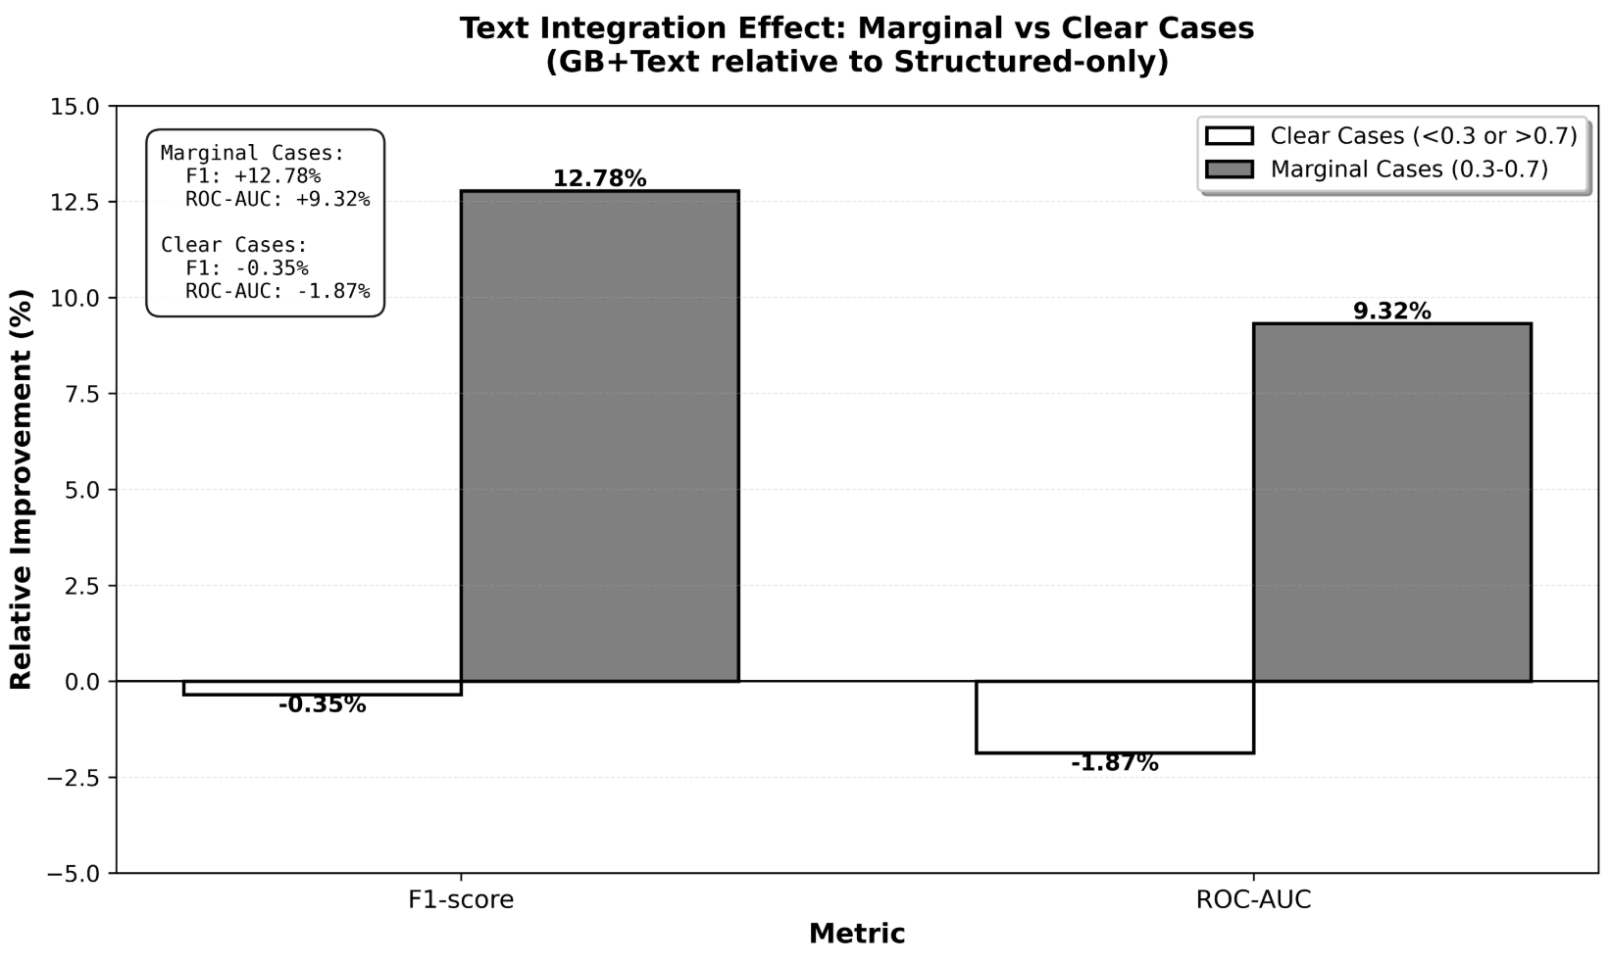

Note: Figure 4-2 presents the relative performance change (%) of GB+Text compared to the structured-only model, separated into marginal cases and clear cases.
4.6.2 Error Case Analysis: FN (False Negative) Recovery Effect
Average performance metrics (ROC–AUC, F1-score) may not directly capture changes in false negatives (FNs)—cases in which actual defaults are incorrectly approved as non-default—which are often among the most consequential error types in credit screening. Accordingly, this subsection evaluates whether text integration improves FN handling using (i) confusion-matrix comparisons and (ii) the FN Recovery Rate.

Net Change in FN/TP Based on Confusion Matrix

Table 4-8 compares the confusion matrices of the structured-only model and the text-combined models (RF+Text, GB+Text). Relative to the structured-only benchmark (FN = 138, TP = 533), RF+Text reduced FN from 138 to 117 (−21 cases; −15.22%) and increased TP from 533 to 554. GB+Text reduced FN from 138 to 129 (−9 cases; −6.52%) and increased TP from 533 to 542. These reductions in FN were accompanied by increases in FP (RF+Text: 188→260; GB+Text: 188→211), indicating a trade-off in classification errors under the fixed threshold (τ = 0.5) used to construct the confusion matrices.

Table 4-8. Comparison of Confusion Matrices
Model | TN | FP | FN | TP | FN Change | FN Change Rate
Structured Standalone | 353 | 188 | 138 | 533 | – | –
RF + Text | 281 | 260 | 117 | 554 | -21 | -15.22%
GB + Text | 330 | 211 | 129 | 542 | -9 | -6.52%
Note: FN Change = (Text-Combined Model FN) − (Structured-Only FN). FN Change Rate = FN Change ÷ (Structured-Only FN) × 100. A negative (-) sign indicates a reduction (improvement) in FN.
FN Recovery Rate Evaluation
To isolate the extent to which text integration recovers defaults missed by the structured-only model, we compute the FN Recovery Rate, defined as the proportion of structured-only FNs that are reclassified as true positives (FN→TP) by the text-combined model. Table 4-9 reports FN recovery counts and recovery rates for the overall test set and by credit tier (high-risk: bottom 30%; low-risk: top 30%). Overall, RF+Text recovered 57 of the 138 structured-only FNs (41.30%), while GB+Text recovered 37 (26.81%). In the high-risk group, recovery rates were higher (RF+Text: 52.63%; GB+Text: 36.84%), indicating that recovery effects are more pronounced in the segment where missed defaults are more concentrated.
Importantly, FN recovery rates can exceed net FN reductions observed in the confusion matrix. This is because the recovery rate counts only FN→TP transitions (recoveries from the structured-only FN set), whereas the net FN change reflects the overall balance after simultaneously allowing other transitions that may introduce new errors (e.g., TP→FN) under the text-combined model. Therefore, FN Recovery Rate and net confusion-matrix changes capture different operational aspects of error movement and should be interpreted jointly.

Table 4-9. False Negative (FN) Recovery Rate by Model and Credit Tier
Category | Structured  FN | RF+Text  Recovery | GB+Text  Recovery | RF  Recovery Rate | GB  Recovery Rate
Overall | 138 | 57 | 37 | 41.30% | 26.81%
High-risk group  (bottom 30%) | 19 | 10 | 7 | 52.63% | 36.84%
Low-risk group  (top 30%) | 68 | 27 | 13 | 39.71% | 19.12%
Note: FN Recovery Rate = (Number of FNs recovered by text-combined model) ÷ (Number of FNs in structured model alone) ×
100. High-risk group refers to the bottom 30% of credit scores, while low-risk group refers to the top 30%.

Figure 4-3. Group-wise FN Recovery Rate (Recovery rate of text-combined FNs compared to structured-only FNs)
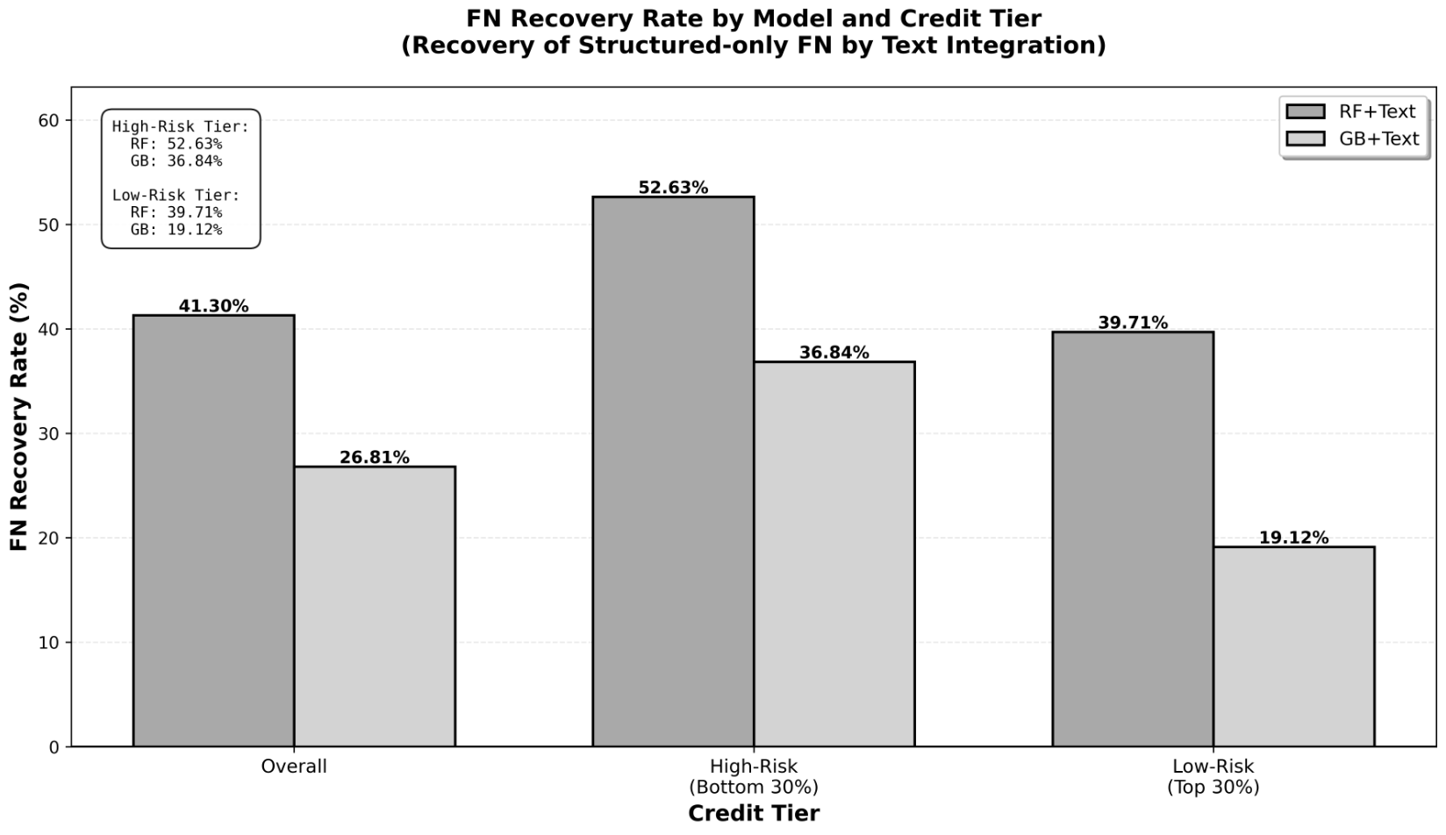
Note: Figure 4-3 presents the recovery rate of FN missed by the structured model alone, recovered by the text-combined models (RF+Text, GB+Text), categorized by overall, high-risk group (bottom 30%), and low-risk group (top 30%).
4.6.3 Threshold Sensitivity Analysis: Risk-Group Performance Gaps

We examine threshold sensitivity by tracking high- vs low-risk performance gaps as the threshold increases. For both RF+Text and GB+Text, gaps widen monotonically: the F1 gap rises to 46.12% (RF+Text) and 42.02% (GB+Text) at τ=0.6, and the Recall gap rises to 72.34% and 76.32%, respectively. Performance gaps increased monotonically as the threshold rose.

Table 4-10. Performance Gaps between High-risk and Low-risk Groups across Classification Thresholds
Model | Threshold | F1-score Gap (%) | Recall Gap (%)
RF+Text | 0.3 | 25.40 | 0.00
RF+Text | 0.4 | 24.85 | 10.28
RF+Text | 0.5 | 30.73 | 36.17
RF+Text | 0.6 | 46.12 | 72.34
GB+Text | 0.3 | 21.77 | 17.88
GB+Text | 0.4 | 23.17 | 31.43
GB+Text | 0.5 | 30.35 | 48.68
 | 0.6 | 42.02 | 76.32
Note: Table 4-10 compares how the performance gap between the high-risk group (bottom 30% credit score) and the low-risk group (top 30%) changes when the classification threshold varies from 0.3 to 0.6 for RF+Text and GB+Text. The gap was calculated as the relative gap compared to the low-risk group.

Figure 4-4. Threshold Sensitivity of F1-score Gap between High-risk and Low-risk Groups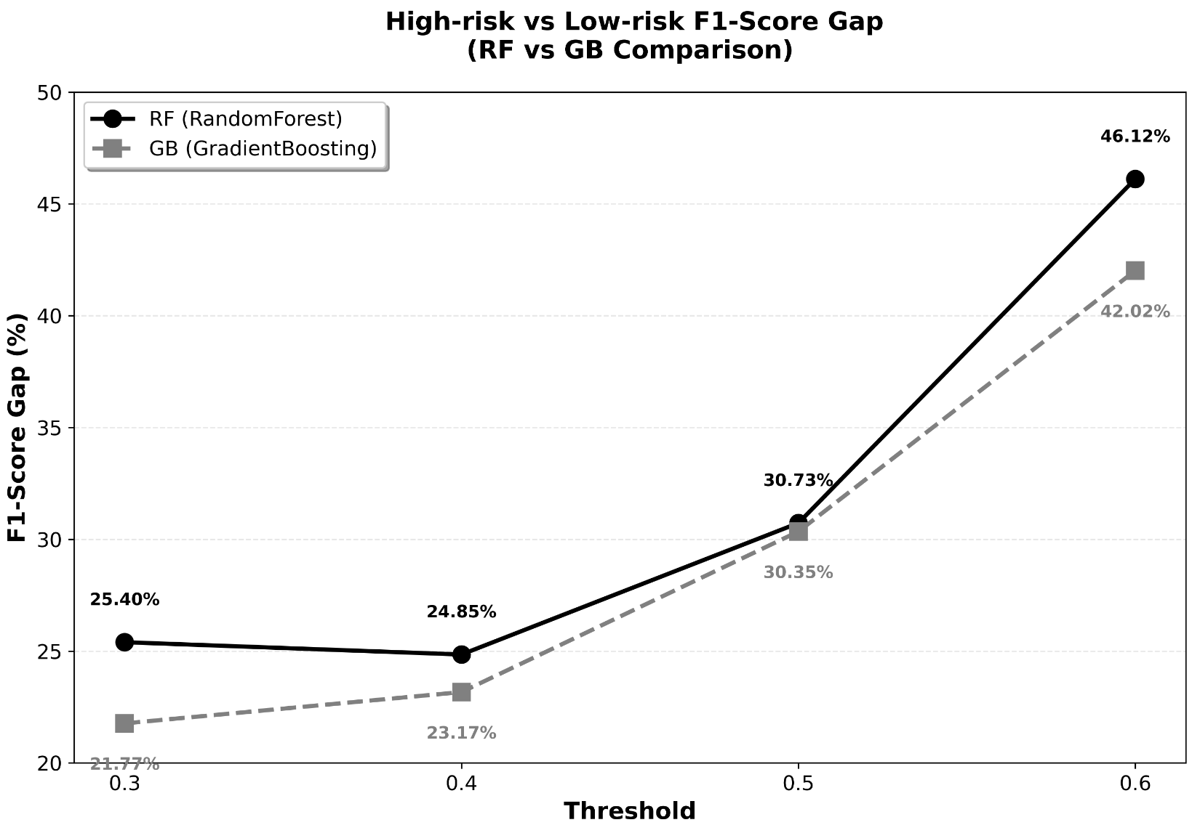
Note: Figure 4-4 compares the relative F1-score gap between the high-risk group (bottom 30%) and the low-risk group (top 30%) at classification thresholds for RF+Text and GB+Text.

Figure 4-5. Threshold Sensitivity of Recall Gap between High-risk and Low-risk Groups
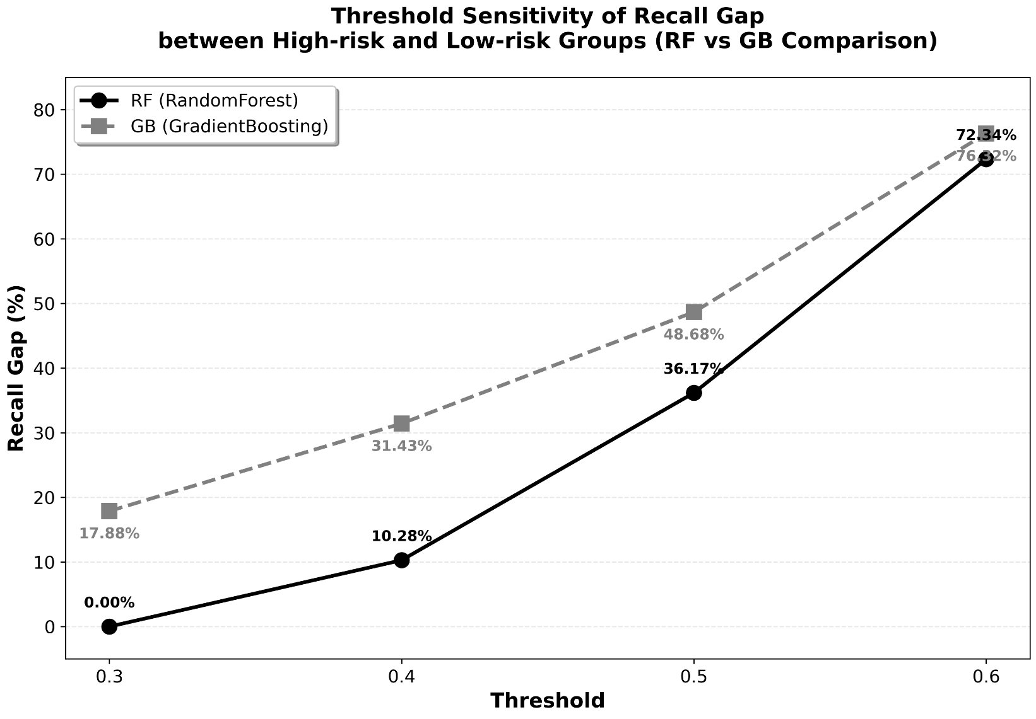

Note: Figures 4-5 show the comparison of the relative recall gap between the high-risk group (bottom 30%) and the low-risk group (top 30%) at classification thresholds , using RF+Text and GB+Text respectively. As the threshold increases, the gap significantly widens for both models, Recall gaps widened at higher thresholds for both models.
4.6.4 Text Length as Information Richness and Its Conditional Effects

Text length is interpreted as a proxy for the information richness of borrower narratives rather than a causal driver of default risk (Zhang et al., 2019; Kriebel & Stitz, 2022). Consistent with the Phase 5 framework (Figure 4-1), this section evaluates three diagnostics: (i) how observed default rates vary across length groups at an aggregated level, (ii) whether model outputs exhibit length sensitivity beyond what is supported by individual-level outcomes, and (iii) whether the incremental contribution of text integration differs by information richness.
Actual Risk Patterns at the Group Level: Distribution of Default Rates by Text Length Percentile
This subsection examines how baseline default risk varies across narrative length when length is treated as a proxy for information richness. Table 4-11 reports mean length (characters) and observed default rates across ten text-length deciles. Default rates ranged from 65.6% in the shortest decile to 46.4% in the longest decile (difference: 19.2 percentage points) Figure 4-6 visualizes the same pattern. At the aggregated (decile-mean) level, the correlation between mean length and default rate is strongly negative (r = −0.9439).

Table 4-11. Average Length and Actual Default Rate by Text Length Decile
Length decile (%) | Mean length (characters) | Observed default rate (%)
0–10 | 89 | 65.6
10–20 | 163 | 58.2
20–30 | 223 | 59.3
30–40 | 280 | 57.2
40–50 | 339 | 56.4
50–60 | 406 | 54.2
60–70 | 485 | 51.8
70–80 | 587 | 53.6
80–90 | 743 | 50.7
90–100 | 1246 | 46.4
Note: Table 4-11 shows the average text length and default rate for each of 10 text length intervals.

Figure 4-6 Actual Default Rate Trends by Text Length Decile
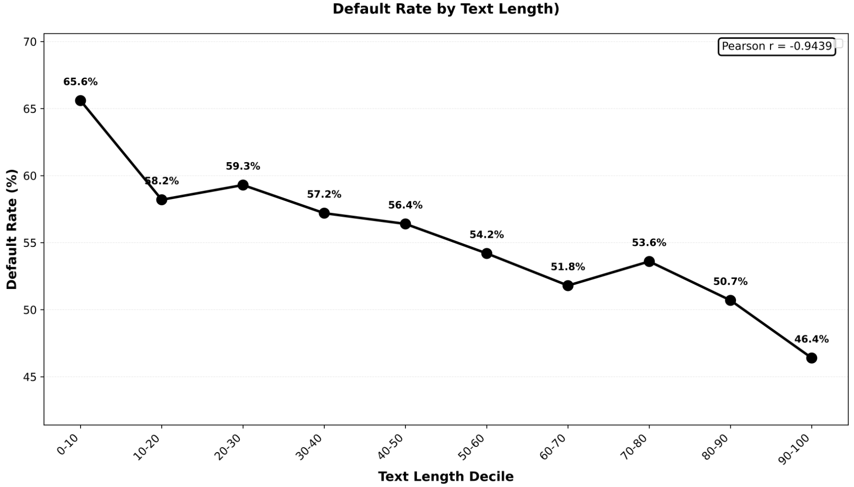

Note: Figure 4-6 visualizes the changes in actual default rates across each of the 10 text length quantiles. This allows for an intuitive understanding of how the default rate changes as text length increases, at the quantile level.
Length Sensitivity Diagnosis at the Individual Level: Comparison of Actual Defaults and Model Predictions
While the decile analysis describes group-level patterns, we next assess individual-level length sensitivity by comparing Pearson correlations between text length and (i) actual default status, (ii) structured-only predicted probabilities, and (iii) text-integrated predicted probabilities (Table 4-12). The length–default correlation is weak (r = −0.0512), indicating that length alone explains little of individual default variation. In contrast, the structured-only model’s scores are more responsive to length (r = −0.1386), suggesting greater length dependence than is supported by the outcome. For text-integrated models, correlations are −0.1660 (RF+Text) and −0.1162 (GB+Text); notably, GB+Text shows reduced length sensitivity relative to the structured-only benchmark. GB+Text showed weaker correlation with length (−0.1162) than the structured-only model (−0.1386).
Table 4-12. Comparison of Correlation Coefficients Between Text Length and Default (Actual/Predicted)
Variable | Correlation_with_Length
Actual Default | -0.0512
Structured Only Pred | -0.1386
RF+Text Pred | -0.1660
GB+Text Pred | -0.1162
Table 4-12 reports Pearson correlations between text length and actual default, structured-only scores, and text-integrated scores.

Figure 4-7 Comparison of Text Length–Prediction Probability Relationship (Structured Only vs. GB+Text)
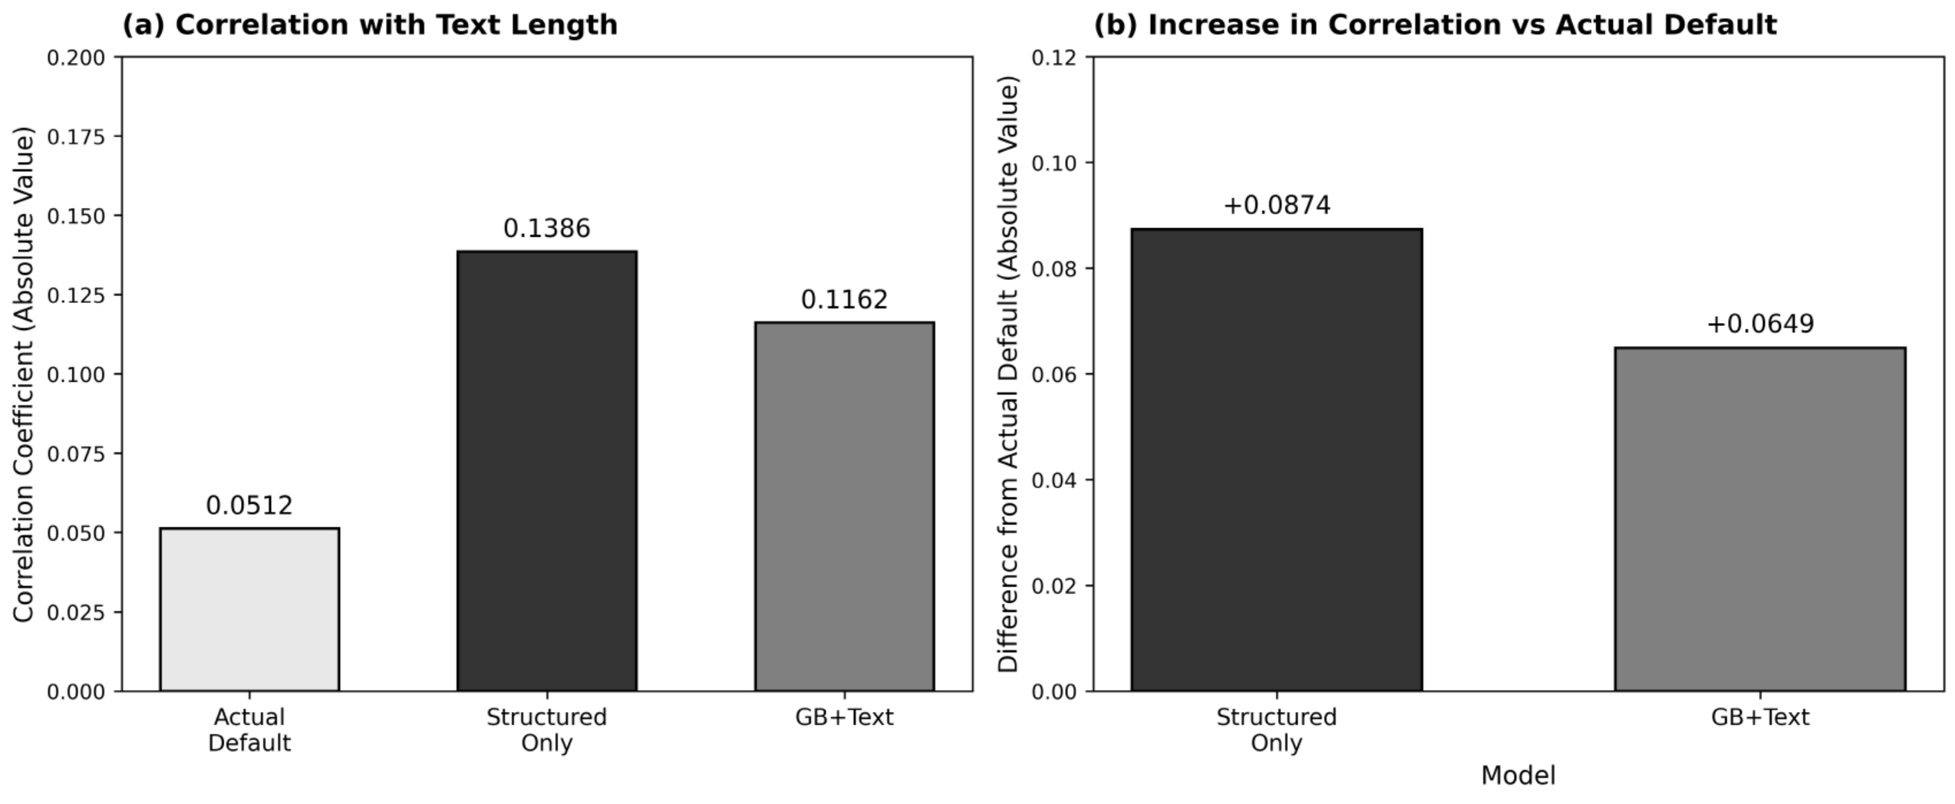

Note: Figure 4-7 visually presents the relationship between text length and the model's default prediction probability, comparing the Structured-only model with the text-combined model (GB+Text), illustrating how sensitively each model's prediction probability responds to text length.
Conditional Effect of Information Content (Long vs Short)
Table 4-13 presents the results comparing the change in classification performance from structured models alone to text- combined models within each group, after dividing the sample into Long and Short groups based on the median text length. The actual default rate in the Short group was 56.69%, slightly higher than the Long group (54.04%), confirming a higher baseline risk level in the Short group.
Focusing on the baseline GB model, the structured-only F1-score was 0.753 for the Long group and 0.785 for the Short group, indicating higher performance in the Short group. After text integration, the GB model's F1-score increased slightly to 0.762 in the Long group, representing a +1.20% improvement. In contrast, in the Short group, it decreased to 0.761, indicating a – 3.06% performance decline. F1 increased in the Long group (+1.20%) but decreased in the Short group (−3.06%). For the RF model, the F1-score decreased after text integration in both the Long and Short groups, indicating no consistent improvement pattern across text lengths.

The Long–Short comparison shows heterogeneous marginal utility. In the Short group, where the structured-only model already attains higher F1, adding text decreases GB’s F1 (0.785→0.761; −3.06%), whereas in the Long group it increases modestly (0.753→0.762; +1.20%). Text effects differed between Long and Short groups.
Table 4-13 Long vs Short Comparison (Default Rate, GB+Text F1, F1 Improvement Margin)
Group | Model | Default_Rate_% | Struct_F1 | Text_F1 | F1_Improvement_%
Long | GB | 54.04 | 0.753 | 0.762 | +1.20
Long | RF | 54.04 | 0.770 | 0.752 | -2.34
Short | GB | 56.69 | 0.785 | 0.761 | -3.06
Short | RF | 56.69 | 0.756 | 0.741 | -1.98
Note. Table 4-13 compares default rates and F1-scores (structured-only vs. text-integrated) across Long and Short groups. The F1 improvement rate is computed as
$$ΔF1(\%)=\frac{F1_{\text{Text}}-F1_{\text{Struct}}}{F1_{\text{Struct}}}×100.$$Positive values indicate an improvement from text integration, and negative values indicate a decline.
4.6.5 Synthesis of Results
First, structured-only models provided the strongest baseline performance. Among them, GB achieved the highest ROC–AUC of 0.812. When text features were added, average ROC–AUC and F1-score across the full sample showed no consistent improvement relative to this benchmark.
Second, performance changes varied across conditional subsamples. In marginal cases defined by structured-model probabilities in the 0.3–0.7 interval, GB+Text increased ROC–AUC from 0.547 to 0.598 (+9.32%) and F1 from 0.532 to 0.600 (+12.78%). In contrast, performance changes were minimal or negative in clear cases. In the confusion-matrix analysis, FN counts decreased from 138 to 117 (−15.2%) for RF+Text and from 138 to 129 (−6.5%) for GB+Text. FN recovery rates reached 41.30% overall and 52.63% in the high-risk group.
Third, performance differed by text length. At the decile level, default rates ranged from 65.6% in the shortest group to 46.4% in the longest group (difference: 19.2 percentage points). At the individual level, the correlation between text length and actual default was weak (r = −0.0512), while correlations between length and predicted scores ranged from −0.1386 (structured-only) to −0.1162 (GB+Text). In the Long group, GB’s F1-score increased from 0.753 to 0.762 (+1.20%) after text integration, whereas in the Short group it decreased from 0.785 to 0.761 (−3.06%).
Overall, these results show that text integration did not improve average full-sample performance but produced localized gains in marginal, high-risk, and information-rich segments.
5. Discussion
5.1 Reinterpreting Key Findings: Average Performance vs. Conditional Value
Using early Korean P2P lending data (2006–2016), structured variables alone provided strong baseline discrimination, with the GB model achieving a ROC–AUC of 0.812. In contrast, text-only models exhibited near-chance discrimination (ROC–AUC ≈ 0.49–0.50), and integrating text with structured variables did not consistently improve average ROC–AUC or F1-score beyond the structured benchmark.
However, limited improvements in average metrics do not necessarily imply that borrower narratives lack value. Rather, the results indicate that the contribution of text is heterogeneous across decision contexts. This interpretation is consistent with prior studies emphasizing that soft or narrative information often provides complementary rather than uniformly additive predictive value in credit markets, particularly when structured variables already capture much of the baseline signal (Dorfleitner et al., 2016; Pengnate & Riggins, 2020).
5.2 Text Contribution under Prediction Uncertainty: Marginal vs. Clear Cases
The empirical findings show that text effects are largest where structured predictions are uncertain. For marginal cases defined by predicted probabilities in the interval 0.3–0.7 (13.9% of the test set), combining text increased ROC–AUC by approximately +9.32% and F1-score by +12.78% relative to the structured-only benchmark. In contrast, for clear cases where structured discrimination was already high, adding text resulted in negligible or slightly negative changes.
This pattern is consistent with selective or multi-stage decision frameworks, in which additional information is allocated primarily to observations near the decision boundary. Similar principles have been discussed in selective classification, reject-option learning, and staged screening approaches, where model complexity is concentrated on uncertain instances rather than applied uniformly (Charoenphakdee et al., 2021; Pugnana et al., 2023; Shen et al., 2020).
5.3 Cost Asymmetry and FN Management: Practical Value Beyond Averages
Because false negatives (FNs) are generally associated with higher economic costs than false positives in credit screening, average discrimination metrics alone may not fully reflect operational value. Prior work in cost-sensitive learning and credit scoring emphasizes that minimizing expected misclassification cost, rather than maximizing accuracy or ROC–AUC, is often the primary objective in financial risk management (Elkan, 2001; David J. Hand, 2009).
Consistent with this perspective, the text-integrated models recovered a substantial proportion of defaults missed by the structured model, with overall FN recovery rates of 41.30% for RF+Text and 26.81% for GB+Text, increasing further within the high-risk tier. These results suggest that text integration may provide additional risk-control benefits even when improvements in average ROC–AUC or F1-score are modest.
At the same time, reductions in FN can be accompanied by increases in FP, implying that net benefit depends on the relative cost structure. Accordingly, joint evaluation using confusion matrices and explicit cost considerations remains important when assessing operational effectiveness (Bahnsen et al., 2014; Valdrighi et al., 2025).
5.4 Threshold Sensitivity: Evidence of a Ranking-Oriented Effect
Threshold-sensitivity diagnostics further indicate that the operational impact of text depends on the chosen decision threshold. As the classification threshold increases from 0.3 to 0.6, performance gaps between high- and low-risk groups widen substantially. This behavior suggests that text-integrated scores increasingly concentrate detections within higher-risk segments under more conservative operating points.
Such patterns are consistent with the interpretation of ROC–AUC as a ranking-based measure and with prior discussions showing that improvements in ranking quality often translate into larger practical gains when stricter thresholds are applied (Tom Fawcett, 2006; Christopher J. Hand & Till, 2001; Verbraken et al., 2013; Bahnsen et al., 2014).
5.5 Information Richness: Length as a Proxy and Heterogeneous Marginal Utility
Interpreting text length as a proxy for information richness rather than a direct causal risk factor, we observe heterogeneity in the marginal utility of narrative features. Under a median split, text integration slightly improved performance in longer narratives but reduced performance in shorter ones.
This finding is consistent with prior studies suggesting that textual signals depend on the availability of sufficiently informative or specific content. When narratives are brief or generic, additional features may introduce noise rather than useful information, whereas richer descriptions may contain complementary cues that enhance prediction (Zhang et al., 2019; Kriebel & Stitz, 2022; Sanz-Guerrero & Arroyo, 2024).
5.6 Practical Implications: Selective Two-Step Screening
Taken together, the findings point toward the selective application of narrative information rather than universal integration. One practical implication is a two-step screening framework in which a strong structured model serves as the primary filter, and text-based enrichment is applied selectively to cases characterized by higher uncertainty or higher expected error costs.
Such a strategy may help allocate modeling and review resources more efficiently while leveraging the conditional gains observed in uncertainty regions, FN recovery, threshold sensitivity, and information-rich segments. This perspective aligns with recent discussions advocating targeted rather than blanket use of complex or unstructured data in credit risk assessment (Dastile et al., 2020; Ariza-Garzón et al., 2020).
5.7 Limitations and Future Research
This study has several limitations. First, the analysis relies on data from a single Korean P2P platform over 2006–2016, which may limit external validity across platforms or more recent market environments. Second, the binary outcome definition aggregates heterogeneous repayment behaviors and may obscure meaningful differences across repayment trajectories. Third, narrative quality factors—such as authenticity, specificity, or redundancy—were not explicitly modeled, which may attenuate the standalone signal of text.
Future research may address these limitations by:
(i) testing external validity through temporal splits and out-of-sample validation on additional platforms;
(ii) optimizing thresholds using explicit cost functions reflecting FN–FP asymmetry;
(iii) incorporating measures of text quality and specificity; and
(iv) evaluating domain-specialized embeddings or LLM-based risk scores and their interaction with structured variables.
6. Conclusion
6.1 Research Summary
This study systematically evaluated how credit-risk prediction performance changes when borrower narrative text is combined with structured variables, using a Stage/Phase framework and loan application/repayment data from an early Korean P2P lending platform period (2006–2016). The dependent variable was defined as a binary outcome of default (1) versus repayment (0). The final dataset consisted of 6,057 observations (3,352 defaults and 2,705 repayments).
6.2 Key Findings
First, in Phase 0, structured-only models provided a strong baseline, with the GB model achieving the highest ROC–AUC (0.812). Across Stages 1–4 (text integration) and subsequent tuning and ensemble stages, average ROC–AUC and F1-score on the full sample did not consistently exceed this structured-only benchmark.
Second, although text integration did not improve overall averages, clear conditional effects emerged in specific decision contexts. In marginal cases—defined by structured-model predicted probabilities in the 0.3–0.7 interval (13.9% of the test set)—GB+Text improved ROC–AUC from 0.547 to 0.598 (+9.32%) and F1 from 0.532 to 0.600 (+12.78%) relative to the structured-only benchmark. In contrast, in clear cases where structured discrimination was already high, performance changes were negligible or slightly negative. This pattern supports a decision-aware view in which additional information is most valuable near the decision boundary, consistent with selective classification and staged screening perspectives (Charoenphakdee et al., 2021; Shen et al., 2020).
Third, from an error-focused perspective, text integration showed practical value in recovering missed defaults. GB+Text recovered 26.81% of the structured-only false negatives overall and 36.84% within the high-risk group, indicating that some gains are concentrated in the FN domain and may not be fully reflected in average ranking metrics. Because false negatives are typically more costly than false positives in credit screening, this result underscores the importance of evaluating operational value under asymmetric error costs rather than relying solely on aggregate discrimination measures (Elkan, 2001; Hand, 2009).
Fourth, threshold-sweep diagnostics indicate that the performance gap between high-risk and low-risk groups widens as the classification threshold increases, implying stronger differentiation under more conservative operating points. This suggests that improvements in ranking quality can translate more clearly into operational gains when stricter thresholds are applied, consistent with the interpretation of ROC–AUC as a threshold-free ranking measure whose benefits may manifest more strongly under conservative decision rules (Fawcett, 2006).
Fifth, the effect of text integration varied with narrative length, interpreted as a proxy for information richness rather than a direct causal risk factor. At the group level, default rates declined monotonically as narrative length increased, with an approximately 19.2 percentage-point gap between the shortest and longest deciles. At the individual level, however, the association between text length and actual default was weak (r = −0.051), indicating limited direct signal from length alone. Importantly, the structured-only model’s predicted scores were more strongly correlated with length (r = −0.139) than the actual outcome, indicating length sensitivity beyond what is observed empirically; text integration partially reduced this sensitivity and aligned the prediction–length relationship more closely with the weak empirical pattern (r = −0.116 for GB+Text, closer to −0.051 than the structured-only baseline). Consistent with this interpretation, performance gains from text were concentrated in longer narratives, whereas shorter narratives showed little benefit and in some cases slight declines, suggesting that richer borrower narratives contain more usable complementary cues while brief or generic text may add noise.
6.3 Implications and Concluding Remarks
Overall, the results do not indicate that borrower narratives uniformly improve predictive performance. Instead, narrative information provides heterogeneous and conditional benefits, particularly in uncertain, high-risk, and information-rich segments. Accordingly, text features should be viewed as complementary signals that can enhance structured models selectively rather than as universal replacements.
From a practical standpoint, the findings motivate a selective two-step screening framework in which (i) a strong structured model serves as the primary filter and (ii) text-based enrichment is applied selectively to cases with higher predictive uncertainty or higher expected error costs. Such a strategy may better allocate modeling and review resources while leveraging the localized gains observed in marginal regions, FN recovery, threshold sensitivity, and longer narratives.

Glossary
- Stage (Text Representation Stage) – Level of text representation used to encode narratives (e.g., TF–IDF, subword features, sentence embeddings).
- Phase (Experimental Phase) – Step in the evaluation pipeline (structured-only baseline, text integration, tuning/ensembling, and conditional diagnostics).
- Structured-only Model – Model trained using structured variables only.
- Text-only Model – Model trained using text-derived features only.
- Text-integrated (Combined) Model – Model trained using both structured variables and text features.
- Marginal Cases – Cases with baseline predicted probability $\hat{p}∈[0.3,0.7]$.
- Clear Cases – Cases with baseline predicted probability $\hat{p}<0.3$or $\hat{p}>0.7$.
- High-risk Tier / Low-risk Tier – Bottom/top 30% group based on credit score.
- ROC–AUC – Threshold-free ranking performance measured by the area under the ROC curve.
- F1-score – Harmonic mean of precision and recall at a specified threshold.
- Threshold ($τ$) – Decision cutoff converting predicted probabilities into class labels (default $τ=0.5$unless otherwise noted). False Negative (FN) – Actual default predicted as non-default.
- FN Recovery Rate – Proportion of structured-only FNs that are reclassified as true positives (FN→TP) by a text-integrated model.
- Text Length – Narrative length measured in characters, used as a proxy for information richness.
- TF–IDF – Term frequency–inverse document frequency text weighting.
- Subword TF–IDF – TF–IDF computed on subword units.
- MiniLM – Lightweight Transformer model used to produce sentence embeddings.
- KoSimCSE – Korean SimCSE-based sentence embedding model.

Data Availability Statement
The data that support the findings of this study were obtained from a P2P lending platform under a confidentiality agreement and are not publicly available. The code used for data preprocessing, model training, and evaluation, together with key experiment settings (train–test split, random seed, and hyperparameters), is available from the corresponding author upon reasonable request.

Acknowledgments
This paper was supported by the Academic Research Funding of Baekseok University in 2026.

References
Ariza-Garzón, M. J., Arroyo, J., Caparrini, A., & Segovia-Vargas, M. J. (2020). Explainable artificial intelligence (XAI) for the identification of credit risk in P2P lending platforms. Applied Sciences, 10(11), 3979.
Bahnsen, A. C., Aouada, D., & Ottersten, B. (2014). Example-dependent cost-sensitive logistic regression for credit scoring. In
Proceedings of the 2014 IEEE International Conference on Data Mining Workshops (ICDMW) (pp. 1–8).
Bone-Winkel, S., & Reichenbach, F. (2024). Survival gradient boosting for credit risk modeling: An interpretable alternative to hazard rate models. Journal of Forecasting, forthcoming.
Dastile, X., Celik, T., & Potsane, M. (2020). Statistical and machine learning models in credit scoring: A systematic literature review. Expert Systems with Applications, 159, 113438.
Devlin, J., Chang, M. W., Lee, K., & Toutanova, K. (2019, June). Bert: Pre-training of deep bidirectional transformers for language understanding. In Proceedings of the 2019 conference of the North American chapter of the association for computational linguistics: human language technologies, volume 1 (long and short papers) (pp. 4171-4186).
Dorfleitner, G., Priberny, C., Schuster, S., Stoiber, J., Weber, M., de Castro, I., & Kammler, J. (2016). Description-text related soft information in peer-to-peer lending – Evidence from two leading platforms. Journal of Banking & Finance, 64, 169–187.
Elkan, C. (2001). The foundations of cost-sensitive learning. In International joint conference on artificial intelligence (Vol. 17, No. 1, pp. 973-978). Lawrence Erlbaum Associates Ltd.
Fitzpatrick, T., & Mues, C. (2021). An empirical comparison of classification algorithms for predicting default in peer-to-peer lending. European Journal of Operational Research, 295(3), 1059–1076.
Hand, D. J. (2009). Measuring classifier performance: a coherent alternative to the area under the ROC curve. Machine learning, 77(1), 103-123.
Hand, D. J., & Henley, W. E. (1997). Statistical classification methods in consumer credit scoring: A review. Journal of the Royal Statistical Society: Series A (Statistics in Society), 160(3), 523–541.
Kim, D. (2021). Bounded rationality in a P2P lending market. Review of Behavioral Finance, 13(2), 184–201.
Kim, D., Maeng, K., & Cho, Y. (2020). Study on the determinants of decision-making in peer-to-peer lending in South Korea.
Asia-Pacific Journal of Accounting & Economics, 27(5), 558–576.
Kim, H., Park, J., & Lee, J. (2021). KoSimCSE: Korean sentence embeddings for semantic-textual similarity. In Proceedings of the 33rd Annual Conference on Human and Cognitive Language Technology.
Kriebel, S., & Stitz, L. (2022). Do textual features improve credit risk prediction in peer-to-peer lending? Decision Support Systems, 154, 113700.
Lessmann, S., Baesens, B., Seow, H.-V., & Thomas, L. (2015). Benchmarking state-of-the-art classification algorithms for credit scoring: An update of research. European Journal of Operational Research, 247(1), 124–136.
Pengnate, S., & Riggins, F. J. (2020). The influence of loan statement sentiment and borrower soft information on funding outcomes in peer-to-peer lending. Electronic Commerce Research and Applications, 39, 100910.
Pugnana, A., de Bacco, C., & Vercellis, C. (2023). Selective classification and reject option in risk-sensitive applications.
Information Sciences, 623, 336–357.
Sanz-Guerrero, P., & Arroyo, J. (2024). Using BERT-like language models for default prediction in peer-to-peer lending.
European Journal of Operational Research, 309(3), 1270–1284.
Shen, F., Wang, Y., Liu, Y., & Jiang, M. (2020). A cost-sensitive logistic regression credit scoring model based on multi-objective optimization. Technological and Economic Development of Economy, 26(2), 331–353.
Thomas, L., Crook, J., & Edelman, D. (2017). Credit scoring and its applications. Society for industrial and Applied Mathematics.
Valdrighi, L., Silva, G. M., & Sernadas, A. (2025). Cost-sensitive evaluation metrics for imbalanced credit risk data. Scientific Reports, 15, 12345.
Verbraken, T., Bravo, C., Weber, R., & Baesens, B. (2013). Development and application of profit-based classification performance measures for customer churn. Operations Research, 61(6), 1246–1262.
Wang, W., Wei, F., Dong, L., Bao, H., Yang, N., & Zhou, M. (2020). MiniLM: Deep self-attention distillation for task-agnostic compression of pre-trained transformers. In Advances in Neural Information Processing Systems 33 (pp. 5776–5788).
Zhang, X., Yu, Y., Wang, F., & Li, D. (2019). Textual analysis and credit risk: Evidence from online peer-to-peer lending. Journal of Empirical Finance, 52, 100–120.
Zhang, Y., Yang, J., & Yao, Y. (2024). An interpretable three-way decision-based credit risk -evaluation model with ambiguous applicants. Applied Soft Computing, 150, 110014.

