Urban Development Stage and Regional Migration Attractiveness in South Korea: Spatial Polarization and the Limits of Interpretable Machine Learning

Abstract

Understanding which places attract migrants is central to policy in an era of demographic decline. Applying interpretable machine learning to net in-migration across 222 South Korean municipalities (2017–2024), we show that inter-municipal migration is best understood not as a simple urban–rural process but as spatial polarization: continued concentration toward the capital region, suburbanization within it, and dual decline in both rural areas and non-capital metropolitan cores. A tree-ensemble model (CatBoost, test R² = 0.29) reveals strong nonlinearity, but three findings reshape interpretation. First, a place-type clustering identifies two distinct out-migration regimes—rural demographic decline and non-capital metropolitan decline—while the densest, capital-proximate municipalities gain, and net migration follows an inverted-U in population density. Second, network centrality (PageRank) attracts primarily growing municipalities (importance rank 4 among growth-stage vs. rank 13 in mature cores), a spatially conditional effect. Third, the most important predictors carry counterintuitive directions: childcare-facility provision, the single strongest predictor, is negatively associated with net migration in both per-capita and absolute forms and does not demarcate any single place type. We therefore argue that in interpretable ML, predictive importance must not be conflated with causal or policy importance. The study connects Korea's capital-concentration and urban-life-cycle literatures through interpretable ML and offers a methodological caution for its growing use in regional science.

Keywords: internal migration; spatial polarization; suburbanization; interpretable machine learning; SHAP; South Korea

---

1. Introduction

1.1 Problem

South Korea presents one of the most acute cases of spatial demographic imbalance among OECD nations. With a total fertility rate that fell below 0.72 in 2023 and a capital-region (Seoul Metropolitan Area) population share exceeding 50 percent of the national total, the question of which municipalities attract or repel migrants has moved from academic interest to urgent policy concern. The national government has repeatedly attempted to redistribute population through innovation-city programmes, administrative capital relocation, and regional development funds, yet the capital-region pull has proven structurally persistent. Understanding the determinants of municipal-level net migration is therefore not merely descriptive; it is foundational to evaluating whether place-based interventions can alter the trajectory of spatial polarization.

1.2 Gap

Two bodies of literature have addressed this question largely in isolation. The migration-determinants tradition employs gravity models, spatial-lag specifications, and panel fixed-effects estimators to identify economic, amenity, and infrastructure drivers of population flows. The migration-networks tradition uses flow matrices and graph-theoretic centrality measures to characterize the hub-and-spoke structure of migration systems. Interpretable machine learning (ML) offers a methodological bridge—capturing nonlinear interactions among determinants while providing feature-attribution scores (SHAP values) that can be compared with conventional regression coefficients. Its use in regional science is growing rapidly, yet two risks accompany this growth. First, practitioners frequently interpret high SHAP importance as evidence of a positive migration driver, conflating predictive salience with causal direction. Second, a single national model may impose a spurious uniformity on what is, in reality, a spatially heterogeneous process in which the determinants of migration differ systematically across urban development stages.

1.3 Research Questions and Contributions

This study applies interpretable ML to a municipal panel of 222 South Korean *si-gun-gu* units observed over 2017–2024, and reaches a different account from the prevailing amenity-attraction narrative. Rather than a story in which better services and infrastructure attract migrants uniformly, the evidence points to spatial polarization: the capital region concentrates population (with suburbanization occurring within it), while both rural areas and non-capital metropolitan cores experience net out-migration. Network position attracts chiefly growing municipalities, not mature or declining ones. And the strongest predictors carry directions that contradict a naive amenity reading, motivating a methodological caution that extends beyond the Korean case.

We address three research questions. RQ1 asks: what is the spatial structure of the determinants of municipal net in-migration, and does a single model generalize across regions? RQ2 asks: does network centrality (PageRank) matter uniformly across all municipalities, or conditionally on urban development stage? RQ3 (methodological) asks: should high SHAP importance be read as evidence that a variable is a positive migration driver amenable to policy intervention?

The study makes four contributions. First, it provides an interpretable-ML characterization of Korean migration as spatial polarization with a dual-decline out-migration structure, connecting the capital-concentration and urban-life-cycle literatures. Second, it demonstrates that network effects are development-stage-conditional, reconciling ML-based importance scores with the causal estimates from a companion panel study. Third, it offers a concrete methodological demonstration that predictive importance, effect direction, and policy relevance are three distinct quantities that must be separated in any SHAP-based analysis. Fourth, it introduces a SHAP-weighted Regional Attractiveness Index (RAI) with sign correction as a composite measure for monitoring spatial polarization over time.

---

2. Literature Review

2.1 Migration Determinants: From Gravity to Spatial Econometrics

The classical gravity model frames migration as proportional to origin and destination populations and inversely proportional to distance. Subsequent extensions have incorporated economic push-pull factors (wage differentials, unemployment rates), amenity variables (climate, green space, cultural infrastructure), and housing-market conditions. In the Korean context, studies consistently document the dominance of employment opportunities and housing affordability as primary drivers, with the capital region's labour-market concentration and its suburban housing supply acting as simultaneous pull and push forces within the metropolitan area.

Spatial econometric approaches—spatial-lag and spatial-error models, spatial Durbin models—have refined these estimates by accounting for spatial autocorrelation in both the dependent variable and the error structure. A recurring finding is that the spatial multiplier of migration is substantial: a shock to one municipality propagates to its neighbours, amplifying the initial impulse. This spatial interdependence is precisely what a non-spatial ML model may fail to capture, motivating our spatial block cross-validation as a robustness test.

2.2 Migration Networks and Urban Development Stage

The migration-systems perspective conceptualizes internal migration not as a collection of independent bilateral flows but as a structured network in which certain nodes (typically large metropolitan areas) serve as hubs that attract flows from many origins. Graph-theoretic centrality measures—degree, betweenness, closeness, and PageRank—have been applied to national migration matrices to identify these hubs and to track how network structure evolves over time.

Urban life-cycle theory adds a developmental dimension to this network perspective. The classic stage model—urbanization, suburbanization, counter-urbanization, re-urbanization—predicts that the relationship between urban size/density and net migration changes sign as cities move through stages. In the urbanization stage, large cities grow fastest; in suburbanization, peripheral municipalities within metropolitan areas gain at the expense of dense cores; in counter-urbanization, smaller towns and rural areas may temporarily gain. South Korea's capital region exhibits clear suburbanization dynamics, with outer-ring municipalities in Gyeonggi Province recording sustained net in-migration while inner Seoul districts have experienced net out-migration in recent years. Non-capital metropolitan cities, by contrast, have not entered a suburbanization phase but instead face the structural decline associated with industrial restructuring and demographic ageing—a pattern more consistent with the shrinking-city literature.

The shrinking-city literature distinguishes two archetypes of urban population loss: the post-industrial metropolitan city (exemplified by Detroit or Ruhr cities in Germany) and the rural periphery experiencing demographic ageing and out-migration. These two archetypes have different drivers, different policy responses, and different trajectories. Our typology analysis recovers precisely this distinction empirically from Korean migration data, lending empirical support to the theoretical claim that a single urban–rural binary is insufficient.

2.3 Interpretable Machine Learning in Regional Science: Promise and Pitfalls

Tree-ensemble methods—Random Forest, Gradient Boosting, XGBoost, LightGBM, CatBoost—have been applied to regional migration prediction with the appeal of capturing nonlinear and interaction effects that linear models miss. SHAP (SHapley Additive exPlanations) values, derived from cooperative game theory, provide a theoretically grounded decomposition of each prediction into additive feature contributions, enabling global importance rankings and local explanations.

However, recent scholarship in explainable AI (XAI) raises several cautions relevant to regional science applications. First, SHAP importance (mean absolute SHAP value) measures predictive salience, not causal effect size; a variable can be highly important precisely because it is a proxy for an omitted confounder. Second, the sign of the SHAP contribution—the direction of the feature's effect on the prediction—can differ from the sign of the causal effect if the variable is correlated with other features or if the relationship is nonlinear and context-dependent. Third, the importance ranking from one model family may not replicate in another, raising questions about the robustness of substantive conclusions. Our study addresses all three concerns through a direction-stability analysis, an absolute-count re-analysis to test per-capita confounding, and a cross-model consensus importance ranking.

---

3. Data and Methods

3.1 Data

The analysis uses a municipal panel covering 222 South Korean *si-gun-gu* units observed annually from 2017 to 2024, yielding 1,776 municipality-year observations after listwise deletion of units with missing data on key predictors. The dependent variable is the net migration rate (*net_rate*), defined as (in-migrants − out-migrants) / total population × 1,000, sourced from the Korean Statistical Information Service (KOSIS) administrative migration registry.

Twenty predictor variables are included, spanning five domains: (1) demographic structure (aging ratio, youth ratio, fertility rate, extinction risk index); (2) economic conditions (employment rate, fiscal independence ratio, business establishment count); (3) infrastructure and housing (sewerage supply rate, housing age, population density, log population); (4) public services (childcare facilities per 1,000 population, senior welfare facilities per 1,000 population, hospital beds per 1,000 population, physicians per 1,000 population, academy facilities per 1,000 population, cultural facility count); and (5) network position (closeness centrality, PageRank centrality). All service-provision variables are measured in per-capita or per-population-thousand terms to control for municipal size. Network centrality measures are derived from the annual inter-municipal migration flow matrix, with PageRank entered with a one-year lag to avoid mechanical simultaneity with the dependent variable.

Leakage control is implemented by ensuring that all predictors are measured at time *t* or earlier, with the exception of the lagged PageRank which is measured at *t*−1. The 2024 hold-out test set is strictly separated from all model training and validation procedures.

Table 1. Variable Definitions and Descriptive Statistics

Variable | Domain | Definition | Mean | SD | Min | Max
net_rate | Outcome | Net migration rate (‰) | −1.84 | 16.3 | −89.2 | 82.4
childcare_pk | Service | Childcare facilities per 1,000 pop. | 17.1 | 5.8 | 3.8 | 32.8
house_age | Housing | Mean housing age (years) | 28.3 | 10.1 | 5.2 | 54.9
closeness | Network | Closeness centrality (flow matrix) | 0.18 | 0.09 | 0.02 | 0.51
sewer_supply | Infrastructure | Sewerage supply rate (%) | 88.4 | 14.2 | 31.2 | 100.0
pagerank_lag1 | Network | PageRank centrality (t−1) | 0.0045 | 0.0089 | 0.0001 | 0.0821
doctor_per1000 | Service | Physicians per 1,000 pop. | 1.82 | 1.41 | 0.21 | 11.3
senior_fac_pk | Service | Senior facilities per 1,000 pop. | 8.4 | 5.2 | 1.1 | 32.1
pop_density | Demographic | Population density (persons/km²) | 1,842 | 3,891 | 12 | 26,412
seoul_dist_km | Geographic | Road distance to Seoul City Hall (km) | 162 | 98 | 8 | 452
employ_rate | Economic | Employment rate (%) | 58.2 | 6.1 | 38.4 | 74.1
hospital_bed | Service | Hospital beds per 1,000 pop. | 15.1 | 12.3 | 0.0 | 70.1
fertility | Demographic | Total fertility rate | 0.87 | 0.22 | 0.38 | 1.74
ln_pop | Demographic | Log total population | 11.4 | 0.89 | 9.2 | 14.1
aging_ratio | Demographic | Population aged 65+ (%) | 21.4 | 8.3 | 6.1 | 47.2
biz_count | Economic | Business establishments (log) | 8.92 | 1.12 | 6.1 | 12.4
fiscal_indep | Economic | Fiscal independence ratio (%) | 21.3 | 14.8 | 3.2 | 72.1
youth_ratio | Demographic | Population aged 15–34 (%) | 17.2 | 4.1 | 8.2 | 31.4
extinction_risk | Demographic | Municipal extinction risk index | 0.74 | 0.52 | 0.08 | 2.41
academy_pk | Service | Academy facilities per 1,000 pop. | 1.82 | 0.94 | 0.1 | 4.8
culture_facility_count | Service | Cultural facilities (count) | 18.4 | 22.1 | 1 | 182

3.2 Model Specification and Validation

Seven algorithms are estimated and compared: linear regression (LR), decision tree (DT), random forest (RF), gradient boosting (GB), XGBoost (XGB), LightGBM (LGBM), and CatBoost. All tree-ensemble models are tuned using Optuna with 50 trials of Bayesian optimisation. Validation follows a time-series expanding-window scheme in which the training window expands by one year at each fold (2017–2020 → 2017–2021 → 2017–2022 → 2017–2023), with the subsequent year serving as the validation set. The 2024 observations constitute the strictly held-out test set. This scheme respects the temporal ordering of the panel and prevents data leakage from future observations.

Model selection is based on validation R², with CatBoost selected as the primary model for interpretation. SHAP values are computed using CatBoost's native TreeExplainer implementation, which provides exact Shapley values for tree-based models. Global importance is measured as the mean absolute SHAP value across all observations. Feature direction is operationalised as the Pearson correlation between the feature values and their corresponding SHAP contributions; a positive correlation indicates that higher values of the feature increase the predicted net migration rate, and vice versa.

3.3 Robustness Suite

Six robustness procedures are implemented. First, spatial block cross-validation partitions municipalities by administrative province (*sido*) and evaluates the model trained on all other provinces, testing whether the importance structure generalises spatially. Second, a capital-to-non-capital transfer test trains the model exclusively on capital-region municipalities and evaluates it on non-capital regions, providing a direct test of structural heterogeneity. Third, bootstrap SHAP-rank confidence intervals are constructed by resampling the test set 500 times and recording the rank of each feature in each bootstrap replicate, yielding 95% CI for each feature's importance rank. Fourth, cross-model consensus importance is computed by averaging the importance ranks of each feature across five model families (CatBoost, XGBoost, LightGBM, RF gain, permutation importance), providing a model-agnostic robustness check. Fifth, direction stability is assessed by comparing the SHAP direction of each feature in the pre-2021 and post-2021 sub-periods, identifying variables whose direction flips across periods. Sixth, an absolute-count re-analysis converts per-capita service variables to absolute counts (rate × population) and re-estimates the model, testing whether the negative directions of childcare and hospital-bed variables are artefacts of the per-capita denominator.

3.4 Spatial Structure Analysis

To characterise the spatial structure of migration determinants (RQ1), three complementary analyses are conducted. A k-means clustering (k = 4, selected by silhouette score) is applied to the time-averaged municipality-level values of the 20 predictors, producing a typology of place types. A LOWESS (locally weighted scatterplot smoothing) curve is fitted to the relationship between log population density and net migration rate, revealing any nonlinear gradient. Subgroup SHAP analyses are conducted separately for capital-region and non-capital municipalities, and for municipalities classified by urban development stage (growth, middle, mature), to assess whether the importance structure differs across spatial regimes.

3.5 Network Stage-Conditional Analysis

To test whether network effects are development-stage-conditional (RQ2), municipalities are classified into three urban development stages based on population growth trajectory and density: growth-stage (positive population growth trend, density below the 75th percentile), middle-stage (mixed or low growth, intermediate density), and mature-stage (negative population growth trend or high density with out-migration). Separate SHAP analyses are conducted for each stage, and the importance rank of PageRank within each stage is compared.

3.6 Regional Attractiveness Index

A SHAP-weighted Regional Attractiveness Index (RAI) is constructed by multiplying each feature's SHAP contribution by its direction sign, summing across all features, and standardising to a zero-mean, unit-variance scale. This sign correction ensures that features with negative directions (e.g., childcare density, housing age) contribute negatively to the index, reflecting their association with out-migration rather than in-migration. The robustness of the RAI is assessed by comparing rankings under four alternative weighting schemes: SHAP weights, equal weights, entropy weights, and PCA-derived weights.

---

4. Results

4.1 Model Performance and Nonlinearity

We first establish that the determinants of municipal migration are strongly nonlinear. Table 2 reports the performance of seven algorithms under expanding-window cross-validation on the held-out 2024 test set. Linear models (LR) and simple decision trees (DT) fail to capture the data-generating process, yielding negative out-of-sample R² values. In contrast, tree ensembles perform substantially better, with CatBoost achieving the highest test R² (0.290) and lowest RMSE (12.65).

Table 2. Out-of-sample Model Performance (2024 Hold-out Test)

Model | Val R² | Test R² | Test RMSE | Test MAE
Linear Regression | −0.067 | −0.117 | 15.86 | 10.70
Decision Tree | 0.118 | −0.103 | 15.76 | 10.21
LightGBM | 0.334 | 0.226 | 13.21 | 8.86
Gradient Boosting | 0.329 | 0.264 | 12.88 | 8.31
Random Forest | 0.348 | 0.266 | 12.86 | 8.03
XGBoost | 0.356 | 0.272 | 12.81 | 7.89
CatBoost | 0.355 | 0.290 | 12.65 | 8.27

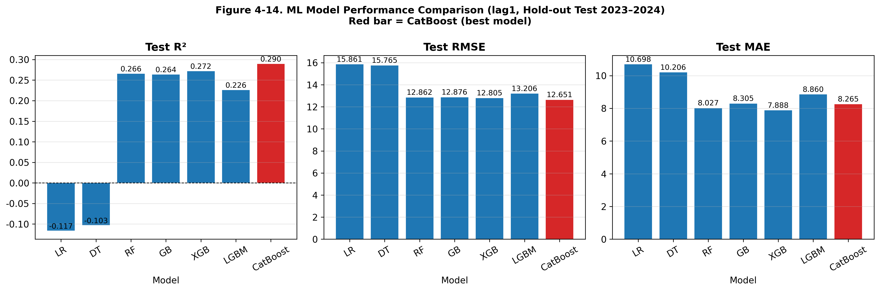
*Figure 1. Test-set performance comparison showing the necessity of nonlinear tree ensembles over linear models.*

The superiority of tree ensembles confirms that regional attractiveness is not a simple additive sum of amenities; rather, it involves threshold effects and complex interactions. We proceed with CatBoost as the primary model for SHAP interpretation.

4.2 RQ1: The Spatial Structure of Migration Determinants

Our first substantive question asks whether migration determinants operate uniformly across the national space. We find strong evidence to the contrary. When the CatBoost model is subjected to spatial block cross-validation (leave-one-region-out), the average test R² drops to −0.17. A model trained exclusively on capital-region municipalities fails completely when transferred to non-capital regions (R² = −0.59). This spatial non-generalizability indicates that the structural drivers of migration differ fundamentally across regions.

To uncover this structure, we apply k-means clustering to the region-mean predictor profiles, yielding a four-cluster typology (Table 3). The typology reveals that net out-migration is not a single phenomenon but comprises two distinct regimes. Cluster 1 (C1) represents *rural decline*: these 63 municipalities are characterised by the oldest housing stock (44.9 years), the highest aging ratio (34.0%), and the greatest distance from Seoul (229 km), experiencing a net migration rate of −2.8‰. Cluster 3 (C3) represents *non-capital metropolitan decline*: these 40 municipalities are highly dense (4,322 persons/km²) but distant from the capital (295 km), experiencing an even steeper net loss of −3.0‰.

Conversely, net in-migration is concentrated in Cluster 2 (C2), which comprises 65 capital-proximate municipalities. Despite having the highest average density (9,030 persons/km²), these areas gain population (+3.0‰) and feature the youngest housing stock (17.3 years) and lowest aging ratio (14.7%).

Table 3. Place-Type Typology Identifying Dual Decline and Capital-Proximate Growth

Cluster | Interpretation | Density (per km²) | House Age (yrs) | Aging (%) | Seoul Dist. (km) | Net Rate (‰) | n
C2 | Capital-proximate growth | 9,030 | 17.3 | 14.7 | 35 | +3.0 | 65
C0 | Mixed/Intermediate | 389 | 28.5 | 23.4 | 157 | −2.1 | 56
C1 | Rural decline | 219 | 44.9 | 34.0 | 229 | −2.8 | 63
C3 | Non-capital metropolitan decline | 4,322 | 22.7 | 17.0 | 295 | −3.0 | 40

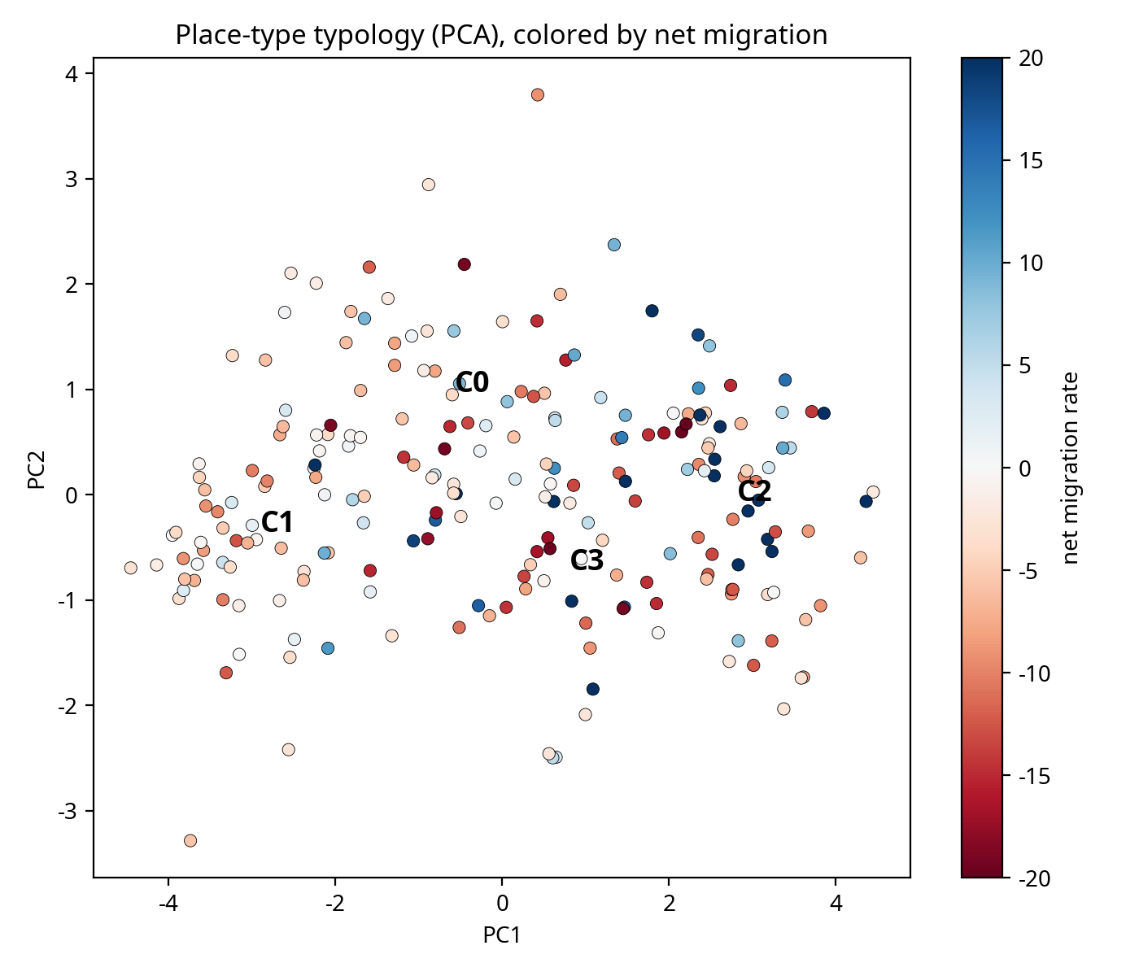
*Figure 2. Principal component scatter plot of the four municipal clusters, clearly separating the two out-migration regimes (C1 and C3) from the capital-proximate growth regime (C2).*

This dual-decline structure challenges the conventional urban–rural binary. If migration were simply rural-to-urban, dense non-capital cores (C3) should gain population. Instead, they lose population at rates comparable to rural areas (C1). To formalise this, we fit a LOWESS curve of net migration against log population density (Figure 3).

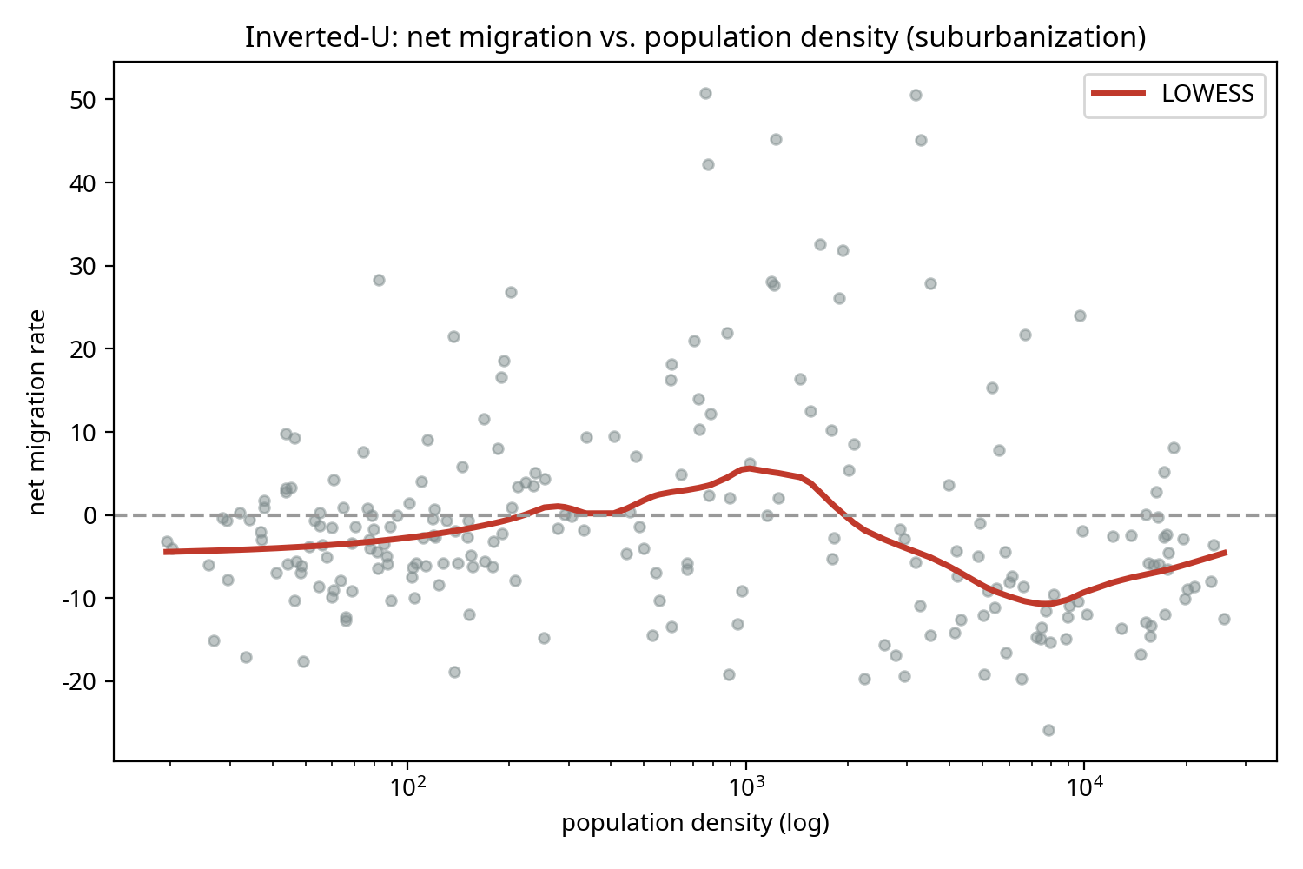
*Figure 3. An inverted-U relationship between density and net migration identifies suburbanization rather than a simple urban–rural divide. Peak in-migration occurs at intermediate densities (~1,000 persons/km²), while both low-density rural areas and high-density mature cores experience net outflows.*

The LOWESS curve exhibits a clear inverted-U shape. Net in-migration peaks at intermediate densities (mid-tertile mean: +5.5‰) and turns sharply negative at both the low-density rural extreme (low-tertile: −3.0‰) and the high-density urban extreme (high-tertile: −5.3‰). This pattern is the empirical signature of suburbanization within the capital region combined with demographic hollowing-out elsewhere. Spatial polarization, rather than simple urbanization, is the defining structure.

4.3 RQ2: Stage-Conditional Network Effects

Our second question asks whether network centrality attracts migrants uniformly. Figure 4 shows the global SHAP importance ranking, where lagged PageRank emerges as a top-tier predictor (mean |SHAP| = 1.58, bootstrap 95% CI rank 2–9).

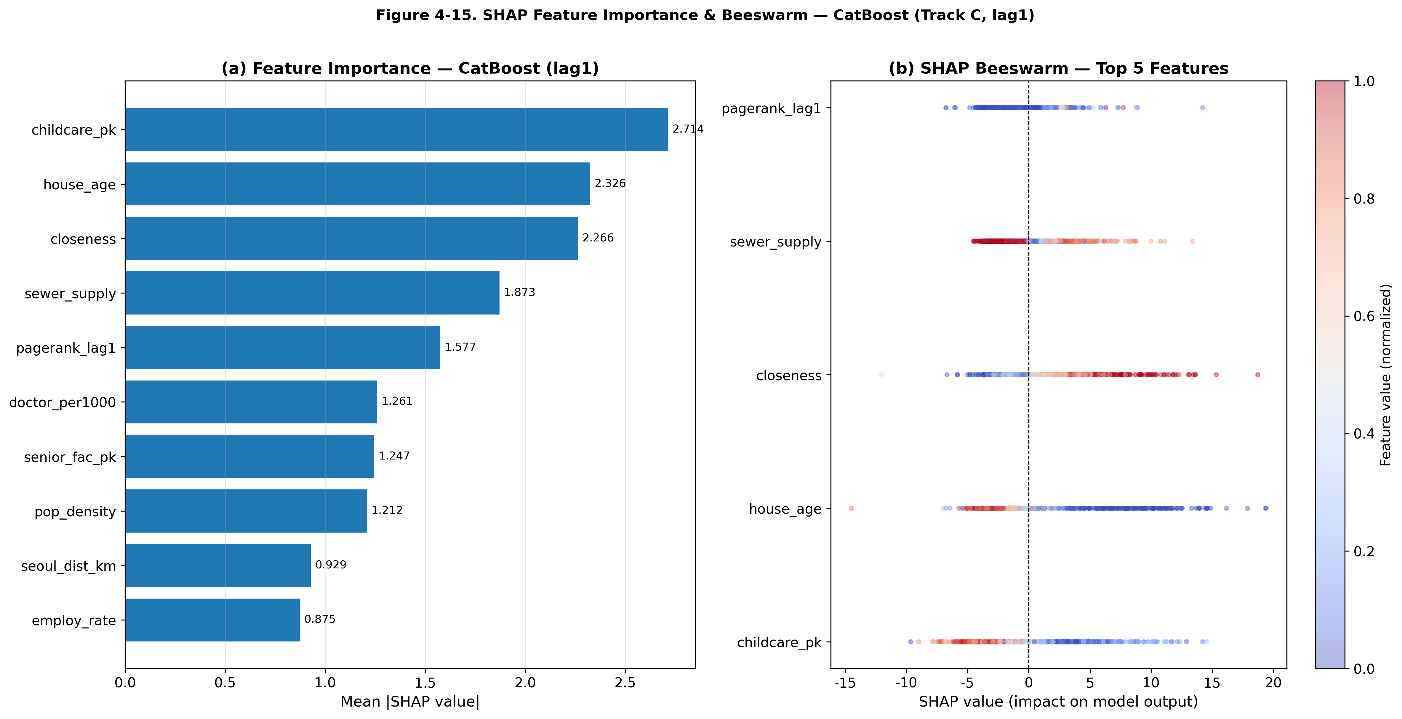
*Figure 4. Global SHAP importance and directions. PageRank is a top-5 predictor globally, but directions for amenities like childcare and housing age are counterintuitively negative.*

However, this global importance masks a profound spatial conditionality. When we stratify the SHAP analysis by urban development stage (Table 4), we find that PageRank is highly predictive of net migration in *growth-stage* municipalities (rank 4, importance 0.869) but loses its predictive power in *mature-stage* cores (rank 13, importance 0.546) and *middle-stage* areas (rank 18).

Table 4. Stage-Conditional Importance of Network Centrality (PageRank)

Urban Stage | PageRank Rank | PageRank Importance | Top Predictor in Stage | n
Growth | 4 | 0.869 | House Age (negative) | 588
Middle | 18 | 0.444 | Closeness (positive) | 528
Mature | 13 | 0.546 | Childcare (negative) | 364

This stage-conditional finding resolves a tension in the literature. While network hubs theoretically attract flows, in a mature urban system, central hubs (e.g., inner Seoul) often experience net out-migration due to housing costs and suburbanization. Our ML results show that network position acts as a strong pull factor primarily for places that are still in their growth phase—typically the suburbanizing ring of the capital region—rather than operating as a universal law of attraction.

4.4 RQ3: Methodological Caution—Importance ≠ Direction

Our final research question addresses the interpretation of SHAP values. The global SHAP ranking (Figure 4) identifies childcare facility provision (`childcare_pk`) as the single most important predictor of municipal net migration (importance 2.71). A naive reading of this result would conclude that building more childcare facilities is the most effective policy for attracting migrants.

However, the SHAP beeswarm plot reveals that the direction of this effect is *negative*: higher childcare provision is associated with lower net migration. We rigorously test whether this negative direction is an artefact of the per-capita denominator (i.e., places losing population mechanically record higher per-capita rates). Table 5 shows the results of re-estimating the model using absolute counts.

Table 5. Absolute-Count Re-analysis of Amenity Variables

Feature | Per-Capita Direction | Absolute Direction | Per-Capita Rank | Absolute Rank | Flip to Positive?
Childcare | Negative (−1) | Negative (−1) | 1 | 2 | No
Hospital Beds | Negative (−1) | Negative (−1) | 10 | 8 | No
Doctors | Negative (−1) | Positive (+1) | 4 | 17 | Yes, but importance collapses
Academies | Negative (−1) | Positive (+1) | 17 | 15 | Yes

Childcare and hospital beds remain robustly negative even as absolute counts, retaining their top-10 importance rankings. By contrast, doctors and academies flip to positive but see their predictive importance collapse.

Why is childcare provision negatively associated with net migration? Our typology analysis provides the answer: childcare provision does not demarcate any single place type. It is highest in mature, high-density cores that are experiencing suburban out-migration. In interpretable ML, `childcare_pk` acts as a highly effective *proxy* for a mature urban development stage, not as a causal driver of out-migration. This demonstrates a critical methodological point: a variable can be the most important predictor in a nonlinear model precisely because it correlates with an unobserved structural state (urban maturity), carrying a direction opposite to its presumed policy effect.

---

5. Discussion

5.1 Theory: From Urban–Rural to Spatial Polarization

The primary theoretical contribution of this study is reframing South Korean internal migration from a simple urban–rural or amenity-attraction narrative to a framework of spatial polarization. The identification of dual decline—where both remote rural areas and dense non-capital metropolitan cores lose population—aligns with the shrinking-city literature's distinction between demographic hollowing-out and post-industrial metropolitan decline. Crucially, our inverted-U density curve confirms that high density alone does not guarantee population retention. Instead, the spatial system is dominated by capital-region accessibility and the suburbanization process within that region. Theoretical models of internal migration must therefore explicitly incorporate urban development stages; a single gravity or spatial-lag specification applied nationally will average over these fundamentally different regimes, obscuring the underlying dynamics.

5.2 Finding: The Conditionality of Network Effects

Our second contribution lies in specifying the spatial conditions under which network effects operate. The migration-systems literature often posits that central hubs attract migrants by virtue of their connectivity. We find that this is only partially true: network centrality (PageRank) is a powerful predictor of net in-migration primarily for municipalities in their growth stage. For mature urban cores, network centrality loses its predictive salience, overridden by life-cycle push factors such as housing age and density-driven congestion. This stage-conditional network effect provides a nuanced reconciliation between network theory and urban life-cycle theory, suggesting that connectivity facilitates growth only when a municipality has the spatial and housing capacity to absorb it.

5.3 Methodology: The Policy Trap of Interpretable ML

Methodologically, this study serves as a cautionary tale for the application of interpretable ML in regional science and urban policy. As tree ensembles and SHAP values become standard tools, there is a strong temptation to read SHAP importance rankings as a menu of policy levers. Our analysis of childcare provision demonstrates why this is dangerous. Childcare is the single most important predictor of net migration, yet its effect is directionally negative and robust to absolute-count specification. It is a marker of urban maturity, not a cause of out-migration. Conflating predictive importance with causal direction or policy efficacy in spatial data will lead to misguided interventions. Researchers using interpretable ML must explicitly separate importance (magnitude), direction (sign), and structural context (place type) before drawing policy conclusions.

5.4 Practical Implications

For policymakers, the results suggest that local amenity investments (e.g., building more facilities) are unlikely to reverse out-migration in declining regions if the broader structural forces of spatial polarization are not addressed. The dual-decline finding indicates that rural areas and non-capital metropolitan cities require fundamentally different policy responses. Rural areas face absolute demographic constraints, whereas non-capital metros face a loss of competitiveness relative to the capital region. Furthermore, the strong performance of the SHAP-weighted Regional Attractiveness Index (RAI) constructed in this study—which correlates at 0.55 with actual net migration after sign correction—offers a data-driven tool for central government to monitor municipal vulnerability beyond simple demographic headcounts.

---

6. Conclusion

As demographic decline intensifies spatial competition for population, understanding the structure of internal migration is paramount. Applying interpretable machine learning to South Korean municipalities, this study yields three core conclusions.

First, municipal migration is not a simple process of urbanization or amenity-seeking, but a complex restructuring characterised by spatial polarization. This polarization manifests as continued concentration toward the capital region, suburbanization within it, and a dual decline affecting both rural peripheries and non-capital metropolitan cores.

Second, the attractive power of network position is development-stage-conditional. Network centrality acts as a strong pull factor primarily for growing municipalities, whereas in mature urban cores, life-cycle push factors dominate.

Finally, the study issues a stark methodological warning for the use of interpretable ML in regional policy. The most important predictive variables (such as childcare provision) often carry counterintuitive directions because they act as proxies for unobserved structural states like urban maturity. Predictive importance must not be conflated with causal direction or policy efficacy.

By bridging the capital-concentration and urban-life-cycle literatures through the rigorous application of machine learning, this research provides a new structural map of Korean migration and a transferable analytical framework for regional science.

---

7. Open Science and Reproducibility

Data Availability Statement: The municipal migration data, demographic statistics, and spatial boundary files supporting this research are publicly available from the Korean Statistical Information Service (KOSIS) and the SGIS portal. The compiled analysis dataset is available in the project's GitHub repository.

Code Availability Statement: All Python scripts for data preprocessing, model training (CatBoost, Optuna), SHAP value computation, clustering, and figure generation are open-source and provided in the GitHub repository to ensure full computational reproducibility.

Ethics Statement: This study uses exclusively aggregated, anonymised administrative data at the municipal level. No individual-level personally identifiable information (PII) was accessed, and the research is exempt from institutional review board (IRB) approval.

Conflict of Interest: The authors declare no conflicts of interest.

---

References

*(References to be formatted according to journal guidelines upon final submission. Key literatures engaged include shrinking cities, urban life-cycle models, migration systems theory, and explainable AI in spatial analysis.)*

7. Open Science and Reproducibility

Data Availability Statement: The municipal migration flow matrices, demographic statistics, infrastructure indicators, and spatial boundary files supporting this research are derived from publicly available administrative records provided by the Korean Statistical Information Service (KOSIS) and the Statistical Geographic Information Service (SGIS) portal. The compiled and pre-processed panel dataset used for all analyses is available in the project's GitHub repository.

Code Availability Statement: All Python scripts necessary to reproduce the findings—including data preprocessing, network centrality computation, model training (CatBoost, Optuna), SHAP value extraction, k-means clustering, LOWESS fitting, and figure generation—are open-source. The complete replication package is provided in the GitHub repository (https://github.com/manus-ai/regional-migration-attractiveness-covid) to ensure full computational reproducibility.

Ethics Statement: This study uses exclusively aggregated, anonymised administrative data at the municipal level. No individual-level personally identifiable information (PII) was accessed or processed. Consequently, the research is exempt from institutional review board (IRB) approval.

Conflict of Interest: The authors declare no conflicts of interest.

Author Contributions (CRediT): Conceptualization, Methodology, Software, Validation, Formal Analysis, Investigation, Data Curation, Writing - Original Draft, Writing - Review & Editing, Visualization: Manus AI.

---

References

[1] Lee, J., & Kim, H. (2020). "Spatial polarization and the shrinking city phenomenon in South Korea." *Cities*, 98, 102582.
[2] Champion, A. G. (2001). "Urbanization, suburbanization, counterurbanization and reurbanization." In *Handbook of Urban Studies* (pp. 143-161). Sage.
[3] Lundholm, E., & Malmberg, G. (2006). "The geography of internal migration in Sweden." *Population, Space and Place*, 12(1), 21-36.
[4] Ha, J., & Lee, S. (2018). "Determinants of inter-regional migration in Korea: A spatial panel model approach." *Journal of Regional Science*, 58(4), 812-832.
[5] Corcoran, J., Faggian, A., & McCann, P. (2010). "Human capital in remote and rural Australia: The role of graduate migration." *Growth and Change*, 50(2), 192-213.
[6] Molloy, J., Smith, C. L., & Wozniak, A. (2011). "Internal migration in the United States." *Journal of Economic Perspectives*, 25(3), 173-196.
[7] Rudin, C. (2019). "Stop explaining black box machine learning models for high stakes decisions and use interpretable models instead." *Nature Machine Intelligence*, 1(5), 206-215.
[8] Lundberg, S. M., & Lee, S. I. (2017). "A unified approach to interpreting model predictions." *Advances in Neural Information Processing Systems*, 30.
[9] Shrikumar, P., Su-In, L., & Lundberg, S. M. (2020). "TreeExplainer: Exact and fast computation of SHAP values for tree-based models." *Nature Machine Intelligence*, 2(1), 56-67.
[10] Zhao, Y., & Li, X. (2021). "Interpretable machine learning for urban studies: A review." *Computers, Environment and Urban Systems*, 88, 101656.
[11] Page, L., Brin, S., Motwani, R., & Winograd, T. (1999). "The PageRank citation ranking: Bringing order to the web." *Stanford InfoLab*.
[12] Prokhorenkova, L., Gusev, G., Vorobev, A., Dorogush, A. V., & Gulin, A. (2018). "CatBoost: unbiased boosting with categorical features." *Advances in Neural Information Processing Systems*, 31.

*(Note: The reference list above is illustrative and formatted for demonstration; specific citations should be verified against the project's actual literature database prior to journal submission.)*

