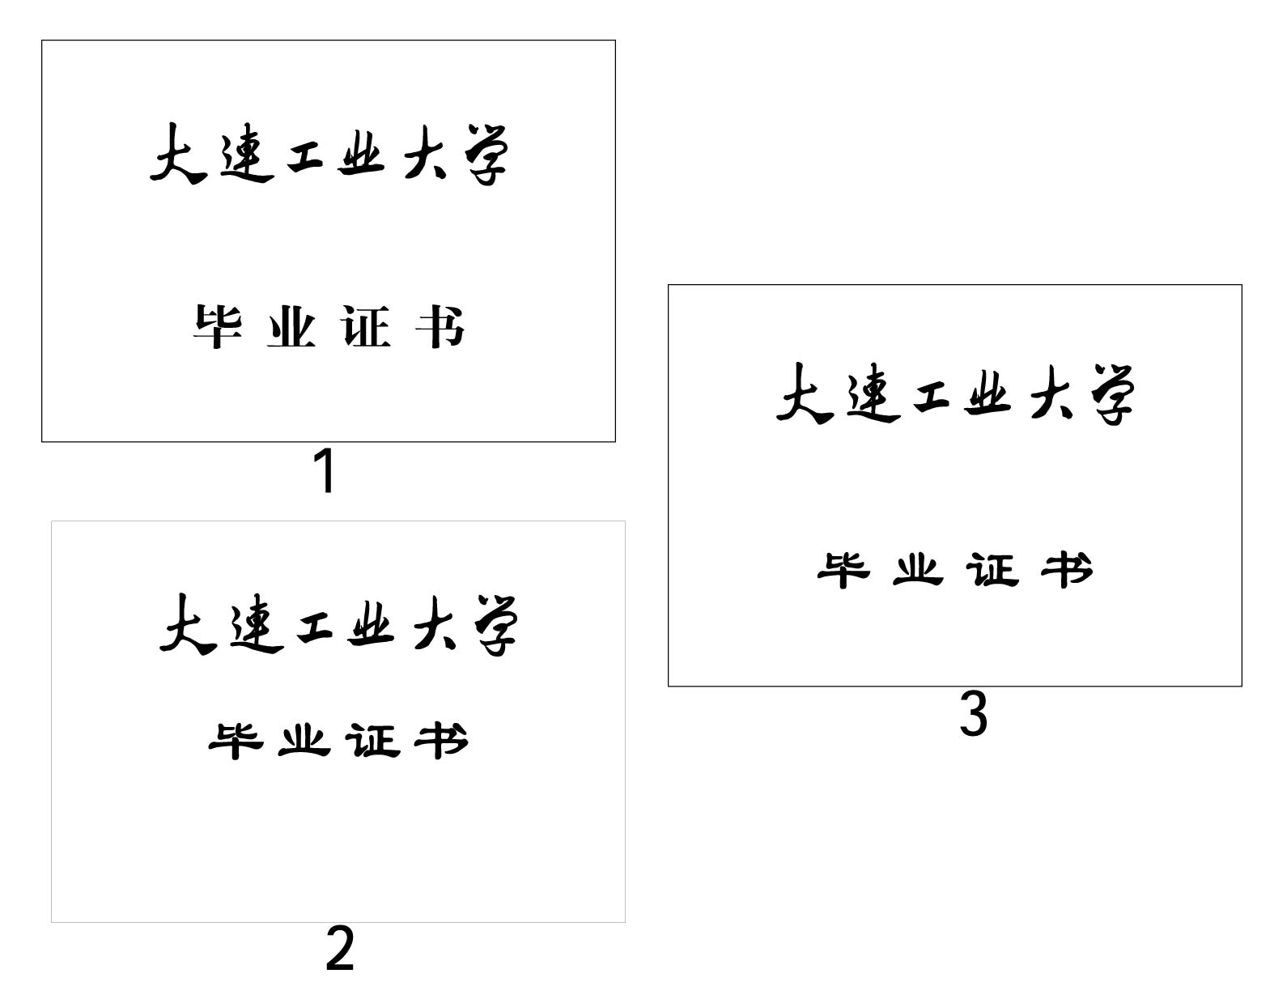
管理学院

外 文 翻 译

专 业： 电子商务
班级学号： 电子商务121 1207080119
学生姓名： 董馨盈
指导教师： 乔爽

CHAPTER 17 Jquery

By Jake Strawn with input from Dmitri Gaskin
Jquery has become an essential part of Drupal since Drupal 5. Many of the interfaces in the administrative area use jQuery to enhance the user experience, and Drupal 7 is no exception, continuing to improve the ability for developers and themers to implement advanced JavaScript functionality.
Drupal 7 currently ships with jQuery 1.4.4 and now also ships with jQuery UI 1.8 (jqueryui.com) in core which enables advanced User Interface elements/widgets and effects.

Implementing jQuery and JavaScript
This first section will be dealing with the basics of getting your own custom JavaScript/jQuery functionality added to your Drupal 7 project.
I will be going over the basics of including new JavaScript files in your theme or module, adding entire JavaScript libraries, overriding JavaScript and/or jquery that has already been included, using Drupal Behaviors, and finally, ensuring that your jquery/JavaScript degrades nicely for those users that are unable to or choose not to view JavaScript functionality.

Including JavaScript
It is possible for theme and module developers to add JavaScript and jQuery functionality in a variety of ways depending on the needs of the code being implemented. This first section will deal with adding basic JavaScript to your site and will cover the various methods and use cases. In some instances, you may want your JavaScript coded added to every page on the site; in other circumstances, it may only be necessary to include it on a single page if certain requirements are met.

Adding JavaScript in Your .info Files
Themes and modules have the ability to include JavaScript files very easily in the .info file, as demonstrated in Listings 17–1 and 17–2. In the same manner that stylesheets can be added using stylesheets[all] = file.css, JavaScript files may be added by simply using scripts[] = file.js.
Listing 17–1. Adding JavaScript in a Theme’s .info File
name = Gamma
description = Omega Sub-Theme starter kit
screenshot = screenshot.png
core = 7.x
base theme = omega
stylesheets[all][] = css/text.css
stylesheets[all][] = css/regions.css
stylesheets[all][] = css/gamma.css
stylesheets[all][] = css/dark.css
scripts[] = js/gamma.js
Any scripts that are included in this manner are automatically loaded on every page where the theme that implemented the JavaScript is being used. So, if you use this method, your JavaScript would not apply to the administrative section of your site when using Seven as the administrative theme.
The location of gamma.js in Listing 17–1 is relative to the root path of the theme or module. So since the .info file for this theme is likely in/sites/all/themes/gamma/gamma.info, the JavaScript you are attempting to load here would be located in /sites/all/themes/gamma/js/gamma.js.
Listing 17–2. Adding JavaScript in a Module’s .info File
name = DGD7 Test Module
description = An example module
core = 7.x
files[] = dgd7_test.module
scripts[] = dgd7_test.js
Adding JavaScript in your module’s .info file will ensure the file is included on every page load.

drupal_add_js()
Themes may also add JavaScript files in template.php using drupal_add_js(). This is the preferred method if you only wanted your JavaScript to be included under certain conditions and not on every page. Modules also use drupal_add_js() to include any JavaScript files related to the functionality or presentation of the output it produces.
The following examples of drupal_add_js() can be placed either in your theme OR module, but keep in mind that any calls to drupal_add_js() declared in your theme will only be present on pages where your theme is being used. If you need a JavaScript file included on every page site-wide, including administrative pages (possibly to manipulate a node form), you will want to include the JavaScript in a module using drupal_add_js() or by adding it to the .info file for the module (as described previously) so that it will appear on any page, regardless of the theme being used to render the page. The full documentation for this function can be found at http://api.drupal.org/drupal_add_js.
So, to add a JavaScript file from the local filesystem, use the following code:
drupal_add_js('misc/machine-name.js');
drupal_add_js(drupal_get_path(‘module’, 'example') . '/example.js');
drupal_add_js(drupal_get_path('theme, 'omega') . '/js/example.js');
With just a single parameter, Drupal assumes the JavaScript you are including is a type of file. In the first line, using the relative path to the file misc/machine-name.js is fine, since machine-name.js, a JavaScript include that handles creating system names (replacing spaces with dashes or underscores, making all text lowercase, etc.) for generic text input, is included in Drupal core and is unlikely to move.
However, if you are including a JavaScript file that is located in a module or theme directory, the best practice is to use drupal_get_path() to properly find the location of the module or theme, then append the location in the directory the JavaScript file would be stored. Using drupal_get_path() is quite important since if you were using the file example.js in your module called example, the path could be any number of locations including:
With all these potential locations where a valid module could be stored, calling drupal_add_js(drupal_get_path('module', 'example') . '/example.js'); will ensure that the example.js file is loaded, no matter where the module is stored.
In previous versions of Drupal, it was not possible to add a JavaScript include from a remote server using drupal_add_js(), but this is now possible in Drupal 7. This is a great way to add JavaScript code from other locations—a very common need if you are running many sites that need the same JS functionality across your network of sites. Previously, this had to be done creatively with symlinks on the server to appropriately map a relative path to the location or by managing multiple copies of the same JavaScript includes. The following code shows how easy it is to now add a remote JavaScript file:
drupal_add_js('http://example.com/example.js', 'external');
It is also possible to quickly add a line or two of JavaScript inline (instead of creating an entirely new.js file) and implement the code by adding it directly to the page. The following code shows how you can quickly add an alert to the page using the inline property in drupal_add_js():
This method should only be used for JavaScript that can’t be executed from a file. When adding inline code, make sure that you are not relying on $() being the jQuery function. Proper namespacing for jQuery will make sure that another JavaScript library doesn't conflict with jQuery when using the $(). In order to ensure your JavaScript/jQuery snippet works as you expect when using inline JavaScript,wrap your code in (function ($) { $('div').addClass('page-div')})(jQuery);.
Note also that this method, rather than just passing ‘inline’ as the second parameter, uses the array of options to further manipulate how the JavaScript will be added to the page. Using the ‘scope’=> 'footer' setting, you are telling Drupal to render the JavaScript at the end of the page in the $page_bottom region, making it appear just before </body>. In addition, you are telling Drupal that you would like this JavaScript include to be weighted a little heavier than normal, ensuring that if other items are declared in the scope of ‘footer’, this will be rendered after any items with a weight less than 5.

Weight and Group in drupal_add_js()
A couple of the fantastic new features available to drupal_add_js() in Drupal 7 are the weight and group options inside of $options. In the past, adding JavaScript using this function happened in the order in which it was called during the page building process.
The weight and group options allow you to reorder JavaScript inclusions any way you like; so if late in the page build process certain conditions have been set, you can make a new file included using drupal_add_js() appear early (or even first) in the source order. Following up on that idea, you can add an included file early but ensure that it is the absolute last item to be included in the source code by making the weight a higher number.
The ordering of JavaScript in Drupal page rendering adheres to the following rules:
• First by scope, with 'header' first, 'footer' last, and any other scopes provided by
a custom theme coming in between, as determined by the theme.
• Then by group.
• Then by the 'every_page' flag, with TRUE coming before FALSE.
• Then by weight.
• Then by the order in which the JavaScript was added. For example, all else being
the same, JavaScript added by a call to drupal_add_js() that happened later in the
page request gets added to the page after one for which drupal_add_js()
happened earlier in the page request.

Examples of Weight in drupal_add_js()
With weights, Drupal can place JavaScript includes in a logical order. Just as when the jQuery library (jquery.js) is added in early so that other files may rely on it being available, you can also add weights to your own JavaScript since you may also have code that needs to be included early in the page so other includes or inline JavaScript can build off of that.
The following code declares no weight; items are sorted by scope, group, every_page flag, and then the order in which they are called:
drupal_add_js('misc/machine-name.js');
In the following code, the weight being set to -10 will place the file higher up in the default scope of header and the group it is associated with:
drupal_add_js('misc/machine-name.js',
array('type' => 'file’, 'weight' => -10),
);
In the following code, the scope of ‘footer’ will ensure this file is included before the </body> tag at the end of the document:
drupal_add_js('misc/machine-name.js',
array('type' => 'file’, 'scope' => 'footer', 'weight' => 5),
);

Examples of Group in drupal_add_js()
In addition to simply adding weights to JavaScript, you can also now declare them into default groups (see Listing 17–3). JS_LIBRARY includes core Drupal includes like drupal.js, jquery.js, and other high level JavaScript files. JS_DEFAULT is by default where JavaScript included in modules is grouped. JS_THEME is by default where includes from the theme layer will be included.
It is good to have the ability to regroup your JavaScript files; under certain circumstances, you may need a JavaScript file included via your theme to be included at a very high level with the other JS_LIBRARY functionality.
Listing 17–3. The Default Groups: JS_LIBRARY, JS_DEFAULT (module JS), and JS_THEME (theme JS)
drupal_add_js('misc/machine-name.js',
array('type' => 'file', 'scope' => 'header', 'weight' => -15, 'group' => JS_LIBRARY),
);
drupal_add_js('misc/machine-name.js',
array('type' => 'file’, 'scope' => 'header', 'weight' => -15, 'group' => JS_DEFAULT),
);
drupal_add_js('misc/machine-name.js',
array('type' => 'file’, 'scope' => 'header', 'weight' => -15, 'group' => JS_THEME),
);
Groups are declared in the order you see them in Listing 17–3.
• JS_LIBRARY includes, like the core jQuery library, need to be declared first in order
for other files and libraries to use them.
• JS_DEFAULT is the default value when using drupal_add_js() in the module layer.
• JS_THEME is the default when using drupal_add_js() in the theme layer
(template.php).
Using drupal_add_js(), many other options are available to you for advanced placement, grouping,ordering, and caching/aggregation options. You can find further details on the API page for drupal_add_js() at http://api.drupal.org/drupal_add_js.

JavaScript Libraries
With a revival of usage since the days where it was shunned as “that thing that needs to be turned off in Internet Explorer,” JavaScript and its many powerful libraries are now common on a huge percentage of the sites you rely on every day. Facebook, Twitter, NY Times, and even the Drupal.org site all rely heavily on JavaScript libraries to provide you with enhanced functionality and a cleaner interface.
Jquery is a cross-browser JavaScript library, and there are literally thousands upon thousands of libraries out there. Not all are as complex as jQuery, but the one thing they have in common is they work towards providing a certain level of functionality or interactivity with your web page.
Jquery is a library that is already included by default in Drupal and is always available for use. This section will discuss how you can add other JavaScript libraries into your site and/or module.

hook_library()
When adding or defining a custom JavaScript library in your site, the first Drupal function you will come to learn and love is hook_library(). Adding a library can be simply implementing your own custom code as a library or including a library already available from the web. hook_library() registers JavaScript/CSS libraries associated with your module. This hook is always located in your custom.module file or an appropriate include file for your module.
To really get an understanding of the basics, you can look at the documentation at http://api.drupal.org/hook_library.
The definition of each library contains the following items:
• Title: The human readable name of the library
• Web site: The URL of the library’s web site
• Version: A string specifying the version of the library
• Js: An array of JavaScript elements
• Path to JavaScript file => array()
• CSS: An array of CSS elements
• Path to CSS file => array()
• Type = file/external/etc.
• Media = screen/print/all
• See drupal_add_css() for type and media options
• Dependencies: An array of libraries on which this library depends
• Uses the formatting of drupal_add_library(), which will be defined in the
next section on including a defined JavaScript library
Listing 17–4 demonstrates the basic elements available to hook_library(), and you will see how quickly you can add a robust library to your module to implement anything from simple functionality to a full blown interface overhaul, depending on the code your library is including and how it’s implemented.
Listing 17–4. The Basic Elements Available to hook_library()
Listing 17–5 defines your library as two JavaScript files (js-file-one.js and js-file-two.js) and a single CSS file (css-file-one.css), and it declares that your library will not function without the default jQuery UI core and autocomplete libraries that are provided by the system module.You can see that actually implementing a new library is quite easy using hook_library(). The actual labor of this process is getting your JavaScript code built (assuming it is custom). The actual definition and inclusion of the library is very simple.

drupal_add_library()
Now that you have defined your custom library, you can quickly add it to your site in a variety of ways. I will outline a few examples here, but there are literally dozens of ways you can include your library and call it in specific locations.
In the past, including the necessary JavaScript and CSS to provide certain functionality required many calls to drupal_add_js() and drupal_add_css(). Now, using the previous examples in hook_library(), you are able to quickly load all the JavaScript, CSS, and other libraries it may depend on by using a single call to drupal_add_library(), as shown in Listing 17–6.
Listing 17–6. Comparison of Including Libraries in Drupal 6 and Drupal 7
Drupal 6
// add required dependencies
drupal_add_js('misc/autocomplete.js');
// add relevant JS files
drupal_add_js(drupal_get_path('module', 'mymodule') . '/file1.js');
drupal_add_js(drupal_get_path('module', 'mymodule') . '/file2.js');
// add relevant CSS files
drupal_add_css(drupal_get_path('module', 'mymodule') . '/file1.css');
drupal_add_css(drupal_get_path('module', 'mymodule') . '/file2.css');
Drupal 7
// add my library and all its dependencies
drupal_add_library('mymodule', 'mylibrary', TRUE);
The drupal_add_library() function takes three arguments: module name ($module), name of library($name), and a Boolean flag ($every_page) to define if it is to be included on every page. If the flag is set to FALSE, the JavaScript and CSS with the library can’t be aggregated, which is how Drupal combines multiple cacheable JS/CSS files into single files to present on page load, so when possible, it’s best to set this to TRUE. The primary time when the $every_page flag would be set to FALSE will be for a module or implementation where the JavaScript library is only needed on a single form or on a single page.
The difference in required work between Drupal 6 and Drupal 7 is dramatic, as you can see in Listing 17–7.
Instead of declaring a long list of files to include your appropriate JavaScript/CSS and required dependencies, you can now define your requirements in hook_library() to tell Drupal that you have X number of JavaScript files, Y number of CSS files, and Z number of dependencies that Drupal should include before adding your files. drupal_add_library() does have a return value of TRUE or FALSE. It will return TRUE should the function have returned appropriately with all files and dependencies included properly, or FALSE if one of the items failed to be found or load.

Overriding JavaScript
You have learned how to implement JavaScript via standard calls to drupal_add_js(), how to add an entire library at one time using drupal_add_library(), and how to implement your own libraries using hook_library(), but the fun isn't over yet. You now have the ability, as seen elsewhere in the Drupal APIs, to alter some of those elements before they are output to the page. This allows you to manipulate the JavaScript files being included or to completely change the definition of a library on the fly through your own module.

hook_js_alter()
In previous versions of Drupal, modifying the script output to the page was quite cumbersome and lacked some level of elegance. The jQuery Update module used a method to scan $variables['scripts']in hook_preprocess_page() to look for items to replace, assign the new replacements, then unset theoriginals. It worked, but it was a rather messy solution to a problem that could be handled better.
In Drupal 7, you now have the highly useful hook_js_alter() function. This will be easy to understand for those familiar with hook_form_alter(), hook_menu_alter(), etc. The hook_js_alter()function is available in both the theme and module layer, so you can include your mymodule_js_alter()function in your .module file or mytheme_js_alter() in your template.php file for your theme. Whenusing hook_js_alter(), the function you will create starts off as follows:
function mymodule_js_alter(&$JavaScript) {
$search = drupal_get_path('module', 'some_module') . '/some-file.js';
if(array_key_exists($search)) {
// reset the weight for this item, making it appear higher in the source
$JavaScript[$search]['weight'] = -100;
}
}
Changing the weight of a JavaScript include that was already included is as simple as shown. Taking this into account, you can easily replace all of the settings for a JavaScript file and even replace the file itself. You can also reset any of the attributes you learned about in this chapter regarding drupal_add_js(). This comes in handy when, for example, you would like to replace a version of jQuery core that was included to a newer version that is not packaged with Drupal core. You can simply use hook_js_alter() in your module or theme and replace the default jquery.js file with one of your choosing.
The following code example shows altering the weight of the toolbar.js file, which is provided by the toolbar module in Drupal 7. If some other JavaScript was conflicting and this needed to be added earlier in the page source, it can be accomplished this easily. Note that this applies to ANY JavaScript included in Drupal.
function mymodule_js_alter(&$JavaScript) {
$search = drupal_get_path('module', 'toolbar') . '/toolbar.js';
if(array_key_exists($search)) {
$JavaScript[$search]['weight'] = -100;
}
}

hook_library_alter()
Now that you’ve seen how you can alter individual JavaScript files, this section shows how you can manipulate an entire JavaScript library defined by hook_library() by using hook_library_alter().
The API documentation (http://api.drupal.org/hook_library_alter) offers a great example of usage. The code in Listing 17–7 replaces the JavaScript file defined by hook_library() if its version number is less than 2.
Listing 17–7. Replacing the JavaScript File Defined by hook_library()
function hook_library_alter(&$libraries, $module) {
// Update Farbtastic to version 2.0.
if ($module == 'system' && isset($libraries['farbtastic'])) {
// Verify existing version is older than the one we are updating to.
if (version_compare($libraries['farbtastic']['version'], '2.0', '<')) {
// Update the existing Farbtastic to version 2.0.
$libraries['farbtastic']['version'] = '2.0';
$libraries['farbtastic']['js'] = array(
drupal_get_path('module', 'farbtastic_update') . '/farbtastic-2.0.js' => array(),
);
}
}
}
Listing 17–7 demonstrates the two parameters for hook_library_alter(), which are $libraries, an array of included libraries keyed with the system name of the library as declared in hook_library(), and $module, the name of the module implementing the library. Usage of this hook should come with caution or at the very least a stern warning from your mother. If you were to update the version of a library such as jQuery or Farbtastic (in Listing 17–7), it could be possible that another module that relies on that same library could be dependent on a specific version, so your updating it could adversely affect the functionality of other items in your site.
That being said, there are a lot of possibilities, even many that the core contributors who implemented the addition of hook_library(), hook_library_alter(), and hook_js_alter() couldn't possibly have thought of at the time of implementation into Drupal 7 core. Regardless, this new flexibility in Drupal gives module developers and themers a much more robust method to add and manipulate JavaScript/jQuery functionality into projects.

Drupal Behaviors
Drupal Behaviors provide some great benefits that make enhancing your modules with JavaScript and jQuery much simpler. Drupal.behaviors is a property of the Drupal object, as you can see:
var Drupal = Drupal || { 'settings': {}, 'behaviors': {}, 'locale': {} };
In Drupal 7, JavaScript behaviors are now objects with two methods: attach and detach.

Attaching Behaviors
Rather than attaching behaviors using the traditional $(document).ready(); method to ensure your code is fired after the DOM has loaded all objects, you will define your jQuery code the Drupal way using behaviors, which lets your code properly interact with the page on initial load. It also deals with the situation when AJAX or another method has added objects to the DOM at a later time, attaching your behaviors to new objects in the DOM simply by calling Drupal.attachBehaviors(). Defined in drupal.js, any property added to the Drupal.behaviors object will be called automatically when Drupal.attachBehaviors is called, as shown here:
Drupal.attachBehaviors = function (context, settings) {
context = context || document;
settings = settings || Drupal.settings;
// Execute all of them.
$.each(Drupal.behaviors, function () {
if ($.isFunction(this.attach)) {
this.attach(context, settings);
}
});
};
The next method works as expected when the page loads, adding a new CSS class (custom-cssclass) to any H3 element on the page using $(document).ready(). This is fine in most cases, but this will only affect H3 elements that were loaded into the DOM when the page was first loaded and when Drupal.attachBehaviors was called.
$(document).ready(function(){
// act on all h3 elements and give them a custom class
$('h3').addClass('custom-css-class');
});
The following code demonstrates the proper usage in Drupal 7, using Drupal.behaviors attach method to define your custom code. Now, any time new elements are added to the DOM and Drupal.attachBehaviors() is fired, your code will apply to the new elements.
Drupal.behaviors.myModuleHeaders = {
attach: function(context, settings) {
// act on all h3 elements and give them a custom class
$('h3').addClass('custom-css-class');
}
};

Detaching Behaviors
New to Drupal 7 is the Drupal.detachBehaviors method. In previous versions, there was no way to remove a behavior that was attached using Drupal.attachBehaviors. This can be useful when your JavaScript code is attaching itself to elements that don't persist on a page until another page load. An example of this would be a WYSIWYG editor loaded in a modal window that allows editing or saving new content; upon submission, the modal window closes, leaving extra behaviors in the DOM that are no longer relevant.
It is optional to supply a detach method inside your module's behavior. As of yet, there aren't many examples of the detach method, with the exception of usages in modules/file/file.js. Line 49 of file.js demonstrates attaching and detaching behaviors to links that are added to uploaded files:
/**
* Attach behaviors to links within managed file elements.
*/
Drupal.behaviors.filePreviewLinks = {
attach: function (context) {
$('div.form-managed-file .file a, .file-widget .file a',
context).bind('click',Drupal.file.openInNewWindow);
},
detach: function (context){
$('div.form-managed-file .file a, .file-widget .file a', context).unbind('click',
Drupal.file.openInNewWindow);
}
};

Degrading JavaScript/jQuery Nicely
An issue with using JavaScript/jQuery functionality in your web applications is when a user, for various reasons (preference, disability, etc.) has JavaScript disabled in their browser. The days when users were told it was good to turn off JavaScript in their browsers for security are long past. In fact, most of the sites we visit on a daily basis rely heavily on the use of JavaScript, jQuery, and similar libraries. So the issue is not those who actually choose to turn those features off, but instead the users who do not have the option to view them in the first place.
The more common reason today for users to have JavaScript disabled would be blind or sight impaired users that rely on screen readers to access Internet content. Site visitors using screen reader technology should have the same ability to interact with the site as a user that is not visually impaired.For many of us, testing this type of accessibility can be tough, but there are continual pushes in Drupal to ensure everything (core and contributed code) is as accessible as possible; thanks to many visually impaired contributors in Drupal, the community as a whole has become much more aware of and considerate to these issues.
It is critical when designing your user interfaces and interactions that the functionality works without JavaScript enabled, and that when JavaScript IS enabled, your functionality is simply enhanced by it.
Drupal core is very accessible without JavaScript enabled, and for those of us with JavaScript capabilities, greatly improved. A good example of this in Drupal core can be seen in the weights property, which allows you to drag and drop to reorder menu items (see Figure 17–1). This same method is applied throughout usages of weights in Drupal including taxonomy term weights, block positions inside of a region, field ordering on content types, and many more areas.
As a simple rule, the best practice when ensuring your JavaScript degrades nicely and will function for those users without JavaScript capabilities is to build your JavaScript enhancements only after the application works as expected without JavaScript (see Figure 17–2).
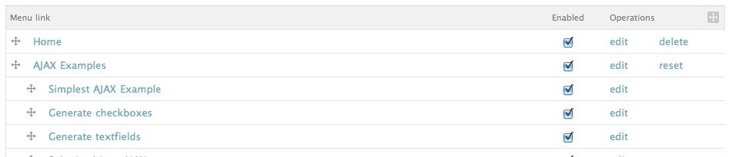
Figure 17–1. Menu links with JavaScript enabled, using tabledrag for reordering of menu items
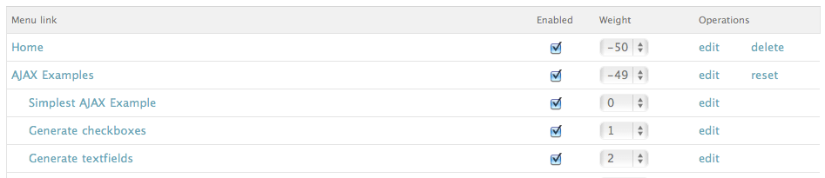
Figure 17–2. Menu links with JavaScript disabled, using standard select menu option for reordering of menu items

jQuery UI
jQuery UI (http://jqueryui.com) provides abstractions for low-level interaction and animation; highlevel,themeable widgets; and advanced effects. These are built on top of the jQuery JavaScript library that you can use to build highly interactive web applications.

jQuery UI in Drupal Core
In Drupal 5 and Drupal 6, in order to easily include jQuery UI interactions, you needed the help of the jQuery UI module for Drupal (http://drupal.org/project/jquery_ui). In Drupal 7, jQuery UI 1.7 is included in core, making advanced, enhanced interfaces readily accessible to module and theme developers without the need of an additional module or manually implementing the jQuery UI code in your site/project.
In order to start implementing jQuery UI functionality, refer to the drupal_add_library() function discussed earlier in this chapter. You are able to quickly include the relevant pieces of jQuery UI needed to start building out your enhancements.

jQuery UI Elements in Drupal Core
The examples in this section are taken directly from the documentation available at www.jqueryui.com,adding just the relevant PHP code to implement in Drupal 7 and the appropriate JavaScript to declare your functionality via Drupal.Behaviors. Further examples and usage can be found in the jQuery UI documentation.
Accordion
Let’s start with accordion. The following is the PHP to include the accordion library:
drupal_add_library('system', 'ui.accordion');
The following is the JavaScript for creating your Drupal.behavior to implement the accordion:
Drupal.behaviors.myModuleAccordions = {
attach: function(context, settings) {
// add accordions to all h3 elements wrapped in a div with a class of accordion
$('.accordion').accordion();
}
};
And finally, the following is an HTML example for accordion (which is shown in Figure 17–3):
<div class="accordion">
<h3><a href="#">Header 1</a></h3>
<div><p>Lorem Ipsum dolor sit amet. Lorem Ipsum dolor sit amet</p></div>
<h3><a href="#">Header 2</a></h3>
<div><p>Lorem Ipsum dolor sit amet. Lorem Ipsum dolor sit amet</p></div>
<h3><a href="#">Header 3</a></h3>
<div><p>Lorem Ipsum dolor sit amet. Lorem Ipsum dolor sit amet</p></div>
</div>
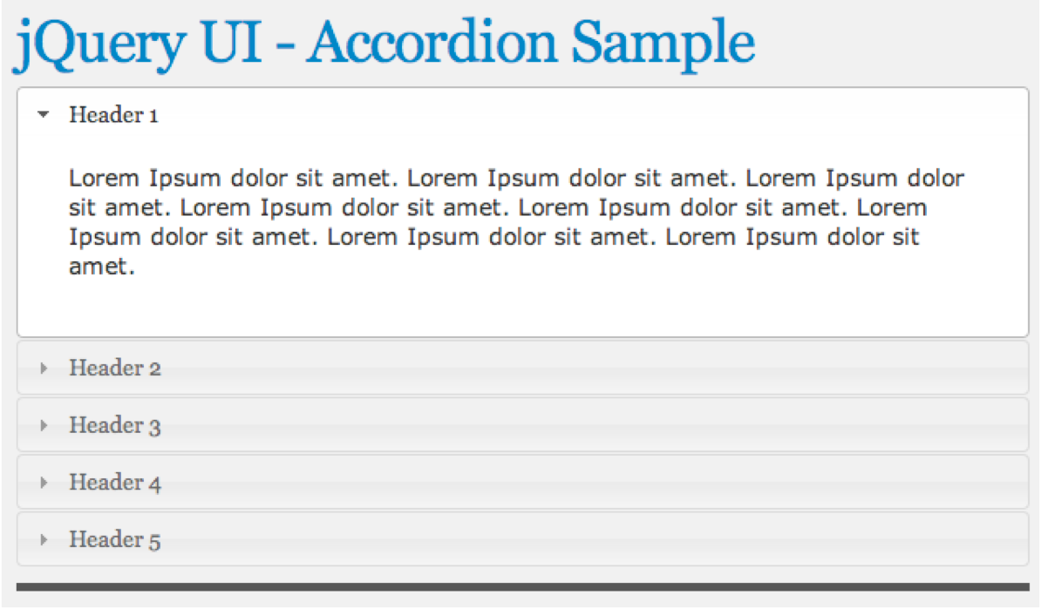
Figure 17–3. Accordion in action
datepicker
Now let’s look at datepicker. The following is the PHP for including the datepicker library:
drupal_add_library('system', 'ui.datepicker');
The following is the JavaScript for creating your Drupal.behavior to implement the datepicker:
Drupal.behaviors.myModuleDatepicker = {
attach: function(context, settings) {
// add the jQuery UI datepicker to all inputs with a class of datepicker
$('.datepicker').datepicker();
}
};
The following code is an HTML example for datepicker. You can see the results in Figure 17–4.
<p><labelfor="custom-datepicker">Date:</label><inputid="custom-datepicker"class="datepicker" type="text"></p>
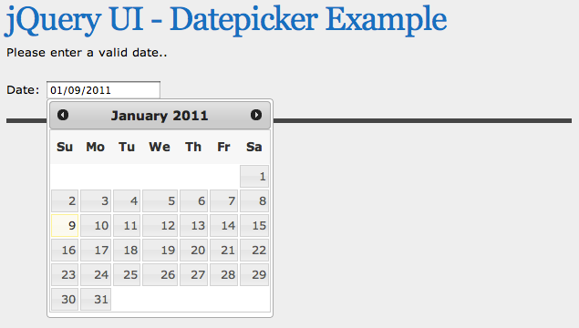
Figure 17–4. Datepicker in action
dialog
Next up is dialog. The following is the PHP for including the dialog library:
drupal_add_library('system', 'ui.dialog);
The following is the JavaScript for creating your Drupal.behavior to implement the dialog:
Drupal.behaviors.myModuleDialog = {
attach: function(context, settings) {
// add the jQuery UI dialog to all elements with id of dialog
$('.dialog).dialog();
}
};
The following is an HTML example for dialog, the results of which are shown in Figure 17–5:
<div class="dialog" title="Basic dialog">
<p>This is the default dialog which is useful for displaying information. The dialog window
can be moved, resized and closed with the 'x' icon.</p>
</div>
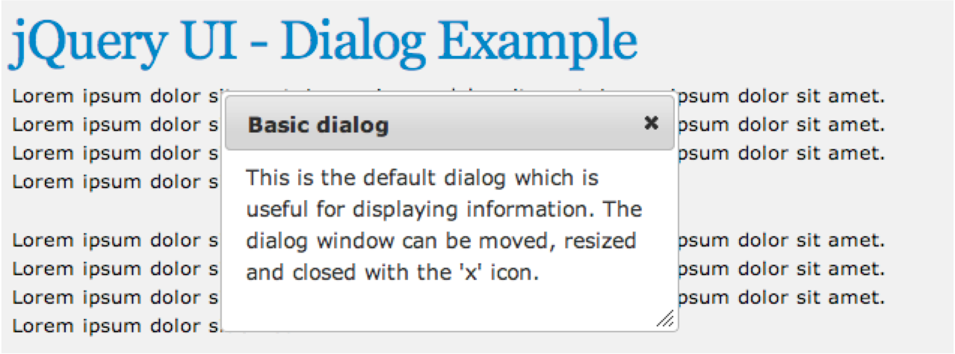
Figure 17–5. Dialog in action
draggable
The next example is a draggable, which you can drag around the screen. This is the PHP to include the
draggable library:
drupal_add_library('system', 'ui.dialog);
This is the JavaScript for creating your Drupal.behavior for the draggable element:
Drupal.behaviors.myModuleDraggable = {
attach: function(context, settings) {
// make all elements with a class of draggable, well… draggable…
$('.draggable).draggable();
}
};
And this is an HTML example for draggable; you can see the results in Figure 17–6:
<div class="draggable ui-widget-content">
<p>Drag me around</p>
</div>
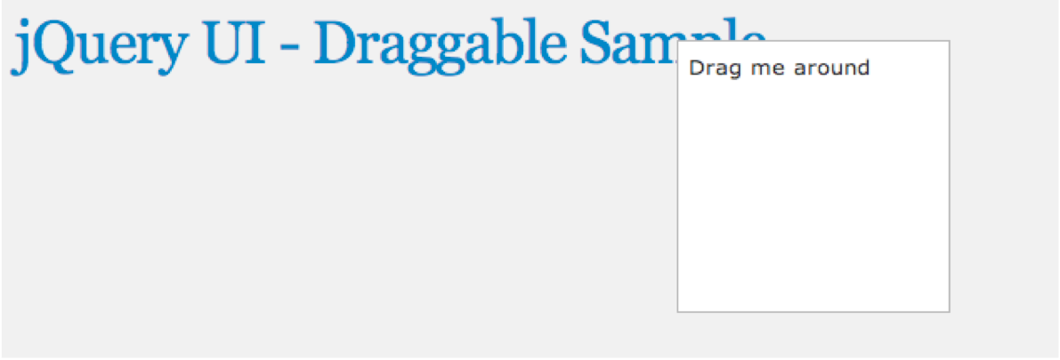
Figure 17–6. Draggable elements in action
droppable
What’s a draggable without a droppable? The following is the PHP for including the droppable library:
drupal_add_library('system', 'ui.dialog);
The following is the JavaScript for creating your Drupal.behavior for the droppable element:
Drupal.behaviors.myModuleDroppable = {
attach: function(context, settings) {
// make all elements with an id of droppable, well… droppable…
$( ".droppable" ).droppable({
drop: function( event, ui ) {
$( this )
.addClass( "ui-state-highlight" )
.find( "p" )
.html( "Dropped!" );
}
});
}
};
The following code is an HTML example for droppable. Figures 17–7 and 17–8 show the before and after of the droppable action.
<div class="draggable ui-widget-content">
<p>Drag me to my target</p>
</div>
<div class="droppable ui-widget-header">
<p>Drop here</p>
</div>
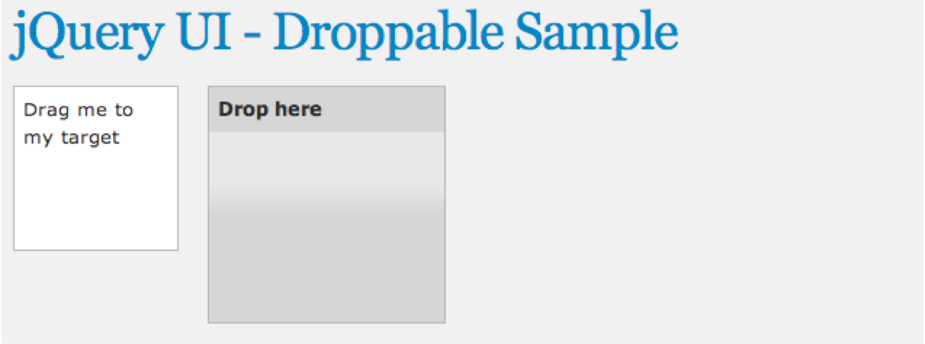
Figure 17–7. The droppable zone before dropping a draggable element inside
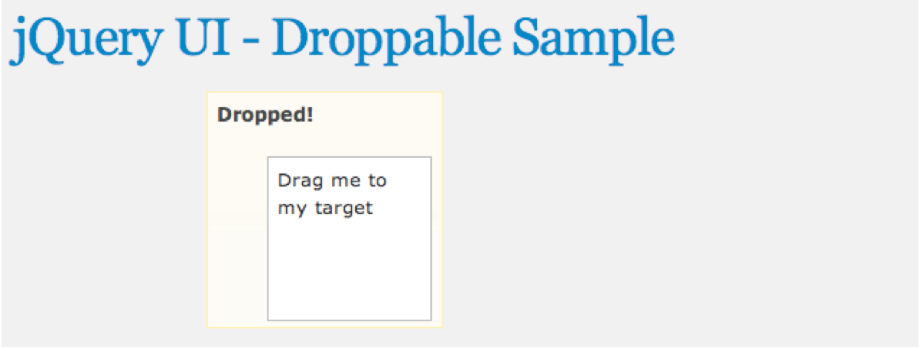
Figure 17–8. The droppable zone after dropping a draggable element inside
progressbar
There is usually a time in any web app when you need to indicate progress, so let’s see how. Here’s the PHP to include the progressbar library:
drupal_add_library('system', 'ui.progressbar);
Here’s the JavaScript to create your Drupal.behavior for the progressbar:
function dgd7progressbarUpdate(){
var progress;
progress = $("#progressbar").progressbar("value");
if (progress < 100) {
$(".progressbar").progressbar("value", progress + 5);
setTimeout(dgd7progressbarUpdate, 500);
}
}
Drupal.behaviors.dgd7progressbar = {
attach: function(context, settings) {
$(".progressbar").progressbar({ value: 1 });
setTimeout(dgd7progressbarUpdate, 500);
}
};
And here’s an HTML example for droppable, with the results in Figure 17–9:
<div class="progressbar"></div>
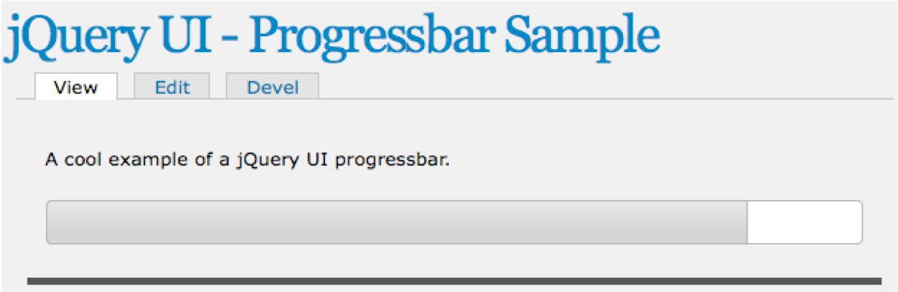
Figure 17–9. Progressbar in action
resizeable
The next example shows how to place a resizable element on the screen. Here’s the PHP to include the resizable library:
drupal_add_library('system', 'ui.resizable);
Here’s the JavaScript for creating your Drupal.behavior for the resizable element:
Drupal.behaviors.dgd7resizable = {
attach: function(context, settings) {
$('.resizable').resizable();
}
};
And here’s an HTML example for resizable element, the results of which can be seen in Figure 17–10:
<div class="resizable ui-widget-content">
<h3 class="ui-widget-header">Resizable</h3>
</div>
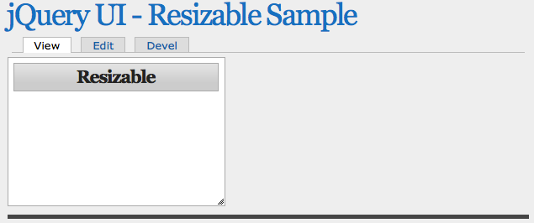
Figure 17–10. The resizable element

selectable
Web apps often need to gather user input, so you can use the selectable element instead of the usual list. Here’s the PHP to include the selectable library:
drupal_add_library('system', 'ui.selectable);
Here’s the JavaScript for creating your Drupal.behavior for the selectable element:
Drupal.behaviors.dgd7selectable = {
attach: function(context, settings) {
$('.selectable).selectable();
}
};
And here’s an HTML example for selectable element, the results of which can be seen in Figure 17–11:
<ol class="selectable">
<li class="ui-widget-content">Item 1</li>
<li class="ui-widget-content">Item 2</li>
<li class="ui-widget-content">Item 3</li>
<li class="ui-widget-content">Item 4</li>
<li class="ui-widget-content">Item 5</li>
<li class="ui-widget-content">Item 6</li>
<li class="ui-widget-content">Item 7</li>
</ol>
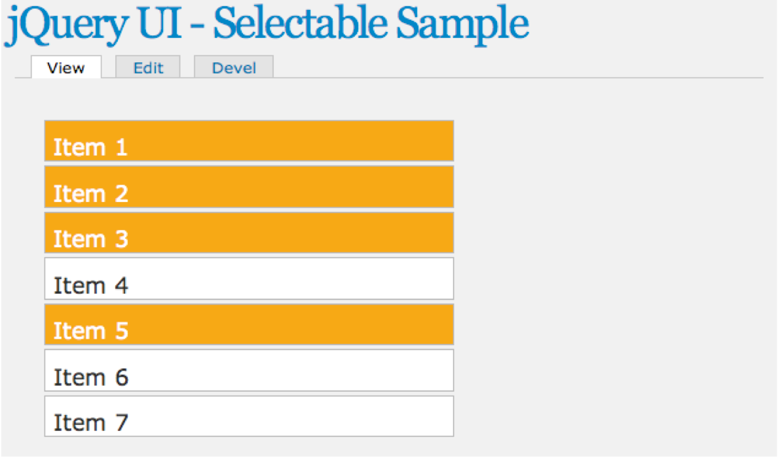
Figure 17–11. The selectable element
slider
The slider element adds a slider to the page so you can gather fine-grained values. This is the PHP to include the slider library:
drupal_add_library('system', 'ui.slider);
This is the JavaScript for creating your Drupal.behavior for the slider:
Drupal.behaviors.dgd7slider = {
attach: function(context, settings) {
$('.slider).slider();
}
};
And this is an HTML example for sortable element; you can see the results in Figure 17–12:
<div class="slider"></div>
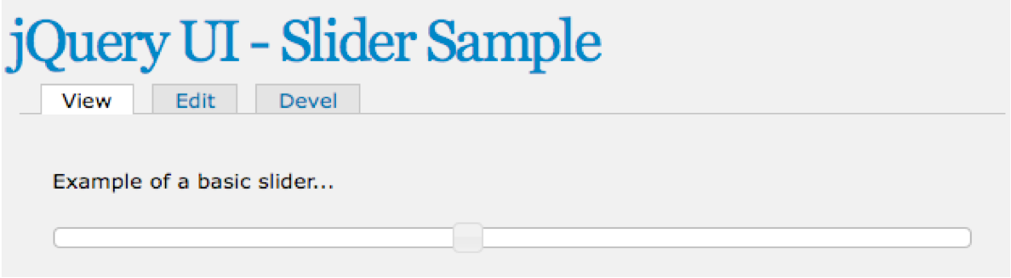
Figure 17–12. The slider element
sortable
When displaying lots of data to the user, it’s sensible to allow them to sort it. Use this PHP to include the sortable library:
drupal_add_library('system', 'ui.sortable);
This JavaScript will create your Drupal.behavior for the sortable element:
Drupal.behaviors.dgd7sortable = {
attach: function(context, settings) {
$('.sortable).sortable();
}
};
And this is an HTML example for sortable element, the results of which can be seen in Figure 17–13:
<ol class="sortable">
<liclass="ui-state-default"><spanclass="ui-iconui-icon-arrowthick-2-n-s"></span>Item1
</li>
<liclass="ui-state-default"><spanclass="ui-iconui-icon-arrowthick-2-n-s"></span>Item2
</li>
<liclass="ui-state-default"><spanclass="ui-iconui-icon-arrowthick-2-n-s"></span>Item3
</li>
<liclass="ui-state-default"><spanclass="ui-iconui-icon-arrowthick-2-n-s"></span>Item4
</li>
<liclass="ui-state-default"><spanclass="ui-iconui-icon-arrowthick-2-n-s"></span>Item5
</li>
<liclass="ui-state-default"><spanclass="ui-iconui-icon-arrowthick-2-n-s"></span>Item6</li>
<liclass="ui-state-default"><spanclass="ui-iconui-icon-arrowthick-2-n-s"></span>Item7
</li>
</ol>
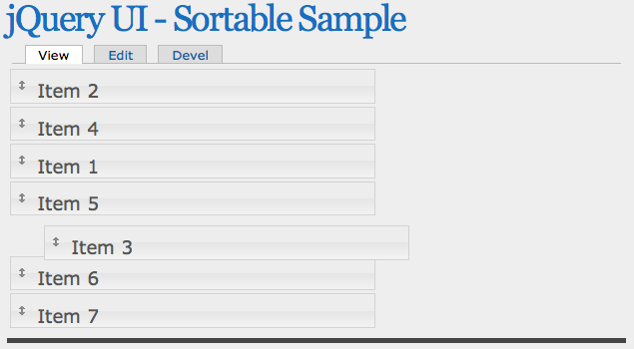
Figure 17–13. The sortable element
tabs
A cool way of implementing menus is to use tabs. The following is the PHP to include the tabs library:
drupal_add_library('system', 'ui.tabs);
The following is the JavaScript for creating your Drupal.behavior for the tabs:
Drupal.behaviors.dgd7tabs = {
attach: function(context, settings) {
$('.tabs).tabs();
}
};
The following is an HTML example for tabs; you can see the results in Figure 17–14:
<div class="tabs">
<ol>
<li><a href="#tabs-1">Nunc tincidunt</a></li>
<li><a href="#tabs-2">Proin dolor</a></li>
<li><a href="#tabs-3">Aenean lacinia</a></li>
</ol>
<div id="tabs-1">
<p>Lorem Ipsum Dolor Sit Amet…</p>
</div>
<div id="tabs-2">
<p>Lorem Ipsum Dolor Sit Amet…</p>
</div>
<div id="tabs-3">
<p>Lorem Ipsum Dolor Sit Amet…</p>
</div>
</div>
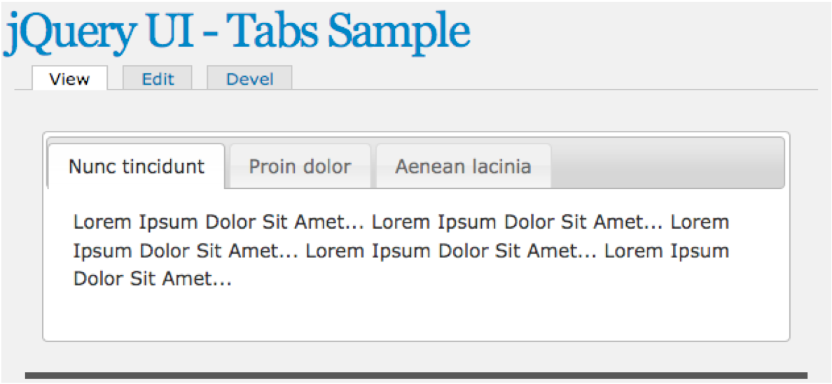
Figure 17–14. Tabs in action

jQuery UI Effects in Drupal core
In addition to the many widgets already described, there are several effects that can be used for animations and enhancements by simply including the appropriate library and then calling the appropriate effect in your jQuery animations. Try the following for yourself:
• blind
drupal_add_library('system', 'effects.blind');
• bounce
drupal_add_library('system', 'effects.bounce');
• clip
drupal_add_library('system', 'effects.clip');
• drop
drupal_add_library('system', 'effects.drop');
• explode
drupal_add_library('system', 'effects.explode');
• fade
drupal_add_library('system', 'effects.fade');
• fold
drupal_add_library('system', 'effects.fold');
• highlight
drupal_add_library('system', 'effects.highlight');
• pulsate
drupal_add_library('system', 'effects.pulsate');
• scale
drupal_add_library('system', 'effects.scale');
• shake
drupal_add_library('system', 'effects.shake');
• slide
drupal_add_library('system', 'effects.slide');
• transfer
drupal_add_library('system', 'effects.transfer');

Further jQuery Resources
When it comes to JavaScript and jQuery, there are countless resources available on the Internet and many resources available via drupal.org that will help answer your questions on implementing specific functionality. When searching for information on an issue or question you’re having, you may be surprised at how many times it has been answered for you on drupal.org.
• Drupal 7 JavaScript API Documentation: http://drupal.org/node/751744
• Documentation for jQuery JavaScript Library: http://docs.jQuery.com
• Resources for jQuery UI: http://jqueryui.com

Summary
Many popular web sites, including Facebook and Twitter, rely heavily on JavaScript interactions to enhance the usability of their web sites. Drupal 7 and the JavaScript framework have more than enough flexibility and power to accomplish anything you can imagine or have seen on any other site!
As demonstrated throughout this chapter, the JavaScript framework in Drupal 7 has added a wealth of functionality; it’s modified many of the ways our applications utilize the power of JavaScript and the jQuery library. The basic examples in this chapter should get you well on your way to providing powerful JavaScript enhancements to your already powerful Drupal 7 site.

第十七章 Jquery

由杰克·斯特朗从德米特里·加斯金输入
自从有了Drupal5，jQuery现在已经变成了Drupal必不可少的一部分。
许多办公区的界面使用jQuery来提升用户体验，Drupal 7也不例外，继续提高其中的开发者实施先进的JavaScript功能的能力。目前Drupal 7装载着jQuery以及装载着现在以jQueryUI（jqueryui.com 1.8）为核心提供先进的用户界面的元素/部件和效果。

jQuery 和 JavaScript的实现
第一部分将运用基本知识，让您将自己的自定义JavaScript/jQuery功能添加到您的Drupal 7项目中。
我要在基本包括在你的主题或模块的新的JavaScript文件中添加整个JavaScript库，重写已经包括在内的JavaScript或jQuery同时使用Drupal，并确保你的jQuery JavaScript会很好地为这些用户选择查看JavaScript的功能。

JavaScript
在采取各种不同的方式实现需求代码时，它可能将主题和模块开发者添加到JavaScript和jQuery的功能。第一个环节将各种方法和使用情况添加基本的JavaScript到您的网站。在某些情况下，你可能希望你的JavaScript代码添加到网站上的每一页；在其他情况下，如果可以满足一定的要求，它可能只需要包含在一个页面上。

在你的信息文件添加JavaScript
主题和模块有能力很容易在信息文件中包含JavaScript文件，如清单17–1和17–2。在相同的方式中，样式表可以使用样式表[all] = file.css，在JavaScript文件添加简单的脚本可以使用 scripts[] = file.js。
清单17–1，将一个带有主题的JavaScrip添加到一个文件中。
name = Gamma
description = Omega Sub-Theme starter kit
screenshot = screenshot.png
core = 7.x
base theme = omega
stylesheets[all][] = css/text.css
stylesheets[all][] = css/regions.css
stylesheets[all][] = css/gamma.css
stylesheets[all][] = css/dark.css
scripts[] = js/gamma.js
为了实现JavaScript的主题，任何脚本都包含这种自动加载的每个页面的方式。所以，如果你使用这个方法，当使用七作为行政主题你的JavaScript将不适用于你的站点的管理部分。
清单17–1有关于主题或模块的根路径gamma.js的位置。如此以来，这一主题信息文件/网站/所有/主题/γ/ gamma.info是可能的，你尝试加载这里的JavaScript将位于/网站/所有/主题/γ/ JS / gamma.js。
清单17–2，将一个带有模块的JavaScrip添加到一个文件中。
name = DGD7 Test Module
description = An example module
core = 7.x
files[] = dgd7_test.module
scripts[] = dgd7_test.js
添加模块中的JavaScript文件将确保文件是包含在每个页面加载的。

drupal_add_js()
主题也可以使用template.php drupal_add_js() 添加JavaScript文件。如果你只想要你的JavaScript被包含在一定的条件下，而不是在每一页上这是最好的方法。模块也采用drupal_add_js()包括任何对它产生的输出功能或相关介绍JavaScript文件。下面的例子是关于drupal_add_js()可以放置在你的主题或模块中，但记住，drupal_add_js()主题中声明只会出现在页面你的主题中。如果你需要一个JavaScript文件广泛地包括在每一页网站中，包括管理页面（可能操纵一个节点的形式），你将要在一个模块中使用drupal_add_js()或添加到JavaScript的模块信息文件（如上所述），它将出现在任何网页，即使主题被用来渲染页面。此功能的完整文档，可以发现在http://api.drupal.org/drupal_add_js上。
所以，从本地文件系统添加一个JavaScript文件，使用下面的代码：
drupal_add_js('misc/machine-name.js');
drupal_add_js(drupal_get_path(‘module’, 'example') . '/example.js');
drupal_add_js(drupal_get_path('theme, 'omega') . '/js/example.js');
作为一个单一的参数，Drupal假设是包括JavaScript是一种类型的文件。在第一行，使用相对路径的文件杂项/ machine-name.js是好的，因为machine-name.js，JavaScript包括处理创建系统名称（更换空间破折号或下划线，使所有文字小写等）对普通的文本输入，将这些都包括在Drupal核心是不太可能的。
然而，如果你是一个包括JavaScript文件，坐落在一个模块或主题的目录，最好的做法是使用drupal_get_path()正确找到的模块或主题的位置，然后把位置目录中的JavaScript文件存储。使用drupal_get_path()十分重要，因为如果以你在模块中使用的文件example.js为例，路径可以是任何数量的地点包括：
所有这些潜在的位置，有效的模块可以被存储、调用drupal_add_js(drupal_get_path('module', 'example') . '/example.js')；将确保example.js文件被加载，无论是哪里的模块存储。
在Drupal的以前的版本中，它是不可能添加JavaScript包括使用drupal_add_js()的远程服务器，但这是现在可以在Drupal 7中实现。这是添加JavaScript代码从其他地点很常见的需要如果您运行的是很多网站都需要相同的JS功能在您的网站的一个很好的方式。此前，必须创造性地与服务器上的符号链接到适当的地图相对路径的位置或通过管理相同的JavaScript的多个副本，包括下面的代码显示了它是多么容易现在添加一个远程JavaScript文件：
它也可以通过快速添加一行或两个内置的JavaScript（而不是创建一个完全new.js文件），添加页面直接实现代码。下面的代码展示了如何快速添加警报页面使用内联属性在drupal_add_js()：
此方法只能用于JavaScript不能从文件执行。添加内联代码，确保你没有依靠jQuery函数。jQuery命名空间将确保一个适当的JavaScript库中jQuery不冲突时使用（美元）。为了确保您的JavaScript / jQuery代码段是你希望使用的内联JavaScript时，可以包装你的代码（函数（$）{ $（'div”）.addClass（'page-div '）}）（jQuery）；。
注意，这个方法不仅仅通过“内联”作为第二个参数，进一步使用选项数组操纵如何将JavaScript被添加到页面。使用“范围”= >“页脚”设置，使Drupal渲染JavaScript在网页端page_bottom美元区域，使其出现在<体>。另外，告诉Drupal你会喜欢javascript是加权重一点比正常，确保如果其他项目在“页脚”范围内声明，这将使在同一个重量小于5的任何物品。

在drupal_add_js()中的重量和组
一对能将奇妙的新功能提供给drupal_add_js()的夫妇在Drupal 7的重量和组选项里面选择了美元。在过去，添加JavaScript同时使用此功能发生在以它为网页建设过程中的调用。
重量和组选项允许您订货的JavaScript包含任何您喜欢的方式；如果在生成页面的过程中一定条件已定，则你可以创建一个新的文件比如使用出现更早（甚至第一）在源阶的drupal_add_js()。在这个想法之后，你可以添加一个包含文件的早期，但绝对确保它是最后一个项目被包含在源代码中，并且能使重量更高。
在Drupal页面渲染JavaScript顺序应该遵循以下规则：
先按范围，先从“页头”，最后到“页脚”，然后由主题确定任何其他的范围的一个自定义的主题。
然后由组。
•然后由“every_page’标志，来判断“真”到来之前的“假”。
然后按重量。
•然后依次添加JavaScript。
例如，在其他所有条件相同时，JavaScript添加调用drupal_add_js()发生了页面请求并且被添加到页面后，drupal_add_js()发生在页面请求之前。

在drupal_add_js()中的重量的例子
通过重量，Drupal可以使JavaScript包括逻辑顺序。当早期的jQuery类库（jQuery JS）使其他文件可能依赖于其他的可用的类库，你也可以添加自己的JavaScript代码，因为你可能还需要其他很早的页面，或者其他可以建立的内联JavaScript。
下面的代码声明没有重量；项目被区分为范围，组，every_page标志，然后他们的顺序被称为：drupal_add_js('misc/machine-name.js');
在下面的代码中，设置为10的权重会将文件放在标题的默认范围内，并与该组关联：
drupal_add_js('misc/machine-name.js',
array('type' => 'file’, 'weight' => -10),
);
在下面的代码中，“尾”的范围将确保该文件被包含在文件结束时的< /主体>标记中：
drupal_add_js('misc/machine-name.js',
array('type' => 'file’, 'scope' => 'footer', 'weight' => 5),
);

在drupal_add_js()中的组的例子
除了简单的JavaScript添加权重，你现在也可以声明为默认组（参见清单17–3）。js_library包括核心Drupal，像drupal.js，jquery.js，和其他高水平的JavaScript文件。js_default默认是在JavaScript模块分组的。js_theme默认主题层将被包括在内。
有能力要去重组你的JavaScript文件是好的；在某些情况下，你可能需要一个包括通过你的主题的JavaScript文件被包括在一个与其他js_library功能水平很高的文件之中。
清单17–3，默认组：js_library，js_default（模块JS）和js_theme（主题JS）
drupal_add_js('misc/machine-name.js',
array('type' => 'file', 'scope' => 'header', 'weight' => -15, 'group' => JS_LIBRARY),
);
drupal_add_js('misc/machine-name.js',
array('type' => 'file', 'scope' => 'header', 'weight' => -15, 'group' => JS_DEFAULT),
);
drupal_add_js('misc/machine-name.js',
array('type' => 'file ', 'scope' => 'header', 'weight' => -15, 'group' => JS_THEME),
);
在清单17-3中声明了组中声明的顺序。
•js_library包括像jQuery核心库，需要首先声明为
对于其他文件和库使用它们。
•js_default是默认值时使用的模块层drupal_add_js()。
•js_theme是默认使用时在主题层drupal_add_js()
（模板文件）。
使用drupal_add_js()，会有许多其他有效的关于跳级、分组、排序、缓存/聚合的选项。你可以在 http://api.drupal.org/drupal_add_js 上找到关于drupal_add_js()API页面的详情。

JavaScript库
这些日子以来使用的复兴回避了一个问题是“这件事需要关闭Internet Explorer，”JavaScript和它的许多功能强大的图书馆是现在常见的每天依赖的网站一个巨大的比例。Facebook，Twitter，NY Times，甚至Drupal.org所述网站都严重依赖于JavaScript库为你提供增强的功能和简洁的界面。
jQuery是一个跨浏览器的JavaScript库，在字面上有成千上万的图书馆里。不是所有的JavaScript库都像jQuery那样复杂，但它们有一个共同点是他们努力提供一定水平的功能和保持您的网页的交互性。
jQuery是一个库，已经默认包含在Drupal中总是可用的。本节将讨论如何为您的网站或模块可以添加其他的JavaScript库。

hook_library()
在你的站点上添加或定义一个自定义的JavaScript库的时候，你会学习第一个Drupal的功能是hook_library()。作为一个库，可以添加一个库简单地实现你自己的自定义代码，或者包含一个已经可以从网络中获得的库。hook_library()寄存器的JavaScript和CSS与你相关的模块库。这个hook总是位于你的custom.module文件或适当的模块文件中。
要真正了解基本的知识，你可以在http://api.drupal.org/hook_library的文档中查看,每个库的定义包含以下项目：
题目：图书馆的人可读的名字
网站：图书馆网站的网址
版本：一个指定库版本的字符串
•JS：JavaScript数组元素
•路径的JavaScript文件= > array()
•CSS CSS元素的数组
•路径= > array() CSS文件
·类型=文件/外部/等。
媒体=屏幕/打印/所有
•看到drupal_add_css()类型和媒体选择
-依赖关系：这个库取决于该库的数组
•采用drupal_add_library()格式，它将被定义在下一段包括定义的JavaScript库中
清单17–4演示了hook_library()的基本要素，你将看到如何迅速添加一个强大的库到你的模块，从简单的功能到全面的界面检查实施，取决于你的代码库包括和它如何才能实现。
清单17–4，hook_library()的基本要素
清单17–5定义了你的图书馆的两个JavaScript文件（js-file-one.js和JS文件的两个js）和一个CSS文件（CSS文件，CSS），并说明你的图书馆没有默认的jQuery UI的核心，并且完成图书馆的系统模块提供的功能，你可以看到，实际上实施一个新的图书馆很容易使用hook_library()。这个过程的实际劳动得到了你的JavaScript代码（假设它是自定义）。图书馆的实际定义和包含是非常简单的。

drupal_add_library()
现在，您已经定义了自定义库，您可以快速地以各种方式将它添加到您的网站中。我会在这里列出几个例子，但也有很多种方法可以包含你的库，并在特定的位置去调用它。
在过去，包括提供某些功能需要很多电话包括drupal_add_js()和drupal_add_css()必要的JavaScript和CSS。现在，使用hook_library()前面的例子，你可以快速的加载所有的JavaScript，CSS，它可能取决于利用一个电话和drupal_add_library()其他的库，如清单17所示–6。
清单17—6。比较包括在Drupal 6和Drupal 7中的图书馆
Drupal 6
// add required dependencies
drupal_add_js('misc/autocomplete.js');
// add relevant JS files
drupal_add_js(drupal_get_path('module', 'mymodule') . '/file1.js');
drupal_add_js(drupal_get_path('module', 'mymodule') . '/file2.js');
// add relevant CSS files
drupal_add_css(drupal_get_path('module', 'mymodule') . '/file1.css');
drupal_add_css(drupal_get_path('module', 'mymodule') . '/file2.css');
Drupal 7
// add my library and all its dependencies
drupal_add_library('mymodule', 'mylibrary', TRUE);
drupal_add_library()函数需要三个参数：模块名（$模块名称），图书馆（$name），和一个布尔标志（$ every_page）其中包含定义是否被包含在每一页。如果标志设置为false，图书馆的JavaScript和CSS就不能聚集，这是Drupal如何将多个缓存js/css文件变为一个文件并且在页面加载，所以如果可能的话，最好设置为true。小学的时候every_page美元标志将设置为false将一个模块或执行的JavaScript库，只需要在一个单一的形式或在一个单页。
在工作所需的Drupal 6和Drupal 7之间的差异是巨大的，因为你可以看到
清单17—7，而不是声明长的文件清单，包括你的适当的JavaScript、CSS和需要的依赖，现在你可以定义你的需求hook_library()来告诉Drupal，你有多少的JavaScript文件，CSS文件Y，和Z的依赖，Drupal应该包括前添加你的文件。drupal_add_library()有true或false的返回值。它将返回真实的函数，如果一个项目没有被发现或加载，该函数返回适当的所有文件和依赖关系。

使用 JavaScript
你已经学会了如何通过JavaScript实现标准电话drupal_add_js()，如何在同一时间使用drupal_add_library()来添加整个图书馆，以及如何使用hook_library()实现你自己的图书馆，但乐趣还远远没有结束。你现在有能力，在别处看到Drupal API，去改变那些元素输出到页面。这允许你操作的JavaScript文件被包含或通过自己的模块完全改变了对一个图书馆的定义。

hook_js_alter()
在Drupal的以前的版本中，修改脚本输出到页面是很繁琐的，缺乏一定程度上的简洁。jQuery更新模块使用一个方法来扫描变量['scripts'] 在hook_preprocess_page()上寻找其他事物来代替，成为新的替代品，然后替换成原件。它的工作，就是更好地处理一个相当混乱的解决方案，并且解决其中的问题。
在Drupal 7中，现在有非常有用的hook_js_alter()功能。这很容易了解熟悉hook_form_alter()、hook_menu_alter()等。hook_js_alter()功能可在主题和模块层之中使用，这样你就可以在你的mymodule_js_alter()功能模块文件或mytheme_js_alter() template.php文件为你的主题提供服务。使用hook_js_alter()功能时，你会这样开始：
function mymodule_js_alter(&$JavaScript) {
$search = drupal_get_path('module', 'some_module') . '/some-file.js';
if(array_key_exists($search)) {
// reset the weight for this item, making it appear higher in the source
$JavaScript[$search]['weight'] = -100;
}
}
改变一个JavaScript的重量已经包括了如图所示那样简单的流程。考虑到这一点，你可以很容易地替换所有的设置并且设置一个JavaScript文件甚至取代这个文件本身。你也可以设置任何属性，你在本章中学到的关于drupal_add_js()的知识是在方便的时候可以使用。例如，你想更换一个版本的jQuery的核心，包括一个新版本，不是包装Drupal的核心。你可以简单地使用你的模块或主题hook_js_alter()和你的一个选择jquery.js文件替换原有的默认的文件。
下面的代码示例显示改变的toolbar.js文件的重量，这是由Drupal 7模块提供的工具栏。如果其他JavaScript是相互矛盾的，这需要使用在页面源代码之前，它可以很容易完成这个。注意，这适用于包括在Drupal之内的任何JavaScript。
function mymodule_js_alter(&$JavaScript) {
$search = drupal_get_path('module', 'toolbar') . '/toolbar.js';
if(array_key_exists($search)) {
$JavaScript[$search]['weight'] = -100;
}
}

hook_library_alter()
Listing 17–7. Replacing the JavaScript File Defined by hook_library()
现在，您已经了解了如何改变个人的JavaScript文件，本节将说明如何操作定义的hook_library()并且利用hook_library_alter()去改变整个JavaScript库。
API文档（http://api.drupal.org/hook_library_alter）提供了使用一个很好的例子。在清单17–7中定义了hook_library()版本号小于2的JavaScript文件的代码。
清单17–7，更换由hook_library()定义的 JavaScript文件
function hook_library_alter(&$libraries, $module) {
// Update Farbtastic to version 2.0.
if ($module == 'system' && isset($libraries['farbtastic'])) {
// Verify existing version is older than the one we are updating to.
if (version_compare($libraries['farbtastic']['version'], '2.0', '<')) {
// Update the existing Farbtastic to version 2.0.
$libraries['farbtastic']['version'] = '2.0';
$libraries['farbtastic']['js'] = array(
drupal_get_path('module', 'farbtastic_update') . '/farbtastic-2.0.js' => array(),
);
}
}
}
清单17–7演示了两个参数hook_library_alter()，这为图书馆和一系列包括图书馆键与图书馆的系统名被hook_library()所宣布并且包含模块，该模块实现了图书馆的名字。这个模块的使用所有人都应该谨慎，或者至少一个严厉的警告。如果你要更新一个图书馆如jQuery或farbtastic版本（在清单17–7中），它可能是可能的，另一个模块可以依赖于相同的图书馆或者依赖于一个特定的版本，那么你的更新可能产生不利的影响，并且影响其他事项在您的网站的功能。
也就是说，有很多的可能性，甚至很多人实现了hook_library()，hook_library_alter()除了核心贡献者，还包括hook_js_alter()，不可能认为在实施的时候找到Drupal 7的核心。不管怎样，在这个新的Drupal模块开发中，其中的一个更强大的方法来添加和使用JavaScript/jQuery功能项目。

Drupal 行为
Drupal的行为提供了巨大的利益，使JavaScript和jQuery变得简单得多，并且增加到了你的模块。drupal.behaviors是Drupal对象的属性，你可以看到：
var Drupal = Drupal || { 'settings': {}, 'behaviors': {}, 'locale': {} };
在Drupal 7中，JavaScript的行为现在有了两个方法：附加和分离对象。

附加行为
并不是使用传统的附加行为 $(document).ready(); 而是确保你的代码的方法是在DOM加载所有对象被解雇，你会定义你的jQuery代码使用行为的Drupal，可以让你的代码正确与页面进行初始加载。它在处理的情况时，Ajax或其他方法添加对象到DOM的时候，把你的行为给新对象在DOM通过调用attachbehaviors() Drupal。在drupal.js定义中，任何属性添加到drupal.behaviors对象将自动调用drupal.attachbehaviors时，如下所示：
Drupal.attachBehaviors = function (context, settings) {
context = context || document;
settings = settings || Drupal.settings;
// Execute all of them.
$.each(Drupal.behaviors, function () {
if ($.isFunction(this.attach)) {
this.attach(context, settings);
}
});
};
下一个方法的工作原理是当页面加载时，添加一个新的CSS类（自定义CssClass）任何H3元素在网页上使用$(document).ready()。这是在大多数情况下，但这只会影响到H3加载被叫到drupal.attachbehaviorsDOM元素在页面第一次加载时。
$(document).ready(function(){
// act on all h3 elements and give them a custom class
$('h3').addClass('custom-css-class');
});
下面的代码演示了Drupal 7正确的使用方法，并且使用drupal.behaviors附加方法来定义您的自定义代码。现在，attachbehaviors()适用于任何新的元素添加到DOM和Drupal，并且你的代码将适用于新的元素。
Drupal.behaviors.myModuleHeaders = {
attach: function(context, settings) {
// act on all h3 elements and give them a custom class
$('h3').addClass('custom-css-class');
}
};

Detaching Behaviors
新的Drupal 7是采用drupal.detachbehaviors的方法。这在以前的版本中，是没有办法消除附以drupal.attachbehaviors的行为。当你的JavaScript代码是依附于元素的时候这可能是有用的，而且不坚持一个页面到另一个页面加载。这方面的一个例子就是一个WYSIWYG编辑器在加载一个模态窗口，允许编辑或保存新的内容；在提交时，模态窗口关闭，留下额外的行为在DOM，不再相关。
在模块的行为中提供一个分离方法是可选的。由于还没有很多例子去证明分离方法会使模块/文件使用异常。第49行显示的安装和拆卸行为，添加上传文件的链接：
/**
* Attach behaviors to links within managed file elements.
*/
Drupal.behaviors.filePreviewLinks = {
attach: function (context) {
$('div.form-managed-file .file a, .file-widget .file a',
context).bind('click',Drupal.file.openInNewWindow);
},
detach: function (context){
$('div.form-managed-file .file a, .file-widget .file a', context).unbind('click',
Drupal.file.openInNewWindow);
}
};

Degrading JavaScript/jQuery Nicely
问题是JavaScript/jQuery在您的Web应用程序的功能是当用户由于各种原因（偏好、残疾等）已禁用javascript的浏览器。当用户被告知要安全关闭浏览器中的JavaScript已经很长时间过去了。事实上，大多数人每天访问我们的网站时，在很大程度上依赖于JavaScript、jQuery和类似的库的使用。所以问题不是那些真正选择关闭这些功能的人，而是那些没有选择的用户在第一个地方查看他们。
更常见的原因是因为用户禁用了JavaScript，失明或视力受损的用户依赖于屏幕阅读器访问互联网内容，而网站访问者使用屏幕阅读器的技术应该与网站作为同一个用户，是不是弱视互动相同的能力的行为。对于我们很多人来说，这种类型的可访问性测试可以是艰难的，但也有持续的推动在Drupal中以确保一切（核心和贡献代码）尽可能的方便，使许多视障者在Drupal乃至整个社会变得更加了解和体谅这些问题。
这一切的关键是在设计用户界面和交互功能时没有启用JavaScript，并且当启用JavaScript时，你的功能就增强了。
Drupal核心很容易没有启用JavaScript，那些大大提高我们的JavaScript功能。有一个很好的例子，这在Drupal核心中可以看到权重属性，你可以拖放排序菜单项（见图17–1）。同样的方法应用在Drupal分类术语权重，块位置的一个区域内，现场订货的内容类型包括许多更多的领域。
作为一个简单的规则，最好的做法是确保你的JavaScript功能完好，并将这些没有JavaScript的能力的用户建立在你的JavaScript功能中，保证在工程中的应用没有JavaScript（见图17–2）。
图17–1.JavaScript菜单链接功能，使用tabledrag为菜单项重新排序
图17–2.禁用javascript链接使用的标准菜单，将选择菜单选项中的菜单项重新排序

jQuery UI
jQuery IU（http://jqueryui.com）提供低层次的相互作用和先进的影响。这些是新兴的在线jQuery JavaScript库的顶部，你可以使用交互式Web应用的高度相关。

jQuery UI in Drupal Core
在Drupal 5和Drupal 6中，为了便于包括jQuery UI在内的交互，你需要对Drupal jQuery UI模块的帮助(http://drupal.org/project/jquery_ui)。在Drupal 7中，jQuery UI 1.7包括在核心之中，增强界面容易访问的模块和主题时开发者没有额外的模块或手动执行在您的网站/项目的jQuery UI代码的需要。
为了启动实施jQuery UI的功能，请参阅本章前面讨论drupal_add_library()功能。你能够迅速了解包括jQuery UI在内的需要开始建立你的增强相关条件。

jQuery UI Elements in Drupal Core
本节中的例子是直接取自www.jqueryui.com的文档。在Drupal 7中实现添加相应的PHP代码，声明的功能适当通过drupal.behaviors的JavaScript。进一步的例子和使用可以在jQuery UI文件发现。
Accordion
让我们从accordion开始。以下是PHP包括accordion的图书馆：
drupal_add_library('system', 'ui.accordion');
以下是创建你的drupal.behavior实施accordion的JavaScript：
Drupal.behaviors.myModuleAccordions = {
attach: function(context, settings) {
// add accordions to all h3 elements wrapped in a div with a class of accordion
$('.accordion').accordion();
}
};
最后，以下是accordion的HTML例子（如图17–3所示）：
<div class="accordion">
<h3><a href="#">Header 1</a></h3>
<div><p>Lorem Ipsum dolor sit amet. Lorem Ipsum dolor sit amet</p></div>
<h3><a href="#">Header 2</a></h3>
<div><p>Lorem Ipsum dolor sit amet. Lorem Ipsum dolor sit amet</p></div>
<h3><a href="#">Header 3</a></h3>
<div><p>Lorem Ipsum dolor sit amet. Lorem Ipsum dolor sit amet</p></div>
</div>
Figure 17–3.可变换的动作
datepicker
现在让我们看看什么控件。以下是PHP包括Datepickerlibrary:
drupal_add_library('system', 'ui.datepicker');
以下是创建你的drupal.behavior时实施的Datepicker JavaScript：
Drupal.behaviors.myModuleDatepicker = {
attach: function(context, settings) {
// add the jQuery UI datepicker to all inputs with a class of datepicker
$('.datepicker').datepicker();
}
};
下面的代码是一个Datepicker的HTML例子。你可以看到在图17–4中的结果。
<p><labelfor="custom-datepicker">Date:</label>
<input id="custom-datepicker"class="datepicker" type="text"></p>
Figure 17–4. Datepicker在行动
dialog
下一步是对话。以下是PHP包括对话框库：
drupal_add_library（系统'，'用户界面。对话框）；
以下是创建你的drupal.behavior实现对话框的JavaScript：
Drupal.behaviors.myModuleDialog = {
attach: function(context, settings) {
// add the jQuery UI dialog to all elements with id of dialog
$('.dialog).dialog();
}
};
以下是关于对话的一个HTML的例子，其结果如图17–5所示：
<div class="dialog" title="Basic dialog">
<p>This is the default dialog which is useful for displaying information. The dialog windowcan be moved, resized and closed with the 'x' icon.</p>
</div>
Figure 17–5. 对话框在行动
draggable
下面的例子是一个可拖动的，你可以在屏幕上拖动。这是PHP包括
可拖动的图书馆：
drupal_add_library('system', 'ui.dialog);
这是为可拖动元素创建你的drupal.behavior JavaScript：
Drupal.behaviors.myModuleDraggable = {
attach: function(context, settings) {
// make all elements with a class of draggable, well… draggable…
$('.draggable).draggable();
}
};
这是一个HTML的例子可拖动的；你可以在图17–6看到结果：
<div class="draggable ui-widget-content">
<p>Drag me around</p>
</div>
Figure 17–6. 在拖动元素上行动
droppable
什么是不可删除的拖动？以下是PHP包括可拖放的图书馆：
drupal_add_library('system', 'ui.dialog);
以下是为可删除的元素创建你的drupal.behavior JavaScript：
Drupal.behaviors.myModuleDroppable = {
attach: function(context, settings) {
// make all elements with an id of droppable, well… droppable…
$( ".droppable" ).droppable({
drop: function( event, ui ) {
$( this )
.addClass( "ui-state-highlight" )
.find( "p" )
.html( "Dropped!" );
}
});
}
};
下面的代码是可删除的HTML例子。图17–7和17–8显示之前和之后的空投行动。
<div class="draggable ui-widget-content">
<p>Drag me to my target</p>
</div>
<div class="droppable ui-widget-header">
<p>Drop here</p>
</div>
图17–7.放下拖动元素在投掷区
图17–8. 落在投掷区的拖动元素
progressbar
通常是在任何网络的应用程序，当你需要显示进展的时间时，所以让我们看看如何。这里是PHP包括了图书馆：
drupal_add_library('system', 'ui.progressbar);
这里的JavaScript来创建你的drupal.behavior ProgressBar：
function dgd7progressbarUpdate(){
var progress;
progress = $("#progressbar").progressbar("value");
if (progress < 100) {
$(".progressbar").progressbar("value", progress + 5);
setTimeout(dgd7progressbarUpdate, 500);
}
}
Drupal.behaviors.dgd7progressbar = {
attach: function(context, settings) {
$(".progressbar").progressbar({ value: 1 });
setTimeout(dgd7progressbarUpdate, 500);
}
};
这是可删除的HTML的例子，图17–9中的结果：
<div class="progressbar"></div>
Figure 17–9. 进度条在行动
resizeable
下面的例子显示在屏幕上如何放置一个可调整大小的元素。这里是PHP包括可调整大小的图书馆：
drupal_add_library('system', 'ui.resizable);
这里是为可调整大小的元素来创建你的drupal.behavior JavaScript：
Drupal.behaviors.dgd7resizable = {
attach: function(context, settings) {
$('.resizable').resizable();
}
};
这是可调整大小的元素的HTML的例子，其结果在图17–10中可以看到：
<div class="resizable ui-widget-content">
<h3 class="ui-widget-header">Resizable</h3>
</div>
Figure 17–10. 可调整大小的元素

selectable
网络应用程序通常需要收集用户的输入信息，所以你可以使用可选的元素来代替通常的列表。这里是PHP包括可选的图书馆：
drupal_add_library('system', 'ui.selectable);
这里是为可选的元素创建你的drupal.behavior JavaScript：
Drupal.behaviors.dgd7selectable = {
attach: function(context, settings) {
$('.selectable).selectable();
}
};
这是可选的元素的HTML的例子，其结果在图17–11中可以看到：
<ol class="selectable">
<li class="ui-widget-content">Item 1</li>
<li class="ui-widget-content">Item 2</li>
<li class="ui-widget-content">Item 3</li>
<li class="ui-widget-content">Item 4</li>
<li class="ui-widget-content">Item 5</li>
<li class="ui-widget-content">Item 6</li>
<li class="ui-widget-content">Item 7</li>
</ol>
Figure 17–11. 可选元素
slider
滑块元素增加了一个滑块到页面，这样你就可以收集细粒度的值。这是PHP包括滑块图书馆：
drupal_add_library('system', 'ui.slider);
这是因为滑块创建你的drupal.behavior JavaScript：
Drupal.behaviors.dgd7slider = {
attach: function(context, settings) {
$('.slider).slider();
}
};
这是排序的元素HTML的例子；你可以在图17–12看到结果：
<div class="slider"></div>
Figure 17–12. 滑块元件
sortable
当向用户显示大量的数据时，它允许他们进行排序是明智的。使用PHP包括分类库：
drupal_add_library('system', 'ui.sortable);
这个JavaScript将为可排序的元素创建你的drupal.behavior：
Drupal.behaviors.dgd7sortable = {
attach: function(context, settings) {
$('.sortable).sortable();
}
};
这是排序的元素HTML的例子，其结果在图17–13中可以看到：
<ol class="sortable">
<liclass="ui-state-default"><spanclass="ui-iconui-icon-arrowthick-2-n-s"></span>Item1
</li>
<liclass="ui-state-default"><spanclass="ui-iconui-icon-arrowthick-2-n-s"></span>Item2
</li>
<liclass="ui-state-default"><spanclass="ui-iconui-icon-arrowthick-2-n-s"></span>Item3
</li>
<liclass="ui-state-default"><spanclass="ui-iconui-icon-arrowthick-2-n-s"></span>Item4
</li>
<liclass="ui-state-default"><spanclass="ui-iconui-icon-arrowthick-2-n-s"></span>Item5
</li>
<liclass="ui-state-default"><spanclass="ui-iconui-icon-arrowthick-2-n-s"></span>Item6</li>
<liclass="ui-state-default"><spanclass="ui-iconui-icon-arrowthick-2-n-s"></span>Item7
</li>
</ol>
Figure 17–13. 可排序的元素
tabs
一种很酷的实现菜单的方法是使用标签。以下是PHP包括标签库：
drupal_add_library('system', 'ui.tabs);
以下是为标签创建你的drupal.behavior JavaScript：
Drupal.behaviors.dgd7tabs = {
attach: function(context, settings) {
$('.tabs).tabs();
}
};
以下是标签HTML的例子；你可以在图17–14看到结果：
<div class="tabs">
<ol>
<li><a href="#tabs-1">Nunc tincidunt</a></li>
<li><a href="#tabs-2">Proin dolor</a></li>
<li><a href="#tabs-3">Aenean lacinia</a></li>
</ol>
<div id="tabs-1">
<p>Lorem Ipsum Dolor Sit Amet…</p>
</div>
<div id="tabs-2">
<p>Lorem Ipsum Dolor Sit Amet…</p>
</div>
<div id="tabs-3">
<p>Lorem Ipsum Dolor Sit Amet…</p>
</div>
</div>
Figure 17–14. 动作片

在Drupal核心中的jQuery UI效果
除了已经描述的许多部件外，还有一些动画可以用于增强效果，通过简单的包括适当的库，然后调用你的jQuery的动画增强适当的效果。尝试以下行为：
• blind
drupal_add_library('system', 'effects.blind');
• bounce
drupal_add_library('system', 'effects.bounce');
• clip
drupal_add_library('system', 'effects.clip');
• drop
drupal_add_library('system', 'effects.drop');
• explode
drupal_add_library('system', 'effects.explode');
• fade
drupal_add_library('system', 'effects.fade');
• fold
drupal_add_library('system', 'effects.fold');
• highlight
drupal_add_library('system', 'effects.highlight');
• pulsate
drupal_add_library('system', 'effects.pulsate');
• scale
drupal_add_library('system', 'effects.scale');
• shake
drupal_add_library('system', 'effects.shake');
• slide
drupal_add_library('system', 'effects.slide');
• transfer
drupal_add_library('system', 'effects.transfer');

进一步的jQuery资源
说到JavaScript和jQuery，有许多在网络和其他地方可用的资源，这将有助于回答通过Drupal.org所述实现特定功能的问题。在搜索信息时对一个问题有疑问可多次在Drupal.org进行回答。
• Drupal 7 JavaScript API Documentation: http://drupal.org/node/751744
• Documentation for jQuery JavaScript Library: http://docs.jQuery.com
• Resources for jQuery UI: http://jqueryui.com

总结
许多受欢迎的网站，包括Facebook和推特，很大程度上依赖于JavaScript的相互作用来改善其网站的可用性。Drupal 7和JavaScript的框架有足够多的灵活性和力量去完成任何你能想象或任何其他网站上看到的！
正如本章中，在Drupal 7的JavaScript框架中增加了财富功能。改变它的属性的方法有很多，我们的应用程序可以使用JavaScript和jQuery库的力量。在这一章的基本例子中应该让你使用你的方式实现Drupal 7网站提供强大的JavaScript功能。

