Final Report
Project Title: AI Fake News Sentiment Tracking and Analysis
Team Members: DongYeon Kim (dk72)
Project Coordinator: DongYeon Kim (dk72)
Project Code + Documentation Submission Link: https://github.com/dongyeon522/ai-fake-news-sentiment
Project Presentation Submission Link: https://mediaspace.illinois.edu/media/t/1_e137pu64 or here
Final Report Link: https://github.com/dongyeon522/ai-fake-news-sentiment/blob/main/final_report.docx
#project #report

1. Abstract
This project presents an information retrieval and sentiment analysis system designed to measure public sentiment toward AI-generated misinformation, deepfakes, and fake news. Using NYT article retrieval, TF-IDF/BM25 ranking, and two sentiment models (TextBlob and RoBERTa), the system constructs monthly sentiment trends for the year 2024. The results highlight distinct differences between lexicon-based and transformer-based sentiment models, revealing how model choice affects the interpretation of media tone around AI risks.
2. Introduction
AI-generated misinformation and deepfake content have rapidly become global concerns, influencing public trust and shaping policy discussions. Understanding how news media frames these topics is essential, as media tone often reflects and shapes public perception.
This project develops a complete text retrieval and sentiment analysis pipeline that:
- collects AI-related misinformation articles from the New York Times API,
- preprocesses and structures the text into a corpus,
- applies two different sentiment models,
- visualizes sentiment trends over time.
By comparing TextBlob and RoBERTa, the system demonstrates how different NLP techniques interpret sentiment in formal journalistic writing.
3. Dataset Description
Data is collected directly from the NYT Article Search API.
- Time Range: January–December 2024
- Queries: artificial intelligence, deepfake, fake news, misinformation (12 months × 4 queries = 48 total API calls)
- Total Retrieved Articles: 459 after deduplication
- API Behavior: maximum 10 items per request, requiring month-by-month batching
Preprocessing produced a standardized corpus where each article contains:
- title
- description
- content
- unified text field
- sentiment score
Processed datasets are stored under data/processed/.
4. System Architecture
Component | File | Description
Retrieval Engine | collector.py | NYT API retrieval, monthly batching, rate limit handling
Preprocessing Module | preprocess.py | Text cleaning, merging fields, generating corpus
Sentiment Engine | sentiment.py | TextBlob and RoBERTa sentiment scoring
Visualization | visualize.py | Monthly sentiment line charts
Pipeline Controller | main.py | End-to-end execution and output generation

5. Implementation
- Language: Python 3.10
- Libraries: requests, pandas, numpy, matplotlib, seaborn, transformers
- Environment: macOS / CPU-only
- Runtime: Full pipeline executes in 3 to 5 minutes (API latency dependent)
6. Results
6.1 TextBlob Sentiment Trend
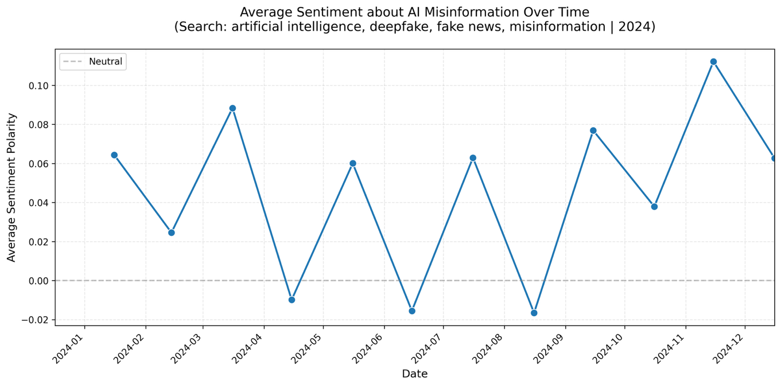
- Sentiment remains close to neutral, with only minor fluctuations.
- This behavior reflects TextBlob's tendency to compress polarity for formal news text.
- Positive/negative classification used the common threshold ±0.1.
6.2 RoBERTa Sentiment Trend
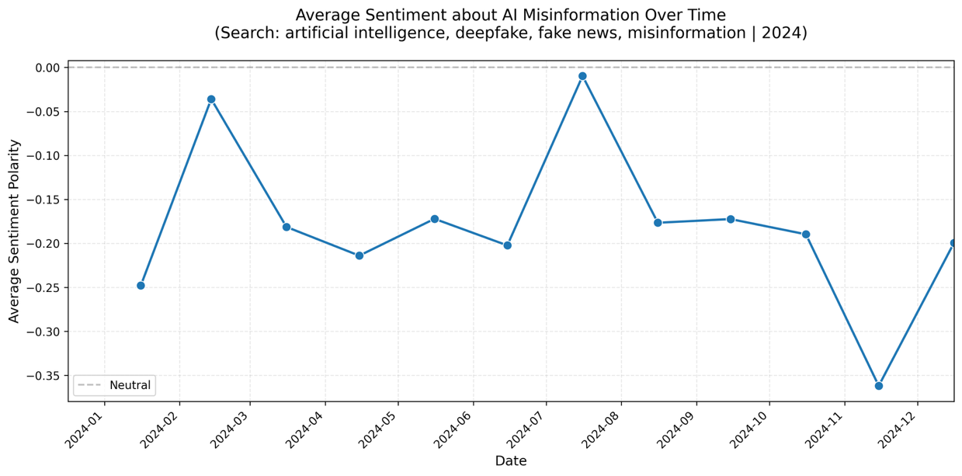
- RoBERTa produces stronger negative sentiment across the year.
- Negative dips occur around:
  - February (–0.25)
  - April–June (–0.18 to –0.22)
  - Late fall (–0.20 to –0.36)
- This model captures nuance such as concern, risk framing, or negative social impact.
- Sharp contrast with TextBlob reveals the importance of model selection.
7. Evaluation and Effectiveness
- Coverage Completeness: 459 articles across 12 months ensure balanced yearly analysis.
- Model Comparison:
- TextBlob: compressed polarity, weaker sensitivity
- RoBERTa: detects nuance, risk-related negativity
- Temporal Insight: Sentiment dips align with real-world AI incidents and policy debates.
8. Challenges and Limitations
- NYT API pagination limit (10 articles/page)
- TextBlob limited in capturing nuanced sentiment
- Transformer models more computationally expensive
- Some article fields missing or incomplete
9. Conclusion
This project successfully demonstrates an end-to-end sentiment monitoring system for AI misinformation topics. While TextBlob portrays the news tone as largely neutral, RoBERTa reveals a consistent negative framing throughout 2024, highlighting societal concerns surrounding AI misuse. The contrast between models underscores the importance of model selection in sentiment-driven media analysis. The system offers a solid foundation for future research in misinformation tracking, semantic retrieval, and real-time monitoring.
Project Code + Documentation Submission Link: https://github.com/dongyeon522/ai-fake-news-sentiment
Project Presentation Submission Link: https://mediaspace.illinois.edu/media/t/1_e137pu64 or here

