乌云知识库

<https://www.madebug.net/>

渗透测试面试题

<https://mp.weixin.qq.com/s/UWPvWJ4FGHQg7Zlcb3UR6Q>

2020护网红方漏洞利用总结（一）

<https://mp.weixin.qq.com/s/wallzqYYCn7khAbxtATpaA>

SRC漏洞挖掘经验+技巧篇

<https://mp.weixin.qq.com/s?__biz=MzI5MDU1NDk2MA==&mid=2247485949&idx=1&sn=3f08c681660acecc0bbe996619df66ed&chksm=ec1f5cc2db68d5d4782eec77fa36ad329815f0b70ff34c3c0a893e3b107d2c262e8b37e85d2a&xtrack=1&scene=0&subscene=131&clicktime=1552380844&ascene=7&devicetype=android-25&version=2700033b&nettype=cmnet&abtest_cookie=BAABAAoACwASABMABQAjlx4AWpkeAMOZHgDamR4A3JkeAAAA&lang=zh_CN&pass_ticket=o4Xs2Q3MafQUYRBnf+T0ECqSZcosHcfvdk/YBfhvUhIUqaABlg968HddUo7QwBpM&wx_header=1>

[BadDNS](https://github.com/joinsec/BadDNS)子域名探测工具

<https://github.com/joinsec/BadDNS>

专项训练靶场

Sql注入

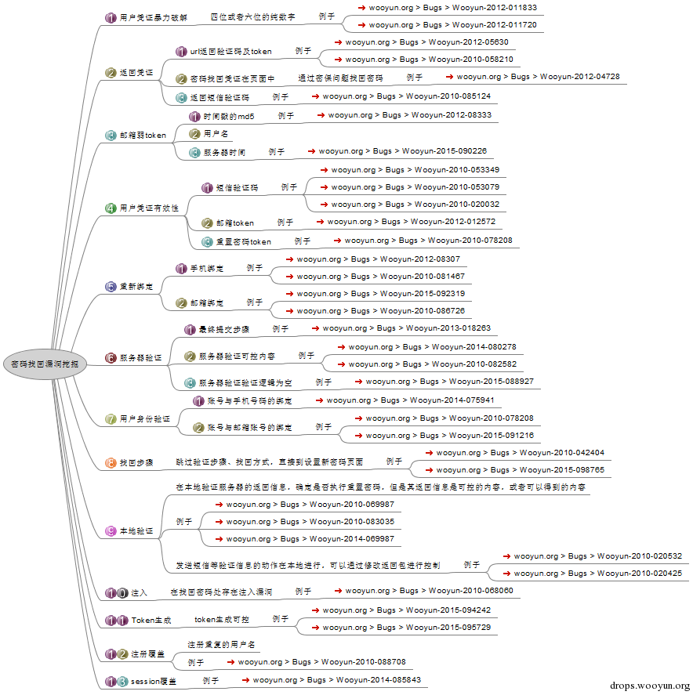

红队人员实战手册

<https://github.com/klionsec/RedTeamer>

## Android渗透工具集合

<https://mp.weixin.qq.com/s/AL84lzI1L86qX6jh4uOdRw>

## 应急响应手册-Windows排查技巧（一）

https://mp.weixin.qq.com/s/q4vEpThyAg1ZaxlS8tyoZg