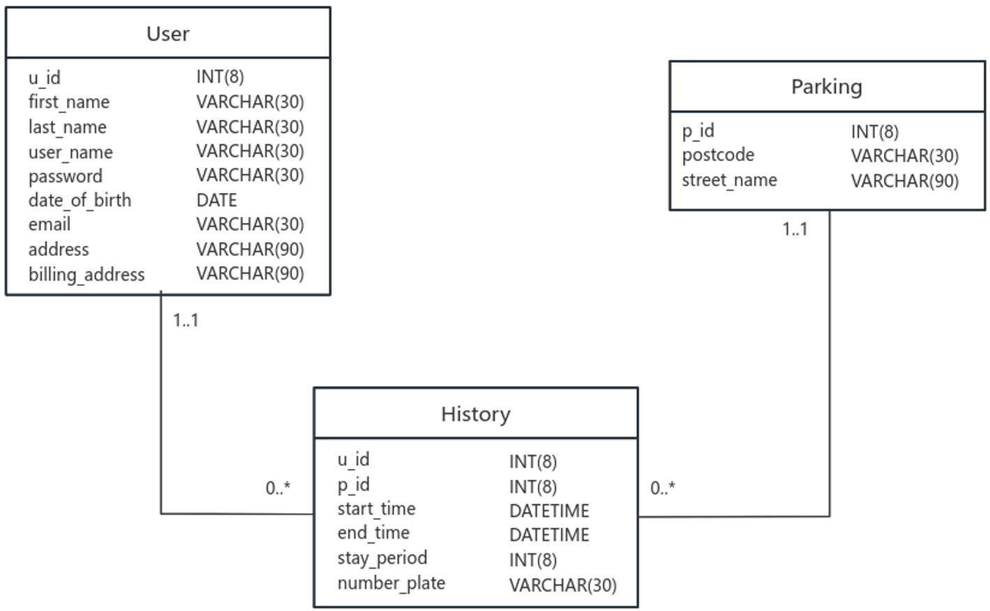

Ideas:

The relationship between user and parking table is many-to-many. (i.e. At different times, a user may park its car at many parking lots, and a parking lot may provide service to many users.) It is difficult to directly store and retrieve data in this case.

However, we can decouple this many-to-many relationship into two one-two-many relationships by using the history table. The role of the history table is to handle the interactions between users and parking lots by logging the parking activities. In this way, each piece of data in the history table can match exactly one user and one parking lot, which makes it more convenient to store and retrieve data.

To implement this, the main ideas are: (1) Let user table only store the information describing users. (2) Let parking table only store the information describing parking lots. (3) The history table is used to log parking activities and serves as a bridge between user and parking table.

Updates:

Remove user_name, start_time, end_time, stay_period, number_plate from parking table.

Add u_id to user table. (u_id means user id and serves as a primary key uniquely identifying each user.)

Add p_id to parking table. (Similar to u_id)

Add u_id, p_id to history table. (Identify each parking activity is performed by which user in which parking lot.)

Add stay_period to history table.

Current functions supported:

get_user_details(user_name, password): Get details of a user given user_name and password

get_parking_history_of_user(u_id, time_scope): Get parking history of a user in a specified time_scope

Create_user(first_name, last_name, user_name, password, date_of_birth, email, address, billing_address): Create a new user

Create_parking_lot(postcode, street_name): create a new parking lot

Post_parking(u_id, p_id, start_time, end_time, number_plate): post a new parking activity to the history table

Delete_history_of_a_user(u_id, time_scope): delete parking history of a user in a specified time scope

Packages required:

mysql-connector-python

Set up:

1. Download and install mysql8.1
2. Set the username and password in the mysql8.1 configurator
3. Enter the password in the mysql command line client
4. Run following command: create database ELEC0138;
5. Run following command: use ELEC0138;
6. Run following command: source path\to\the\file\ELEC0138.sql
7. Firstly run init_db_connection(host, user, password, database) in db_operations.py. host is ‘localhost’ by default. User and password correspond to your username and password of mysql. Database means the name of the database(‘ELEC0138’ )
8. All the other functions could be called after running init_db_connection()