NW Trails — Project Proposal

CSIS 4280 Special Topics in Emerging Technology — Winter 2026
Phase 1 & 2: Project Proposal + Prototype
Due: March 02, 2026, 17:00
Note: This is a communication draft for team coordination. The final submission must be in .docx format named group06-proposal.docx.

i. Cover Page
App Name | NW Trails
Group Number | Group 06
Course | CSIS 4280 Special Topics in Emerging Technology
Term | Winter 2026

Name | Student ID | Role
Dong Zhang | 300403848 | Team Lead
Diego Romero-Lovo De la Flor | 300398786 | Member
Zhi Kang | 300403869 | Member
Menghua Wang | 300397100 | Member

ii. Description
NW Trails is a gamified city exploration app designed for Douglas College students to discover New Westminster through location-based check-ins and achievement collection.
The app features an interactive map displaying 15 curated landmarks across New Westminster, spanning historic sites, nature spots, food destinations, and cultural attractions. Users explore the city by physically visiting these landmarks and checking in via GPS verification. Each check-in contributes to a personal achievement system where users earn badges — Bronze, Silver, and Gold — based on the number of landmarks visited, as well as themed badges for completing category-specific collections such as "History Buff" or "Foodie Explorer."
To provide a structured exploration experience, NW Trails offers pre-set walking routes such as "Historic Downtown Walk" and "Waterfront Trail," each with distance, duration, and difficulty information. Users can follow these guided routes to efficiently discover landmarks while enjoying a curated walking tour of the city.
The app encourages community engagement through a leaderboard that ranks users by exploration progress and displays trending landmarks. Users can also share their achievements and check-in highlights on social media.
NW Trails addresses a common challenge faced by new students: unfamiliarity with the surrounding city. Rather than relying on generic tourism apps, NW Trails offers a fun, social, and gamified way for students to build a connection with New Westminster while staying physically active.
The project follows a client-server architecture. The Flutter-based client communicates with a SpringBoot REST API backend, with MongoDB serving as the centralized database. In Phase 1, the client operates with locally stored mock data, with full backend integration planned for subsequent phases.

iii. Market Analysis

Reference Application: Pokemon GO
Pokemon GO, developed by Niantic and launched in 2016, is the most widely recognized location-based mobile game in the world. With over 600 million downloads, it pioneered the concept of gamified real-world exploration by encouraging users to physically visit locations to interact with virtual content. We selected Pokemon GO as our reference application because it shares the same foundational concept as NW Trails — motivating users to explore real-world locations through game mechanics.
We have identified three core features from Pokemon GO that we aim to replicate and improve upon in the context of a campus-oriented city exploration app.

Feature 1: Location-Based Discovery & Check-in
How Pokemon GO does it:
Pokemon GO uses "PokeStops" and "Gyms" tied to real-world landmarks. Users must physically travel to these locations to interact with them, spinning a PokeStop disc to collect items. The system uses GPS to verify the user's proximity.
How NW Trails replicates and improves it:
Aspect | Pokemon GO | NW Trails
Content | Virtual creatures at generic locations | Curated real landmarks with educational descriptions
Check-in | Spin a disc (game mechanic) | One-tap check-in with optional photo upload
Verification | GPS proximity | GPS proximity (within 50m)
Value | Collect game items | Learn about New Westminster's history, food, and culture
Our improvement: While Pokemon GO's PokeStops are often placed at arbitrary locations with little context, NW Trails curates each landmark with meaningful descriptions, practical information (opening hours, tips from students), and category tags. The goal shifts from collecting virtual items to gaining genuine knowledge about the city.

Feature 2: Achievement & Progression System
How Pokemon GO does it:
Pokemon GO features an extensive medal system. Players earn medals for catching certain types of Pokemon, walking specific distances, or completing raids. Medals progress through Bronze, Silver, and Gold tiers, each requiring increasing thresholds.
How NW Trails replicates and improves it:
Aspect | Pokemon GO | NW Trails
Tiers | Bronze, Silver, Gold | Bronze (5), Silver (10), Gold (15)
Categories | Pokemon types (Fire, Water, etc.) | Landmark themes (Historic, Nature, Food, Culture)
Scope | 100+ medals, overwhelming | Focused set of achievable badges
Motivation | Completionist grind | Realistic weekend goals
Our improvement: Pokemon GO's medal system is vast and can feel unattainable for casual players. NW Trails intentionally limits the scope to 15 landmarks and a focused set of badges, making 100% completion a realistic and rewarding goal achievable within a semester. The themed badges (e.g., "History Buff" for visiting all historic sites) provide clear, short-term objectives that maintain motivation.

Feature 3: Guided Exploration Routes
How Pokemon GO does it:
Pokemon GO introduced "Routes" in 2023, allowing players to follow community-created paths. Routes show a trail on the map and reward players with special Pokemon encounters along the way. However, routes are user-generated with minimal curation, and the focus remains on game rewards rather than exploration value.
How NW Trails replicates and improves it:
Aspect | Pokemon GO | NW Trails
Route creation | User-generated, inconsistent quality | Professionally curated by the development team
Information | Minimal (just a path line) | Distance, duration, difficulty, landmark descriptions
Purpose | Catch special Pokemon | Discover the city with structured walking tours
Navigation | Follow a line on map | Step-by-step directions between landmarks
Our improvement: NW Trails routes are thoughtfully designed walking tours with practical metadata (distance, time, difficulty). Each route tells a story — the "Historic Downtown Walk" guides users through New Westminster's heritage sites in chronological order, while the "Waterfront Trail" follows the scenic Fraser River path. This transforms a game mechanic into a genuinely useful city guide.

Summary
Core Feature | Pokemon GO | NW Trails Improvement
Location check-in | Generic PokeStops | Curated landmarks with educational content
Achievement system | Overwhelming 100+ medals | Focused, achievable badge collection
Guided routes | User-generated, game-focused | Curated walking tours with practical info
NW Trails takes proven engagement mechanics from the world's most successful location-based game and reimagines them for a focused, practical purpose: helping Douglas College students discover and connect with New Westminster.

iv. Target Audience

Primary Audience: Douglas College Students New to New Westminster
The primary target users of NW Trails are Douglas College students, particularly those who are new to the New Westminster area. This includes:
- International students who have recently arrived in Canada and are unfamiliar with the local area. These students often spend their first semester confined to campus and their residence, missing out on the vibrant community surrounding Douglas College.
- Domestic students from other cities who have moved to New Westminster for their studies and want to explore their new neighborhood but do not know where to start.
- First-year students looking for social activities beyond the classroom. NW Trails provides a low-pressure, self-paced way to explore the city — alone or with friends.

Secondary Audience: Current Students Seeking Weekend Activities
Even students who have lived in New Westminster for a while may not have explored many of its landmarks. NW Trails serves as a weekend activity planner by offering:
- Structured walking routes that turn a casual walk into a guided exploration.
- Gamification elements (badges, leaderboard) that create motivation to visit places they have walked past but never entered.
- Social competition through the leaderboard, encouraging friend groups to compete on who can explore the most landmarks.

User Needs
User Need | How NW Trails Addresses It
"I don't know what's around campus" | Interactive map with 15 curated landmarks, each with descriptions and categories
"I want something fun to do on weekends" | Guided walking routes with varying difficulty, gamified with badge rewards
"I want to feel connected to this city" | Educational landmark content about New Westminster's history, food, and culture
"I want to do this with friends" | Leaderboard, social sharing, community stats that encourage group exploration
"I don't have a lot of time" | Short routes (30-70 min), one-tap check-in (3 seconds), progress saves automatically

Why They Would Use NW Trails
Unlike generic tourism apps (Google Maps, TripAdvisor) that serve all travelers, NW Trails is specifically designed for Douglas College students exploring New Westminster. The curated landmarks are chosen for relevance to student life — affordable food spots, free parks, cultural venues with student discounts, and transit-accessible locations. The gamification layer transforms routine exploration into an engaging challenge, and the community leaderboard adds a social dimension that generic apps lack.

v. Features

Must-Have Features

Must-Have 1: Landmark Discovery & Map
As a Douglas student new to New Westminster, I want to view a map showing curated landmarks around the city so that I can discover interesting places to visit nearby.
As a user, I want to tap on a landmark pin on the map to see its details (name, description, photo, distance from me) so that I can decide whether to visit it.
As a user, I want to filter landmarks by category (Historic, Nature, Food, Culture) so that I can find places that match my interests.

Must-Have 2: Location-Based Check-in
As a user visiting a landmark, I want to check in when I am within 50 meters of the location so that my visit is verified and recorded.
As a user, I want to optionally upload a photo when checking in so that I can keep a visual memory of my visit.
As a user, I want to see my check-in history with dates and photos so that I can review all the places I have explored.

Must-Have 3: Achievement & Badge System
As a user, I want to earn achievement badges (Bronze for 5 landmarks, Silver for 10, Gold for all 15) so that I feel motivated to explore more of New Westminster.
As a user, I want to earn special themed badges (e.g., "History Buff" for visiting all historic sites, "Foodie Explorer" for visiting all food spots) so that I have additional goals to pursue.
As a user, I want to view my achievement progress on a personal profile page so that I can track how close I am to earning the next badge.

Must-Have 4: Guided Walking Routes
As a user who wants a structured exploration experience, I want to browse pre-set walking routes (e.g., "Historic Downtown Walk", "Waterfront Trail") so that I can follow a curated path through the city.
As a user, I want to see each route's distance, estimated duration, and difficulty level so that I can choose a route that fits my schedule and fitness level.
As a user on an active route, I want to see the next landmark in the route with navigation directions so that I can easily find my way.

Nice-to-Have Features

Nice-to-Have 1: Social Sharing & Achievement Wall
As a user, I want to view a personal "achievement wall" displaying all my badges and check-in highlights so that I can showcase my exploration journey.
As a user, I want to share my achievements or check-ins to social media (Instagram, Twitter) so that I can let friends know about my New Westminster experiences.

Nice-to-Have 2: Community Leaderboard
As a user, I want to see a leaderboard ranking all users by the number of landmarks visited so that I can compete with fellow students.
As a user, I want to see a community exploration heatmap showing which landmarks are most popular so that I can discover trending spots.

Nice-to-Have 3: Landmark Reviews & Tips
As a user who has checked in at a landmark, I want to leave a short review or tip (e.g., "Best visited at sunset", "Free parking nearby") so that other users benefit from my experience.
As a user, I want to read reviews from other students before visiting a landmark so that I can plan my visit better.

vi. Wireframes (5 Pages)
Wireframes will be created in Figma by assigned members. Below is the detailed layout specification for each page.

Wireframe Screenshot Placement (for final .docx)
Insert screenshots exported/imported from the HTML wireframes in this order:
- Figure 1 - P1-HomeMap
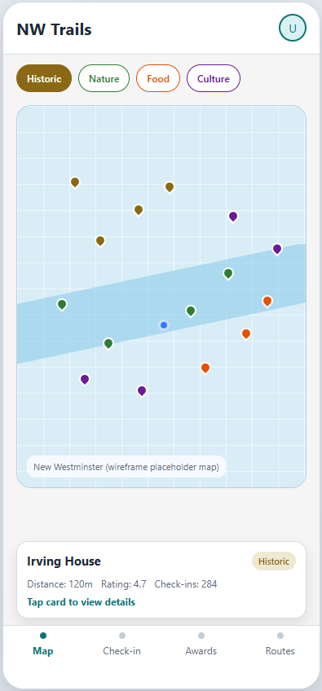
- Figure 2 - P2-LandmarkDetail-Within50m
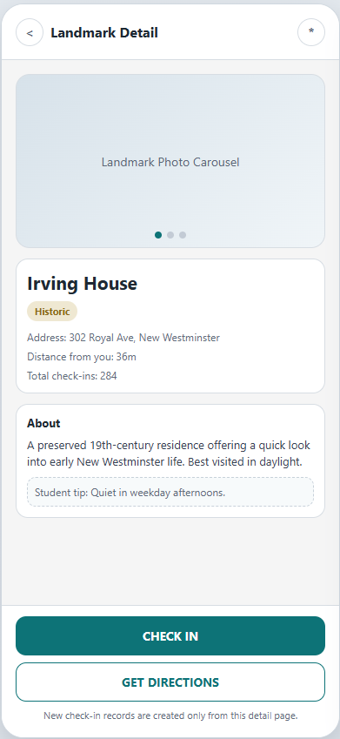
- Figure 3 - P3-AchievementProfile
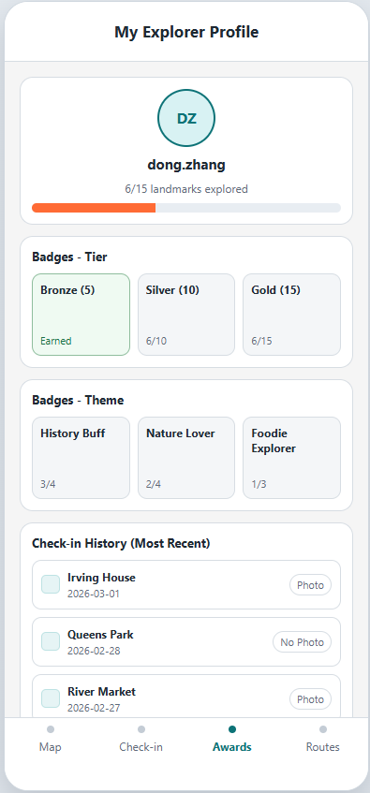
- Figure 4 - P4A/P4B Routes
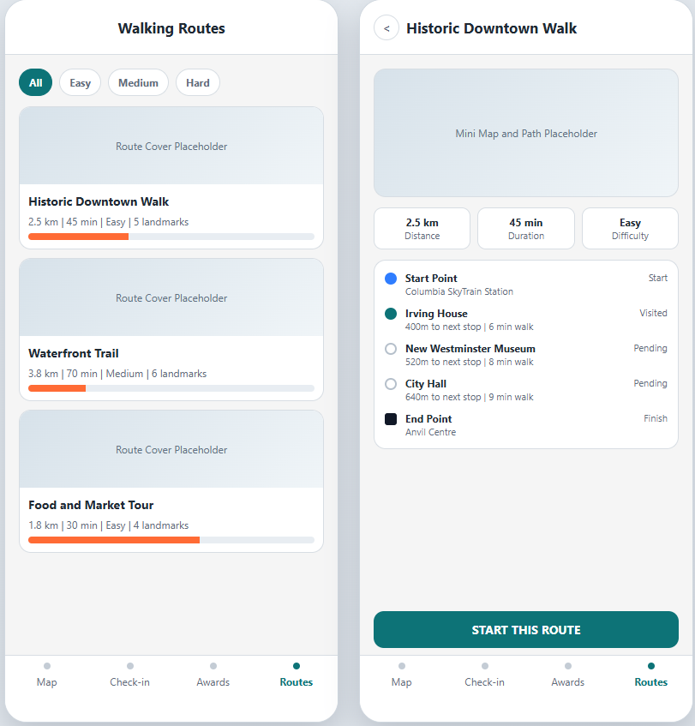
- Figure 5 - P5-CommunityLeaderboard
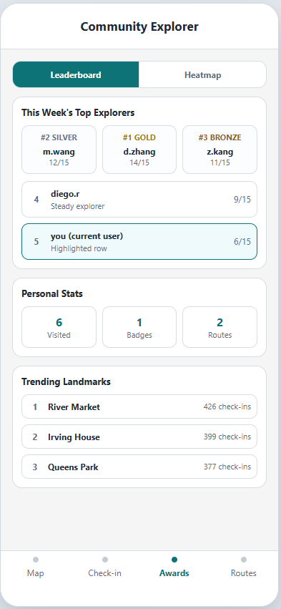

Page 1: Home / Map Screen
Purpose: Main screen showing the interactive map with all landmark pins.
Layout (top to bottom):
- AppBar
- Left: App name "NW Trails"
Right: User avatar icon (tap to go to Profile)
- Category Filter Bar (horizontal scroll)
- Chips: Historic (brown), Nature (green), Food (orange), Culture (purple)
Supports multi-select, selected chips are filled color, unselected are outlined
- Map Area (~60% of screen)
- Google Map centered on New Westminster
15 landmark pins, color-coded by category
User's current location shown as blue dot
Tapping a pin highlights it and opens the bottom preview card
- Bottom Preview Card (appears when a pin is tapped)
- Landmark icon + name
Category tag + distance from user
Star rating + total check-in count
Tap card to navigate to Landmark Detail (Page 2)
- Bottom Navigation Bar (4 tabs)
- Map (active) | Check-in | Awards | Routes
Check-in tab is used for history/status review; new check-in actions are initiated from Landmark Detail

Page 2: Landmark Detail + Check-in
Purpose: Show full landmark info and enable check-in.
Layout (top to bottom):
- AppBar
- Back button + Bookmark/favorite icon
- Image Carousel (~200px height)
- Landmark photos, swipeable
Dot indicator at bottom
- Info Section
- Landmark name (large, bold)
Category tag (colored chip)
Address with map pin icon
Distance from user
Total check-in count
- Description Section
- "About" header
2-3 sentences about the landmark
Practical info: hours, tips
- Student Tips Section (Nice-to-Have)
- Header: "Tips from students"
Cards with tip text and username
- Action Buttons (bottom, sticky)
- Primary: "CHECK IN" — green if within 50m, gray if too far (shows distance)
Secondary: "GET DIRECTIONS" — opens native maps app
New check-in records are created only from this page's CHECK IN action
- Check-in Success Dialog (popup after check-in)
- Celebration animation/icon
Landmark name + date
Optional photo upload button + note button
Progress bar: "X/15 landmarks"
Next badge hint: "Next badge: Silver (10)"
"Done" button to dismiss

Page 3: Achievements & Profile
Purpose: Personal profile showing badges, progress, and check-in history.
Layout (top to bottom):
- AppBar
- "My Explorer Profile"
- Profile Header
- User avatar (center)
Username
Progress text: "6/15 landmarks explored"
Progress bar (filled proportionally)
- Badges Section — "Badges" header
- Row 1: Tier badges in 3 cards
- Bronze (5) — checkmark if earned, lock + progress if not
- Silver (10) — same
- Gold (15) — same
Row 2: Theme badges in 3 cards
- History Buff (all historic sites)
- Nature Lover (all nature spots)
- Foodie Explorer (all food spots)
Earned badges: full color with checkmark
Locked badges: grayed out with "X/Y" progress
- Check-in History — "Check-in History" header
- Scrollable list, each item shows:
- Category icon + landmark name
- Date
- Photo indicator icon if photo was uploaded
Sorted by most recent first

Page 4: Routes Browser + Route Detail
Purpose: Browse and select walking routes; view route details.
Page 4A — Routes List:
- AppBar
- "Walking Routes"
- Difficulty Filter Tabs
- All | Easy | Medium | Hard
- Route Cards (scrollable list), each card contains
- Route cover image/thumbnail
Route name (e.g., "Historic Downtown Walk")
Metadata: distance (km), duration (min), difficulty
Number of landmarks on this route
Personal completion progress bar for this route
- Bottom Navigation Bar
- Map | Check-in | Awards | Routes (active)
Page 4B — Route Detail (tap a route card):
- AppBar
- Route name + back button
- Mini Map (~150px height)
- Shows the route path as a line connecting landmarks
All landmark pins on the route visible
- Route Metadata Bar
- Distance | Duration | Difficulty (horizontal row with icons)
- Route Stops (Timeline/Stepper layout)
- Start point (filled circle)
Each landmark as a step:
- Filled circle + checkmark if visited
- Empty circle if not visited
- Landmark name
- Distance + walk time to next stop
End point (square icon)
- Action Button (bottom, sticky)
- "START THIS ROUTE" — primary color, full width

Page 5: Community Leaderboard
Purpose: Show rankings, personal stats, and trending landmarks.
Layout (top to bottom):
- AppBar
- "Community Explorer"
- Tab Bar
- Leaderboard | Heatmap
- Leaderboard Tab
- Header: "This Week's Top Explorers"
Top 3 with medal icons (gold/silver/bronze) and landmark count
Remaining users in plain list
Current user's row highlighted with arrow marker
Each row: rank + avatar + username + "X/15"
- Personal Stats Bar (3 stat cards in a row)
- Visited (number) | Badges (number) | Routes (number)
- Trending Landmarks Section
- Header: "Trending Landmarks"
List of top 3 most checked-in landmarks
Each item: rank + name + check-in count with people icon

Wireframe Design Guidelines
Element | Specification
Primary Color | Deep Teal #0D7377
Accent Color | Warm Orange #FF6B35 (CTA buttons, check-in highlights)
Background | Light Gray #F5F5F5
Cards | White #FFFFFF with subtle shadow, 12px border radius
Category Colors | Historic: Brown #8B6914, Nature: Green #2E7D32, Food: Orange #E65100, Culture: Purple #6A1B9A
Typography | Titles: Bold 18-20sp, Body: Regular 14-16sp, Caption: 12sp
Icons | Material Icons, rounded style
Spacing | 16px standard padding, 8px between cards

Wireframe Assignment
Page | Assigned To | Description
Page 1: Home / Map Screen | Dong Zhang (Team Lead) | Main map with landmark pins and category filters
Page 2: Landmark Detail + Check-in | Dong Zhang (Team Lead) | Landmark info, photos, check-in flow
Page 3: Achievements & Profile | Dong Zhang (Team Lead) | Badges, progress, check-in history
Page 4: Routes Browser + Detail | Dong Zhang | Route list, route detail with timeline
Page 5: Community Leaderboard | Dong Zhang (Team Lead) | Rankings, stats, trending landmarks

Interaction Prototyping Assignment
Task | Assigned To | Description
Figma Prototype Interaction Linking | Zhi Kang | Configure page-to-page click-through flow and validate the main sequence (Map -> Detail -> Check-in Success -> Profile, plus Routes flow)
Wireframes are created in Figma with a low-to-mid fidelity focus on UX flow clarity, navigation logic, and component consistency (visual polish is secondary in this phase).

vii. Peer Evaluation Table
Peer evaluation scores are finalized for this draft revision.
Rubric:
- 1 Point: No or very little contribution; cannot deliver artifacts or largely miss deadlines; no passion.
- 2 Points: Little contribution with no negative effect; sometimes misses deadlines; mainly follows others.
- 3 Points: Fairly large and positive contribution; handles most tasks and delivers on time.
- 4 Points: Large and positive contribution; helps others tackle problems; proactive and passionate.
Evaluator \ Evaluatee | Diego Romero-Lovo De la Flor | Dong Zhang | Zhi Kang | Menghua Wang
Diego | — | 4 | 4 | 4
Dong | 4 | — | 4 | 4
Zhi | 4 | 4 | — | 4
Menghua | 4 | 4 | 4 | —

Appendix A: Prototype Task Assignment

Architecture Overview (Phase 1)
Phase 1: Client only (Flutter)
- All data hardcoded or stored locally
- No REST API calls yet
- Focus on UI, navigation, and core feature logic
Phase 2+ (Future):
Client (Flutter) --REST API--> Server (SpringBoot) ---> Database (MongoDB)

Prototype Requirements Checklist
- [x] Minimum Viable UI: Basic screens with navigation
- [x] At least 3 core features (3 completed user stories)
- [x] Use local data storage or hardcoded data

Confirmed Task Assignment (Execution Plan)
Member | Module | Must-Have Feature | Key Screens | Deliverables
Dong Zhang (Team Lead) | App Shell, Routes, Integration | Must-Have 4 + cross-module integration | App shell, Routes list/detail, shared navigation | Bottom navigation architecture, routes workflow, module integration, final merge and release packaging
Diego Romero-Lovo De la Flor | Map & Landmark Discovery | Must-Have 1 | Home/Map Screen, Landmark Detail | Landmark data model, category filter chips, pin/preview interaction, detail page layout
Zhi Kang | Check-in + Figma Prototype Linking | Must-Have 2 | Landmark Detail Check-in, Check-in History, Figma prototype links | Distance verification stub (within 50m simulation), check-in action and history list, Figma click-through flow wiring
Menghua Wang | Achievement & Profile | Must-Have 3 | Profile page, Badge display | Bronze/Silver/Gold progress logic, themed badge states, profile progress bar and history section

Milestone and Handoff Schedule
Timebox | Owner(s) | Target Output
Mar 1 night | Dong + Zhi | Complete wireframe frames and configure Figma interaction linking for primary user flow
Mar 2 morning | Diego, Zhi, Menghua | Module code handoff to team lead and basic self-test completed
Mar 2 noon | Dong + all | Integration test pass: navigation + 3 core features demo flow
Mar 2 before 17:00 | Dong (submitter) | Final package: group06-proposal.docx + group06-app.zip -> group06-project01.zip

Shared Components (to be built collaboratively)
- Bottom Navigation Bar (4 tabs)
- Common AppBar style
- Landmark data model (hardcoded list of 15 landmarks)
- Color theme and constants file
- Category enum and color mapping

15 Curated Landmarks (Reference Data)
# | Name | Category | Coordinates (approx.)
1 | Irving House | Historic | 49.2077, -122.9128
2 | New Westminster Museum | Historic | 49.2043, -122.9108
3 | City Hall | Historic | 49.2044, -122.9070
4 | Westminster Pier Park | Historic | 49.2002, -122.9088
5 | Queens Park | Nature | 49.2134, -122.9026
6 | Fraser River Trail | Nature | 49.1980, -122.9150
7 | Hume Park | Nature | 49.2170, -122.8920
8 | Tipperary Park | Nature | 49.2060, -122.9070
9 | River Market | Food | 49.2005, -122.9095
10 | Columbia Street Cafes | Food | 49.2045, -122.9100
11 | Steel & Oak Brewing | Food | 49.2010, -122.9055
12 | Anvil Centre | Culture | 49.2015, -122.9105
13 | Massey Theatre | Culture | 49.2132, -122.9030
14 | Douglas College (New West) | Culture | 49.2048, -122.9120
15 | Samson V Maritime Museum | Culture | 49.2000, -122.9090
Note: Coordinates are approximate. Verify with Google Maps before implementation.

Pre-Set Walking Routes (Reference Data)
Route Name | Difficulty | Distance | Duration | Landmarks
Historic Downtown Walk | Easy | 2.5 km | 45 min | #1, #2, #3, #4, #12
Waterfront Trail | Medium | 3.8 km | 70 min | #4, #6, #9, #11, #15, #12
Food & Market Tour | Easy | 1.8 km | 30 min | #9, #10, #11, #14
Queens Park & Beyond | Medium | 3.2 km | 55 min | #5, #7, #8, #13
Complete New West | Hard | 6.5 km | 120 min | All 15 landmarks

Appendix B: Submission Checklist
- [x] Proposal document: group06-proposal.docx
- [x]Flutter project zip: group06-app.zip
- [x]Final package: group06-project01.zip
- [x] All Student IDs filled in on Cover Page
- [x] Peer Evaluation table completed by all members
- [x] Wireframes (5 pages) included in proposal
- [x]Only ONE member (team lead) submits to Blackboard
Current implementation status (internal tracking):
- [x] Prototype code path validated (flutter analyze, flutter test, flutter build apk --debug, Android smoke run)
- [x] Core route/check-in/awards logic validated by team testing

Appendix C: Project Log (for final group06-proposal.docx)
The assignment requires proposal + project log in one document. No fixed template is specified, so use a concise table and cite commit hashes/PRs as evidence.
Date | Member(s) | Work Completed | Evidence (commit/PR/test artifact)
2026-03-01 | Dong Zhang, Zhi Kang | Completed wireframe set and interaction flow linking for proposal and prototype walkthrough. | wireframes/html/p1_home_map_default.html; wireframes/html/p2_landmark_detail_within50m.html; docs/ui_design_sequence_review.md
2026-03-02 | Diego Romero-Lovo De la Flor | Delivered map discovery module and landmark detail layout for category filtering and preview/detail flow. | lib/features/landmarks/map_page.dart; lib/features/landmarks/landmark_detail_page.dart
2026-03-02 | Zhi Kang | Implemented check-in validation and history flow, including detail-page check-in behavior handoff. | lib/features/checkin/checkin_history_page.dart; lib/app/state/app_state.dart
2026-03-02 | Menghua Wang | Implemented profile/awards module with tier badges and themed progress states. | lib/features/awards/awards_page.dart; lib/core/models/badge_progress.dart
2026-03-02 | Dong Zhang (integration owner) + all members | Integrated routes and cross-module state, ran end-to-end verification, and prepared submission artifacts. | lib/features/routes/routes_page.dart; lib/features/routes/route_detail_page.dart; test/app/state/app_state_routes_test.dart

