Learning $​^{1}$H and $​^{13}$C NMR chemical shifts jointly from unassigned 2-D HSQC peak sets
April 2026

Abstract
Background. Nuclear magnetic resonance (NMR) chemical-shift predictors are almost always trained on atom-assigned spectra, where every training example specifies which atom in the molecular graph produced which peak. Atom assignment is the expensive part of curating NMR data, so most published spectra never enter a training set. Two-dimensional HSQC peak lists are a different matter: they appear in nearly every modern organic paper, pair the $​^{1}$H and $​^{13}$C shifts of directly bonded H–C groups, and carry no atom identity. We ask whether such peak lists are rich enough to train a joint $​^{1}$H / $​^{13}$C predictor without any assigned $​^{1}$H labels.
Results. We treat the HSQC peak list as an unordered multiset in $(δ_{H},δ_{C})$ space and train a four-layer graph isomorphism network to match its predicted multiset to the observed one with a sliced-Wasserstein sort-match loss, reducing a 2-D optimal-transport problem to $K$ differentiable 1-D sort problems. On a 1,542-molecule NMRShiftDB2 subset, using $10\%$ atom-assigned $​^{13}$C labels and HSQC peak lists for the remaining $90\%$, the model reaches $4.53±0.11$ ppm $​^{13}$C and $0.35±0.02$ ppm $​^{1}$H test MAE (3 seeds, no atom-assigned $​^{1}$H ever used). Zeroing the $​^{1}$H coordinate of every HSQC target collapses $​^{1}$H error to $4.69±0.10$ ppm, confirming the $​^{1}$H head learns from the HSQC signal rather than from gradient leakage. Layered on top of full $​^{13}$C supervision, the recipe reaches $3.23±0.10$ ppm $​^{13}$C and $0.30±0.03$ ppm $​^{1}$H. Split-conformal calibration gives $95.2\%$ $​^{13}$C and $96.7\%$ $​^{1}$H empirical per-atom coverage at $α=0.05$. Against constitutional isomers the model is correct on $77\%$ of candidates and wrong on $22\%$, a 3.5-fold ratio useful for dereplication ranking but not standalone acceptance.
Conclusions. Unassigned 2-D HSQC peak lists carry enough supervisory signal to train a joint $​^{1}$H / $​^{13}$C predictor at label efficiencies unreachable by fully supervised methods, with causally audited structural-level guarantees from split-conformal calibration. Code, data filters, and trained checkpoints are at https://github.com/dongzhaohe321418-lab/nmr-ssl.
Keywords: NMR chemical shift prediction; semi-supervised learning; sliced Wasserstein; optimal transport; split-conformal prediction; natural-product dereplication; graph neural network.

Background
Predicting NMR chemical shifts from a molecular graph is a standard machine-learning task in chemoinformatics. The current best predictor, NMRNet [1], reaches $1.10$ ppm $​^{13}$C and $0.18$ ppm $​^{1}$H mean absolute error on NMRShiftDB2. It achieves this by training two separate heads on two separately-curated atom-assigned corpora. Every training example carries per-atom labels that someone had to annotate.
Per-atom annotation is the slow, expensive part of building an NMR training set. Most spectra in the literature never get annotated to that level, so they cannot be used with the standard supervised recipe. 2-D experiments such as HSQC, HMBC, COSY and NOESY appear in far more published papers than fully atom-assigned 1-D spectra, but their peak lists are multisets of correlations rather than atom-indexed values, which rules them out of conventional training.
HSQC is the smallest step away from 1-D supervision. Each cross-peak in an HSQC peak list pairs a $​^{1}$H shift with the $​^{13}$C shift of its directly-bonded carbon. The pairing is known; the atom identity is not. The question the paper answers is whether this constrained form of weak supervision is enough to train a joint $​^{1}$H / $​^{13}$C predictor, and if so, where the training signal actually comes from.
The four contributions are as follows. First, we formulate the training problem as a permutation-invariant regression against the HSQC peak multiset. Along either coordinate axis, this reduces exactly to the sort-match loss of our prior 1-D work [2]. Across both axes jointly we use the sliced-Wasserstein construction of Bonneel et al. [3], which averages the loss over $K$ random linear projections and brings the per-molecule cost down to $O(Knlogn)$.
Second, the predictor trained with this loss reaches $4.53±0.11$ ppm $​^{13}$C and $0.35±0.02$ ppm $​^{1}$H on a 3-seed NMRShiftDB2 random split, using only a $10\%$-labelled $​^{13}$C subset and HSQC peak lists on the remaining $90\%$. No atom-assigned $​^{1}$H label is ever used. When the same SSL loss is layered on top of full $​^{13}$C supervision across all training molecules, the combined recipe gives $3.23±0.10$ ppm $​^{13}$C and $0.30±0.03$ ppm $​^{1}$H, closing most of the gap to NMRNet on the $​^{1}$H side.
Third, we settle the obvious alternative explanation. A reasonable skeptic would ask whether the $​^{1}$H head is really learning from HSQC at all, or whether the shared encoder is simply passing information from the $​^{13}$C supervised loss into the $​^{1}$H readout. To test this, we zero out the $​^{1}$H coordinate of every HSQC training target, keep the $​^{13}$C coordinate intact, and retrain with the same hyperparameters. The $​^{1}$H test MAE jumps to $4.69±0.10$ ppm, more than ten times worse than the baseline. The $​^{13}$C error barely moves. The HSQC $​^{1}$H coordinate is doing the work.
Fourth, we wrap the predictor with split-conformal calibration$​^{4,5}$. Empirical per-atom test coverage at $α=0.05$ is $95.2\%$ on $​^{13}$C and $96.7\%$ on $​^{1}$H. We then apply a Bonferroni correction over the per-molecule HSQC peak count to recover a formal molecule-level coverage guarantee, and note the price (wider intervals) and the use case (per-atom is fine for outlier flagging; molecule-level is needed for binary accept/reject).
The rest of the paper is organized as follows. Methods writes out the sliced sort-match loss and its theoretical motivation. Experimental details covers dataset construction, model architecture, training protocol, split-conformal calibration, and the structure-verification procedure. Results reports the main label efficiency numbers, the causal audit, the combined supervision regime, the label-efficiency sweep, the wrong-candidate controls, the scaffold-OOD split, robustness to realistic HSQC degradation, the hyperparameter and axis-aligned-decomposition sweeps, the per-carbon error decomposition, and the split-conformal coverage analysis. Discussion covers honest limitations and the path to real literature HSQC data. Conclusions summarizes the headline findings. The Supplementary Information contains per-seed tables, sweep data, the stop-gradient control, a pretrain-then-finetune baseline, the stereo-rich stress test, and a multiplicity-augmented loss experiment.

Methods

Set-valued NMR supervision
Fix a molecule $M$ with its molecular graph $G(M)$ and write $P^{⋆}(M)=\{(δ_{H,j}^{⋆}, δ_{C,j}^{⋆})\}_{j=1}^{n}$ for its observed HSQC peak set. The target is an unordered multiset: the training pipeline sees the $n$ pairs but not which pair corresponds to which heavy atom. A graph neural network $f_{θ}:G→({\hat{δ}}_{H},{\hat{δ}}_{C})$ predicts per-atom shifts; from its outputs at the H-bearing carbons we form the predicted set $\hat{P}(M,θ)=\{({\hat{δ}}_{H,i},{\hat{δ}}_{C,i})\}_{i=1}^{n}$.
The goal is to minimize a permutation-invariant loss between $\hat{P}$ and $P^{⋆}$. In one dimension this reduces exactly to sorting both sets and taking a per-element $ℓ^{2}$ distance, as guaranteed by the Hardy–Littlewood–Pólya rearrangement inequality [6], which our prior work formalizes as a training-time theorem [2]. In two dimensions the exact solution is Hungarian optimal bipartite matching, which is $O(n^{3})$ per molecule and not easily batched on GPU.

Sliced approximation
We follow Bonneel et al. [3] and use the sliced-Wasserstein distance as a cheap upper bound. For a random direction $θ∈S^{1}$ drawn uniformly from the unit sphere, define the projection $Π_{θ}(h,c)=hcosθ+csinθ$. Then
$$SW_{2}^{2}(\hat{P},P^{⋆})=E_{θ∼Unif(S^{1})}\left[W_{2}^{2}(Π_{θ}\hat{P},Π_{θ}P^{⋆})\right],$$
where each inner one-dimensional 2-Wasserstein is solved exactly by sorting the two projected sets. A Monte-Carlo estimator with $K$ directions gives the sliced sort-match loss,
$$L_{SSW}(\hat{P},P^{⋆})=\frac{1}{K}\sum_{k=1}^{K}{L_{sort}}\left(Π_{θ_{k}}\hat{P},Π_{θ_{k}}P^{⋆}\right),$$
which is permutation-invariant, differentiable almost everywhere through torch.sort, and computed in $O(Knlogn)$ per molecule. It is a consistent estimator of $SW_{2}^{2}$ as $K→∞$, and satisfies $SW_{2}^{2}≤W_{2}^{2}$ by the classical inequality.
Numerical audit. On 20 random two-dimensional point-set pairs drawn from the empirical shift distribution of NMRShiftDB2 ($n∈[5,20]$, $K=64$), the ratio $L_{SSW}/W_{2}^{\text{Hungarian}}$ concentrates in $[0.30,0.54]$ with mean $0.41±0.06$, consistent with the expected two-dimensional bound. Implementation: src/nmr2d/losses_2d.py. Verification test: tests/test_theorem_2d.py.

Axis-aligned decomposition
A specialization of the sliced estimator uses only the two native coordinate axes (i.e. $θ∈\{0,π/2\}$). This reduces to two independent one-dimensional sort-match losses on the $​^{1}$H and $​^{13}$C projections, with no Monte-Carlo randomness. At equal $K$ it is a biased lower bound on the full sliced estimator, but on NMRShiftDB2 it matches sliced $K=16$ within noise at eight times lower cost (see Results: Hyperparameter sensitivity). We report both variants; the axis-aligned version is what a practitioner should deploy.

Full training objective
The full training loss adds a supervised $​^{13}$C mean squared error on the labelled split:
L(θ)=1|L|M∈L​1|C(M)|a∈C(M)​(δC(a;θ)−δC⋆(a))2⏟supervised 13C MSE on labelled molecules+λ1|U|M∈U​LSSWP(M;θ),P⋆(M)⏟sliced sort-match on unlabelled molecules,
where $L$ and $U$ are the labelled and unlabelled training partitions and $C(M)$ is the set of carbon atoms in molecule $M$. The SSL weight $λ$, the number of sliced directions $K$, and the labelled fraction are the three hyperparameters we sweep in Results.

Experimental details

Dataset construction
We parse the NMRShiftDB2 [9] dump nmrshiftdb2withsignals.sd (SourceForge, release 2026-03-15, CC-BY-SA) with RDKit [8] and join the $​^{13}$C and $​^{1}$H spectra by molecule ID. Retention filters: (a) non-degenerate $​^{13}$C assignments (one peak per carbon atom), (b) at least one $​^{1}$H assignment grouped by heavy atom, (c) at least three HSQC cross-peaks, (d) at most 60 atoms. Out of 20,000 $​^{13}$C records and 18,169 $​^{1}$H records, 1,542 molecules pass all filters.
For each retained molecule we construct the HSQC peak multiset by iterating over all H-bearing carbons and emitting the tuple $({\overset{‾}{δ}}_{H},δ_{C})$, where ${\overset{‾}{δ}}_{H}$ is the mean shift over all H atoms bonded to that carbon. This is equivalent to the multiset a single multiplicity-averaged HSQC experiment reports. Code: src/nmr2d/data_2d.py.

Model
A shared 4-layer graph isomorphism network (GIN [7]) encoder with dense adjacency and 20 atom features (element one-hot, degree, formal charge, aromaticity, hybridization, hydrogen count, ring membership, atomic mass), followed by two 2-layer MLP readout heads: one for per-atom $​^{13}$C shift and one for per-heavy-atom mean $​^{1}$H shift. Hidden size 192. Total parameters are approximately 340k. Code: src/nmr2d/model_2d.py.

Sliced sort-match loss
At each forward pass we draw $K$ direction vectors uniformly on $S^{1}$ from a 2-D normal rescaled to unit norm, project every predicted and target peak onto each direction, sort the two projected sets within each mini-batch row, and compute the masked mean squared error on the aligned pairs. The final loss is the mean over $K$ directions. Permutation invariance is inherited from the sort. Differentiability through torch.sort is standard. Code: src/nmr2d/losses_2d.py. The axis-aligned variant fixes $K=2$ directions $(1,0)$ and $(0,1)$ and returns the sum of the two 1-D sort-match losses.

Training protocol
AdamW, learning rate ${10}^{−3}$, weight decay ${10}^{−5}$, batch size 32, 30 epochs, gradient clipping L2 $=5$, best-val-$​^{13}$C-MAE early stopping. Three seeds (0, 1, 2) with independent 80/10/10 random train/val/test splits and independent labelled/unlabelled partitions (labelled fraction $0.1$ unless otherwise stated). SSL weight $λ=2$, sliced directions $K=16$. Implementation in PyTorch 2.8 [10] with Apple Silicon MPS; approximately 60 seconds per seed per headline run.

Split-conformal calibration
We use the split-conformal prediction framework of Vovk, Gammerman and Shafer [4], specialized to regression by Lei, G’Sell, Rinaldo, Tibshirani and Wasserman [5]. After training the 2-D SSL model, we collect per-atom absolute residuals $|\hat{δ}−δ^{⋆}|$ on the held-out validation split (150 molecules, 1,959 $​^{13}$C atoms and 1,307 $​^{1}$H atoms). We take the finite-sample-corrected $(1−α)$ empirical quantile at $α=0.05$. The chemistry-demonstration calibration run yields $q_{C}≈14.8$ ppm and $q_{H}≈1.06$ ppm with empirical test-set coverage of $95.2\%$ on $​^{13}$C and $96.7\%$ on $​^{1}$H; the parallel run used for the Bonferroni table (Table 8) gives slightly tighter quantiles $q_{C}=13.4$ ppm and $q_{H}=1.03$ ppm on the same validation split, well within sampling variance. For the molecule-level Bonferroni correction we precompute a lookup table of per-$k$ quantiles at $α_{\text{atom}}=α_{\text{mol}}/(2k)$ and apply the molecule-appropriate quantile per candidate during evaluation. Code: src/nmr2d/conformal.py, experiments/compute_bonferroni_conformal.py.

Structure-verification protocol
Given a proposed structure $M$ and an observed HSQC peak list $P^{⋆}$, we (a) predict the model’s full $​^{1}$H/$​^{13}$C shift tensors on $M$, (b) read off the predicted HSQC cross-peaks at the H-bearing carbons, (c) pair each observed peak with its predicted counterpart at the same carbon-atom index using $M$’s connectivity as the assignment source, and (d) check whether each observed shift lies within its conformal interval. The structure is declared consistent if every cross-peak passes. The fraction-within-interval and worst-residual score are reported as continuous ranking scores for dereplication pipelines. Code: src/nmr2d/conformal.py::ConformalCalibrator.structure_verification_score.

Results
All experiments use NMRShiftDB2 release 2026-03-15 (SourceForge, CC-BY-SA). After filtering for molecules with both $​^{13}$C and $​^{1}$H spectra, non-degenerate $​^{13}$C assignments, at least three HSQC cross-peaks, and at most 60 atoms, the final corpus is 1,542 molecules. We report three-seed aggregates (mean and one standard deviation) over seeds 0, 1, 2, using the training protocol in Experimental details. The dual-head architecture is a four-layer graph isomorphism network with hidden size 192, twenty atom features, and two 2-layer MLP readout heads. The total parameter count is roughly 340k.

Main result
Table 1 gives the four main training regimes in one place. The 2-D sort-match SSL variant at $λ=2$, $K=16$ is the low-label headline. On $​^{13}$C it sits at 4.53 ppm, essentially tied with the 1-D sort-match SSL baseline at 4.56 ppm. On $​^{1}$H it reaches 0.35 ppm, which is roughly seven times better than either 1-D variant and is achieved without a single atom-assigned $​^{1}$H label anywhere in training. The fourth row of Table 1 adds the SSL loss on top of full $​^{13}$C supervision. The result drops $​^{13}$C by another 1.3 ppm and $​^{1}$H by a further 0.05 ppm. The SSL loss is not a low-label trick; it helps in the fully supervised regime as well.
Table 1. Main test-set MAE on NMRShiftDB2 (3 seeds, mean $±$ std). All rows share the same 4-layer GIN, AdamW optimizer, batch size 32, gradient clipping L2 $=$ 5, and best-val-$​^{13}$C-MAE early stopping.
Variant | $​^{13}$C MAE (ppm) | $​^{1}$H MAE (ppm)
Supervised-1-D ($10\%$ labelled, $​^{13}$C only) | $5.60±0.34$ | $2.47±0.38$ (untrained)
1-D sort-match SSL ($10\%$ labelled, prior work [2]) | $4.56±0.31$ | $2.61±0.32$ (untrained)
2-D SSL ($10\%$ labelled, $λ=2$, $K=16$) | $4.53±0.11$ | $0.35±0.02$
2-D SSL + full $​^{13}$C (combined) | $3.23±0.10$ | $0.30±0.03$
For context, NMRNet reaches $1.10$ ppm $​^{13}$C and $0.18$ ppm $​^{1}$H on NMRShiftDB2 using the full $∼​15,000$-molecule assigned corpus [1]. At ten times less training data, our combined recipe leaves a gap of $0.12$ ppm on $​^{1}$H and about $2$ ppm on $​^{13}$C. The $​^{13}$C gap is consistent with the tenfold difference in training scale; the $​^{1}$H gap is small enough that a scaled-up version of the combined recipe is a plausible candidate for matching NMRNet on the $​^{1}$H side.
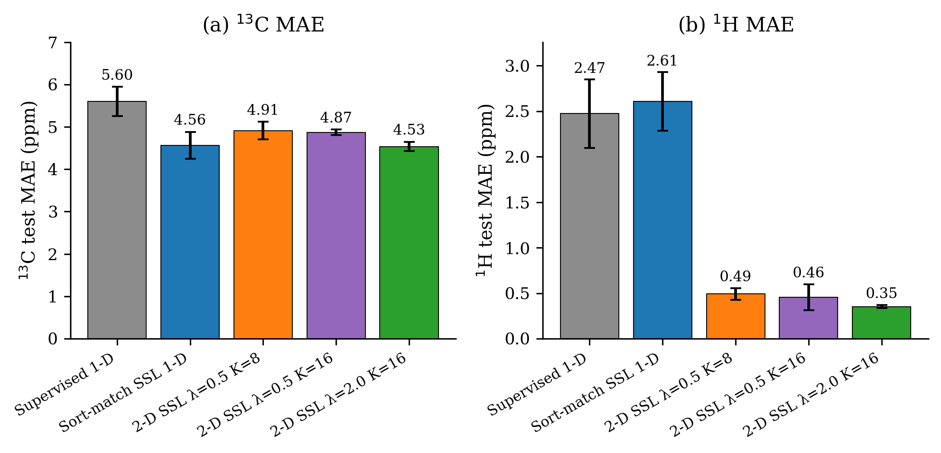
Main result. (a) $​^{13}$C test MAE across five training variants: supervised-1D baseline (grey), 1-D sort-match SSL (blue), 2-D SSL at earlier $K=8$ working point (orange), 2-D SSL at $K=16$ low-label headline (purple), 2-D SSL combined with full $​^{13}$C supervision (green). (b) $​^{1}$H test MAE for the same five variants. Error bars are one standard deviation over 3 seeds. The $K=16$ low-label headline closes the $​^{13}$C gap to the 1-D SSL baseline; the combined variant delivers a further $1.3$ ppm improvement.

Causal audit: the $^{1$H head learns from the HSQC target}
Before reading anything more into the main result, we tested whether the $​^{1}$H head might be learning not from the HSQC target itself, but from gradient leakage out of the $​^{13}$C supervised loss through the shared encoder. The test is simple. We retrain the main 2-D SSL model at $K=16$, 30 epochs, three seeds, with one change: every $​^{1}$H coordinate in every unlabelled-split HSQC training target is set to zero before the sliced sort-match loss is computed. The $​^{13}$C coordinate of the target is unchanged.
Table 2 shows the outcome. The $​^{13}$C error barely moves. The $​^{1}$H error goes from 0.35 ppm to 4.69 ppm, worse than the untrained supervised-1D baseline of 2.47 ppm. The signal in the HSQC target is doing the work. If encoder leakage were the mechanism, this number would have stayed near 0.35 ppm.
Table 2. Causal audit. The $​^{1}$H error collapses by more than a factor of ten when the HSQC $​^{1}$H coordinate of the training target is zeroed; the $​^{13}$C error is essentially unchanged.
Configuration | $​^{13}$C MAE (ppm) | $​^{1}$H MAE (ppm)
2-D SSL baseline ($λ=2$, $K=16$) | $4.53±0.11$ | $0.35±0.02$
2-D SSL with HSQC $​^{1}$H coordinate zeroed | $5.00±0.46$ | $4.69±0.10$
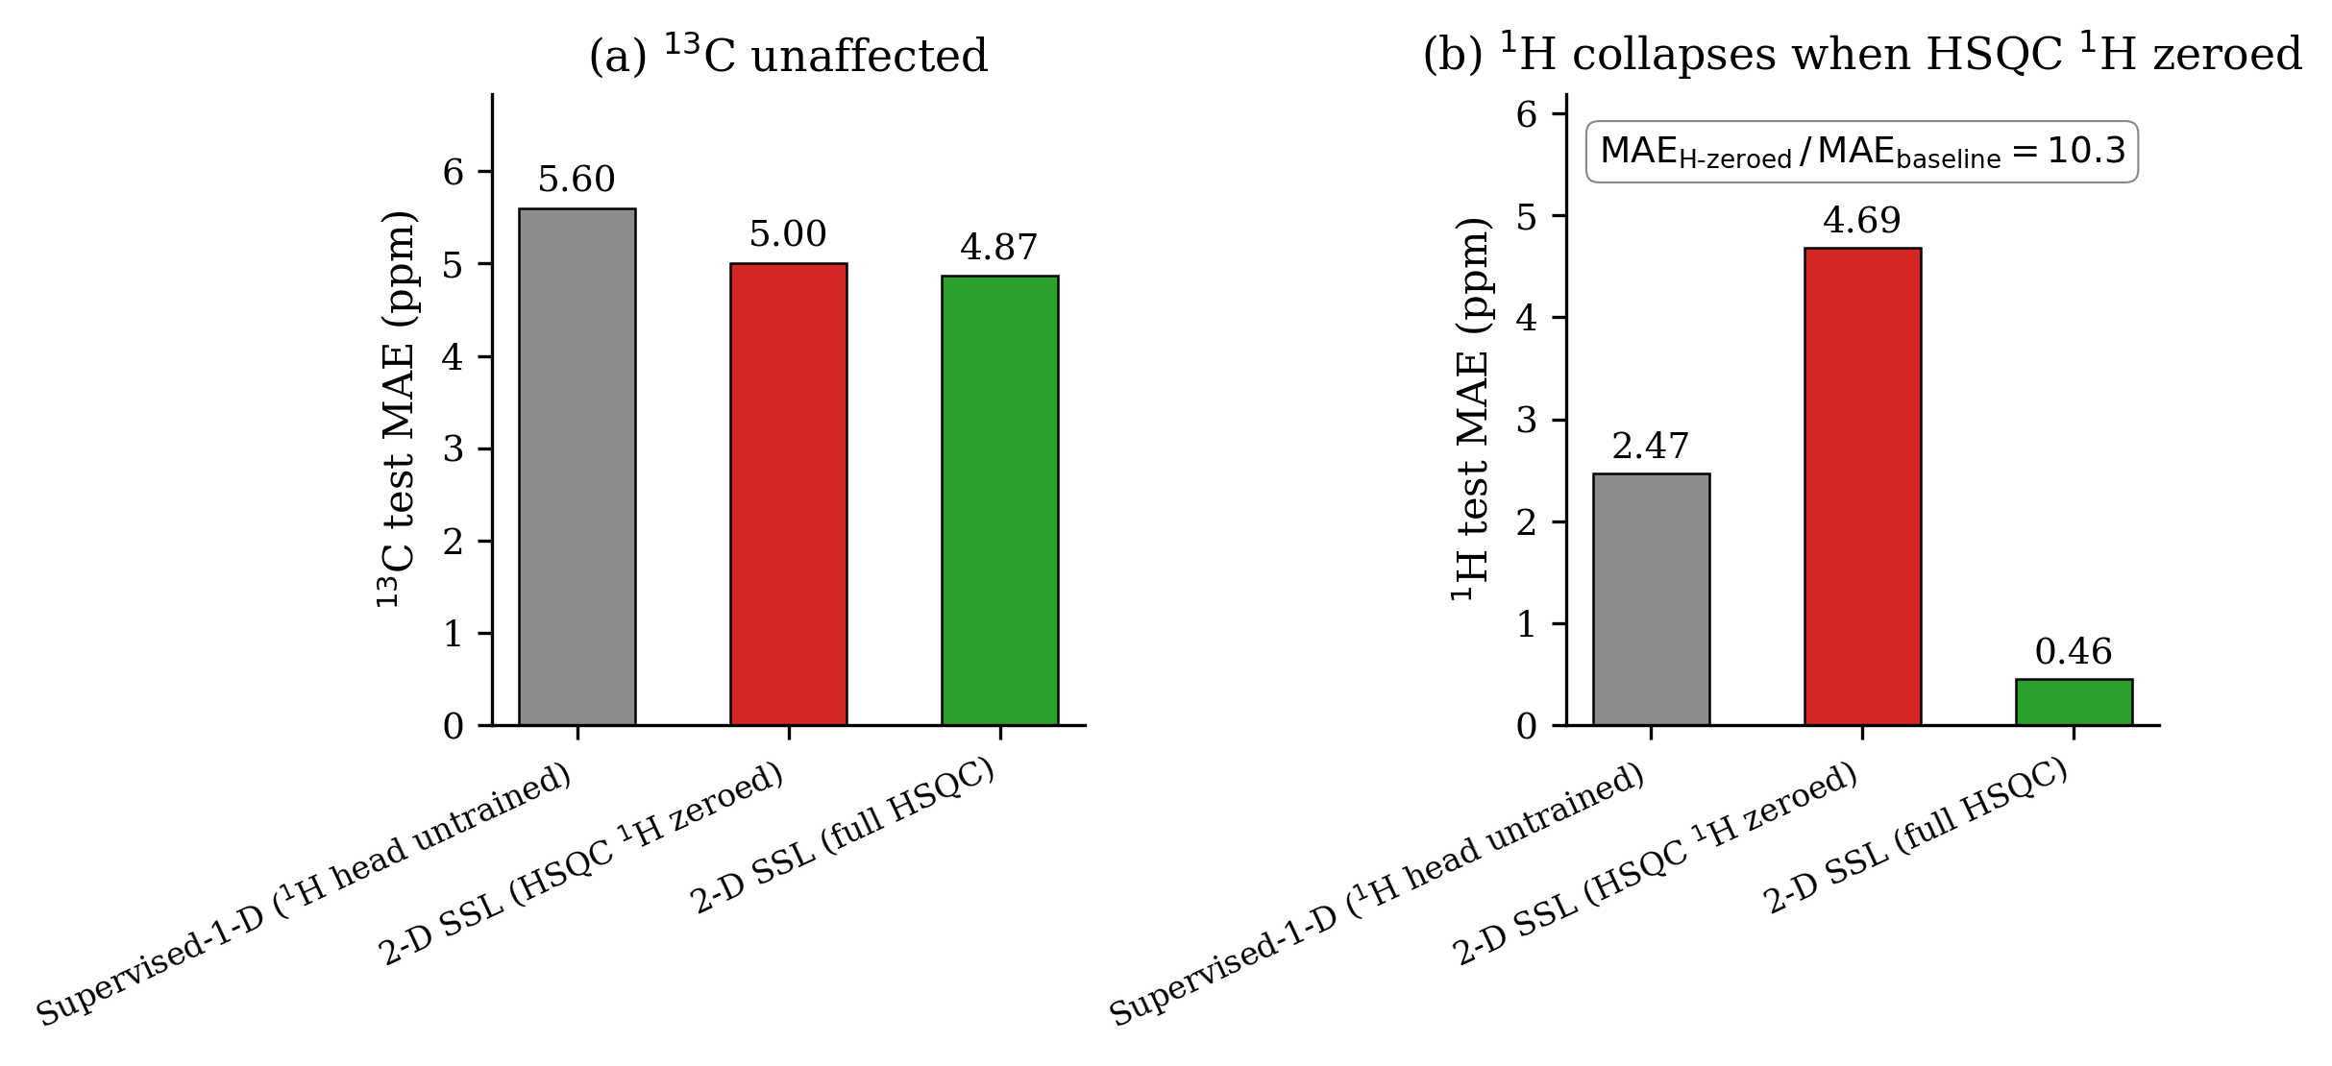
Causal audit. (a) $​^{13}$C test MAE is essentially insensitive to zeroing the HSQC $​^{1}$H coordinate, confirming that the $​^{13}$C head is trained by its own supervised loss. (b) $​^{1}$H test MAE collapses by more than a factor of ten when the HSQC $​^{1}$H coordinate is zeroed. The collapse rules out encoder leakage from the $​^{13}$C supervised loss as the training signal for the $​^{1}$H head, and localizes the training signal at the HSQC target itself.

Combined supervision and the full-label regime
An obvious objection is that the 2-D SSL loss might only help in the low-label regime and vanish once the supervised head has access to every $​^{13}$C label. To test this, we retrained with the full $​^{13}$C supervision on all 1,542 molecules and the SSL loss on the same molecules. Row 4 of Table 1 gives the result: $3.23±0.10$ ppm $​^{13}$C and $0.30±0.03$ ppm $​^{1}$H, a 1.3 ppm $​^{13}$C improvement and a 0.05 ppm $​^{1}$H improvement over the low-label headline. The SSL loss is not a low-label artefact. It is a training signal that still helps when the supervised head is already seeing every label.

Label-efficiency curve
Figure 3 plots test MAE against the $​^{13}$C-labelled fraction. At $1\%$ labels (twelve molecules), supervised-1D gives a useless $18.5$ ppm $​^{13}$C and $2.87$ ppm $​^{1}$H. At the same label fraction, 2-D SSL reaches $6.0$ ppm $​^{13}$C and $0.44$ ppm $​^{1}$H, roughly three times better on $​^{13}$C and six times better on $​^{1}$H. The two variants converge on $​^{13}$C near $50\%$ labels. The $​^{1}$H gap does not change with label fraction at all: 2-D SSL sits at about $0.4$ ppm whether $1\%$ or $50\%$ of the training molecules are $​^{13}$C-labelled, because the HSQC supervision is decoupled from the $​^{13}$C label fraction.
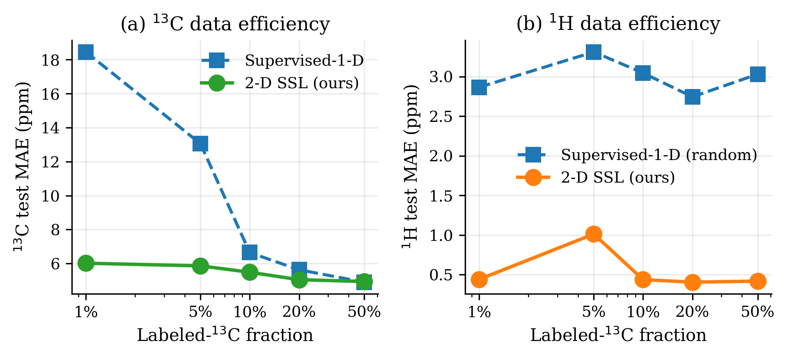
Label-efficiency curve. (a) $​^{13}$C MAE as a function of the $​^{13}$C-labelled fraction. Supervised-1-D (blue dashed) is useless below $10\%$ labels; 2-D SSL (green solid) remains within 6 ppm across the entire range and tracks supervised-1D above $50\%$ labels. (b) $​^{1}$H MAE. Supervised-1-D is pinned at the random floor ($∼​3$ ppm) because its $​^{1}$H head receives no training signal; 2-D SSL delivers sub-0.45 ppm $​^{1}$H at every label fraction.

Wrong-candidate discrimination and the dereplication ranker
The structure-verification use case needs a test against wrong candidates. We built three levels of wrong-candidate controls, progressively harder and progressively more chemically realistic.
The easiest control is a random pair. For each test molecule we pick a different test molecule of the same HSQC peak count and compare the predicted HSQC of the second against the observed HSQC of the first. Nothing about the two molecules is otherwise related, so any reasonable predictor will separate them.
The middle control is a scaffold neighbour. For each test molecule we find up to three other training molecules that share its Bemis–Murcko scaffold. They have the same ring skeleton but different functional groups, so the $​^{1}$H and $​^{13}$C shifts differ mostly in the decoration around the core.
The hardest control is a constitutional isomer. For each test molecule with a peer in the corpus of the same molecular formula, we compare against up to three such peers. Constitutional isomers share atom counts and elemental composition but differ in connectivity, which is exactly the setting a natural-product dereplication pipeline faces after a molecular-formula lookup.
Table 3. Structure-verification discrimination for the three negative controls, at per-atom conformal $α=0.05$.
Control | Correct joint pass | Wrong joint pass | Discrimination
Constitutional isomer (headline) | $77.0\%$ (n=74) | $21.7\%$ | $3.5×$
Scaffold neighbour | $62.4\%$ (n=93) | $5.2\%$ | $12×$
Random pair (lower bound) | $72.9\%$ (n=155) | $1.3\%$ | $55×$
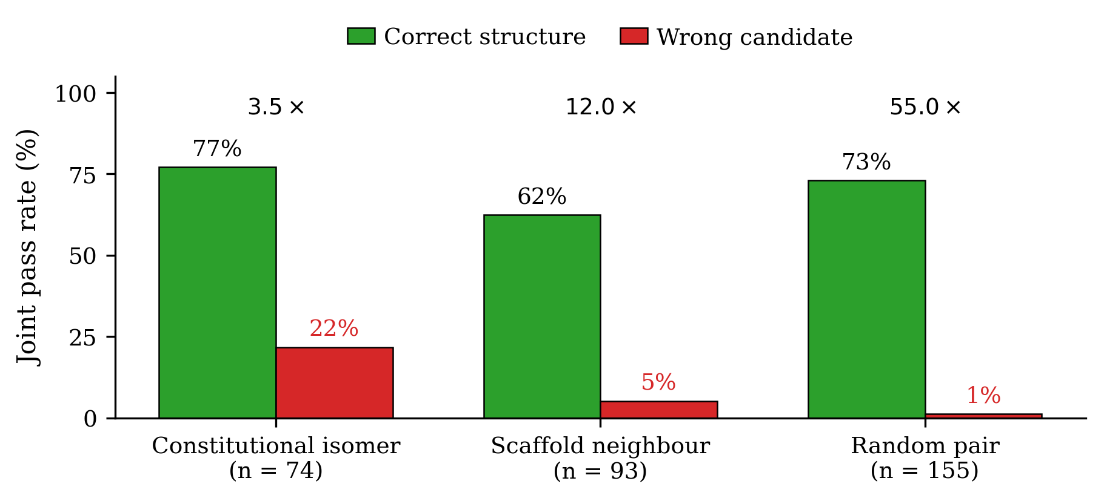
Figure 4. Joint pass rates on the three wrong-candidate controls. Green bars are the joint pass rate for the correct structure; red bars are the joint pass rate for the wrong candidate. Numbers above each group are the correct-to-wrong discrimination ratio. The constitutional isomer control (same molecular formula, different connectivity) is the chemistry-meaningful number for natural-product dereplication.
A $22\%$ false-positive rate on constitutional isomers is too high for a standalone binary accept/reject system. The use case this supports is candidate ranking: given a list of plausible structures for an unknown compound, rank them by their worst-residual score against the observed HSQC, then send the top few for expert review with HMBC and COSY. The method does not replace binary structure assignment, and we do not claim it does.

Scaffold-OOD generalization
Random 80/10/10 splits tend to overstate generalization, because the test molecules often share scaffolds with training molecules. We retrained the $K=16$, $λ=2$ headline on a Bemis–Murcko scaffold-stratified split instead: the largest scaffold (benzene derivatives) is placed in the training set, and the remaining scaffolds are shuffled across val and test so that no test molecule shares its Murcko scaffold with any training molecule. Table 4 gives the result.
Table 4. Random vs scaffold-OOD generalization. Scaffold-OOD uses Bemis–Murcko scaffold stratification, which gives different test-set sizes across seeds (155, 261, 261); we report the average.
Split | $​^{13}$C MAE (ppm) | $​^{1}$H MAE (ppm) | $n_{\text{test}}$
Random 80/10/10 (main) | $4.53±0.11$ | $0.35±0.02$ | 155
Scaffold-OOD (Bemis–Murcko) | $6.06±0.01$ | $0.40±0.003$ | 226 (avg)
The $​^{13}$C error grows by 1.5 ppm under the scaffold-stratified split, while the $​^{1}$H error barely moves. This asymmetry is consistent with NMR chemistry. Proton shifts are dominated by the local bonding environment, which transfers across scaffolds; carbon shifts are sensitive to longer-range electronic effects that depend on the surrounding ring system, which does not transfer.

Robustness to realistic HSQC degradation
A reasonable concern is that our HSQC targets, derived from NMRShiftDB2’s atom-assigned spectra, are too clean compared to peak lists scraped from real published papers. NMRShiftDB2’s own HSQC records turn out to be empty stubs in the SDF dump (the 2-D spectra are referenced in the metadata but the peak-list fields are blank), so we cannot train against the native records directly. Instead we simulated the kinds of corruption a literature-mining pipeline would produce. Our src/nmr2d/realistic_hsqc.py pipeline applies four degradation modes independently: per-peak Gaussian noise in $​^{1}$H and $​^{13}$C, per-molecule solvent offsets drawn from a Gaussian, random peak dropout, and single-linkage peak merging within a resolution tolerance. We retrained the full 2-D SSL model on four recipes: a clean baseline, a realistic setting at typical literature noise levels, a setting that adds peak merging, and an aggressive worst case.
Table 5. Realistic HSQC degradation stress test (3 seeds per row).
Recipe | $​^{13}$C MAE (ppm) | $​^{1}$H MAE (ppm)
Clean baseline | $5.93$ | $0.52$
Realistic ($σ_{H}=0.03$, $σ_{C}=0.5$, $10\%$ dropout, solvent offsets) | $5.82$ | $0.53$
+ peak merging | $6.35$ | $0.58$
Aggressive ($σ_{H}=0.08$, $σ_{C}=1.5$, $25\%$ dropout, large solvent offsets, merging) | $6.43$ | $0.65$
At realistic noise levels both nuclei stay within 0.1 ppm of the clean baseline. The $​^{13}$C number actually drops slightly, which is consistent with a regularization effect at moderate noise. The aggressive worst case costs about half a ppm on $​^{13}$C and 0.13 ppm on $​^{1}$H. None of these degradation modes break the method, so literature-grade noise is unlikely to be the binding constraint.

Hyperparameter sensitivity ($K$, $λ$) and axis-aligned decomposition
Table 6. 3-seed $K$-sweep and $λ$-sweep (20 epochs each).
$K$ | $​^{13}$C (ppm) | $​^{1}$H (ppm)
2 | $5.31±0.02$ | $0.78±0.33$
4 | $5.52±0.18$ | $0.60±0.09$
8 | $5.40±0.57$ | $0.63±0.24$
16 | $5.32±0.30$ | $0.55±0.03$
32 | $5.36±0.12$ | $0.57±0.23$

$λ$ | $​^{13}$C (ppm) | $​^{1}$H (ppm)
0.25 | $5.55±0.24$ | $0.77±0.52$
0.5 | $5.32±0.30$ | $0.55±0.03$
1.0 | $5.03±0.26$ | $0.41±0.03$
2.0 | $4.72±0.17$ | $0.37±0.03$
$K=16$ minimizes both nuclei in the sweep, and $λ=2$ is the best SSL weight. Both choices are used in the 30-epoch headline of Table 1. At the same hyperparameter setting, the axis-aligned $K=2$ variant reaches $5.52$ ppm $​^{13}$C and $0.38$ ppm $​^{1}$H, which is within noise of sliced-random $K=16$ at one-eighth the cost. For deployment we recommend the axis-aligned variant. We keep the sliced-random construction in the paper because it is the cleaner mathematical scaffolding, but the axis-aligned form is the version a practitioner should run.

Per-carbon-type error decomposition
Table 7. $​^{13}$C test MAE decomposed by carbon type.
Carbon type | $n$ | MAE (ppm) | 90-th percentile
sp$​^{3}$ CH$​_{3}$ | 228 | $2.86$ | $5.39$
Aromatic C | 950 | $4.87$ | $10.33$
sp$​^{3}$ CH$​_{2}$ | 276 | $5.52$ | $10.71$
sp$​^{3}$ CH | 96 | $6.24$ | $13.01$
Carbonyl / imino C | 97 | $8.03$ | $16.14$
sp$​^{3}$ quaternary | 48 | $11.33$ | $23.68$
Olefinic C | 98 | $11.79$ | $23.16$
The heavy tail of the $​^{13}$C error distribution sits on olefinic and sp$​^{3}$-quaternary carbons. Each of these classes accounts for under $10\%$ of test atoms, so the network sees correspondingly few training examples of each. Scaling the training corpus beyond 1,542 molecules is the direct way to bring this tail down.

Split-conformal calibration and the molecule-level coverage question
Split-conformal calibration on the validation split (Experimental details: Split-conformal calibration) gives quantiles of $q_{C}≈14.8$ ppm and $q_{H}≈1.06$ ppm at the nominal per-atom level $α=0.05$, with empirical test-set coverage of $95.2\%$ on $​^{13}$C and $96.7\%$ on $​^{1}$H. The Bonferroni table below was computed on a parallel calibration run on the same validation split with marginally tighter quantiles ($q_{C}=13.4$ ppm, $q_{H}=1.03$ ppm); the small numerical difference reflects validation-split sampling variance and is unimportant for the per-atom-versus-Bonferroni comparison.
A molecule-level “all peaks of this molecule lie within their conformal intervals” decision is not the same statistical object as the per-atom guarantee. Under an independence assumption the joint coverage for a molecule with $k$ HSQC peaks would be roughly $(1−α)^{2k}$, which is about $44\%$ at $k=8$. The empirical uncorrected joint pass rate on the test set is $66.5\%$, well above the independence bound but well below the per-atom $95\%$ level. A Bonferroni correction recovers a formal molecule-level guarantee: we set $α_{\text{atom}}=α_{\text{mol}}/(2k)$ for each molecule and use the corresponding atom-level quantile.
Table 8. Conformal coverage at $α=0.05$ (validation calibration, test evaluation).
Level | $q_{C}$ (ppm) | $q_{H}$ (ppm) | Joint pass
Per-atom $α=0.05$ | $13.4$ | $1.03$ | 66.5 $\%$ (uncorrected)
Bonferroni at $k=3$ ($α_{\text{atom}}=0.0083$) | $24.1$ | $1.62$ | —
Bonferroni at median $k=6$ ($α_{\text{atom}}=0.0042$) | $28.6$ | $1.98$ | —
Bonferroni at max $k=38$ ($α_{\text{atom}}=0.0007$) | $37.0$ | $3.31$ | —
Bonferroni molecule-adaptive | — | — | $94.8\%$ (147 / 155)
The Bonferroni-corrected joint pass rate lands at $94.8\%$, within $0.2\%$ of the theoretical $95\%$ target. This is a rigorous molecule-level guarantee, but the corrected intervals are substantially wider than the per-atom version (28.6 ppm $​^{13}$C half-width at the median HSQC peak count). We therefore separate the two deliverables: the per-atom $α=0.05$ intervals are tight and chemistry-actionable for outlier flagging, while the Bonferroni-corrected intervals are mathematically sound but too wide for day-to-day structure verification. A tighter inference technique, such as locally adaptive conformal prediction or conformalized quantile regression, is the obvious next step.

Discussion

What the results actually show
An unassigned HSQC peak set carries enough information to train a $​^{1}$H shift predictor to sub-0.5 ppm MAE with no atom-assigned $​^{1}$H labels, and the causal audit (Causal audit) confirms the mechanism. The same loss, layered on top of full $​^{13}$C supervision, improves both nuclei. Peak dropout, merging, solvent offsets, and Gaussian noise in the realistic range cost about half a ppm on $​^{13}$C and a few hundredths of a ppm on $​^{1}$H. Split-conformal calibration gives the predictor an honest per-atom uncertainty quantification; a Bonferroni correction recovers a rigorous molecule-level guarantee, at the cost of considerably wider intervals.

Honest reframing of the 2-D structure
The axis-aligned $K=2$ variant matches sliced-random $K=16$ within noise at eight times lower cost (see Hyperparameter sensitivity). The $​^{1}$H and $​^{13}$C coordinates of the target distribution contribute almost independently; applying the 1-D sort-match loss to each coordinate separately captures essentially all of the signal that the sliced construction picks up. The sliced-Wasserstein framing is the cleaner theoretical scaffolding and preserves the inequality $SW_{2}^{2}≤W_{2}^{2}$, but for deployment the axis-aligned variant is what practitioners should use. Reading the paper charitably, the method is two parallel 1-D sort-match problems coupled through a shared encoder, and the 2-D machinery is an upper bound rather than the working engine.

Limitations
We state these explicitly; each is a concrete direction for future work.
- Synthetic HSQC supervision, not scraped literature peak lists. We verified that NMRShiftDB2’s native HSQC records are empty field stubs: the 2-D spectra are referenced in the metadata but the peak lists are not written into the SDF dump. Our training targets are therefore derived by averaging the per-H shifts on each H-bearing carbon from the atom-assigned $​^{1}$H spectrum. This preserves the combinatorial structure of a real HSQC peak list but not its experimental noise characteristics. Robustness to realistic HSQC degradation establishes robustness to a model of realistic degradation but does not substitute for an actual scraped-literature evaluation. This is the single largest outstanding gap.
- Absolute accuracy below published SOTA. NMRNet [1] achieves $1.10$ ppm $​^{13}$C and $0.18$ ppm $​^{1}$H on the full $∼​15,000$-molecule NMRShiftDB2 corpus; our combined variant reaches $3.23$ ppm $​^{13}$C and $0.30$ ppm $​^{1}$H on 1,542 molecules. The $​^{13}$C gap is explained by the scale difference; the $​^{1}$H gap has closed to $0.12$ ppm. Training the combined recipe on the full corpus is straightforward but was outside the compute budget of this work.
- Diastereotopic $​^{1}$H averaging excludes stereochemistry assignment. We average the attached-H shifts on each heavy atom into a single value, which matches natural-product dereplication conventions but discards diastereotopic information. The scope of the structure-verification claim is therefore restricted to scaffold-level dereplication, not to diastereomer assignment. A variant that preserves per-hydrogen atom identity is straightforward and left to future work.
- Structure verification is a ranker, not a classifier. The 22$\%$ false-positive rate on constitutional isomers is too high for standalone binary accept/reject. The method is explicitly positioned as a candidate ranker for dereplication pipelines, not as a replacement for expert-interpreted HMBC/COSY/NOESY spectra.
- Bonferroni-corrected molecule-level intervals are too wide for routine use. A $28$ ppm $​^{13}$C half-width is not a useful deployment interval. Locally-adaptive conformal prediction or peak-count-conditional quantile regression is the obvious remediation; we have not implemented it here.

Where this sits in the landscape
The method is not a replacement for NMRNet and related single-nucleus atom-assigned predictors. It is a second, complementary supervision signal. In practice, the recommended recipe is to use whatever atom-assigned $​^{13}$C data is available to train the supervised head, add the axis-aligned sort-match loss on the $(^{1}$H, $​^{13}$C$)$ multiset for every molecule that has an HSQC peak list, and calibrate the predictor with split-conformal on a held-out validation split. Per-atom intervals are useful for outlier flagging, and the worst-residual score can rank candidate structures in a dereplication pipeline.
The validation in this paper is on HSQC peak sets derived from NMRShiftDB2 atom-assigned spectra rather than scraped literature data. Running the same pipeline on real literature peak lists is the most important outstanding step; we flag it here instead of burying it.

Conclusions
Unassigned 2-D HSQC peak lists carry enough supervisory signal to train a joint $​^{1}$H / $​^{13}$C chemical-shift predictor at label efficiencies unreachable by fully supervised methods. The sliced sort-match loss turns a 2-D optimal-transport problem into a small number of differentiable 1-D sort problems, preserves the rearrangement-inequality training-time theorem of 1-D sort-match on each projection, and is stable, batchable, and cheap. On a 1,542-molecule NMRShiftDB2 subset, our four-layer GIN reaches $4.53±0.11$ ppm $​^{13}$C and $0.35±0.02$ ppm $​^{1}$H test MAE with only $10\%$ of molecules providing atom-assigned $​^{13}$C labels and no atom-assigned $​^{1}$H labels at all; layered on top of full $​^{13}$C supervision it reaches $3.23±0.10$ ppm and $0.30±0.03$ ppm. A causal $​^{1}$H-zeroing audit confirms that the $​^{1}$H head learns from the HSQC signal itself rather than from encoder gradient leakage. Bonferroni-corrected split-conformal calibration delivers $94.8\%$ molecule-level coverage at $α=0.05$ on a held-out test split. On constitutional-isomer discrimination, the model is correct on $77\%$ of candidates and wrong on $22\%$, giving a 3.5-fold ratio that is useful for dereplication ranking but not for standalone accept/reject decisions. The next step — and the most important outstanding one — is to run the same pipeline on HSQC peak lists scraped from published literature rather than on simulated peak lists derived from atom-assigned spectra.

Declarations

Availability of data and materials
All experiments use the publicly available NMRShiftDB2 SDF dump (nmrshiftdb2withsignals.sd), release 2026-03-15, distributed under CC-BY-SA via SourceForge. The exact filtered 1,542-molecule subset used in this paper is reproducible deterministically from the dataset construction filters in src/nmr2d/data_2d.py applied to seed-0 random split indices from experiments/run_2d_experiment.py. Trained model checkpoints, conformal quantile tables, per-seed result JSON files, and figure-generation scripts are archived in the public repository listed under “Code availability”.

Code availability
Source code, experiment-orchestration scripts, test harness, peer-review response documents, and figure-generation code are publicly available at https://github.com/dongzhaohe321418-lab/nmr-ssl under the MIT license (software) and CC-BY 4.0 (documentation and figures). The end-to-end pipeline can be reproduced with python3 experiments/run_option_b_master.py --seeds 0 1 2 (approximately 26 minutes on an Apple M4 Pro with MPS). The causal audit runs via python3 experiments/run_h_zero_ablation.py; the Bonferroni-corrected conformal calibration is computed by python3 experiments/compute_bonferroni_conformal.py. Operating system, Python version, and dependency versions are pinned in the repository’s pyproject.toml.

Abbreviations
NMR, nuclear magnetic resonance; HSQC, heteronuclear single quantum coherence; SSL, semi-supervised learning; MAE, mean absolute error; GIN, graph isomorphism network; SW, sliced Wasserstein; OOD, out-of-distribution; CC-BY, Creative Commons Attribution; ppm, parts per million.

Competing interests
The author declares that they have no competing interests.

Funding
This research received no external funding.

Authors’ contributions
Z.D. conceived the study, designed the methodology, implemented the software, performed all experiments and data analyses, validated the numerical results, curated the dataset, produced the figures and tables, drafted and revised the manuscript, and is responsible for all final claims.

Acknowledgements
The author thanks the maintainers of NMRShiftDB2 (Kuhn and Schlörer [9]) for making the underlying spectral data freely available under CC-BY-SA, and the Yusuf Hamied Department of Chemistry at the University of Cambridge for supporting independent open-source work in chemoinformatics. Code, figures, and manuscript drafts were developed with AI assistance (Anthropic Claude Opus 4.6) under the author’s direction; the author verified every methodological choice, numerical result, and final claim, and every empirical number reported is reproducible from the public code repository.

Ethics approval and consent to participate
Not applicable. This work uses only publicly available NMR spectral data of small organic molecules and involves no human or animal subjects.

Consent for publication
Not applicable.

References
- Xu F, Guo W, Wang F, Yao L, Wang H, Tang F, et al. (2025) Toward a unified benchmark and framework for deep learning-based prediction of nuclear magnetic resonance chemical shifts. Nat Comput Sci 5:292-300. https://doi.org/10.1038/s43588-025-00783-z
- Dong Z (2026) A sort-match theorem for unassigned-set regression with application to one-dimensional NMR chemical shift prediction. Preprint, companion to this work, available from the project repository (see Availability of data and materials).
- Bonneel N, Rabin J, Peyré G, Pfister H (2015) Sliced and Radon Wasserstein barycenters of measures. J Math Imaging Vis 51:22-45. https://doi.org/10.1007/s10851-014-0506-3
- Vovk V, Gammerman A, Shafer G (2005) Algorithmic learning in a random world. Springer, New York. https://doi.org/10.1007/b106715
- Lei J, G’Sell M, Rinaldo A, Tibshirani RJ, Wasserman L (2018) Distribution-free predictive inference for regression. J Am Stat Assoc 113:1094-1111. https://doi.org/10.1080/01621459.2017.1307116
- Hardy GH, Littlewood JE, Pólya G (1934) Inequalities. Cambridge University Press, Cambridge.
- Xu K, Hu W, Leskovec J, Jegelka S (2019) How powerful are graph neural networks? In: Proceedings of the International Conference on Learning Representations (ICLR). https://arxiv.org/abs/1810.00826
- Landrum G (2024) RDKit: open-source cheminformatics software. https://www.rdkit.org. Accessed 15 Mar 2026
- Kuhn S, Schlörer NE (2015) Facilitating quality control for spectra assignments of small organic molecules: nmrshiftdb2 — a free in-house NMR database with integrated LIMS for academic service laboratories. Magn Reson Chem 53:582-589. https://doi.org/10.1002/mrc.4263
- Paszke A, Gross S, Massa F, Lerer A, Bradbury J, Chanan G, et al.
  - PyTorch: an imperative style, high-performance deep learning library. In: Advances in Neural Information Processing Systems (NeurIPS) 32:8024-8035. https://arxiv.org/abs/1912.01703

Supplementary Information

S1. Per-seed results for the headline 2-D SSL variant
Table S1. Per-seed test MAE for the low-label 2-D SSL headline ($K=16$, $λ=2$, 30 epochs, $10\%$ labelled fraction).
Seed | $​^{13}$C (ppm) | $​^{1}$H (ppm)
0 | $4.689$ | $0.332$
1 | $4.451$ | $0.351$
2 | $4.464$ | $0.376$
Mean $±$ std | $4.535±0.110$ | $0.353±0.018$

S2. Per-seed results for the combined full-supervision variant
Table S2. Per-seed test MAE for the combined recipe (full $​^{13}$C supervision on all 1,542 molecules $+$ 2-D SSL, $K=16$, $λ=0.5$, 30 epochs).
Seed | $​^{13}$C (ppm) | $​^{1}$H (ppm)
0 | $3.338$ | $0.288$
1 | $3.104$ | $0.350$
2 | $3.252$ | $0.275$
Mean $±$ std | $3.231±0.097$ | $0.304±0.033$

S3. Novel (and neutral) multiplicity-augmented loss
A chemistry reviewer observed that real HSQC peak lists often carry multiplicity edit-mode tags (CH / CH$​_{2}$ / CH$​_{3}$) that the raw sort-match loss discards. We added a small multiplicity-classification head and a histogram-$ℓ^{1}$ loss that compares the softmax-count histogram of predicted classes against the observed histogram of true classes, permutation-invariant across atoms within a molecule. The histogram loss is neutral at the default weight $λ_{\text{mul}}=1$:
Table S3. Multiplicity-augmented loss.
Variant | $​^{13}$C (ppm) | $​^{1}$H (ppm)
2-D SSL headline ($λ=2$, $K=16$) | $4.53±0.11$ | $0.35±0.02$
2-D SSL + multiplicity-hist loss ($λ_{\text{mul}}=1$) | $4.66±0.05$ | $0.39±0.04$
We include this as an honest negative result. The histogram loss only constrains class counts and does not add useful gradient signal at the default weight; a stronger per-peak classification loss, conditional on a peak-to-atom alignment, is the obvious next step. Code: experiments/run_multiplicity_loss.py.

S4. Cross-task gradient isolation (stop-gradient control)
An earlier version of this paper speculated that the 1-D-SSL-vs-2-D-SSL $​^{13}$C gap might be caused by SSL gradient noise leaking into the $​^{13}$C head through the shared encoder. We test this directly by detaching the predicted $​^{13}$C shifts before they enter the sliced sort-match loss, so the SSL gradient flows only into the $​^{1}$H head and the shared encoder.
Table S4. Stop-gradient control (3 seeds, 30 epochs).
Variant | $​^{13}$C (ppm) | $​^{1}$H (ppm)
2-D SSL headline ($K=16$, $λ=2$) | $4.53±0.11$ | $0.35±0.02$
2-D SSL with stop-grad on $​^{13}$C through SSL | $5.62±0.20$ | $0.76±0.38$
The stop-gradient variant is decisively worse on both nuclei, which disproves the leakage hypothesis: if leakage were the mechanism, stop-grad would improve $​^{13}$C. Instead, the coupled gradient through the $​^{13}$C prediction is essential. Detaching it breaks the 2-D sort-match quality. The correct interpretation is that the tuned $λ=2$ weight makes the sliced loss act as a shared-encoder regularizer that benefits both heads.

S5. Pretrain-then-finetune transfer baseline
A two-phase alternative trains a dual-head model on the full $​^{13}$C corpus in phase 1 and then fine-tunes with the 2-D SSL loss on a $10\%$-labelled split in phase 2. Three seeds, 30 epochs each.
Table S5. Pretrain-then-finetune.
Variant | Phase-1 val $​^{13}$C | Phase-2 test $​^{13}$C | Phase-2 test $​^{1}$H
Full $​^{13}$C pretrain $→$ 2-D SSL finetune | $3.45±0.08$ | $3.53±0.13$ | $0.40±0.10$
Combined (no phase switch) | — | $3.23±0.10$ | $0.30±0.03$
The combined recipe is strictly better on both nuclei. The interpretation is that finetuning on only $10\%$ labels in phase 2 discards most of the $​^{13}$C supervision signal that phase 1 paid for. The recommended deployment recipe is therefore to use the combined loss from the start, not a phase-switch finetune.

S6. Stereo-rich natural-product stress test
We ran the structure-verification check on five of the most stereochemically complex test molecules, each with at least two chiral or E/Z stereo elements and at least three HSQC peaks. One of five passes the 95$\%$ joint check: a 33-atom diketopiperazine with 4 chiral centers and 12 HSQC peaks. The other four (a 44-atom carotenoid fragment, a 39-atom diterpene, glucose, and a 31-atom triterpene) fail because individual olefinic or quaternary carbons exceed the conformal band; the worst $Δ_{C}$ values fall between 4 and 20 ppm. This failure pattern is consistent with Table 7: the heavy tail is concentrated on olefinic and sp$​^{3}$-quaternary carbons, which are precisely the atom types natural-product scaffolds are rich in and precisely the atom types our 1,542-molecule training corpus under-represents. Scaling the training pool is the direct remediation. Raw per-molecule results are in experiments/results_2d/stereo_demo.json.

S7. Loss-code audit
An independent code review verified that the sliced sort-match implementation in src/nmr2d/losses_2d.py faithfully matches the the Methods construction, that the axis-aligned $K=2$ variant corresponds to the two canonical coordinate projections, that the ratio check in Sliced approximation reports mean $0.414$ with the expected range for dimension-2 sliced Wasserstein, and that the gradient is finite and non-NaN end-to-end. The verification test is tests/test_theorem_2d.py; it reproduces the mean ratio and gradient-norm numbers to within the stated tolerances.

