Viewing, Listening and Speaking,

Book 4 Viewing, Listening and Speaking, Book 4 Units 1-5 review

Speak for 1-2 minutes about one topic (teacher will choose your topic at the beginning of the exam)

以上就是我关于有关 的问题的一些观点

The above are some of my views on the issue of

Unit 1 (Free Therapy)

Upgrade your life (pg 12 + 13)

Should you upgrade your life?

是的我认为我应该。在之前填写的调查问卷中，我的得分是比较低的，尤其是在饮水量以及mental activity方面，这两项我的得分都只有1，为此，我准备每天多喝几杯水，多进行一些mental activity来让我的得分相对高一点。此外，我每周吃水果的次数也很少，主要是因为南京农业大学的水果店比较贵，但现在我有了比较便宜的水果来源，我会增加每周吃水果的次数，这样我的分数就会进一步提高。

Yes, I think I should. In the survey questionnaire I filled out earlier, my score was relatively low, especially in terms of water intake and mental activity, both of which I only scored 1. Therefore, I plan to drink a few more glasses of water every day and do more mental activities to make my score relatively high. In addition, I eat fruits very few times a week, mainly because the fruit shop at Nanjing Agricultural University is relatively expensive. However, now that I have a cheaper source of fruits, I will increase the number of times I eat fruits every week, which will further improve my score in the questionnaire.

Things to do on the weekend to improve your life?

Eg: exercise, express gratitude, enjoy your hobbies, etc.

在周末有时候作业太多我也会整个周末都呆在，宿舍里做作业，有时候我会到校园外面去玩，去见识一下校外的事物来拓宽自己的视野，同时还能放松自己，使自己从繁重的学习任务中短暂的脱离出来，以便于下周更好的投入到学习中。有时候我会在学校和好朋友一起打游戏，一起体验在游戏中击败对手获得胜利的快乐，被对手击败之后也不会气馁，因为有人一起陪伴着我，大家在一起玩，周末就是比较快乐的时光了，

On weekends, sometimes there is too much homework to do, and I have to stay in the dormitory to do it all weekend. Sometimes, I may go outside the campus to play and see things outside the campus to broaden my horizons. At the same time, I can relax and temporarily break away from the heavy learning tasks, so that I can better immerse myself in learning next week. Sometimes I play games with my good friends in the dormitory, experiencing the joy of defeating opponents and winning together. Even after being defeated by opponents, I won't be discouraged because there are people accompanying me. Everyone plays together, and weekends will be a relatively happy time,

Suggested topics (pg 14)

1. A place you know well

令我印象最深刻的地方是我的母校江苏省赣榆高级中学，位于连云港市赣榆区青口镇，他在小镇的核心位置。作为全赣榆最好的高中，每年他都为全国的高校培养出大批优秀的学生，他们在大学毕业后也称为社会的中坚力量。此外，校园内部的金色也十分美丽，校内有两个湖，一个叫怀仁湖，一个叫dushu湖，两个湖里面都有鱼和荷花，每当夏天到来，满池荷花开放是一番令人沉醉的景色

The most impressive place for me is my alma mater, Jiangsu Ganyu Senior High School, located in Qingkou Town, Ganyu District, Lianyungang City. It is located at the core of the town. As the best high school in Ganyu, he cultivates a large number of outstanding students for universities across the country every year, who are also known as the backbone of society after graduating from university. In addition, the golden color inside the campus is also very beautiful. There are two lakes on campus, one called Huairen Lake and the other called Dushu Lake. Both lakes contain fish and lotus flowers. Whenever summer comes, the pond is filled with lotus flowers, which is an intoxicating scenery

1. A good friend

我的一位好朋友是高中时候的一位同桌，他是一个成绩很好的学生，每次我遇到不会的题目都会和他一起讨论，有时候我俩会因为在一道题上的看法不同而争论一整天。除此之外，他和爱运动，特别是跑步，去年他参加了南京的半程马拉松，虽然没能获得一个好的名次，但是他坚持跑完了全程。他性格也很开朗，每次看他他都保持着笑容，即使遇到了伤心的事情很快也就恢复了，这一点很令我佩服。

One of my good friends was a high school desk mate. He was a student with good grades, and every time I encountered a problem that I couldn't solve, I would discuss it with him. Sometimes we would argue all day because we had different opinions on the same problem. In addition, he loves sports, especially running. Last year, he participated in the half marathon in Nanjing. Although he did not achieve a good ranking, he persisted in running the entire distance. He has a very outgoing personality, and every time he looks at him, he always keeps a smile on his face. Even when encountering sad things, he quickly recovers, which I admire very much.

1. A TV show you enjoy

我最喜欢的TVshow是go fighting，意思是challenge the extreme。不同于其他的TVshow，他没有固定的剧本，只有大体的节目走向，具体的内容由演员们自己决定，充满了不确定性，每次演员们的决定都会让人们开心大笑。但这样有时候也会有危险，有一次导演组计划在水中拍摄一期节目，但是有一位演员不会游泳，差点溺水。自此以后，导演组在安排节目时也会考虑到安全因素，保证演员的安全。总的来说这是一个很好的TVshow，我希望他能发展的更好

My favorite TVshow is go lighting, which means challenging the extreme. Unlike other TVshows, he does not have a fixed script, only a general program direction, and the specific content is determined by the actors themselves, full of uncertainty. Every time the actors make a decision, it makes people laugh happily. But sometimes this can also be dangerous. Once, the director team planned to shoot a program in the water, but one actor couldn't swim and almost drowned. From then on, the director team will also consider safety factors when arranging programs to ensure the safety of the actors. Overall, this is a great TVshow and I hope it can develop better

Smiling (pg 11 + 19)

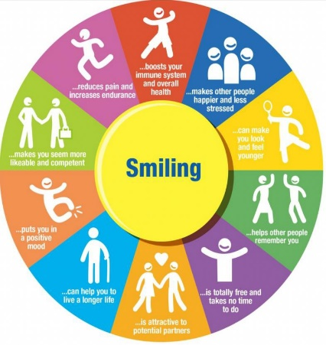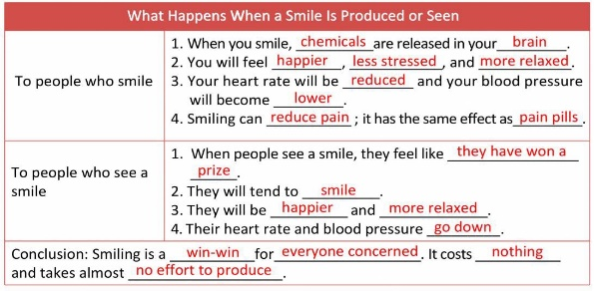

Reasons for smiling?

当我微笑的时候，我的大脑中会产生一种化学物质，它会让我感觉更加开心，减少我的压力并且使我放松。同时我的心跳会变慢，血压会下降。微笑还可以像某些止痛药一样减少疼痛。对他人微笑，他们的心情也会变得更好，也会微笑。他们也会感到很放松。而且，有科学研究表明，经常微笑还可以让我们看上去更加年轻并且延长我们的寿命，，使我们生活的更加健康。这样一个双赢的动作，而且不会有任何代价，所以为什么不微笑呢？

When I smile, my brain produces a chemical that makes me feel happier, reduces my stress, and makes me relax. At the same time, my heart rate will slow down and my blood pressure will decrease. Smiling can also reduce pain like some painkillers. Smiling at others can also improve their mood and make them smile. They will also feel very relaxed. Moreover, scientific research has shown that smiling regularly can make us look younger and extend our lifespan, making our lives healthier. This is a win-win action, and there will be no cost, so why not smile?

Unit 2 (The Right to Know)

What would you ask? (pg 29)

Which company would you question? What would you ask? Why would you ask this?

我想要问的公司是阿里云。问题是为什么他要在程序员35岁的时候把他们开除。我认为，35岁是一个人最劳累的时候，他们有年迈的父母需要赡养，有年幼的孩子要上学，全家人的衣食住行都在他的肩上，这时候把他开除相当于一个家庭的顶梁柱倒下了，这个家庭的生活也会变得艰难。这就是我要问的阿里云他们为什么要在程序员35岁的时候把他们开除的原因。

The company I want to ask is Alibaba Cloud. The question is why it fired programmers when they were 35 years old. I believe that the age of 35 is the most exhausting time for a person. They have elderly parents to support, young children to attend school, and the entire family's clothing, food, housing, and transportation are on their shoulders. At this time, firing him is like the backbone of a family collapsing, and the life of the family will become very difficult. This is the reason why I want to ask Alibaba Cloud why they fire programmers when they were 35 years old.

Transparency (pg 37)

Examples of companies being transparent?

比如那些食品公司，国家要求他们必须在国家的相关网站上注册登记自己的品牌信息，并且将自己所生产的食物的详细信息都在网站上罗列出来，让公众知道这种食物是由什么制造出来的，吃了可能会有什么副作用。还有一些药品制造商，国家药品管理局要求他们在相关网站上发表自己药品的实际组成，实验过程和结果，以及最终的药效和副作用。否则就不允许他们的药品上市。

For example, for food companies, the government requires them to register their brand information on relevant national websites and list detailed information about the food they produce on the website, so that the public can know what this food is made from and what side effects it may have. There are also some drug manufacturers, and the National Drug Administration requires them to publish the actual composition, experimental process and results, as well as the final efficacy and side effects of their drugs on relevant websites. Otherwise, their drugs will not be allowed to go on the market.

Positives and negatives of companies being transparent?

一些经营良好的公司在将他们的生产数据公开之后，人们会看到他们所收取的利润确实很少，就会更加支持他们的公司，更多地购买他们的产品，这样他们拥有的经济资本就会更多了，就会生产出更多好的产品从而促进国家经济的发展。而一些公司经营的不好，在公开数据之后，群众会看到他们赚取的巨额利润，就不会再去购买他们的产品，他们赚得的利润就会少，从而被迫退出市场，这样也会促进市场的良性发展，促进经济的发展

After some well managed companies disclose their production data, people will see that the profits they receive are indeed small, and they will support their companies more and purchase more of their products. This will increase their economic capital, produce more good products, and promote the development of the national economy. And some companies operate poorly. After disclosing data, the public will see the huge profits they earn and will no longer purchase their products. The profits they earn will be small, forcing them to withdraw from the market. This will also promote the healthy development of the market and promote economic development

Transparency Vs privacy?

我认为是保持透明或者隐私是相对的，有的时候保持透明是好的行为，比如一些经营良好的公司在将他们的生产数据公开之后，人们会看到他们所收取的利润确实很少，就会更多地购买他们的产品，这样他们拥有的经济资本就会更多，就会生产出更多好的产品从而促进国家经济的发展。有时候保持隐私是好的，比如医生在治疗患者的时候，不会告诉患者特具体的病情，而是和患者的家属谈论，这样尊重了患者的隐私，还能缓解他的心情，有利于他病情的恢复，所以保持透明或者隐私是相对的

I believe that maintaining transparency or privacy is relative, and sometimes maintaining transparency is a good behavior. For example, some well run companies will see that their production data is indeed very small after being disclosed, and people will purchase more of their products. This will increase their economic capital and produce more good products to promote the development of the national economy. Sometimes maintaining privacy is good, for example, when doctors treat patients, they do not tell them specific conditions, but instead discuss with the patient's family members. This respects the patient's privacy, alleviates their mood, and is beneficial for their recovery. Therefore, maintaining transparency or privacy is relative

Examples of being transparent in other relationships?

我认为师生关系也是需要保持透明的一种关系，因为老师通过考试可以比较系统的了解一名学生对于知识点的掌握情况，之后老师可以一对一地和学生们进行谈话，告诉他们他们自己的弱势和优点，学生可以有针对性地制定自己的学习方案。学生也要及时和老师反映自己在学习中遇到的难题，经过老师的指点之后，学生可能会有更加好的想法，老师也能从中学习到一些东西。所以在师生之间保持透明是一种双赢的做法

I believe that the teacher-student relationship also needs to be transparent, as teachers can systematically understand a student's mastery of knowledge points through exams. Afterwards, teachers can have one-on-one conversations with students, telling them their own weaknesses and strengths, and students can develop their own learning plans in a targeted manner. Students should also promptly report their difficulties in learning to the teacher. With the teacher's guidance, students may have better ideas, and the teacher can also learn something from them. So maintaining transparency between teachers and students is a win-win approach

Eg :doctors being transparent about their training and experience when they speak to their patients.

Unit 3 (Listen up!)

The business of listening (pg 50)

What are some jobs for which listening skills is very important?

我认为医生是一个很需要聆听技巧的职业，担负着救死扶伤的使命，他们需要仔细倾听患者对于自身病情的描述，之后快速的进行判断患者的病是什么病，病情如何。此外，他们还要倾听患者的家庭条件从而采取适合患者家庭的治疗方案决定为患者开什么药才能使得他们的病情得到治疗的同时家庭也能负担的起。最重要的时，医生需要聆听患者在治疗过程中的苦恼帮他们缓解压力，这样患者才能恢复的更快

I believe that doctors are a profession that requires listening skills, responsible for the mission of saving lives and helping the wounded. They need to carefully listen to patients' descriptions of their own conditions, and then quickly determine what and how their illness is. In addition, they also need to listen to the patient's family conditions in order to adopt treatment plans that are suitable for the patient's family and decide what medication to prescribe for the patient in order to receive treatment for their condition, while the family can also afford it. Most importantly, doctors need to listen to patients' distress during the treatment process to help them relieve stress, so that patients can recover faster

Other important skills include speaking, writing and reading. Which skill is most valuable?

我认为speaking时最重要的一项技能，因为在日常生活之中，除了listening之外，我们最需要做的是让别人清楚的理解我们所要表达的意思，只有别人正确理解了我们在说什么，我们才能与他人进行有效的沟通，进而达到与他人交流、解决问题、交换信息的目的。如果我们的speaking技能不好，别人无法理解甚至错误理解我们的意思，就可能发生争执，无法有效的解决问题从而停留在事情的某一阶段无法前进

I think speaking is the most important skill in daily life, because in addition to listening, what we need to do most is to make others understand the meaning we want to express clearly. Only when others correctly understand what we are saying can we communicate effectively with others, thereby achieving the goal of communicating, solving problems, and exchanging information with others. If our speaking skills are not good, others may not understand or even misunderstand our meaning, which may lead to disputes, ineffective problem-solving, and inability to move forward at a certain stage of the matter

Why is listening important?

我认为听很重要的原因如下：在日常生活中，如果我们想要与他人进行有效的沟通，第一步就是正确理解他人的意思，只有当我们正确理解了他人的意思之后，我们才能组织自己的语言区表达我们自己的意思。有时候，与他人沟通仅仅需要静静地倾听就够了，甚至都不需要我们说话，倾诉者就会得到安慰。一名好的倾听者给人的感觉是静谧的，大多数人都愿意与他共同工作，一起进步

I think the reason why listening is important is as follows: in daily life, if we want to communicate effectively with others, the first step is to correctly understand their meaning. Only after we have correctly understood their meaning can we organize our own language area to express our own meaning. Sometimes, communicating with others simply requires listening quietly, without even needing us to speak, and the speaker will receive comfort. A good listener gives a feeling of tranquility, and most people are willing to work with him and progress together

Listening styles (pg 53)

What is your listening style?

我的listening style应该是action-focused类型，因为相比较于与他人进行交流，我的关注点更加侧重于这次交流为什么会发生，还有这次对话过后我会做出什么举动，这些举动又会带来什么样的结果。我也比较倾向于倾听那些说话清晰准确的人说话，因为他们的话语然我很快地就抓住了此次对话的重点，并迅速给出我的答案从而节约双方的时间。此外，我很喜欢那些在对话开始就直接进入主题的对话，这种对话的效率比较高，着重点也比较明显。

My listening style should be of the action focused type, because compared to communicating with others, my focus is more on why this conversation occurred, what actions I will take after this conversation, and what results these actions will bring. I also tend to listen to people who speak clearly and accurately, because their words quickly capture the focus of this conversation and provide my answers quickly, saving time for both parties. In addition, I really like conversations that directly enter the topic at the beginning of the conversation, which are more efficient and have a clear focus.

Advantages and disadvantages of each style?

我认为action-focused类型的人做事情的效率可能比较高，但是他们的幽默感可能没有那么好，人际关系可能不是很好。相反，people-focused类型的人幽默感比较好，但是会可能会过度关注和他人的关系导致无法全身心地投入到工作之中。content-focused类型的人知识渊博，可以解决很多问题，但是他们的创新能力比较差。time-focused类型的人办事效率也是比较高的，但他们办事可能会有一点死板，不近人情

I think action focused individuals may be more efficient in doing things, but their sense of humor may not be as good and their interpersonal relationships may not be very good. On the contrary, people of the people used type have a better sense of humor, but may overly focus on their relationships with others, preventing them from fully immersing themselves in their work. Content focused individuals have extensive knowledge and can solve many problems, but their innovation ability is relatively poor. Time used people are also more efficient in their work, but they may be a bit rigid and unfriendly in their work

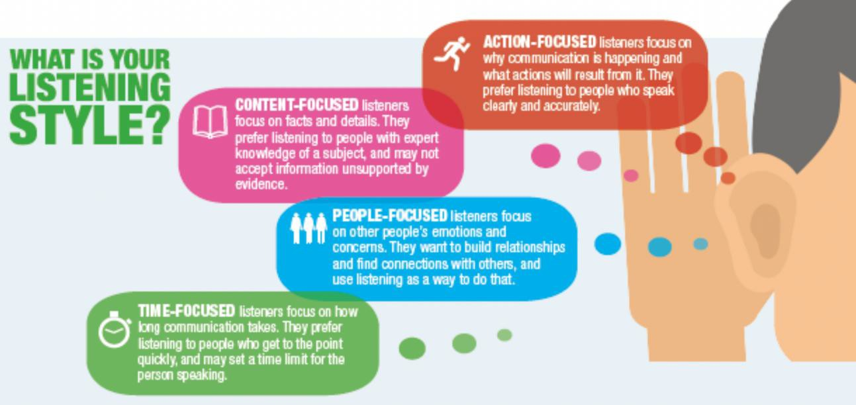

Humour (pg 60)

2 types of humour

Say something humorous/Say something humorously

Advantages and disadvantages of using humour?

我认为在对话中使用humour的优势有：humour可以使得原本平淡的对话变的生动有趣，让听者更加有兴趣去听自己讲述，而不是丢失听者的注意力，一个人独自讲述。劣势有：在不懂得当地的风俗习惯的时候，使用humour可能会与当地的风俗相反，比如红色在中国表示吉利喜庆的意思，但是在泰国就是死亡的意思，因此在泰国随意使用红色可能会引起当地人的不高兴。只有当我们充分了解当地的风俗习惯之后，合理使用humour才能使我们的对话更加生动有趣

I think the advantages of using humour in conversations are: humour can make the originally dull conversation more vivid and interesting, making the listener more interested in listening to their own story, rather than losing the listener's attention and speaking alone. Disadvantages: When not understanding local customs and habits, using humour may be opposite to the local customs. For example, in China, red means auspicious and festive, but in Thailand, it means death. Therefore, using red casually in Thailand may cause dissatisfaction among local people. Only when we fully understand the local customs and habits, can we use humour reasonably to make our conversation more vivid and interesting

Do you use humour when speaking English? Why or Why not?

我在说英语的时候一般不会使用humour。一方面我对英语国家的习俗了解过少，可能我认为有趣的事情在他们的认知中就不是一件有趣的事情，而且可能我认为好的事情在他们的习俗中是一件不好的事情，使用humour可能会使得对话的氛围变的冷漠。而且我现在的英语水平不是很高，很多用汉语说很有趣的事情翻译成英语之后就没有了原有的趣味，这样humour就没有了原有的作用，还可能会使别人误解我的意思

I usually don't use humour when speaking English. On the one hand, I have too little understanding of the customs of English speaking countries. Perhaps I believe that interesting things are not interesting things in their cognition, and perhaps I believe that good things are not good things in their customs. Using humour may make the atmosphere of the conversation become indifferent. Moreover, my current English proficiency is not very high. Many interesting things that are said in Chinese are translated into English and lose their original interest. This way, humour loses its original function and may even cause others to misunderstand my meaning

Unit 4 (Big Data)

What is big data? (pg 71)

根据百度百科，大数据又被称为巨量资料，是指所涉及的资料量规模巨大导致短时间内无法通过主流软件工具，达到管理、处理、并整理成帮助人们进行决策的有效信息。大数据包括结构化数据、半结构化数据和非结构化数据。现在，非结构化数据已经成为了数据的主要部分。其实大数据就是互联网发展到现在阶段的一种表象而已，在以快速计算为代表的技术的支持下，这些原本难以收集和使用的数据开始容易被收集起来，从而构成了所谓的大数据

According to Baidu Baike, big data is also called huge data, which means that the amount of data involved is so huge that it can not be managed, processed and sorted into effective information to help people make decisions through mainstream software tools in a short time. Big data includes structured data, semi-structured data and unstructured data. Now, unstructured data has become the main part of data. In fact, big data is just a representation of the current stage of the development of the Internet. With the support of technologies such as fast computing, these previously difficult to collect and use data are becoming easier to collect, thus forming the so-called big data

Datatainment (pg 72)

What is datatainment?

字面上看datatainment是由两个单词组成的data和tainment。data就是数据的意思，tainment是娱乐的后缀，二者组合在一起就是datatainment。所以我认为datament的意思就是用data去做一些能够是人们心情愉悦的事情，从而以一种比较简单的方式让人们看懂一些原本看不懂的事情。比如在一场足球比赛之中，举办方可以在转播的视频中加上一些data使得视频更加具有观赏性，包括球的速度，球员的速度，球距离旧梦的距离等等，这些都可以引起观众的兴趣，使他们更加喜欢足球比赛。

Literally, datatainment is composed of two words: data and tainment. Data means data, entertainment is the suffix for entertainment, and the combination of the two is dataentertainment. So I think the meaning of data is to use data to do things that can make people feel happy. For example, in a football match, the organizer can add some data to the broadcast video to make it more enjoyable to watch, including the speed of the ball, the speed of the players, the distance between the ball and the old dream, etc. These can arouse the interest of the audience and make them more enjoy the football match

Examples of datatainment?

有关于datatainment的一个例子是足球比赛，在一场足球比赛之中，举办方可以在转播的视频中加上一些data使得视频更加具有观赏性，包括球的速度，球员的速度，球距离旧梦的距离等等，这些都可以引起观众的兴趣，使他们更加喜欢足球比赛。还有就是一些调查问卷当中可以使用datatainment，一份调查如果报告只有文字叙述，那么这份报告大概率是一份失败的报告，因为一份好的报告中会有一些datatainment来吸引群众的乐趣，从而调查研究的结果最大程度的传播

An example of datatainment is a football game. In a football game, the organizer can add some data to the broadcast video to make it more enjoyable, including the speed of the ball, the speed of the player, the distance between the ball and the old dream, etc. These can all arouse the audience's interest and make them more fond of the football game. Also, some survey questionnaires can use datatainments. If a survey report only contains textual descriptions, it is likely to be a failed report because a good report will contain some datatainments to attract the fun of the public, thereby maximizing the dissemination of research results

Predictable entertainment (pg 75)

What do you think is most predictable, books, movies, music, TV shows or video games?

我认为这其中最好预测的就是电影，因为在中国，电影的拍摄必须要符合社会主义核心价值观，虽然电影的政治方向和价值观没有了问题，但也导致了电影的结局比较单一，一般都是大团圆结局，大家克服了困难最后达成了某种目的，或者就是主角团为了保护他人的利益而牺牲了自己的利益甚至生命最后被人民所纪念。总之，中国的电影基本上都是循着一个探路去拍摄，因此结局也比较容易预测

I think the best predictor of this is the movie, because in China, the filming of the movie must comply with the socialist core values. Although the political direction and values of the movie are no longer problematic, it also leads to a relatively single ending, usually a happy ending. Everyone overcame difficulties and ultimately achieved a certain goal, Or perhaps the protagonist group sacrificed their own interests or even their lives in order to protect the interests of others, ultimately being commemorated by the people. In short, Chinese movies are basically shot following a path of exploration, so the ending is also relatively easy to predict.

Big data in business (pg 83)

How is big data used in different industries?

现在大数据在每一个邻域都有涉及，我们身边几乎都是大数据的杰作。比如在工业中，工厂可以及时收集仪器和产品的相关数据，之后去适当的改变仪器设置的功率和产品原料，从而改良自己的产品，使得自己所获得的利润更高。另一个例子，在医院中，医生们可以使用大数据实时监测病人的身体状况，并设置一个报警值，一旦病人的身体指标超过了报警值，电脑就会通知医生前往查看，从而确定病人是否处于一个安全的状态。

Nowadays, big data is involved in every neighborhood, and we are almost surrounded by masterpieces of big data. For example, in industry, factories can collect relevant data on instruments and products in a timely manner, and then adjust the power and raw materials of the instruments appropriately to improve their products and achieve higher profits. Another example is in hospitals where doctors can use big data to monitor the patient's physical condition in real-time and set an alarm value. Once the patient's physical indicators exceed the alarm value, the computer will notify the doctor to go and check to determine whether the patient is in a safe state.

Unit 5 (Fear Factor)

Fear in the media (pg 98)

Have you ever been affected after hearing a news story in the media?

我在听到媒体上的新闻后可能会受到影响，因为媒体所报道的都是我们身边的事情，与我们有紧密的联系，可能明天这件事就会在我身边发生，所以我会作出相应的变化去适应这种影响。对于一些小型媒体的报道，我基本上会忽略掉，因为他们所报道的内容有很多都是片面的，摘取事物的某一部分进行放大以吸引群众的注意力，这样一来，媒体的权威性就会下降，就不会有人去相信小的自媒体。总的来说，我对媒体所报道的内容基本上是半信半疑，因此不会被它影响很大

After hearing news from the media, I may be affected because what the media reports is all about things around us and has a close connection with us. It is possible that this matter will happen around me tomorrow, so I will make corresponding changes to adapt to this impact. For some small media reports, I tend to overlook them because many of their content is one-sided. Extracting a certain part of something and amplifying it to attract public attention will reduce the authority of the media, and no one will trust small self media. Overall, I am generally skeptical about the content reported by the media, so I will not be greatly affected by it

Does the media make things sound worse than they are?

我认为这要看是什么类型的媒体。像是路透社和人民日报这种比较大型的媒体平台有着良好的信誉，他们会将事情的发生过程不加改动的报道出来，并且加上自己中立的评论，让公众对事情有一个更加客观的看法。而一些小型的自媒体，不会顾及这些，他们想要的只是引起公众的注意从而获取更多的利益，如此以来，他们所报道的事情必然会失去原来的样子，经过他们的加工，事情确实会变得更加糟糕。所以我们要更多的关注大型媒体的报道。

I think it depends on what type of media it is. Large media platforms such as Reuters and People's Daily have a good reputation. They will report the process of events without modification and add their own neutral comments, allowing the public to have a more objective view of the situation. And some small self media companies do not take these into account. They only want to attract public attention and gain more benefits. In this way, the things they report will inevitably lose their original appearance, and after their processing, things will indeed become worse. So we need to pay more attention to the reports of large media.

Domains of fear (pg 101)

Different categories of fear

根据我们的书，fear可以分为以下几类：害怕孤独、气候变化等，我认为fear的种类是无法用完全用文字去定义的，每个人的fear都是不一样的，像我，我比较害怕在人多的场合下讲话，看到有很多陌生人在一起我就不想过去了，这被称为社恐。但是我又不害怕书上所说的孤独、气候变化等等。这就是恐惧因人而异的表现，但总体来说，恐惧还是能够被总结出几个大的类型的，就像是书上写的那样。

According to our book, gears can be divided into the following categories: fear of loneliness, climate change, etc. I believe that the types of gears cannot be completely defined in words, and everyone's gears are different. Like me, I am afraid of speaking in crowded situations, and seeing many strangers together makes me reluctant to go, which is called social phobia. But I am not afraid of the loneliness, climate change, and so on mentioned in the book. This is the manifestation of fear that varies from person to person, but overall, fear can still be summarized into several major types, just like in books.

What are you afraid of?

在我小的时候，我比较害怕打针，因为每次打针护士都要把一根长长的针扎到我的身体里，有时候还比较疼，还会出血。但我现在我已经不怕打针了，但还是害怕血，每次看到血都有一种想要呕吐的冲动，而且在血很多的时候我甚至还会晕过去，医学上这被称为晕血，但我在逐步克服它，前段时间我还参加了献血，看到血我也没有了很大的反应。我认为有害怕的事情不是坏事，不敢去面对并克服它才是坏事。

When I was young, I was quite afraid of getting injections because every time I received an injection, the nurse would stick a long needle into my body, sometimes causing pain and bleeding. But now I'm not afraid of getting an injection, but I'm still afraid of blood. Every time I see blood, I have an impulse to vomit, and when there's a lot of blood, I even faint. In medicine, this is called blood sickness, but I'm gradually overcoming it. Recently, I even participated in blood donation, and I didn't have a big reaction when I saw blood. I believe that having fear is not a bad thing, and not daring to face and overcome it is a bad thing.

Effects of fear?

一方面，恐惧可以帮助我们更好的为未来的事情做好准备，同时避免可能得风险。在一些情况下，适当的恐惧比放松的状态更加有利。当我们处于恐惧的时候，大脑的运算速度会变得更快，能在更短的时间内找出比较合适的答案。另一方面，知道自己害怕的事物也是一个自我认识的必经过程，只有看清自己害怕的东西再深刻分析它内部的原因才能令我们克服恐惧，进一步成长。在人际交往中，之后害怕失去朋友我们才会更加珍惜朋友，更加珍惜彼此之间的关系

On the one hand, fear can help us better prepare for future events while avoiding potential risks. In some cases, moderate fear is more advantageous than a relaxed state. When we are in fear, our brain's computational speed becomes faster and we can find more suitable answers in a shorter time. On the other hand, knowing what we are afraid of is also a necessary process of self-awareness. Only by seeing what we are afraid of and deeply analyzing its internal reasons can we overcome our fear and further grow. In interpersonal relationships, only when we are afraid of losing friends can we cherish our friends and our relationships more

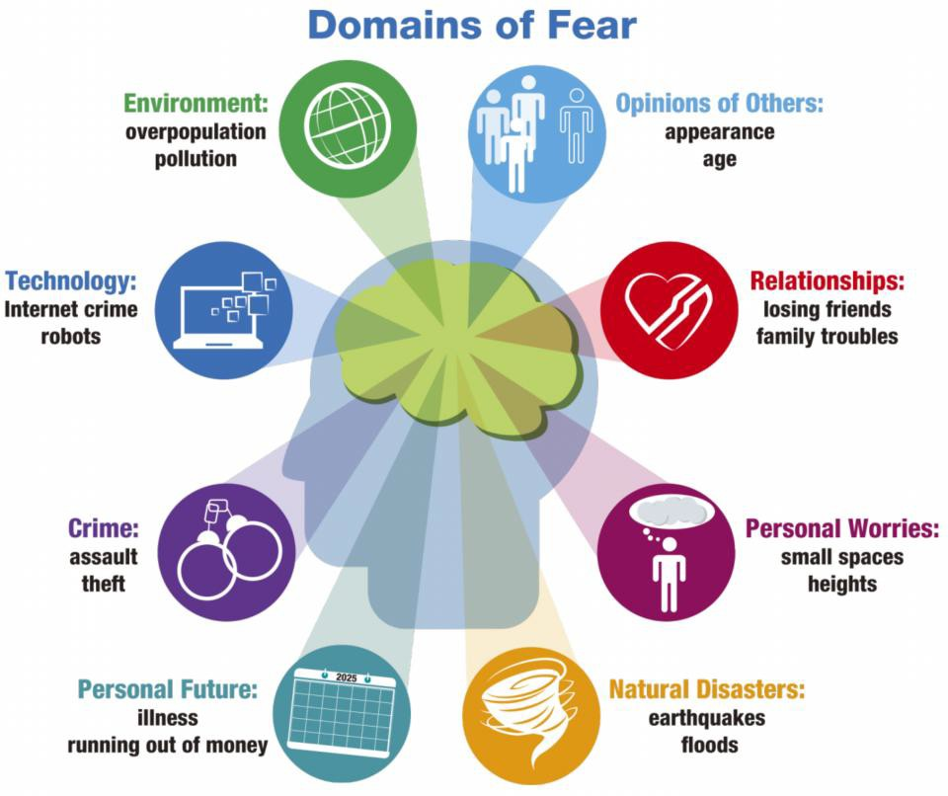

Unit 6

How you feel about eating genetically altered food?(P.120)

有各种各样的观点和意见。一些人支持转基因食品的想法，因为它可以提高作物产量、抗虫性和营养。另一方面，一些人认为，转基因食品对人类健康和环境的影响尚未得到充分理解，其中存在潜在风险。最终，食用转基因食品的决定是个人的决定，个人在做出知情决定之前应该教育自己潜在的好处和缺点。而且，转基因食品还在不断地改进中，在未来可能会成为主流的食物

There are various viewpoints and opinions. Some people support the idea of genetically modified food because it can improve crop yield, insect resistance, and nutrition. On the other hand, some people believe that the impact of genetically modified foods on human health and the environment is not yet fully understood, and there are potential risks involved. Ultimately, the decision to consume genetically modified foods is an individual decision, and individuals should educate themselves on potential benefits and drawbacks before making informed decisions. Moreover, genetically modified foods are constantly improving and may become mainstream foods in the future

Int what ways has technology changed how we prepare food and what we eat?

技术对我们如何准备、消费和体验食物产生了深远的影响。技术可以提高食品的生产效率。技术使食品的生产和加工更加高效成为可能，从而提高了生产力，减少了食品浪费。食品加工机、烤箱和冰箱等机器有助于提高食品制备的速度和一致性。利用技术可以开发新食品，现在已经研发出了营养价值较高的食物。比如蛋白棒已经成为受欢迎的食物选择。除此以外，技术使我们能够根据个人需求定制饮食。应用程序和联机平台可以根据我们最近的饮食帮我们制定出个性化的食谱

Technology has had a profound impact on how we prepare, consume, and experience food. Technology can improve the production efficiency of food. Technology has made it possible to produce and process food more efficiently, thereby increasing productivity and reducing food waste. Food processing machines, ovens, and refrigerators can help improve the speed and consistency of food preparation. New foods can be developed using technology, and now foods with high nutritional value have been developed. For example, protein bars have become a popular food choice. In addition, technology enables us to customize our diet according to individual needs. Applications and online platforms can help us develop personalized recipes based on our recent diets

Would you be happy to eat food produce instantly by machines

机器生产速食食品的想法很好，它可能会带来许多好处，比如效率、方便等。然而，是否接受这种技术将取决于各种因素。首先是食物的味道，人们对它的重视程度各不相同。一种食物的味道会严重影响它的受欢迎程度。其次是质量，我倾向于将新鲜制作的食物与更高的质量联系在一起。还有就是健康问题，我担心机器生产食品的营养成分以及食用此类食品可能产生的副作用。最后是环境因素：我担心使用机器生产食物可能会对环境造成一定的伤害，比如二氧化碳的排放等。

The idea of machine producing instant food is very good, as it may bring many benefits, such as efficiency, convenience, etc. However, the acceptance of this technology will depend on various factors. The first is the taste of food, and people attach varying degrees of importance to it. The taste of a food can seriously affect its popularity. Secondly, there is quality, and I tend to associate freshly prepared food with higher quality. Another health issue is that I am concerned about the nutritional components of machine produced food and the potential side effects of consuming such food. Finally, there are environmental factors: I am concerned that using machines to produce food may cause certain harm to the environment, such as carbon dioxide emissions.

What do you know/canyou imagine about the food crisis?

我可以想到的导致粮食危机原因有以下几点，第一点是气候变化，大多数情况下，气候变化会对粮食生产产生负面影响，导致作物产量下降，供水减少，害虫增加，导致作物被毁和粮食短缺。其次是人口过剩，过多的人口导致对粮食的需求更高，在某些程度上也导致粮食短缺。最后就是政治不稳定，比如冲突和战争就可能导致粮食供应链中断，人们可能难以获得粮食，从而导致粮食危机。

I can think of the following reasons for the food crisis. The first point is climate change. In most cases, climate change can have a negative impact on food production, leading to a decrease in crop yield, a decrease in water supply, an increase in pests, crop destruction, and food shortages. Secondly, there is overpopulation, which leads to a higher demand for food and to some extent, leads to food shortages. Finally, political instability, such as conflicts and wars, may lead to disruptions in the food supply chain, making it difficult for people to access food, leading to a food crisis.

Do you believe that technology can solve food crisis?

技术可以在解决粮食危机方面发挥重要作用。通过技术进步，我们可以实现更好、更高效的粮食生产方法，这有助于为快速增长的全球人口提供粮食。例如，通过基因改造，可以生产出对病虫害具有抵抗力、营养含量更高、保质期更长的作物，从而解决粮食短缺的问题。还可以利用技术实现精准的粮食分配，并且用技术提高食品配送的速度和效率。此外，利用技术，我们可以全年在室内种植作物，这有助于解决城市地区土地供应有限和恶劣天气条件等问题。

Technology can play an important role in solving the food crisis. Through technological progress, we can achieve better and more efficient food production methods, which can help provide food for the rapidly growing global population. For example, through genetic modification, crops with resistance to pests and diseases, higher nutritional content, and longer shelf life can be produced, thereby solving the problem of food shortage. Technology can also be used to achieve precise food distribution and improve the speed and efficiency of food distribution.Also, using technology, we can plant crops indoors all year round, which helps solve problems such as limited land supply and adverse weather conditions in urban areas.

**Grading**

|  |  |  |  |  |  |
| --- | --- | --- | --- | --- | --- |
| 1. Good comprehension of topic | 1 | 2 | 3 | 4 | 5 |
| 2. Clearly explained topic in detail | 1 | 2 | 3 | 4 | 5 |
| 3. Used pauses effectively | 1 | 2 | 3 | 4 | 5 |
| 4. Spoke accurately and fluently | 1 | 2 | 3 | 4 | 5 |
| 5. Clear pronunciation | 1 | 2 | 3 | 4 | 5 |

Low (1)- high (5)