VALLEY VIEW UNIVERSITY
FACULTY OF SCIENCE
DEPARTMENT OF COMPUTING SCIENCES AND ENGINEERING
A THESIS SUBMITTED IN PARTIAL FULFILMENT OF
THE REQUIREMENTS FOR THE BACHELOR OF SCIENCE (BSC.) IN
INFORMATION TECHNOLOGY DEGREE

TOPIC:
A MOBILE APPLICATION FOR AN EMERGENCY DEPARTMENT FOR STROKE PATIENTS

BY:
EZIHE HENRY OBINNA

ID:
213IT01000422

SUPERVISOR:
MR. JOSEPPH ABANDOH SAM

TABLE OF CONTENTS
CHAPTER ONE
1.0 INTRODUCTION……………………………………………………………………………………………………7
1.1 SUBJECT AND FIELD OF STUDY…………………………………………………………….8
1.2 PROBLEM STATEMENT………………………………………………………………………………………8
1.3 STUDY OBJECTIVES……………………………………………………………………………………….9
1.2.1 GLOBAL OBJECTIVES………………………………………………………………………….9
1.2.2 SPECIFIC OBJECTIVES………………………………………………………………………9
1.4 BACKGROUND TO THE STUDY………………………………………………………………………9
1.5 SCOPE OF THE STUDY……………………………………………………………………………………10
1.6 SIGNIFICANCE OF STUDY……………………………………………………………………………10
1.8 EXPECTED RESULTS OF THE STUDY………………………………………………………11
1.9 STUDY WORK PLAN……………………………………………………………………………………………11
CHAPTER TWO
2.0 LITERATURE REVIEW ……………………………………………………………………………11-18
CHAPTER THREE
3.0 Crystallization of the problem………………………………………………….19
3.1 Background…………………………………………………………………………………………………………19
3.2 How it operates……………………………………………………………………….………….20
3.2.1 Components of the system……………………………….………19-20
3.2.2 Advantages of the system……………………………………….…………20
3.2.3 Disadvantages of the system……………………………….…….20
CHAPTER FOUR
4.0 Analysis of the proposed system…………………………….…………21
4.1 Overview of the proposed system……………………………….…….21
4.2 Major features/components of the proposed system……….22
4.3 Benefits/Advantages of the proposed system…………………………22
4.1.1 Functional Requirements………………………………………………………………………22
4.1.2 Non-Functional Requirements……………………………………………………………22
4.4 Algorithm of the proposed system……………………………………………………22
4.4.1 Flow chart of the proposed system……………………………………………23
4.4.2 Pseudocode of the proposed system…………………………….……23-24
4.5 System context diagram of the proposed system…….…………24
CHAPTER FIVE
5.1 Functional Processes of the Proposed System………………………… 27-29
5.2 Data Flow Diagrams…………………………………………………………………………………………… 30-31
5.3 Process Models……………………………………………………………………………………………………… 32

CHAPTER SIX
6.1 Implementation………………………………………………………………………………………………………… 33-34
6.2 Testing…………………………………………………………………………………………………………………………… 35-36
CHAPTER SEVEN
System Documentation………………………………………………………………………………………………… 37-44
CHAPTER EIGHT
Conclusion and Recommendation…………………………………………………………………………… 45

ACKNOWLEDGEMENTS
The fulfillment that comes with the successful completion of any work would be incomplete without the recognition of certain people that made it possible.
I thank God almighty for getting me to this level in my life to be able to finally finish up my school, I appreciate the efforts of my parents and that of. My lectures for impacting so much into me to be able to get to this level.

DECLARATION
I hereby declare that this project proposal titled “A MOBILE APPLICATION FOR AN EMERGENCY DEPARTMENT FOR STROKE PATIENTS” is submitted into the custody of the Computer Science and Information Technology Department of Valley View University and is the original work of HENRY EZIHE OBINNA I.D. NO 213IT01000422.
The information in this report is authentic as it can to the very best of my knowledge and it has not or never been submitted to any other university or educational institution before.

STUDENT: SUPERVISOR:
HENRY EZIHE OBINNA Mr.JOSEPH ABANDOH SAM
. . . . . . . . . . . . . . . . .
SIGNATURE SIGNATURE
DATE: DATE:

Abstract

The use of mobile devices have been rampant in health care and medicine and research has shown how they have contributed lots of benefits. The purpose of this project is to consider the processes a stroke patient goes through to receive health care and treatment and employ it by the use of a mobile application which will be a decision maker for doctors when a stroke patient arrives to the emergency department. And this system should help in evaluating of patients at stroke emergency unit.

CHAPTER ONE

- 0 Introduction

Health care is a highly dynamic environment of which physicians and health workers perpetually perform task while moving and making high risk decisions office and death and doing this at s point of care. This high mobility requires the use of mobile devices platforms and applicable software’s to be used in this environment. Several studies done, test and proved on how mobile devices are, can be used in health care. This will aid in the prevention of medical errors and faster diagnosis and also in the processes one needs to go through for treatment and a lot of these show that the usage will improve productivity and increase performance, improved communication and decreased medical errors. Stroke is a medical condition in which if there is a blood cloth or bleed in the brain. It is a medical emergency and can leave a permanent damage if not treated quickly. Treating this predicament in time can help save the patient and prevent the long-lasting damage and this is what this whole project seeks to attain.

1 .1 Subject and field of study
The subject for this proposal is A Mobile Application For An Emergency Department For Stroke Patients whereas field of study is health care and mobile development.

1.2 Problem Statement
Many barriers of traditional ways of treating patients are being solved by the emergence of health software’s and systems but the project seeks to focus more on stroke patients, time taken for diagnosis and treatment and even the accuracy in the treatment process.

1 .3 Study objectives

1.3.1 Global objectives:
The global objective is to help doctors make decisions in an emergency Department where time and caution is at uttermost priority.

1 .3 .2 Specific objectives:
The below are the specific objectives of the project:
- Request and access patient medical records

- Availability of NHIS stroke scale

- Checklist for each stage completed
- Order thrombolysis treatment

- Track patient movement

1 .4 Background of study
A stoke is a medical condition in which if there is a blood cloth or bleed in the brain and it is a medical emergency and can leave a permanent damage if not treated quickly. Technology moved in fast and helped in many ways than one. The flaws in the existing system, processes and treatment spear headed the study and upon observance and studies, updates or better ways to make the system more useful will be needed. The project seeks to help achieve these goals.

  - Scope of study
The scope of this project is very broad in terms of other manually taking exams and the online aspect as well.
I. This can be used in educational facilities and institution as well as in corporate world.
II. Can be used anywhere (Hospitals) any time as it is a mobile application (user location doesn’t matter).

1.6 Justification of the study
The system contains sides to which ultimately aims for the greater good such of these are;
I. The high usability level of the system.
II. Economical aspects
III. The ease of handling stroke patients at the Emergency.
IV. Time cut

1.7 Expected results on the study
This system after building is expected of the following;
1. To primarily handle patient records
2. Easy navigation through the system.
3. Order thrombolysis
4. The existence of NHIS stroke scale
5. Checklist for each stage completed
6. Track patient movement

1.8 Study Work Plan
This project is scheduled to take at least four (4) to five (5) months with all necessary aspects being working and done.

  - Presentation of Thesis
Chapter Title | Summary
Chapter 1 | In this chapter, the topic is introduced and the problem defined Insight into how the problem would be solved is also provided and the method used to solve the problem.
Chapter 2 | This chapter mainly contains reviews about existing systems and their limitations.
Chapter 3 | This chapter delves into the system being currently used and its advantages and disadvantages.
Chapter 4 | In this chapter, the proposed system is laid out and its components revealed.
.

CHAPTER TWO
LITERATURE REVIEW

2.0 Overview and Objectives
The reviews done aims to tackle the existing systems on stroke apps to underlay the technologies in them.
Peak:
This app focuses on brain training after the damage is done. The app consists of games to challenge oneself and appeal to the brain to work more and teach its potential therefore there are insights and workout that one needs to through to achieve that. The app also has two modes that’s the paid and non-paid which obviously the paid has more features and functionalities than the non-paid.

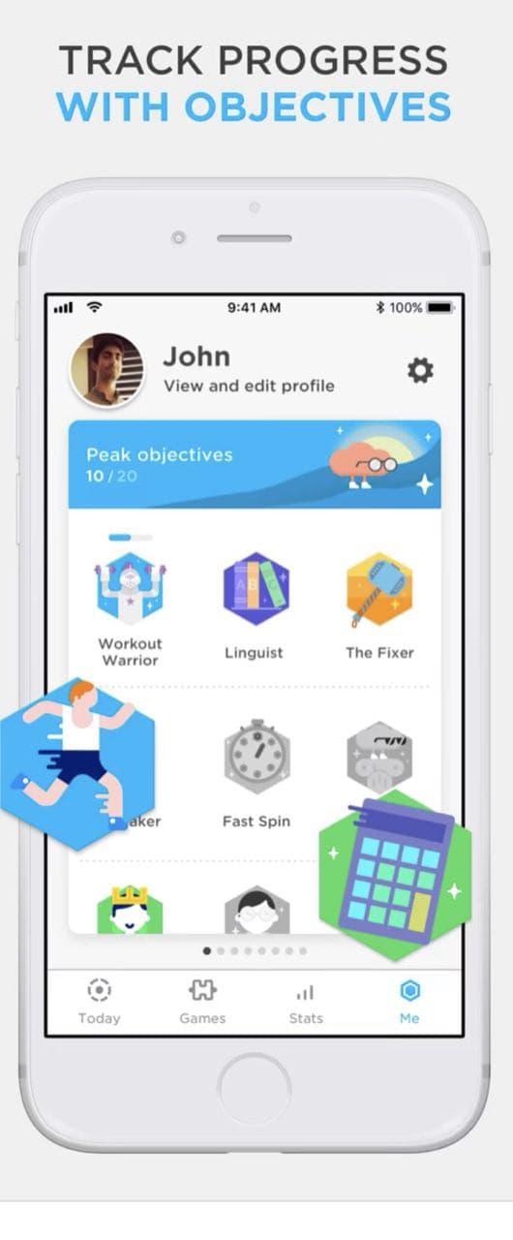
Stroke Triage app:
This app serves as a guide and individual aid for suspected stroke patients transported by the ambulance and it’s mainly for paramedics to calculates the probability of good outcome of a suspected stroke patient for two transportation strategies which are drive to the nearest general hospital or directly to a thrombectomy-capable intervention center. The App then advises the optimal transportation strategy for each individual patient. The paramedics who are involved with a participating ambulance service and who successfully completed the embedded e-learning can receive access to the triage function.
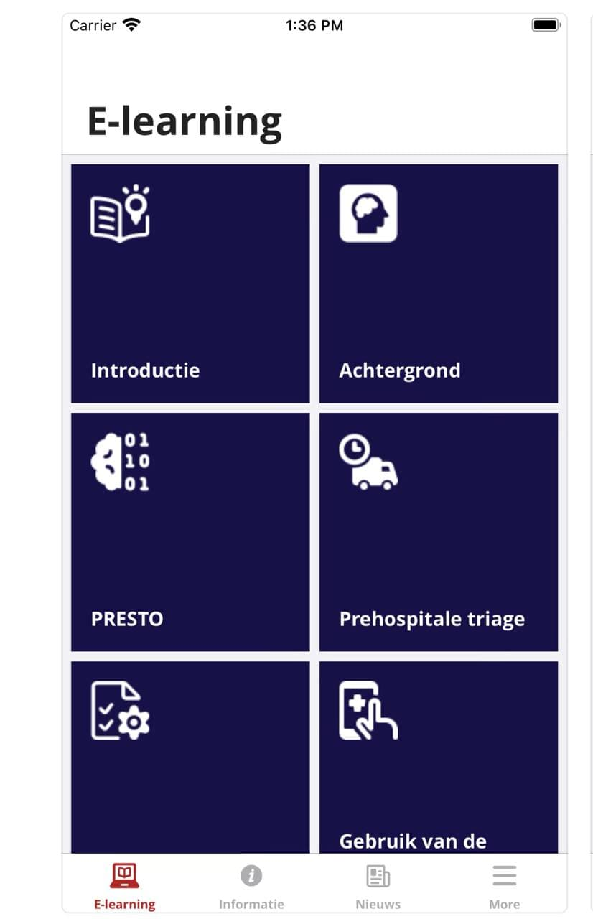

JoinTriage:
This app helps paramedics and EMTs to swiftly and accurately triage patients, ensuring that they receive the care they need as quickly as possible. Because it provides several assessment scales, commonly used among EMS providers. Question responses, such as the onset time, are used to evaluate symptoms of stroke or cardiac disease. The patient’s condition is summarized with a score and accompanied by other useful information such as the probability of severe outcomes, when applicable. A map is incorporated, showing a list of all recommended medical centers best suited to treat the patient (IV tPA, thrombectomy, etc.).
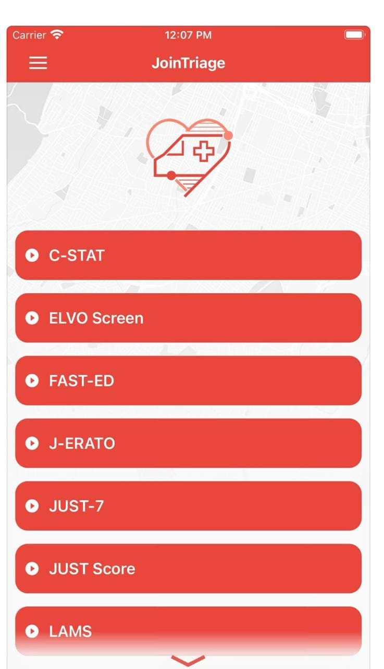

The Join Mobile Smartphone Application:
The join app helps to improve the treatment of patients with ischemic stroke. The purpose for the development of the application is to enable the survival and preservation of neurologic functions in patient suffering from ischemic stroke form the time the symptoms start showing up till when therapy sand reperfusion (act of restoring blood flow to an organ or tissue), so the join app was built to maximize coordination and communication among members of the stroke team, which is essential to maximizing the efficiency of reperfusion and also help in saving the patient.

A Mobile Intelligent Checklist System for Stroke Emergency:
Mobile intelligent checklist system helps to regulate medical behavior and reduce errors, a mobile checklist is needed in the acute stroke working environment due to time-critical, high pressure, and heavy workload associated with dealing with an emergency involving stoke patients. In recent times the emergency Department is a dynamic high risk, error prone working environment, with the average number of stroke patients yearly on the increase, a crowded facility will defiantly affect the patient satisfaction and increase doctor patient confliction.

Pedi STAT app:
The Pedi stat app is a quick drug dosage reference for emergency in pediatric Emergency and critical care.
The Pedi stat app presents materials in clear and easy to understand color coded format to eliminate uncertainties in a critical situation in a pediatric emergency. Drug doses are calculated based on weight loss or an estimation of weight based on age or length if the weight of the child is unknown.
The app also includes scoring guidelines and formulas for calculating various medical calculations, such as the Glasgow scale, croup score, and the burn size estimation that adjusts for the patient age.
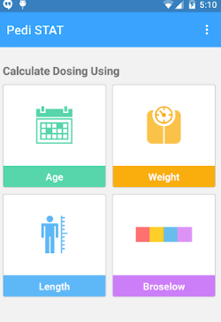

Constant therapy:
The app is designed for people who have had a brain injury or cognitive disorder to give them direct access to clinical exercises that can rebuild their cognitive, speech, and language functions. Built by neuroscientists and clinicians at Boston University in 2012, the Constant Therapy app digitizes therapy through a Neuro Performance Engine (NPE) that creates a highly customized and detailed map of each user’s strengths and deficits across 80 different categories.

Feature Analysis On Review Systems
Systems | User-friendly | Paid app | Appointments | Billing | Alerts | Open-source | Tracking
Peak | Yes |  | No | No | No | No | No
Stroke triage | Yes |  | No | No | Yes | No | No
JoinTriage | Yes |  | No | No | No | No | Yes
Join Mobile Smartphone | Yes |  | No | Yes | No | No | No
Mobile Intelligent Checklist System for Stroke Emergency | No |  | Yes | Yes | No | No | No
Pedi-Stat | Yes |  | No | Yes | No | No | No
Constant Therapy | Yes |  | Yes | Yes | No | No | No

CHAPTER THREE

3.0 Crystallization of The Problem

3.1 History of The Existing System
Paramedics have the responsibility of keeping alive victims and patients before surgery or even reaching the hospital. To make their work easy and accurate since lives depend on it, there should be system that would help them make the right choice and consequently saving the lives of victims.

3.2 Components and Features of The System
a. Triage customization
b. Efficient patient transfer
c. Cloud based
d. Seamless hand-offs
e. Easy-to-use interface

3.3 Strengths of the existing system
1. Hospital Mode
2. Emergency transport triage
3. Convenient
4. Stroke patients centered

  - Disadvantages of the system
- Security
- Accessing and triaging stroke patients

  - Context Diagram of the system
Diagram is shown the diagram below
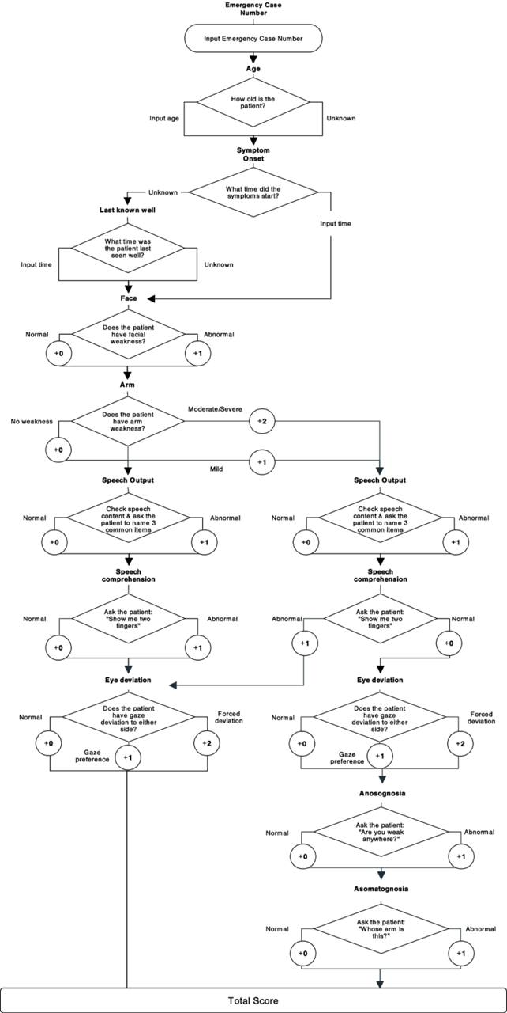
CHAPTER FOUR

4.0 Analysis of The Proposed System

4.1 Overview
The proposed system would use the necessary programming languages to build a mobile application for stroke patients in the Emergency department.

4.1.1 Functional Requirements
1. The proposed system should be able to access and request for patient records.
2. The proposed system should be able to be easy to navigate around.
3. The system should be able to ensure the existence of NHIS scale and also order thrombolysis.
4. The system should be able to track patient movement.

4.1.2 Non-Functional Requirements
a. Performance: the system should be able process the patient and consequently get the right treatment
b. Usability: the system should be intuitively easy to use and navigate within.
c. Reliability: this system should have the ability perform its functionalities properly.

4.2 Major Components of The Proposed System
i. Tracking feature
ii. Accessing and order of patient records
iii. Alert on patient progress

4.3 Benefits of The System
A. Easy navigation
B. Security
C. Time cut and accuracy
D. Alerts on patient progress

4.4 Algorithms of The Proposed System
4.4.1 Flowchart
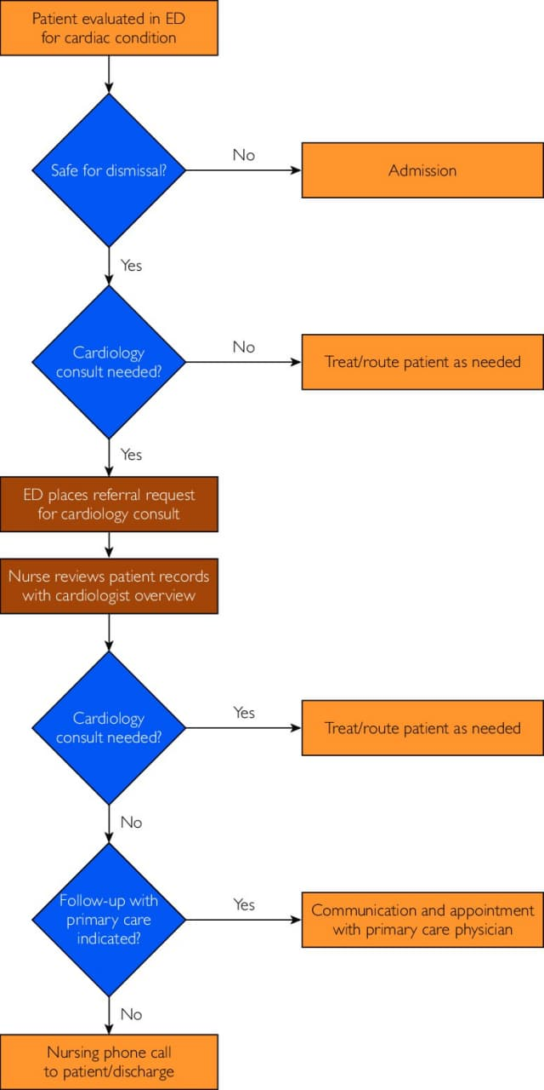
4.4.2 Pseudocode of The Proposed System
STEP 1: Start.
STEP 2: Access the dashboard off to the system according to the responsibility
STEP 3: Access patient and examine
STEP 4: Transfer patient to appropriate health care department
STEP 5: Logout
STEP 6: End

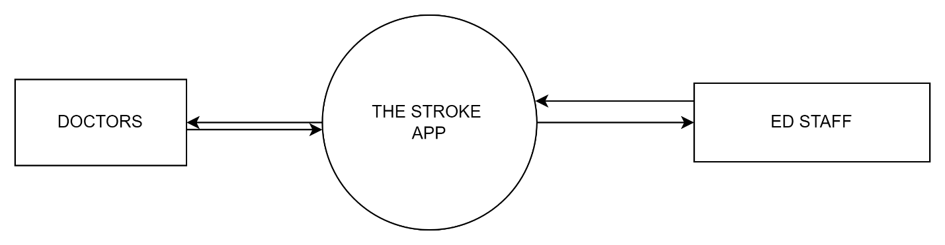
4.5 Context Diagram of the proposed system
Feed data of patient
EMS STAFF
Saves data
Saves and record
Access patient and examine

CHAPTER FIVE
Detailed Design of the Proposed System
5.1 Functional Processes of the System
Entity | Input | Output
Login page | EMS Staff and Doctors enters username and password to access the app and Admin also inputs username and password to make some modifications and the necessary updates to the system | Opens the EMS staff and doctors page when credentials are rightly inputted and the Admin page opens when an admin logs in successfully
EMS staff and Doctors page | ER and doctors enter username and password to access the app using the touchscreen | The data is inputted and feedback is received for proper arrangements and treatment procedures

5.2 Algorithm and flowchart of the processes
ALGORITHM FOR ER STAFF FOR REGISTRATION PROCESS
STEP 1: START
Step 2: Enter Registration Page
Step 3: Enter information required
Step 4: Obtain Username and password
Step 5: Click on Save Button to Save
Step 6: STOP

ALGORITHM FOR ACCESSING THE APP FOR THE EMS STAFF
STEP 1: START
STEP 2: Enter EMS page.
STEP 3: Select the stroke scale according to the assessment of the patient.
STEP 4: check for the nearest or available hospital
STEP 5: Update the new patient information.
STEP 6: Log out.
STEP 7: STOP

ALGORITHM FOR TREATMENT PROCESS FOR THE DOCTORS
STEP 1: START
STEP 2: Enter the doctor’s page.
STEP 3: Access the patient further based on the stroke scale and the checklist.
STEP 4: Arrange for the necessary medical procedures to receive patient for immediate treatment.
STEP 5: Log out
STEP 6: STOP

5.3 PROCESS MODELS
5.3.1 FLOWCHART
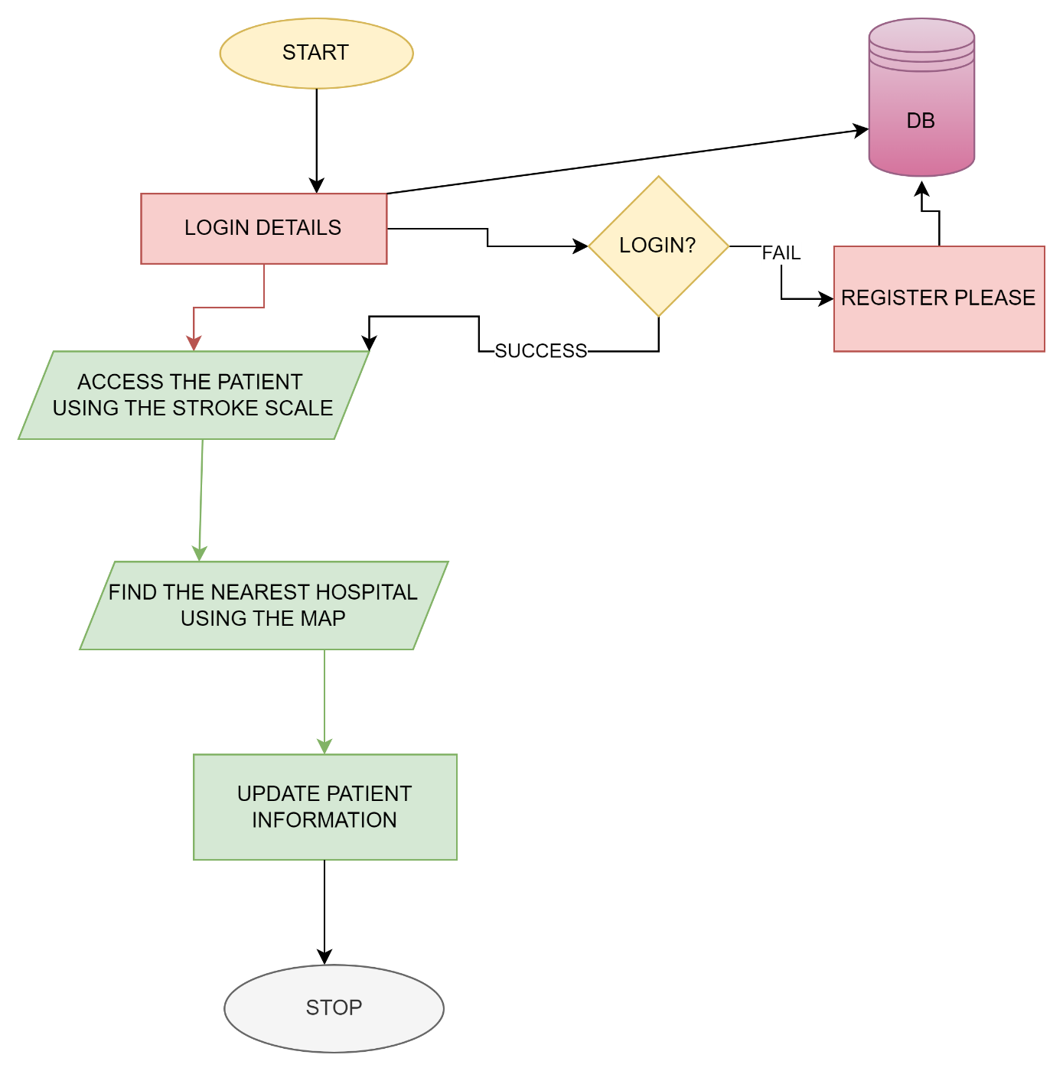

5.3.2 DATA FLOW DIAGRAMS
DATA FLOW FOR AUTHENTICATION OF THE USERS (EMS STAFF AND DOCTORS)
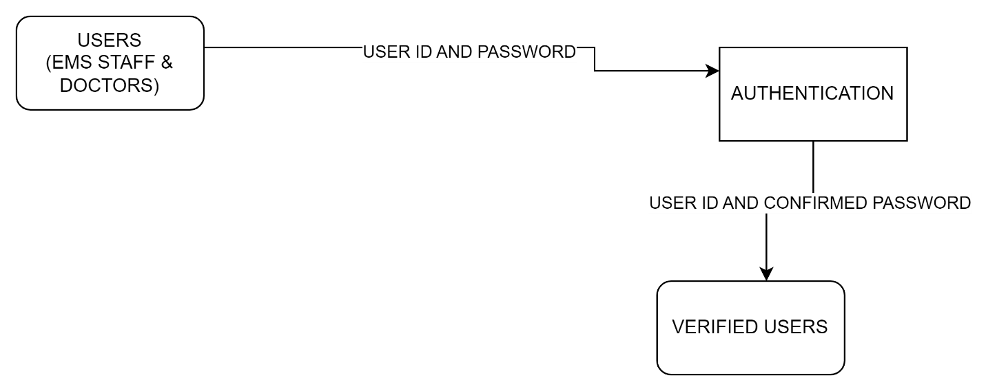

DATA FLOW DIAGRAM THE APP USAGE FOR EMS STAFF
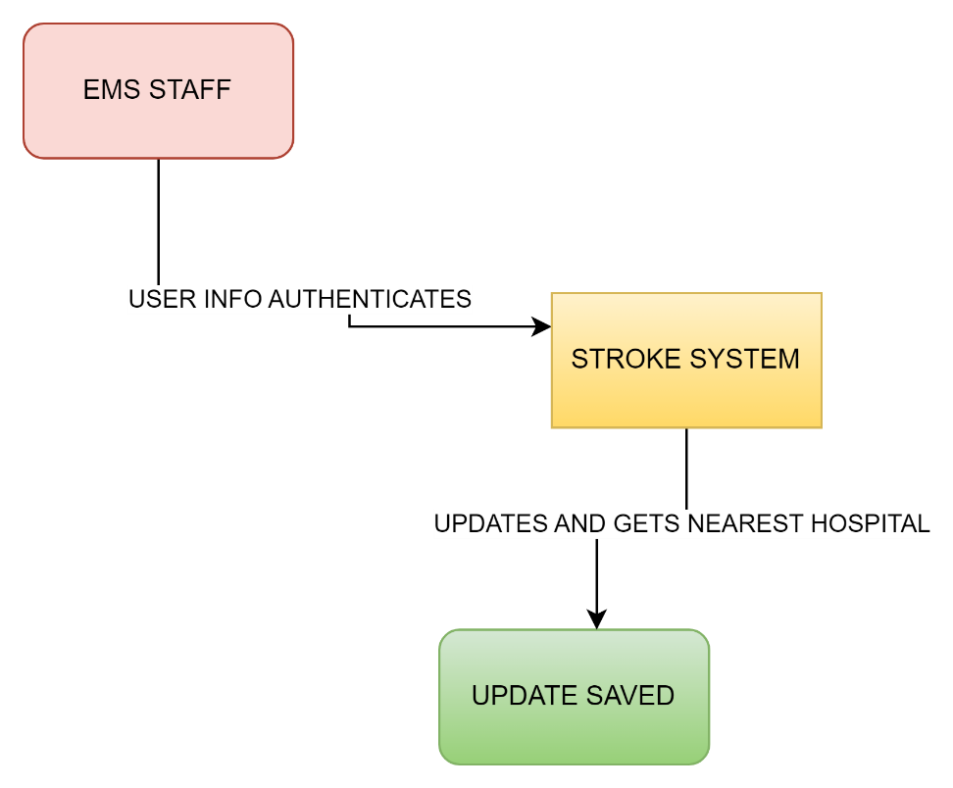

DATA FLOW FOR DOCTORS
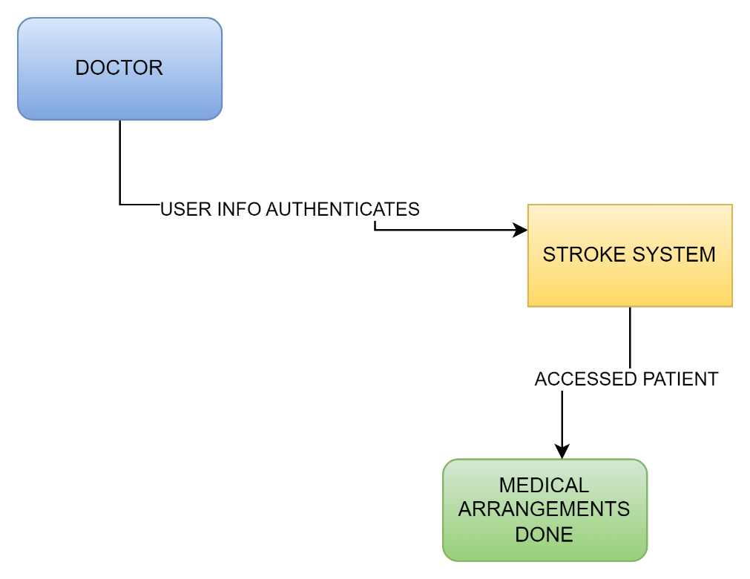

USE-CASE DIAGRAMS
EMS STAFF
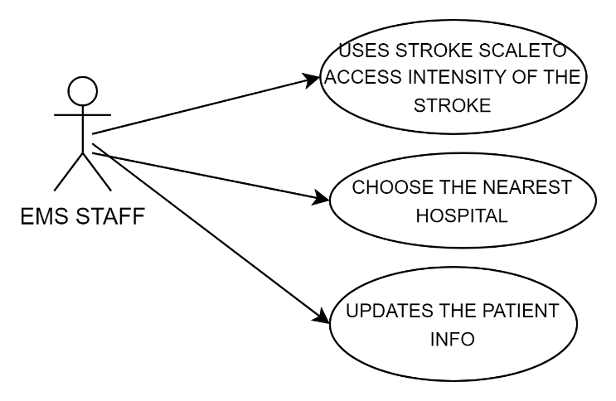

DOCTOR
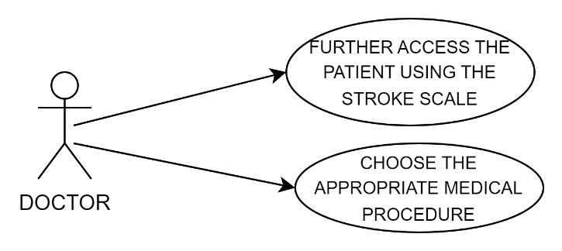

CHAPTER SIX
SYSTEM IMPLEMENTATION AND TESTING
6.1 IMPLEMENTATION
Description of both the Hardware and Software required for the implementation of the system are as follows.
HARDWARE REQUIREMENTS
Component | Minimum | Recommended
Memory | 500 MB | 1.5 GB or above
Processor | 1 GHz (x86) /  1.5GHz(x64) Single processor | 2.3GHz or Faster
Available disk space | 400 MB | 1 GB
Database Server | 5GB database space | 10GB database space
Display | Type: pls lcd, 60Hz  Size:5.8inches | Type: pls-lcd, 60Hz or higher Resolution  size:6.6inch or higher

SOFTWARE REQUIREMENTS
The following is a list of software required for the smooth running of system:
- Android based operating system
For the installation procedure of each of this software, please refer to the vendors‟ documentation of the system.

TESTING
The Description of the testing strategies are as follows
The test strategies that would be used in testing the system.
Test Strategy should provide the generic test requirements of project or product to the Organization.

Black Box Testing
This is the technique of testing without any knowledge of the interior workings of the application and that is called Black Box testing.

White Box Testing
White box testing on the other hand tests the internal structure of a working application. Also, It focuses primarily on strengthening security, the flow of inputs and outputs through the application.

Test Cases for the system
This procedure is to ensure correct outputs from the system. Different tests such as stress test, volume test and the user-friendly nature of the system.
Test Case Number | Test Case | Expected Results | Unit Or System Testing | White-Box Or Black-Box
1 | Login | Authenticates only users with valid username and password and denies invalid username and password | Unit Testing | Black-Box
2 | logout | Terminates all sessions and direct users back login page | Unit Testing | Black-Box
3 | User registration | Ensures that all required field in the registration form are entered fulfilled | Unit Testing | Black-Box
4 | Stroke Scale | Ensure the proper functioning of the stroke scale to access patient stroke intensity | Unit Testing | Black-Box
 | Database Connection | All opened connections should be closed | System Testing | Black-Box

CHAPTER 7
SYSTEM DOCUMENTATION
This section focuses on the user manual of the system.
7.1 Splash screen
This is the first interface when the system is launched. It contains the system logo.
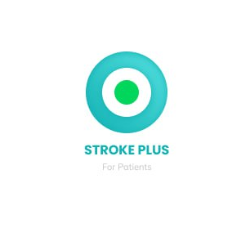

7.2 Index page
After the splash screen the app now sends the user to the index page where the user can select their part of the app to login and make the necessary utilization of the app.

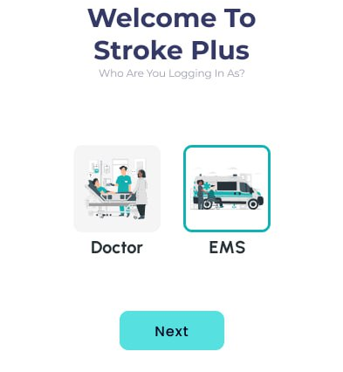

7.3 Sign Up interfaces for EMS Staff and Doctor
This is the sign-up interface for the EMS Staff and the doctor on the system which requires a full name, username, mobile number password for a staff or doctor to be authenticated into the system.

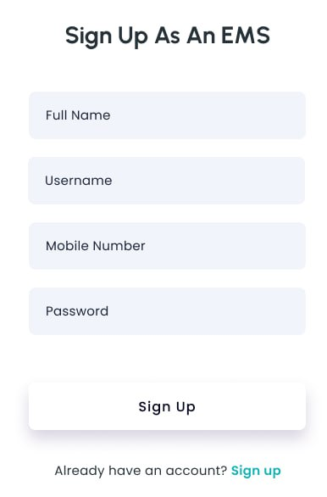
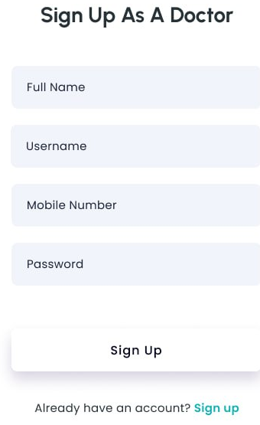

7.4 Sign In Interface for EMS Staffs and Doctors
After acquiring a username and password the users of the system would have to sign in unto the system. And This would allow the user to use the features of the system pertaining to their privileges.

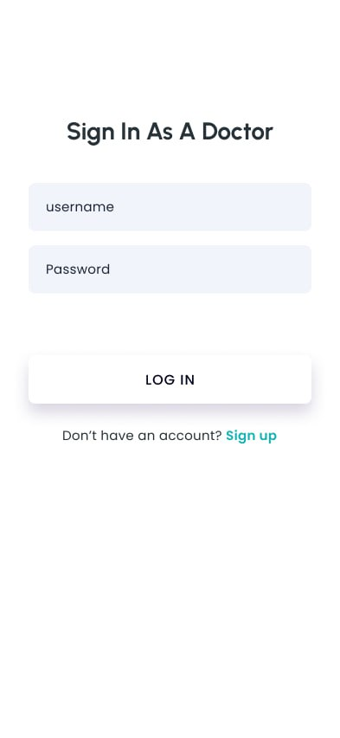
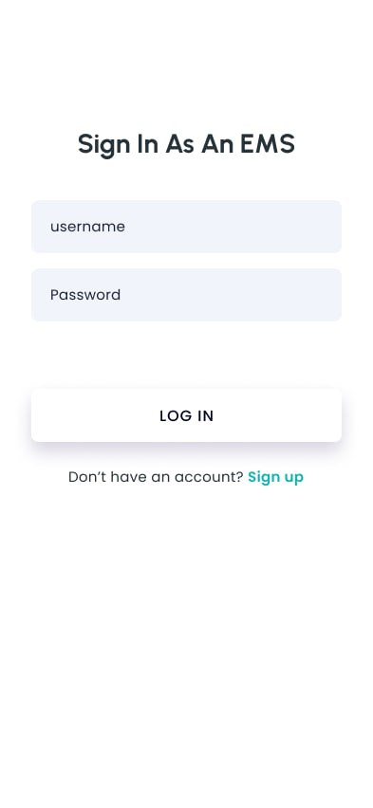

7.5 The Home Page
This is used by both the EMS Staff and the doctor, after logging now must come and update the system on the current patient at hand. Select the type of stroke scale and after the process select the nearest hospital using the map button. And the doctors can see the records and make the necessary arrangements.

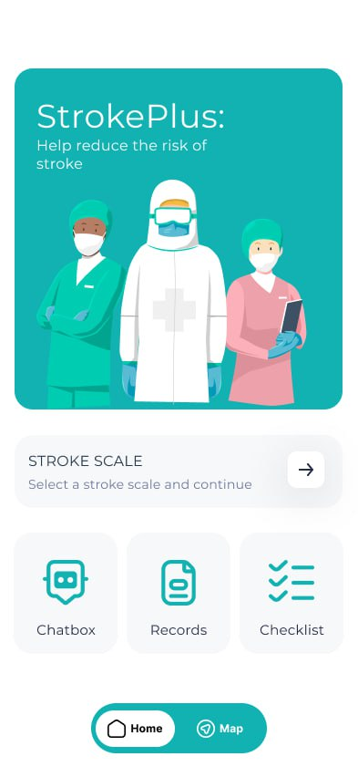

7.6 The Stroke Scale page
This is where the type of stroke scale is selected based on the condition of the patient as per EMS staff’s assessment.
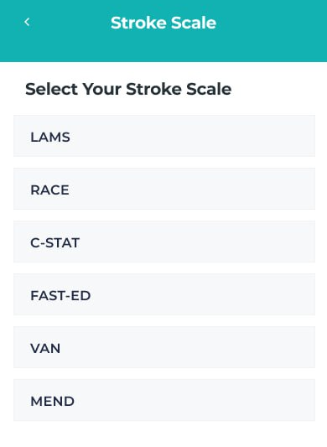

7.7 Assessment pages
These pages consist of essential questions in relation to the stroke and its severity. After selecting the scale. And the assessment of the patient is done through this after vital signs and the necessary essentials are done.

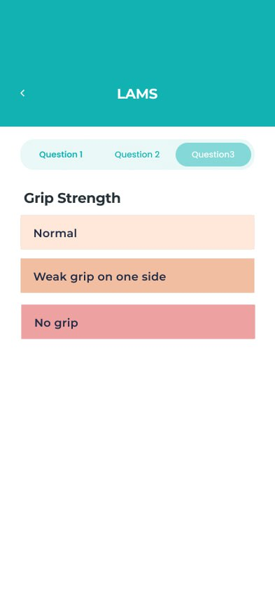
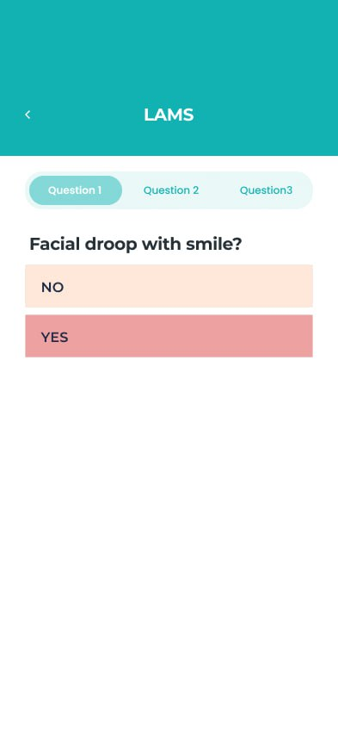

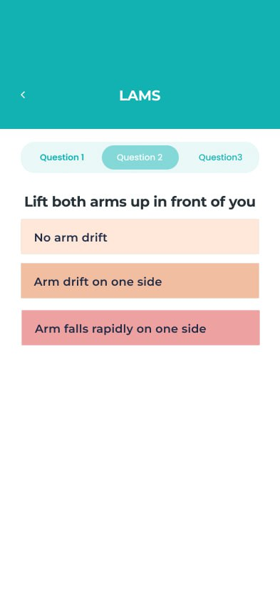

The above are some few assessment parameters when the EMS staff selects LAMS the type of stroke scale to use in assessing the patient.

7.8 Records
This interface deals mainly with the records of patients. After the patient data is recorded, it saves to the record page and doctors can infer from that in treating the patient. All records display on the All records page and recently inferred records can be seen on the recent records page.

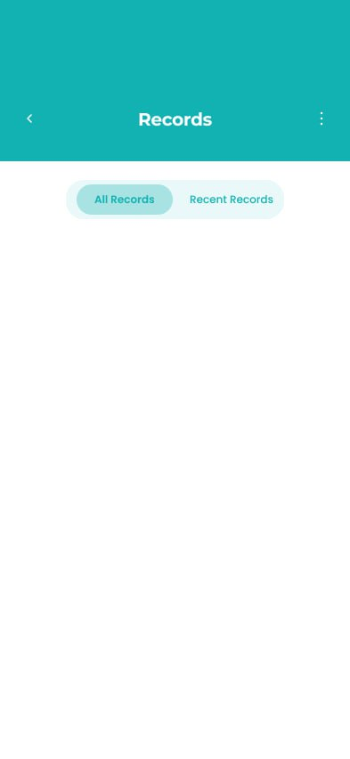

7.9 The Intelligent Checklist
This is another important feature of the system where items on the list are checked all in relation to properly assess the patient.

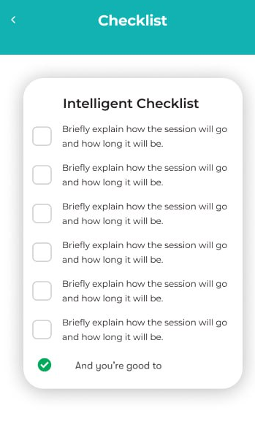

7.10 Map Feature
The map feature is embedded in the app to aid the EMS staffs navigate their route to the nearest hospital for the patient to receive immediate treatment to prevent further repercussions.

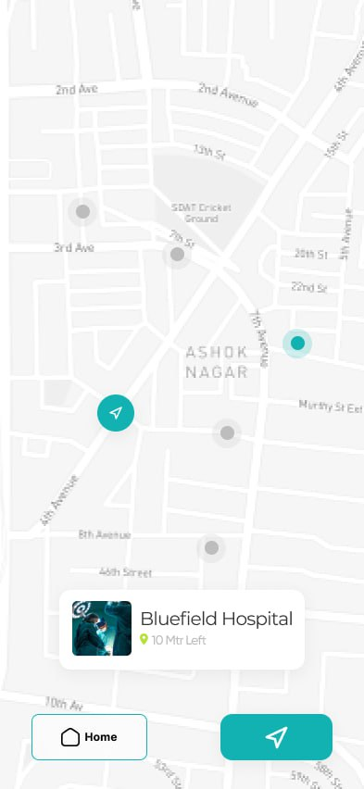

7.12 Conversation Feature
The system has an embedded feature where the EMS staff or the doctor have a conversation with one another to help if there is a challenge in treating or assessing the patient or make comments pertaining a patient.
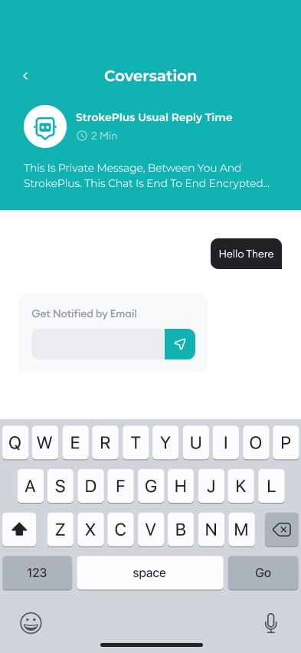

CHAPTER 8
CONCLUSION AND RECOMMENDATION
The stroke system is far more efficient to use and should be incorporated in Ghana Health Service. The main purpose of this project is to make speed up the treating stroke patients before it gets to the uncontrolled stage.
The advancement of technology making it possible for the invention of stroke scale and intelligent checklist has aided in treatment of the stroke patients and their prevention. The world is moving in a technological era and technology mostly reduces manual operation, and accuracy level of its processes is high. EMS staffs and doctors should be able to use the advantage of technology to make more accurate treatment and be fast in saving lives. Health professional should then be familiar and exposed to systems such as this which aims at the best solution for stroke treatment problems, it being simple and easy to use and productive as well.

I would recommend that the web application of this system would be made and work seamlessly with the mobile application and physiotherapist and nurses can also be part of the system.

