Final Project Draft

1. Project Proposal
Project title: Uralsk Lens: City Photography Portfolio & Social Archive
Topic: This project is an advanced web platform and REST API designed to showcase the visual history and modern life of Uralsk city. It functions as a social archive where users can share photos, create thematic albums, and explore the city through an interactive map.
Why did you choose it? We chose this topic to digitalize the cultural heritage of Uralsk. Existing platforms lack a centralized, high-quality focus on our city. This project solves that by combining professional portfolio tools with social features, helping tourists find locations and residents to preserve memories.
Main features:
Advanced Authentication: Secure signup/login system using JWT (JSON Web Tokens) with role-based access (Admin, Photographer, Viewer).
Photo Portfolio Management: Full CRUD (Create, Read, Update, Delete) for uploading high-quality images with descriptions and categories.
Social Interactivity: Functionality for users to like photos and leave comments to discuss locations.
Interactive City Map: Integration of geolocation data (latitude/longitude) to display photo markers on a map of Uralsk.
Smart Organization: Grouping photos into Albums and a personal "Favorites" list for users.
Search & Filter: Advanced filtering by category (Nature, Architecture, History) and search by keywords.
Team members and their responsibilities:
- Danial — Lead Backend Developer: Responsible for the core API logic, implementing all REST endpoints (Auth, Photos, Social), handling file uploads (Multer), and business logic.
- Ulan — Database Architect: Responsible for designing the MongoDB schemas, managing relationships between collections (Users, Photos, Comments), and data integrity.
- Maksat — System Architect: Responsible for the server configuration, middleware setup (security, CORS), and overall project structure.
- Nurbakyt — Product Manager & Frontend: Responsible for project documentation, API testing (Postman), and designing the user interface concepts.

2. Database Design (Schemas)
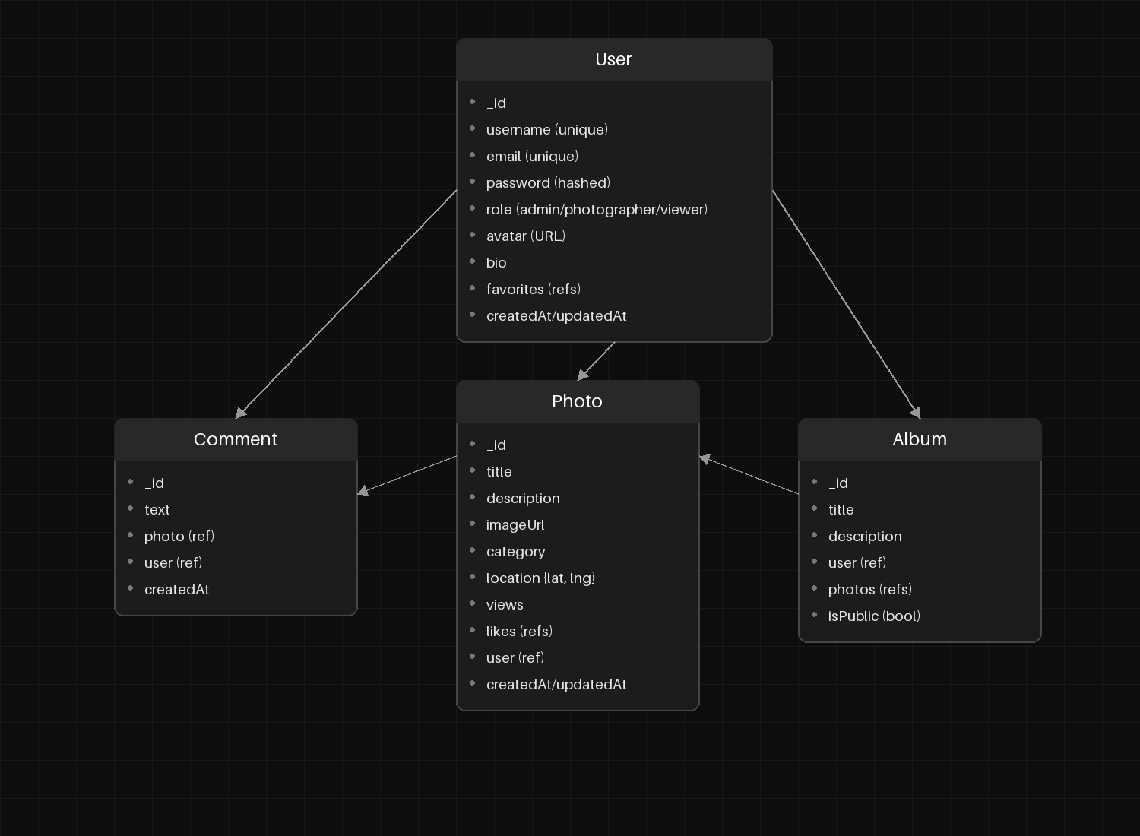
Text Description:
- User Collection:
  - username, email, password: Core authentication data.
  - role: To distinguish between Admins and regular users.
  - favorites: Array of references to Photos saved by the user.
  - avatar, bio: Profile customization.
- Photo Collection:
  - title, description, imageUrl: Main content.
  - category: For filtering (e.g., "Architecture").
  - location: Object { lat, lng } for the Map feature.
  - likes: Array of User IDs (for social features).
  - user: Reference to the author.
- Comment Collection:
  - text: Content of the comment.
  - photo, user: References to link comments to specific posts and authors.
- Album Collection:
  - title, description: Album metadata.
  - photos: Array of references to Photo documents.
  - isPublic: Visibility setting.

3. API Endpoint List
Authentication & Users:
- POST /api/auth/register — Register a new user.
- POST /api/auth/login — Login and receive JWT token.
- GET /api/users/profile — Get current user's profile information.
- PUT /api/users/profile — Update profile details (avatar, bio).
- GET /api/users/favorites — Get list of photos added to favorites.
Photos (Main Resources):
- GET /api/photos — Get all photos (supports query params for filtering).
- GET /api/photos/:id — Get details of a single photo.
- POST /api/photos — Upload a new photo (Protected).
- PUT /api/photos/:id — Update photo details (description, category).
- DELETE /api/photos/:id — Delete a photo.
- GET /api/photos/search — Search photos by keywords.
Social Features:
- PUT /api/photos/:id/like — Like or remove like from a photo.
- GET /api/photos/:id/comments — Get all comments for a specific photo.
- POST /api/photos/:id/comments — Add a new comment.
- DELETE /api/comments/:id — Delete a comment.
Map & Albums:
- GET /api/photos/map — Get photos with geolocation data for the map.
- POST /api/albums — Create a new album.
- POST /api/albums/:id/add — Add a photo to an album.
- GET /api/categories — Get list of available categories.

