**Name**:donia el-tokhy abd-el-hady

**B.N**:330

**Topic**: Internet of things

**GitHub Link: https://github.com/donia2mr/ece001**

**GitHub Page:** **https://donia2mr.github.io/ece001/**

*Internet of things:* The Internet of Things, a newly emerging term, means the new generation of the Internet (the network), which provides understanding between devices that are interconnected (via IP). These devices include various tools, sensors, sensors and AI tools, among others. This definition goes beyond the traditional concept of people communicating with computers and smartphones via one global network and through the well-known traditional Internet Protocol. What distinguishes the Internet of Things is that it allows a person to be free from the place, meaning that the person can control the tools without having to be in a specific place to deal with a specific device

### *Applications of Internet of things:*

### 1. Smart Home

### 2. Wearables

### 3. Connected Cars

### 4. Industrial Internet

### 5. Smart Cities

### 6. IoT in agriculture

### 7.Smart Retail

*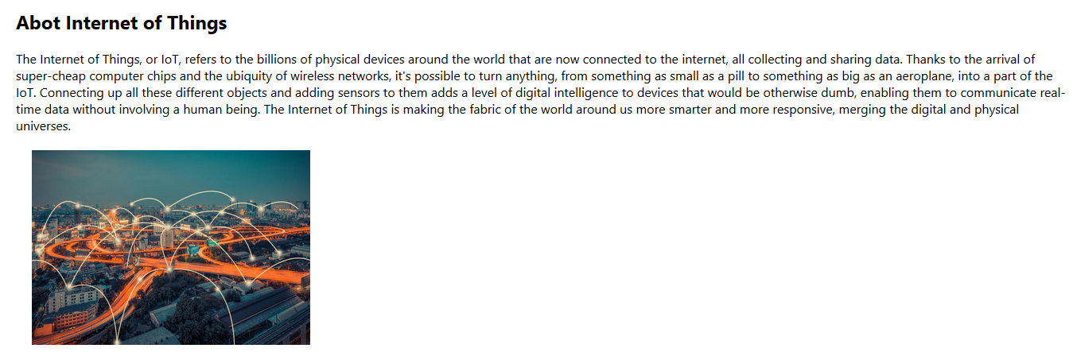Screenshots:*

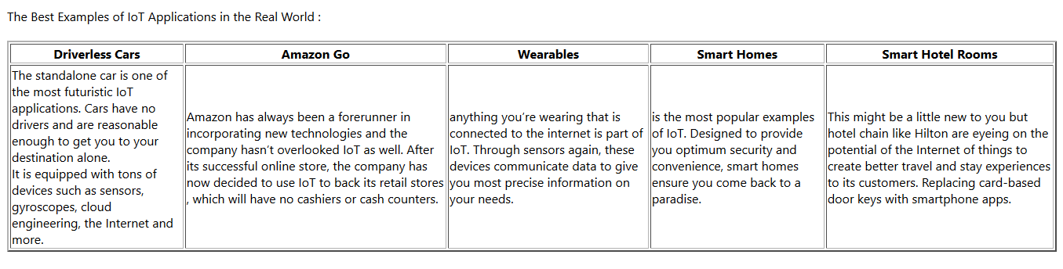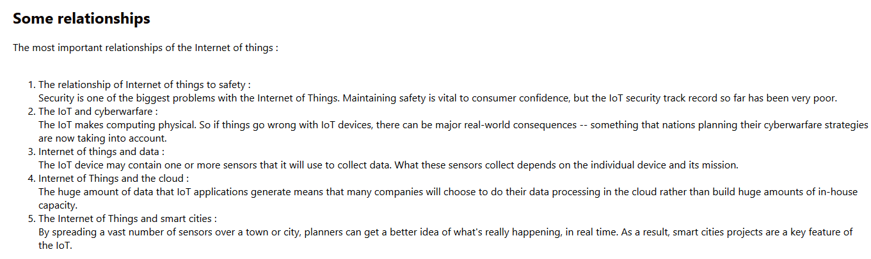

*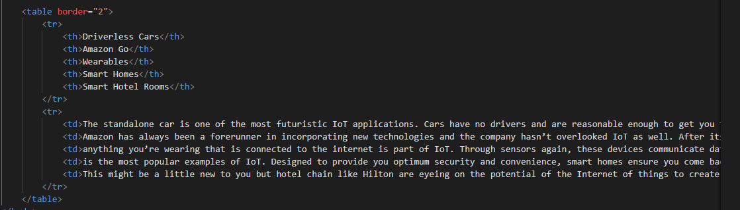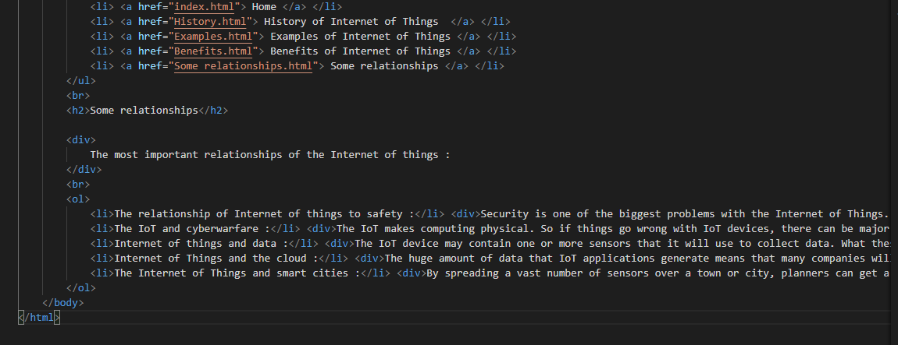Source Code:*