

[CSCE460402 - Pract Machine Deep Learning](https://blackboard.aucegypt.edu/webapps/blackboard/execute/launcher?type=Course&id=_78911_1&url=)

**Report on assignment #2**

**Name:** Donia Ghazy

**ID:** 900172124

**Neural Network Model:**

Data-preprocessing:

* The data is divided into training set (90%) and validation set (10%).
* The image’s mean is taken in order to zero center the outputs.
* The image’s standard variation is taken in order to normalize the values.

Sanity Check:

* I have tested the overfitting in order to test the correctness of the training model.

The accuracy of the training model has reached 100% as shown in the next screenshot.

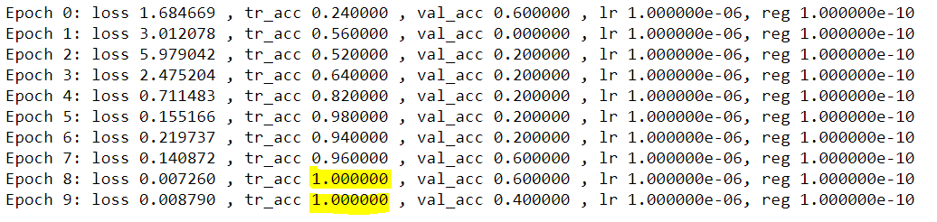

* The initial loss when regularization term is zero equals to 1.6 which is –ln(1/5)



Hyper-parameter Optimization:

* 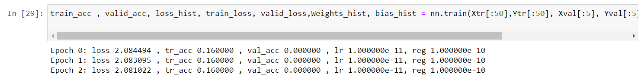Min Range of the learning rate For a learning rate of value 10^(-11) , the loss is hardly changing as shown in the following screenshot:
* Max Range of the learning rate For a learning rate of value 10^(-5) , the loss explodes as shown in the following screenshot:

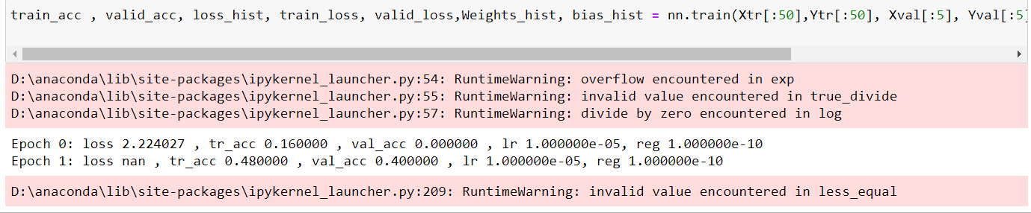

* Coarse Search After finding the min and max range of the learning rate. The search was done in the range shown in the following screenshot:

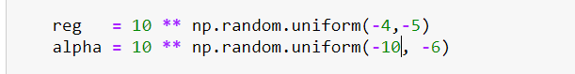

* Fine Search After examining the coarse search results , the range has changed to be :

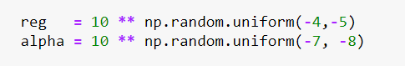

The best 19 learning parameters that gave the highest validation accuracy are shown in the following screenshot:

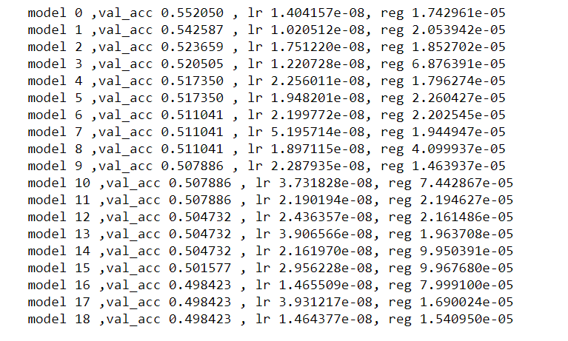

**Training with model 0:**

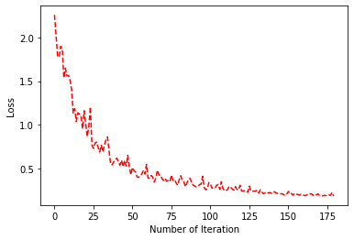

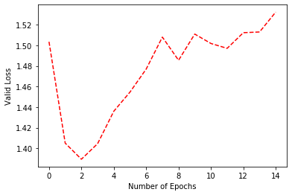

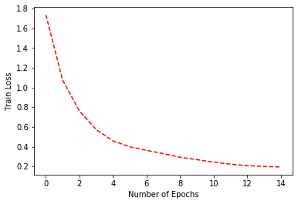

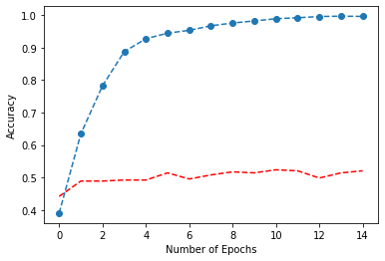

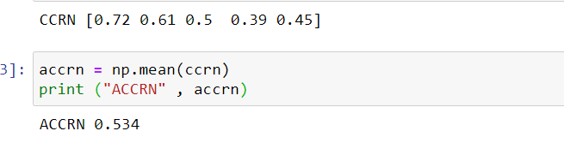

**Accuracy of the NN model is 53.4%, it is higher than KNN which was 34.85%**