Name: Donia Ali Bakr

B.N: 333

Date:

Topic: Programming Language

URL : <https://doniaali9.github.io/HTML-Project/>

# Application Brief:

Programming language is important because it defines the relationship, semantics and grammar which allow the programmers to effectively communicate with the machines that they program.

A programming language serves several purposes:

1. You can instruct the computer what to do in a human-readable form
2. Allows the programmer to structure the instructions into functions, procedures, etc.

This also allows the program to be broken into "chunks" which can be developed by a group of developers

Provides portability - the low-level instructions of one computer will be different from that of another computer.

# Screen shoots:

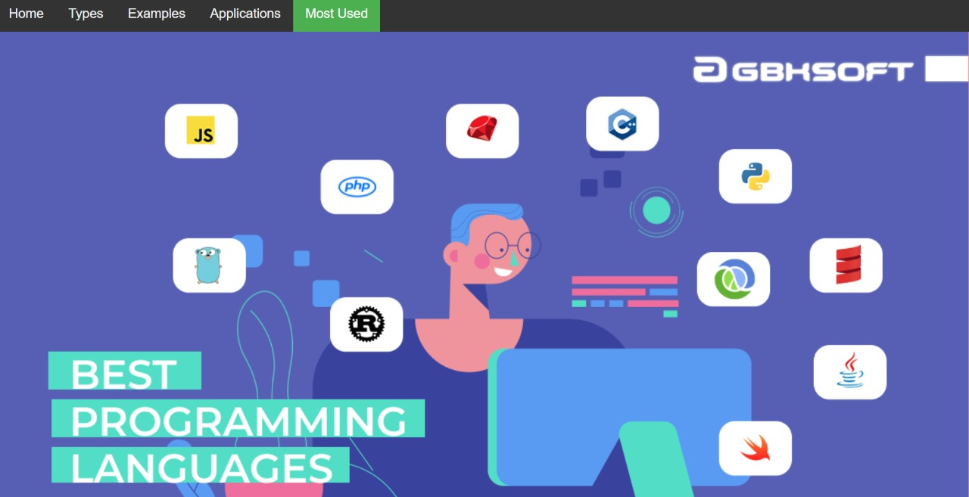

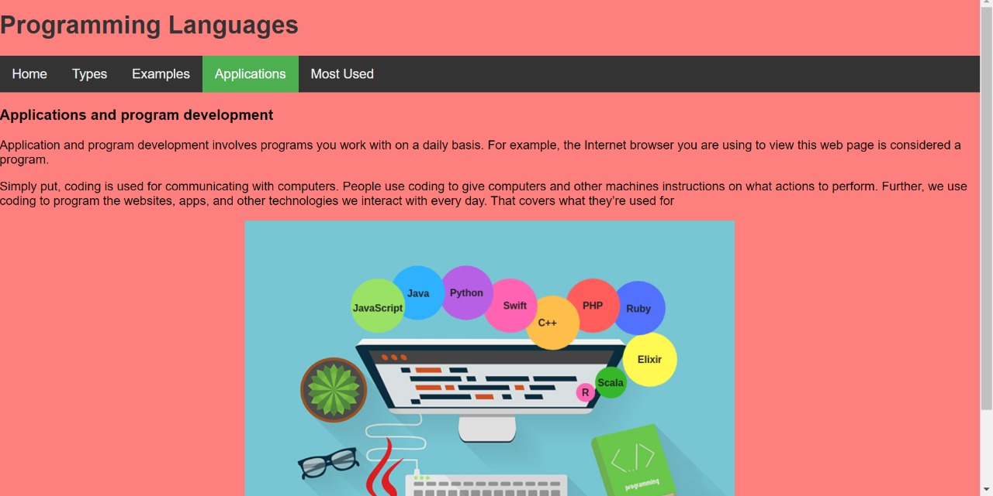

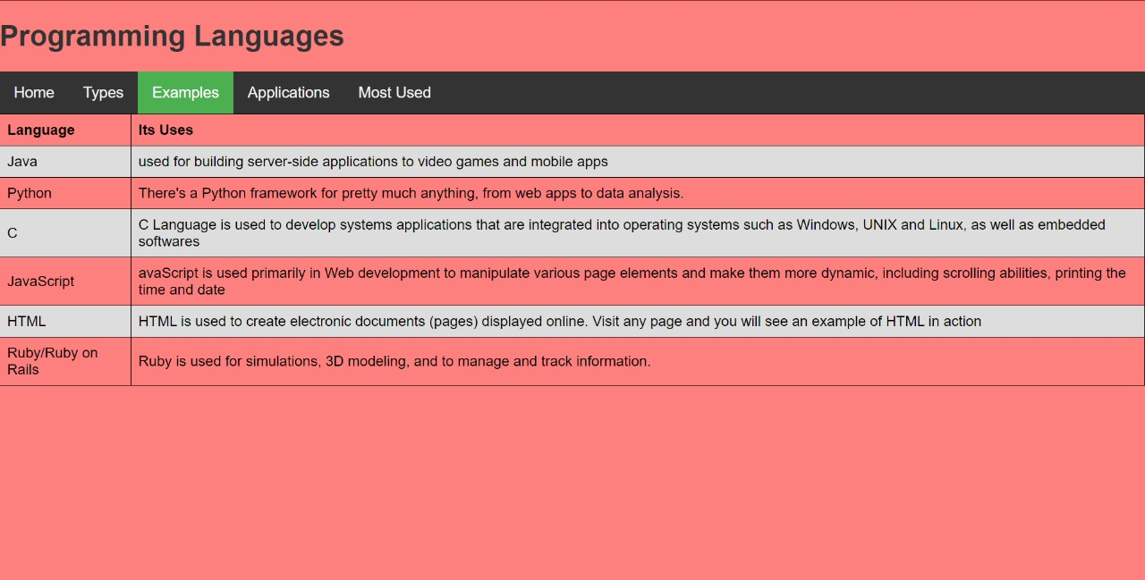

# Source code:

