Exercise 2 Creating a project with LWJGL
LWJGL (Lightweight Java Game Library) is a popular open source library for creating games and multimedia applications in Java. It provides access to powerful graphics, audio, and input/output libraries using low-level hardware interfaces such as OpenGL, Vulkan, OpenAL, and others. LWJGL is often used by 3D game and graphics application developers because it makes it easier to access GPU (graphics processing unit) functions.
LWJGL (Lightweight Java Game Library) is a library that provides direct access to low-level APIs such as OpenGL, OpenAL, and GLFW in Java. This makes it suitable for the Graphics Systems course, as students can learn the basic principles of rendering, graphics transformations, lighting, and optimization.
LWJGL allows for direct interaction with OpenGL, which provides a deep understanding of how graphics hardware works. Compared to libraries such as JavaFX or Unity, LWJGL requires manual management of buffers, shaders, and rendering, which is useful for a fundamental understanding of 3D graphics.
Create a project
- Download the library archive from https://www.lwjgl.org/customize
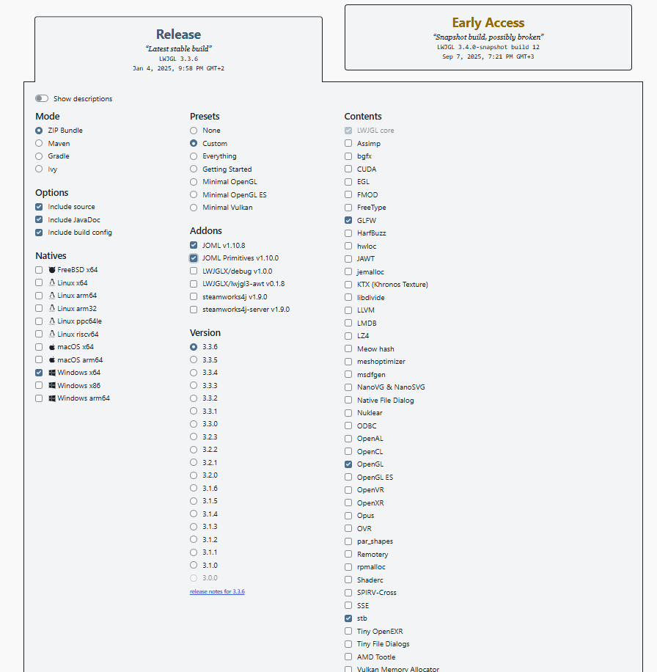
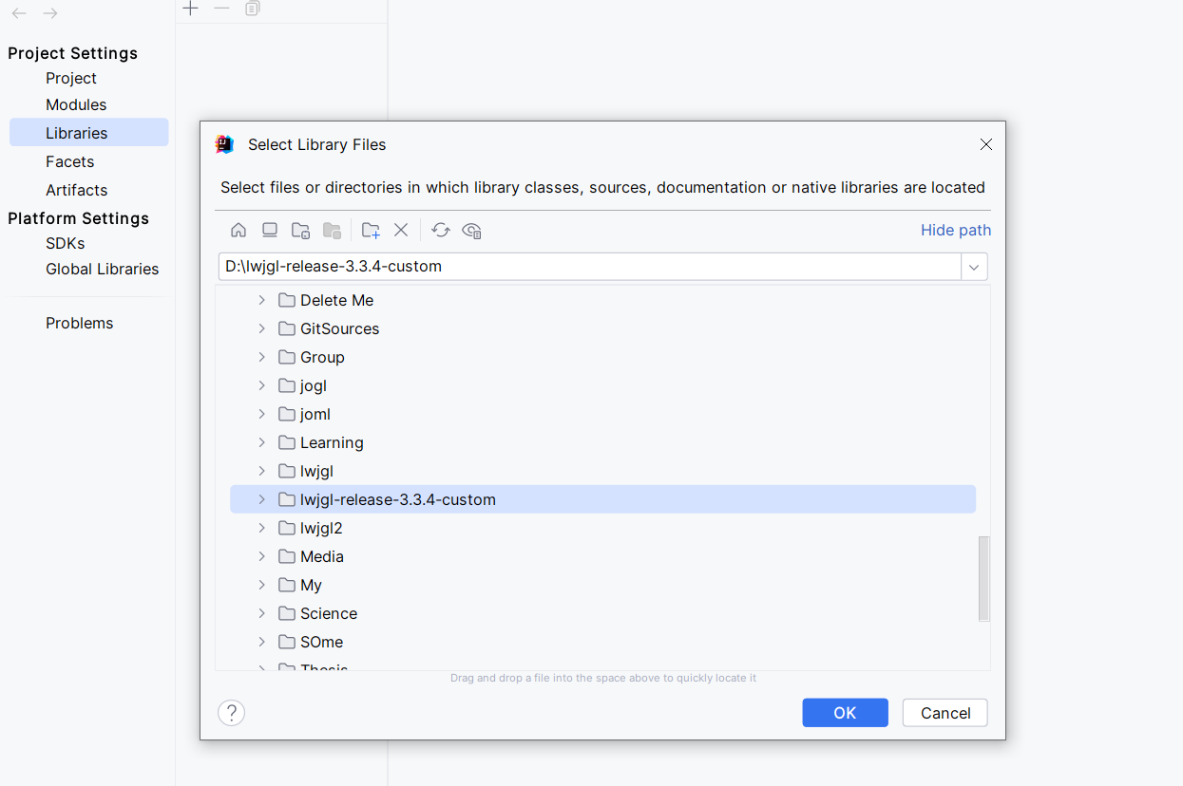
- Create an empty Java project (Java>=11) and add the downloaded libraries in
File >Project Structure > Libraries
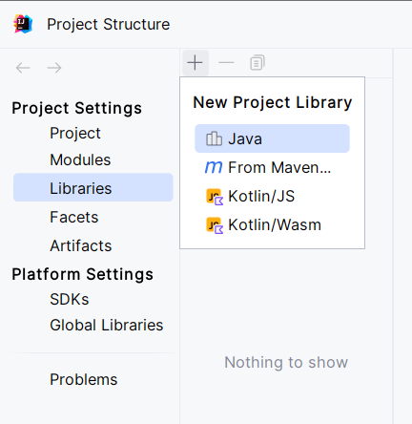

We will implement a basic project that we will build on throughout the semester. At this stage, we need to create classes that will implement the following responsibilities:
- Window - the main structure that will manage the graphics window and context. It provides GLFW initialization, window creation, input event handling (in later exercises), and rendering.
- Renderer - is responsible for drawing graphics in OpenGL. While Window manages the window and OpenGL context, Renderer contains the rendering logic, such as:
  - Initializes shaders and buffers (Vertex buffer object (VBO), Vertex Array Object (VAO)).
  - Draws primitives (triangles, textures, etc.).
  - Updates the graphics frame.
- ShaderProgram - responsible for loading, compiling, linking and using shaders (GLSL) in OpenGL. Instead of managing vertexShader and fragmentShader manually, this class provides a convenient way to work with them.
- Main with a main() method to start the project;
Managing the graphics window and context
It will be implemented using the Window class. Provide the following fields for the class.
private long window;
private int width, height;
private String title;
private Renderer renderer;
window stores the identifier (ID) of the window to be created. In GLFW, windows are represented by a long ID.
width, height, and title – store the dimensions and title of the window
renderer stores an instance of Renderer that manages the rendering of the graph
Add a parameterized constructor with width, height, and title parameters.
To implement the functionality related to the graphics window and OpenGL context, the GLFW library (included in the LWJGL packages) is used. It is a cross-platform library that is used to manage windows, contexts, and input events in OpenGL, Vulkan, and other graphics APIs.
The logic of the Window class will be broken down into methods that describe the window lifecycle. Add the described logic sequentially in each of the methods:
- private void init()

For the GLFW library to be used, it needs to be initialized. Initialization is done using the glfwInit() method:
if (!GLFW.glfwInit()) {
throw new IllegalStateException("Error of initialization of GLFW!");
}
The next step is to create an OpenGL window in which the graphics will be rendered.
window = GLFW.glfwCreateWindow(width, height, title, 0, 0);
if (window == 0) {
throw new RuntimeException("Неуспешно създаване на прозорец!");
}
The glfwCreateWindow() method takes 5 parameters:
- Window width;
- Window height;
- Title;
- Whether the window should be full screen (0 – normal window, glfwGetPrimaryMonitor() – full screen. If the second option is chosen, the specified width and height have an effect on the window resolution);
- Whether resources will be shared between two windows (0 – no)
The OpenGL context for the current window must be set. OpenGL can only render in one active context, so we need to set it with glfwMakeContextCurrent().
GLFW.glfwMakeContextCurrent(window);
The following initializations that need to be performed are described by the following code:
GL.createCapabilities();
GL46.glViewport(0, 0, width, height);
GL46.glClearColor(0.1f, 0.1f, 0.1f, 1.0f);
GL.createCapabilities() loads all OpenGL functions for the current context.
GL46.glViewport() defines the drawing area in the created window.
GL46.glClearColor() sets the color to clear the screen.
At the end of the init() method, provide a call to the init method of the Renderer class (will be described later).
renderer = new Renderer();
renderer.init();

- private void loop()

The loop() method is the main rendering loop (game loop) of OpenGL. It runs continuously as long as the window is open, and has the following content:
private void loop() {
while (!GLFW.glfwWindowShouldClose(window)) {
GL46.glClear(GL46.GL_COLOR_BUFFER_BIT);
renderer.render();
GLFW.glfwSwapBuffers(window);
GLFW.glfwPollEvents();
}
}
GLFW.glfwWindowShouldClose(window) checks if the user has pressed "X" (close the window) or ESC, if such a shortcut is set. As long as the window is open, the loop continues to execute.
GL46.glClear(GL_COLOR_BUFFER_BIT) erases the previous frame and fills the screen with the color specified in glClearColor. If we do not clear the screen, old frames will leave artifacts. This should be done every frame.
renderer.render() - calls the render() method of the Renderer class, which contains OpenGL drawing commands.
GLFW.glfwSwapBuffers(window) displays the new frame on the screen.
OpenGL uses double buffering - the currently displayed frame (front buffer) and a new frame that OpenGL is rendering (back buffer). glfwSwapBuffers(window) swaps the two buffers to avoid flickering.
GLFW.glfwPollEvents(); handles input events. Checks for keystrokes, mouse, window resizing.
- private void cleanup()

private void cleanup() {
GLFW.glfwDestroyWindow(window);
GLFW.glfwTerminate();
}
GLFW.glfwDestroyWindow(window) destroys the window that we created with glfwCreateWindow(). It closes the graphics window and releases all resources associated with it. If this line is missing, graphics resources may remain in memory when the program exits.
GLFW.glfwTerminate() stops GLFW and releases all resources associated with it. This includes initialized contexts, buffers, and internal GLFW structures.
- public void run()

public void run() {
init();
loop();
cleanup();
}

Loading, compiling, linking, and using shaders (GLSL) in OpenGL
Shaders are small programs that run directly on the graphics processing unit (GPU) and determine how pixels and vertices are processed and rendered in OpenGL. They replace the old OpenGL "Fixed Pipeline" (glBegin/glEnd) and allow for greater flexibility in rendering.
OpenGL uses several types of shaders, but the main ones are:
- Vertex Shader - processes each vertex of the geometry; determines the position of the vertex in space; can pass data such as normals, UV coordinates, colors to the next stages.
- Fragment Shader - processes each pixel of the primitives (triangles, lines, points). Determines the color of each pixel. Allows the application of textures, lighting and effects.
In the project, create a res/shaders directory and place the following files in it:
vertexShader.vert

#version 460 core
layout (location = 0) in vec3 aPos;
void main() {
gl_Position = vec4(aPos, 1.0);
}

fragmentShader.frag
#version 460 core
out vec4 FragColor;
void main() {
FragColor = vec4(0.0, 1.0, 0.0, 1.0);
}
Shaders in OpenGL are written in GLSL (OpenGL Shading Language). GLSL (OpenGL Shading Language) is a C-like language designed for GPU programming. It works directly on the GPU, handling vertices, pixels, textures, lighting, etc.

#version 460 core specifies the version of GLSL being used.
(vertexShader.vert)
layout (location = 0) in vec3 aPos defines an input variable aPos – the coordinates of the vertex. layout (location = 0) means that this data comes from the VAO attribute with index 0. vec3 aPos is a three-dimensional vector (x, y, z) with the coordinates of the vertex.
main() is the main function that OpenGL executes for each vertex. gl_Position is a special variable that sets the final position of the vertex. We convert vec3 to vec4 by adding 1.0 to the w-coordinate (homogeneous coordinates).
(fragmentShader.frag)
out vec4 FragColor declares an output variable that will determine the color of the pixel. vec4 is a vector of 4 values ​​(red, green, blue, alpha).
main() is the main function that OpenGL calls for each fragment (pixel) of the rendered object. vec4(0.0, 1.0, 0.0, 1.0) sets the color of the pixel and means: red (Red) = 0.0, green (Green) = 1.0, blue (Blue) = 0.0, alpha (transparency) = 1.0 (fully opaque). This means that all pixels will be colored pure green (RGB = (0,255,0) in 8-bit format).
Interaction with shaders will be implemented using the ShaderProgram class. It has the following form:
import static org.lwjgl.opengl.GL20.*;
import java.nio.file.Files;
import java.nio.file.Paths;
import java.nio.charset.StandardCharsets;
public class ShaderProgram {
private final int programID;
public ShaderProgram(String vertexPath, String fragmentPath) {
int vertexShader = compileShader(loadShader(vertexPath), GL_VERTEX_SHADER);
int fragmentShader = compileShader(loadShader(fragmentPath), GL_FRAGMENT_SHADER);
programID = glCreateProgram();
glAttachShader(programID, vertexShader);
glAttachShader(programID, fragmentShader);
glLinkProgram(programID);
if (glGetProgrami(programID, GL_LINK_STATUS) == GL_FALSE) {
throw new RuntimeException("Грешка при линкване на шейдъри: " + glGetProgramInfoLog(programID));
}
glDetachShader(programID, vertexShader);
glDetachShader(programID, fragmentShader);
glDeleteShader(vertexShader);
glDeleteShader(fragmentShader);
}
public void use() {
glUseProgram(programID);
}
private int compileShader(String shaderCode, int type) {
int shaderID = glCreateShader(type);
glShaderSource(shaderID, shaderCode);
glCompileShader(shaderID);
if (glGetShaderi(shaderID, GL_COMPILE_STATUS) == GL_FALSE) {
throw new RuntimeException("Грешка при компилиране на шейдър: " + glGetShaderInfoLog(shaderID));
}
return shaderID;
}
private String loadShader(String filePath) {
try {
return Files.readString(Paths.get(filePath));
} catch (Exception e) {
throw new RuntimeException("Грешка при зареждане на шейдър: " + filePath, e);
}
}
}

private final int programID is a key variable for rendering with OpenGL in LWJGL. It represents the identifier of the OpenGL shader program. This identifier is used to attach and link shaders to the program.
The loadShader(String filePath) method reads the contents of the shader file as text and returns it.
The compileShader(String shaderCode, int type) method creates a new shader, assigns it GLSL code, and compiles it.
The constructor loads and compiles the vertex and fragment shaders. It creates an OpenGL program (programID) and attaches the two shaders to it. It links the program. Once the shaders are part of the OpenGL program, it removes them from memory.
The use() method activates the shader program for use in rendering.
Drawing the graph
It will be implemented by the Renderer class. In the given example, a point with a size of 10 pixels will be displayed in the window. It will be green, because this is the color set by the shader.
import static org.lwjgl.opengl.GL30.*;
import org.graphics.utils.ShaderProgram;
import java.nio.FloatBuffer;
import org.lwjgl.BufferUtils;
public class Renderer {
private int vaoID, vboID;
private ShaderProgram shaderProgram;
public void init() {
shaderProgram = new ShaderProgram("res/shaders/vertexShader.vert", "res/shaders/fragmentShader.frag");
float[] vertices = {
0.0f, 0.0f, 0.0f
};
vaoID = glGenVertexArrays();
glBindVertexArray(vaoID);
vboID = glGenBuffers();
glBindBuffer(GL_ARRAY_BUFFER, vboID);
FloatBuffer vertexBuffer = BufferUtils.createFloatBuffer(vertices.length);
vertexBuffer.put(vertices).flip();
glBufferData(GL_ARRAY_BUFFER, vertexBuffer, GL_STATIC_DRAW);
glVertexAttribPointer(0, 3, GL_FLOAT, false, 3 * Float.BYTES, 0);
glEnableVertexAttribArray(0);
glBindBuffer(GL_ARRAY_BUFFER, 0);
glBindVertexArray(0);
}
public void render() {
shaderProgram.use();
glPointSize(10.0f);
glBindVertexArray(vaoID);
glDrawArrays(GL_POINTS, 0, 1);
glBindVertexArray(0);
}
}
The Renderer class is responsible for initializing and rendering OpenGL graphics objects in LWJGL. It uses shaders, buffers, and VAO/VBO to draw a point in space.
vaoID is an identifier for a VAO that stores vertex information.
VBO is a buffer in graphics memory that stores all the vertices of an object. This includes: coordinates (x, y, z), colors (r, g, b, a), texture coordinates (u, v), lighting normals (nx, ny, nz). OpenGL cannot directly work with float[] arrays in Java. VBO sends vertices to graphics memory so that the GPU can process them quickly. This allows for efficient rendering without unnecessary copies from RAM to the GPU.
vboID is an identifier for the VBO that stores the coordinates themselves.
A VAO is a container that stores all the vertex settings, including: what attributes each vertex has (position, texture, normals); where in memory they are located (which VBOs are used); how OpenGL should interpret them.
The Init() method is responsible for loading shaders, VAOs, and VBOs, while the render() method draws the graphic.
The coordinates of the vertices for rendering in OpenGL are specified as an array of floating-point numbers. float[] vertices = {0.0f, 0.0f, 0.0f}; in this case, it specifies the coordinates of a vertex located at the origin of the coordinate system. To describe a line segment, you need to describe two vertices, and to describe a triangle, you need to describe three.

Project launch
public class Main {
public static void main(String[] args) {
Window window = new Window(800, 600, "OpenGL with Shaders");
window.run();
}
}

Independent work tasks
- Look at the code provided. Try changing the color and size of the graph.
- Instead of a point, display a line segment. To do this, make the following changes: instead of one, two vertices should now be described:
float[] vertices = {
-0.4f, 0.5f, 0.0f,
0.4f, 0.5f, 0.0f
};
In the render() method, we call a method to create a primitive – a line: glDrawArrays(GL_LINES, 0, 2);
The line thickness is set with glLineWidth(float width);
- Instead of a line segment, draw a triangle. To do this, make the following changes: instead of two, three vertices should now be described:
float[] vertices = {
-0.4f, -0.5f, 0.0f,
0.4f, -0.5f, 0.0f,
0.0f, 0.5f, 0.0f,
};
In the render() method, we call a method to create a primitive – a triangle: glDrawArrays(GL_TRIANGLES, 0, 3);
Whether the triangle will have a fill is set with the method glPolygonMode(GL_FRONT_AND_BACK, GL_FILL);
GL_FILL – Fills the triangle (default).
GL_LINE – It only draws the edges.
GL_POINT – Draws only the vertices.

- Perform two segments. Directions:
- 4 vertices;
- glDrawArrays(GL_LINES, 0, 4);

- Draw a line segment and a point. Guidance:
- 3 vertices;
- glDrawArrays(GL_LINES, 0, 2);
glDrawArrays(GL_POINTS, 2, 1);

- Draw the following compositions:

