Exercise 5 Projections. Camera view.
The goal of the exercise is to understand and apply the different types of projections in computer graphics, as well as configure the camera view in a scene rendered with the LWJGL library.
Key points:
• To clarify the concepts of perspective and orthographic projection.
• To understand the principles of transforming the scene relative to the camera view.
• Implementation of the specified transformations in a graphical environment.
After the exercise, students will be able to configure and manipulate the view of a scene through projections and will gain practical skills in working with JOML and LWJGL when setting up the camera.
We recall that the vertex processing stage in the programmable graphics pipeline includes the following main points:
- Model Transformation - converts the coordinates of objects from local space (Object Space) to world space (World Space). Transformations such as scaling, rotation and translation are applied here. We examined this point in exercise 4.
- Camera (viewpoint) - converts the scene to the camera view (from World Space to View Space). The position and orientation of the camera are applied using a view matrix.
- Projection - here the 3D coordinates are converted to clip space (clipping space). This stage determines whether perspective or orthographic projection is used. A projection matrix is applied, which deforms the scene to comply with perspective or orthographic rules.

- Camera position
This transformation converts the coordinates from the world coordinate system to the camera coordinate system. The camera is usually positioned at a specific position with a given orientation and must transform the entire scene so that it appears relative to its view.
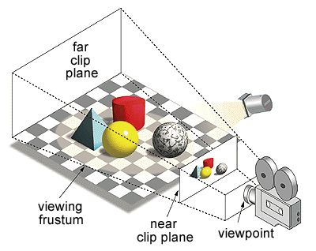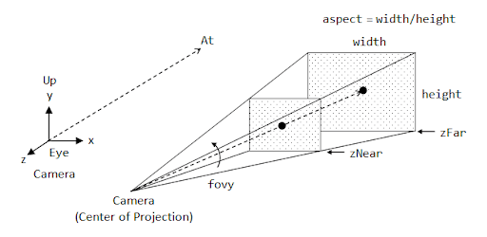

Three moments need to be defined regarding the camera position:
- eye – the position of the camera.
- at – the point the camera is looking at.
- up – defines the orientation of the camera.

The camera does not physically move, but the entire scene is transformed relative to it. This is done by a view matrix, which translates and rotates the world as if the camera were at (0,0,0) and looking along the -z axis (in OpenGL by default). So if we want to move the camera forward, we are technically moving the entire world space backward.
To define the camera coordinate system, three mutually perpendicular vectors are calculated:
- Forward vector - points from the camera to the target point
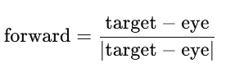
- Vector right (right) - defines the "right" side of the camera
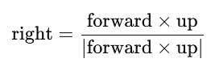
- Up vector (up) – recalculated to ensure orthogonality to the z axis.

The view matrix is ​​used to transform objects from world space to camera space.
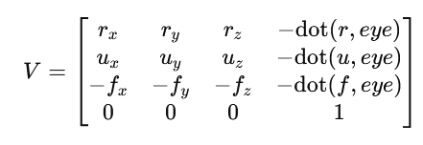
where:
right = (r_{x}, r_{y}, r_{z})
up = (u_{x}, u_{y}, u_{z})
forward = (f_{x}, f_{y}, f_{z})

- Perspective and orthographic projection
Projection is an important step in graphics rendering and is responsible for converting the 3D coordinates of a scene into 2D coordinates for on-screen representation. Projection is necessary because computer screens are two-dimensional (2D), and objects in a scene are often three-dimensional (3D).
In the real world, we perceive our environment through perspective - objects that are further away appear smaller. In computer graphics, it is necessary to explicitly define how 3D objects will be displayed on a 2D screen. This is achieved through a projection transformation.
A projection can be:
а) Perspective projection - imitates human vision: distant objects appear smaller, and nearby objects appear larger. Creates a sense of depth.
b) Orthographic projection - does not apply perspective scaling. Objects appear the same size regardless of distance.
To clarify the role of projection and how it can be applied, we will return to a concept we defined in lecture 2 – frustum (the space visible to the camera).
A frustum is a pyramidal volume that determines which objects are visible in the scene and which should be clipped. It defines the rendering boundaries (near/far planes); improves performance by clipping invisible objects; defines perspective distortion.
It is defined by 6 planes:
- Near plane – the near plane of visibility. Defines the closest point that can be seen.
- Far plane – the far plane of visibility. Defines the furthest point that is rendered.
- Top plane – the upper boundary.
- Bottom plane – the lower boundary.
- Left plane – the left boundary.
- Right plane – the right boundary.

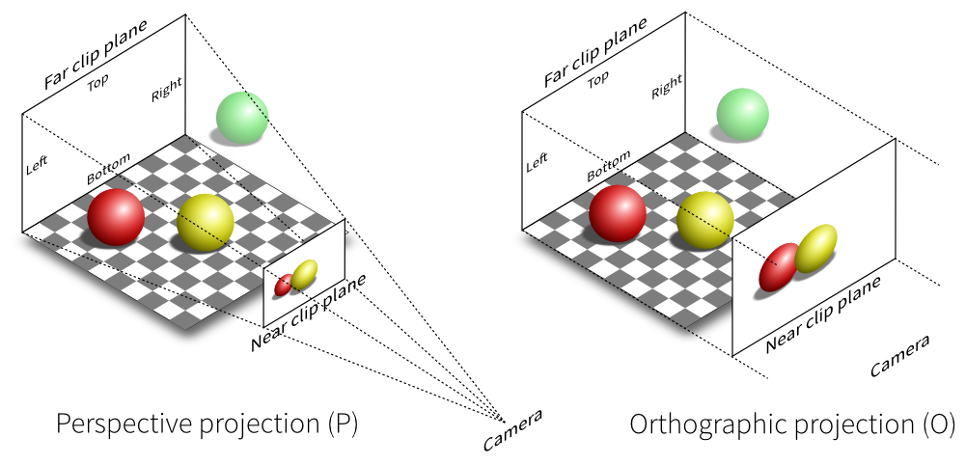
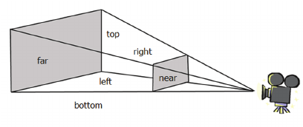
Objects outside this volume are not rendered.
In perspective projection, the frustum has a truncated pyramidal shape. It is defined by the following key parameters:
- Field of View (FOV) – the angle of view.
- Aspect Ratio – the ratio of width to height.
- Near and Far Clipping Planes – limit the visible objects.

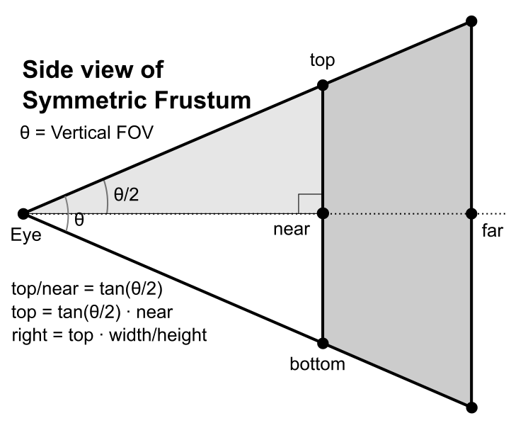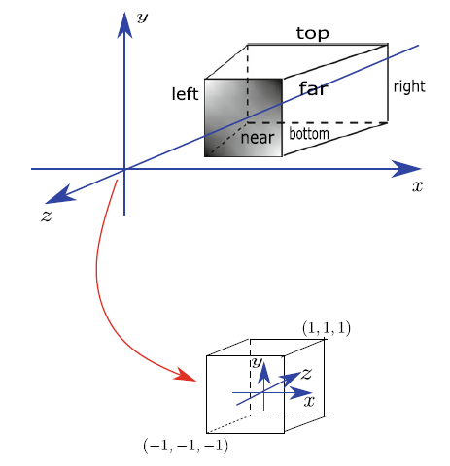
The perspective projection matrix is:
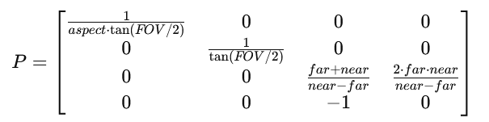

The matrix scales the X and Y coordinates depending on the viewing angle and aspect ratio; scales the Z coordinate, thereby transforming depth. Adds perspective by dividing by W - provides the effect of making distant objects appear smaller.
In orthographic projection, the frustum has the shape of a rectangular parallelepiped, unlike the truncated pyramid in perspective projection. The Near and Far Planes have the same width and height, and the sides of the frustum are parallel. Objects do not change size depending on distance, and all lines that are parallel in 3D remain parallel in 2D.
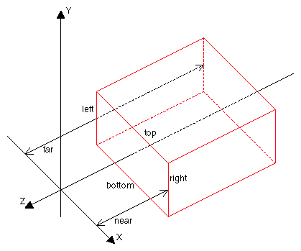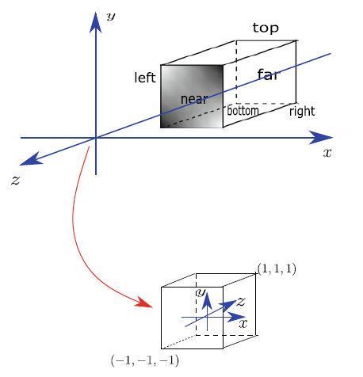

Orthographic projection converts 3D coordinates to 2D coordinates by linearly scaling the coordinates without applying perspective division.
If we specify the following rendering volume:
- X-bounds - left (l), right (r);
- Y-bounds - bottom (b), top (t);
- Z-bounds - near (n), far (f)
the orthographic projection matrix will have the following form:
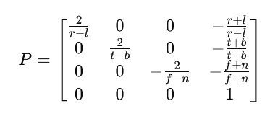
Its main purpose is to convert coordinates in the range [-1,1].

- Realization of perspectives in a graphical environment
As a basis, we will use the project containing a colored triangle: https://github.com/donikast/ColoredTriangleBasisProject.git.
To fully track the perspective of the scene, we will add values ​​for the third coordinate (z). We will draw a cube, and to understand the differences in different perspective and camera settings, we will make each wall of the cube a different color. As preparation in the Renderer class, we will need to add a mechanism for controlling the depth of pixels in 3D space, so that objects that are closer to the camera obscure those that are further away.
In the init() method on Renderer:
glEnable(GL_DEPTH_TEST);
In the render() method:
glClear(GL_COLOR_BUFFER_BIT | GL_DEPTH_BUFFER_BIT);

The vertices of the cube will have the following coordinates:
float[] vertices = {
// предна страна
-0.5f, -0.5f, 0.5f, 1.0f, 0.0f, 0.0f,
0.5f, -0.5f, 0.5f, 1.0f, 0.0f, 0.0f,
0.5f, 0.5f, 0.5f, 1.0f, 0.0f, 0.0f,
-0.5f, -0.5f, 0.5f, 1.0f, 0.0f, 0.0f,
0.5f, 0.5f, 0.5f, 1.0f, 0.0f, 0.0f,
-0.5f, 0.5f, 0.5f, 1.0f, 0.0f, 0.0f,
// задна страна
-0.5f, -0.5f, -0.5f, 0.0f, 1.0f, 0.0f,
0.5f, -0.5f, -0.5f, 0.0f, 1.0f, 0.0f,
0.5f, 0.5f, -0.5f, 0.0f, 1.0f, 0.0f,
-0.5f, -0.5f, -0.5f, 0.0f, 1.0f, 0.0f,
0.5f, 0.5f, -0.5f, 0.0f, 1.0f, 0.0f,
-0.5f, 0.5f, -0.5f, 0.0f, 1.0f, 0.0f,
// вляво
-0.5f, -0.5f, -0.5f, 0.0f, 0.0f, 1.0f,
-0.5f, -0.5f, 0.5f, 0.0f, 0.0f, 1.0f,
-0.5f, 0.5f, 0.5f, 0.0f, 0.0f, 1.0f,
-0.5f, -0.5f, -0.5f, 0.0f, 0.0f, 1.0f,
-0.5f, 0.5f, 0.5f, 0.0f, 0.0f, 1.0f,
-0.5f, 0.5f, -0.5f, 0.0f, 0.0f, 1.0f,
// вдясно
0.5f, -0.5f, -0.5f, 1.0f, 1.0f, 0.0f,
0.5f, -0.5f, 0.5f, 1.0f, 1.0f, 0.0f,
0.5f, 0.5f, 0.5f, 1.0f, 1.0f, 0.0f,
0.5f, -0.5f, -0.5f, 1.0f, 1.0f, 0.0f,
0.5f, 0.5f, 0.5f, 1.0f, 1.0f, 0.0f,
0.5f, 0.5f, -0.5f, 1.0f, 1.0f, 0.0f,
// горе
-0.5f, 0.5f, 0.5f, 0.0f, 1.0f, 1.0f,
0.5f, 0.5f, 0.5f, 0.0f, 1.0f, 1.0f,
0.5f, 0.5f, -0.5f, 0.0f, 1.0f, 1.0f,
-0.5f, 0.5f, 0.5f, 0.0f, 1.0f, 1.0f,
0.5f, 0.5f, -0.5f, 0.0f, 1.0f, 1.0f,
-0.5f, 0.5f, -0.5f, 0.0f, 1.0f, 1.0f,
// долу
-0.5f, -0.5f, 0.5f, 1.0f, 0.0f, 1.0f,
0.5f, -0.5f, 0.5f, 1.0f, 0.0f, 1.0f,
0.5f, -0.5f, -0.5f, 1.0f, 0.0f, 1.0f,
-0.5f, -0.5f, 0.5f, 1.0f, 0.0f, 1.0f,
0.5f, -0.5f, -0.5f, 1.0f, 0.0f, 1.0f,
-0.5f, -0.5f, -0.5f, 1.0f, 0.0f, 1.0f
};

12 triangles with a total of 36 vertices will be rendered.

glDrawArrays(GL_TRIANGLES, 0, 36);
Starting the project, we will see only the front wall of the cube. Let's rotate it to get the necessary visibility. In the render() method of the Renderer (add an angle field to the class and initialize it):
private float angle = 0f;

angle += 0.0005f;
Matrix4f modelMatrix = new Matrix4f().identity()
.rotate(angle, 0,0,1)
.rotate(angle, 0, 1, 0)
.rotate(angle, 1, 0, 0);
Don't forget to send the matrix data to the vertex shader.
shaderProgram.setUniform("modelMatrix", modelMatrix);

In the vertex shader:
uniform mat4 modelMatrix;
***
gl_Position = modelMatrix*vec4(aPos, 1.0);

We can now see the cube from all sides. What is striking is its unnatural appearance to the human eye. Let's change the coordinates of the vertices using perspective.
We will include a perspective projection with a viewing angle of 45 degrees and a camera view:
Matrix4f viewMatrix = new Matrix4f().lookAt(0.0f, 0.0f, 3.0f, 0.0f, 0.0f, 0.0f, 0.0f, 1f, 0.0f);
Matrix4f projectionMatrix = new Matrix4f().perspective((float) Math.toRadians(45.0f), 1.0f, 0.1f, 100f);
shaderProgram.setUniform("viewMatrix", viewMatrix);
shaderProgram.setUniform("projectionMatrix", projectionMatrix);
In the shader:
uniform mat4 viewMatrix;
uniform mat4 projectionMatrix;
***
gl_Position = projectionMatrix*viewMatrix*modelMatrix*vec4(aPos, 1.0);
Test the added code.
- Change the angle of view of the projection.
- Change the position of the camera (the first three parameters of the lookAt() method).
- Change the point the camera is looking at (the second three parameters of the lookAt() method).
Change the type of projection used to orthographic and notice the difference.
Matrix4f projectionMatrix = new Matrix4f().ortho(-1f,1f,-1f,1f, 0.1f, 100f);

Independent work assignment
1. In addition to the task above, complete the following steps:
- Remove the animated rotation and rotate the cube in x and y by 18 degrees (or another suitable angle to observe the three-dimensionality);
- Scale it by a factor of 0.3;
- Add a second cube with the same dimensions, but with shifted coordinates. Let it stand partially behind the first cube.

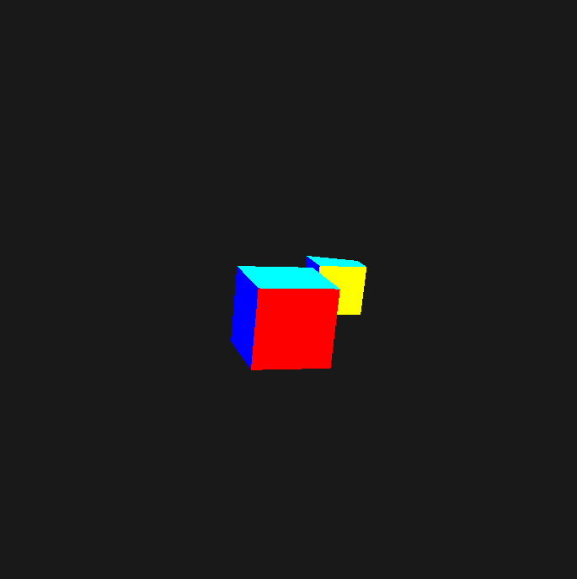

- Change camera parameters and observe scenes.
2. Try rendering a triangular pyramid with dimensions of your choice. Set appropriate camera and projection parameters.

