# DATASETS

|  |  |  |  |
| --- | --- | --- | --- |
| **Name** | **Path** | **N** | **Desc** |
| Relighted Cube+ complex segmentation | project/dataset_relighted | 13950 | Corrected Cube+ images relighted by finding edges and contours, combination of saturated and non-saturated images |
| Combined dataset | project/dataset_combined | 3064/2589[1] | Corrected Cube+ images relighted using all tried segmentation models (convex hull, threshold, erosion, edges…) which contains saturated images |
| Adaptive threshold dataset | project/complex6 | 1030 | Corrected Cube+ images relighted using adaptive threshold[2] segmentation which contains saturated images |
| Lab - projector | project/lab/combined[_tiff] | 248 | Images taken of objects illuminated by one projector projecting an image simulating two illuminants |
| Lab - projector+ambient | project/lab/realworld[_tiff] | 10 | Images taken of scenes where one illuminant is ambient, and one is generated by a projector |
| Crf - laboratory | project/dataset_crf/lab | 58 | Images of objects in a dark environment illuminated by two light sources, small difference between illuminants |
| Crf - realworld | project/dataset_crf/realworld | 20 | Images of real-world scenes with one artificial illuminant, has many unbalanced masks |
| Test | project/dataset_test | 70 | Test images combined from all datasets to evaluate model performance |

**Dataset directory structure:**

|__ images - Images used as the input for the regression model and model testing

|__ gt - The groundtruth infoirmation about the illumination for each pixel

|

|__ img_corrected_1 - Images corrected for one illuminant, used to train segmentation models

|__ gt_mask - The mask used for segmentation[3]

# RESULTS

|  |  |  |  |  |  |  |
| --- | --- | --- | --- | --- | --- | --- |
| Segmentation | | | |  |  |  |
| Model | Dataset | | Dice | | | |
| Train | Test | Mean | Std | Max (id) | Min (id) |
| U-Net efficientnet b0 | Combined | [V1@dataset_test](mailto:V1@dataset_test) | 0.570 | 0.177 | 0.809 (9) | 0.003 (37) |
| Adaptive thresh | [V1@dataset_test](mailto:V1@dataset_test) | 0.587 | 0.104 | 0.803 (9) | 0.292 (64) |
| Custom U-Net | Adaptive thresh | [V1@dataset_test](mailto:V1@dataset_test) | 0.357 | 0.200 | 0.797 (5) | 0.101 (10) |
| U-Net efficientnet b2 | Desaturated | [V1@dataset_test](mailto:V1@dataset_test) | 0.586 | 0.158 | 0.807 (2) | 0.005 (66) |

Table 2. Results of the segmentation model on the test dataset. The desaturated dataset refers to the original generated dataset with ~ 9000 images with only desaturated illuminants.

Discussion:

* Custom architecture was to simple to achieve any sort of competitive results
* Little difference between the EfficientNet U-Nets, however the B2 architecture is still being trained and could improve
* There isn’t much difference in between the median and the mean values, so only mean is shown

|  |  |  |  |  |  |  |  |  |  |
| --- | --- | --- | --- | --- | --- | --- | --- | --- | --- |
|  | Regression | | | | | | |  |  |
| Model | | Dataset | | Angular error per-pixel | | | | | |
| Train | Test | Mean | Std | Med. | Trimean | Min (id) | Max (id) |
| U-Net Efficientet b2 | | Desaturated | [V1@dataset_test](mailto:V1@dataset_test) | 11.56 | 10.37 | 5.125 | 9.353 | 1.094 (15) | 26.50 (68) |
| Crf laboratory | 25.52 | 0.779 | 25.51 | 25.51 | 24.14 (47) | 25.82 (1) |
| Crf realworld | 26.24 | 0.953 | 26.21 | 26.17 | 24.45 (5) | 28.73 (9) |
| Generated test set | 4.561 | 4.543 | 2.884 | 3.168 | 1.032 (15) | 22.06 (22) |
| Cube 12500 (desaturated + saturated) | [V1@dataset_test](mailto:V1@dataset_test) | 10.232 | 9.081 | 4.134 | 8.261 | 1.488 (1) | 25.75 (64) |
| Crf laboratory | 22.63 | 1.233 | 22.41 | 22.53 | 20.84 (23) | 25.83 (1) |
| Crf realworld | 25.60 | 1.025 | 25.86 | 25.95 | 22.95 (5) | 26.80 (9) |
| Generated test set | 3.840 | 2.327 | 3.312 | 3.262 | 1.488 (1) | 13.22 (5) |
| Cube 15000 (desaturated + saturated) | [V1@dataset_test](mailto:V1@dataset_test) | 10.57 | 10.52 | 3.835 | 8.686 | 1.094 (0) | 27.18 (64) |
| Crf laboratory | 25.74 | 0.959 | 25.66 | 25.69 | 24.46 (23) | 28.25 (1) |
| Crf realworld | 26.69 | 1.007 | 26.96 | 27.03 | 24.16 (5) | 28.24 (12) |
|  | | Generated test set | 3.021 | 1.351 | 2.897 | 2.901 | 1.094 (0) | 8.587 (5) |

Table 3. Results of the regression models trained on different datasets. Experiments were conducted on the test dataset and the crf[4] dataset

Discussion:

* High mean value and low trimean and median values indicate that there are numerous images for which the regression works well and a few for which it does not
* That is why additional experiments were conducted on the crf dataset, and the results show that the models perform bad on those images, which suggests overfitting on the train dataset
* It was noted that the saturated colors were problematic for these models (Appendix)

# Appendix

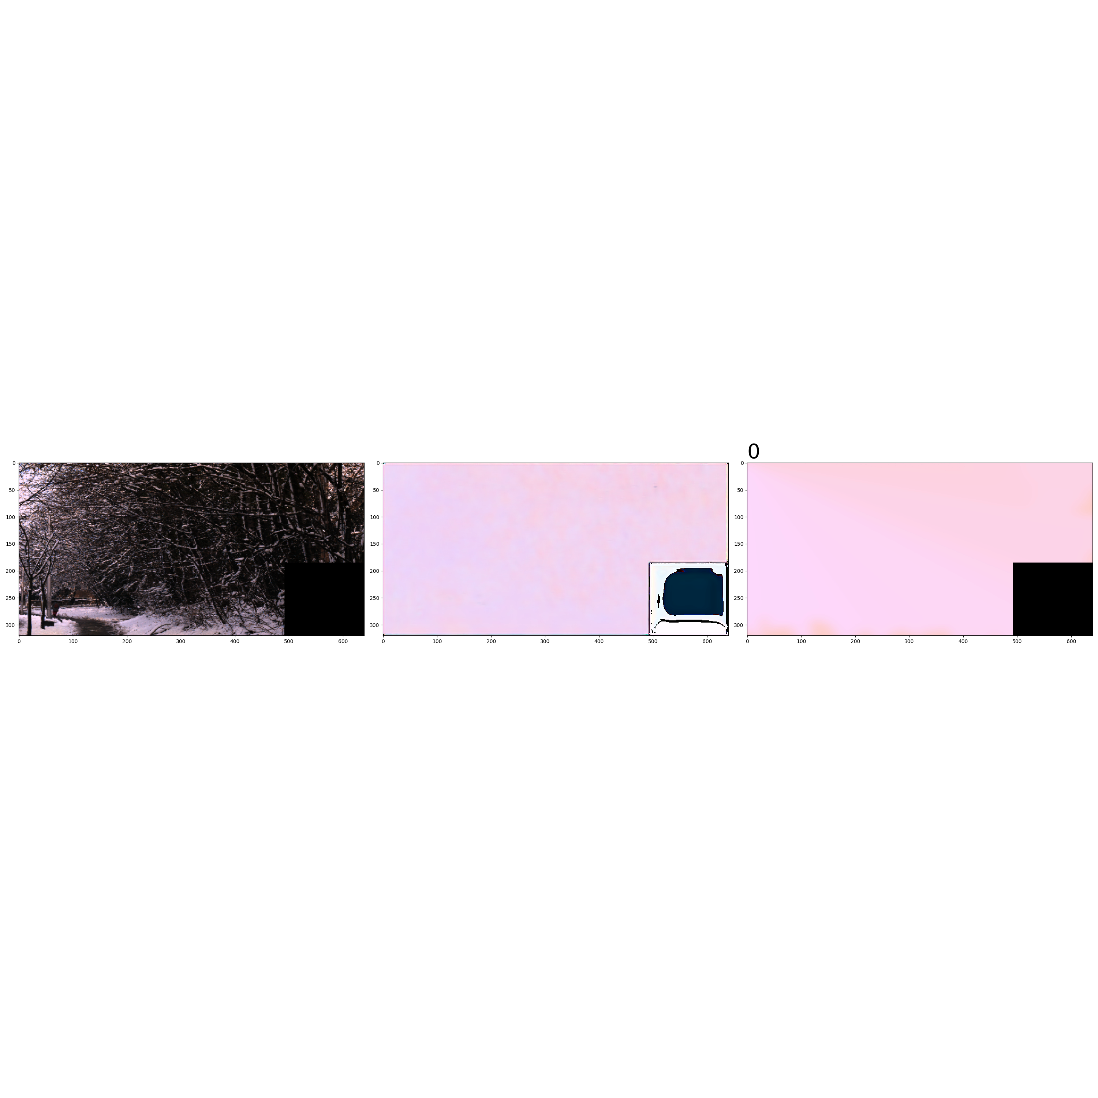Figure 1: Output of the first regression model on the image with index 0 from the generated dataset, good performance of the model

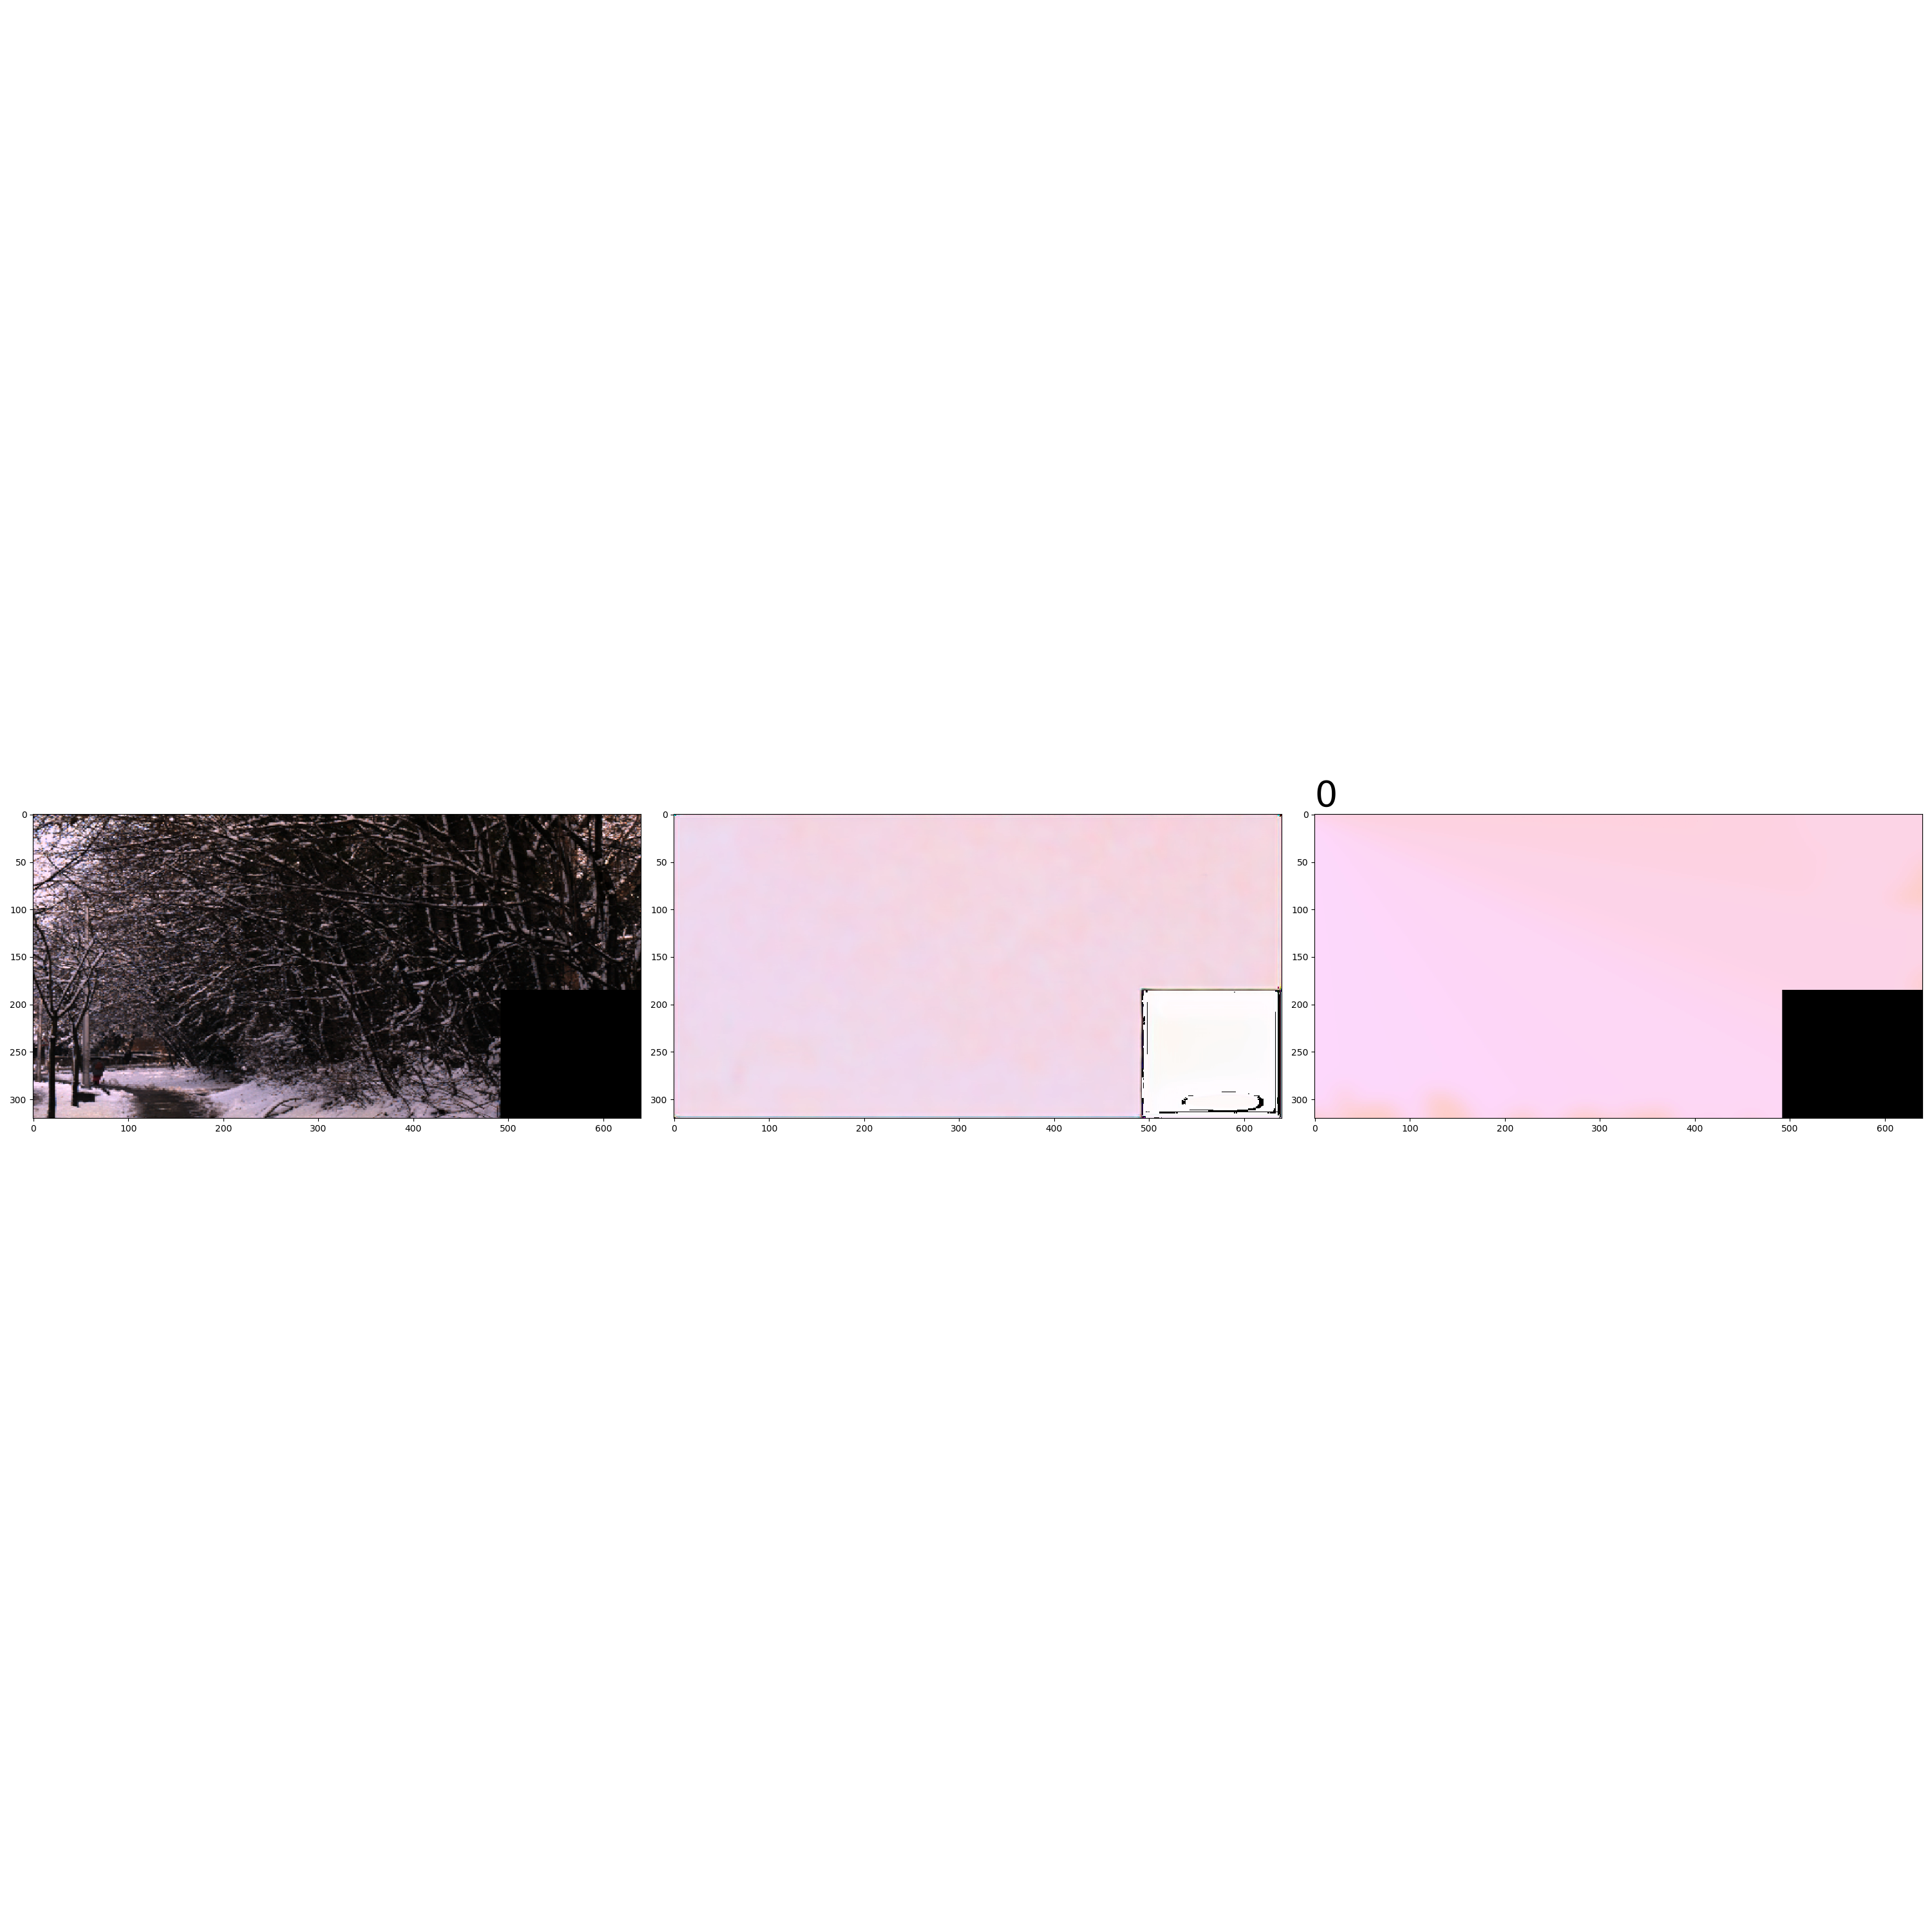 Figure 2: Output of the second regression model on the image with index 0 from the generated dataset, good performance of the model

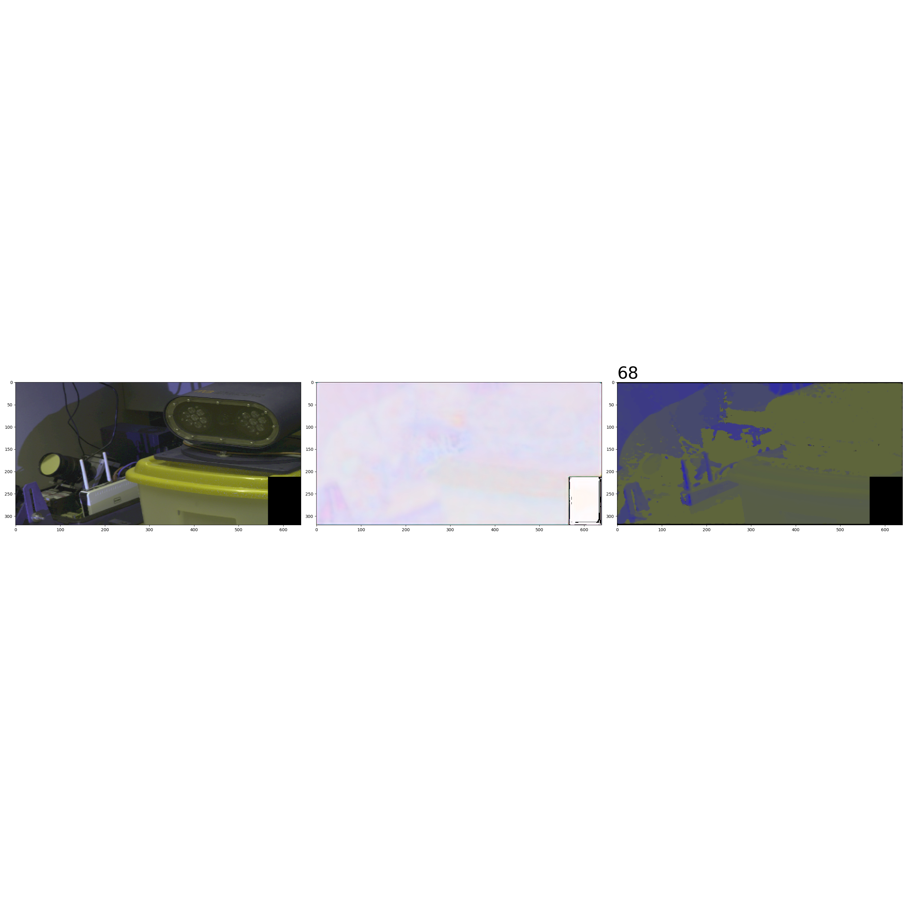

Figure 3: Output of the first regression model on the image with index 68 from the crf realworld dataset, poor performance of the model

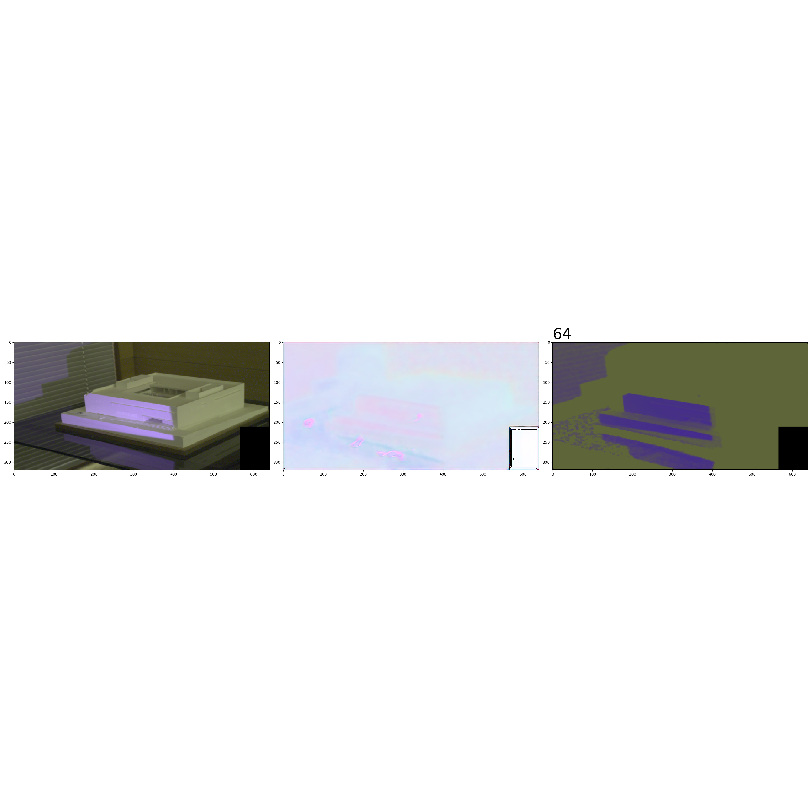

Figure 4: Output of the third regression model on the image with index 64 from the crf realworld dataset, poor performance of the model

1. Regression/Segmentation
2. Adaptive threshold – threshold for detecting contours was acquired taking the mean luminance and adding a random shift vector
3. Obtained by clustering illuminant values in groundtruths and comparing each pixel to one of the centers to determine to which illuminant it is closer
4. Shida Beigpour, Christian Riess, Joost Weijer, i Elli Angelopoulou. Multi-illuminant estimation with conditional random ﬁelds. *IEEE transactions on image processing: a publication of the IEEE Signal Processing Society*, 01 2014. doi: 10.1109/TIP. 2013.2286327.