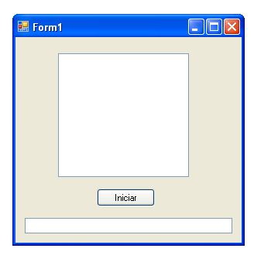
Imports System.Threading
Public Class Form1
Dim oHebra As Thread
Private Sub BtnIniciar_Click(ByVal sender As System.Object, ByVal e As System.EventArgs) Handles BtnIniciar.Click
oHebra = New Thread(AddressOf llenarLista)
oHebra.Start()
End Sub
Private Sub llenarLista()
CheckForIllegalCrossThreadCalls = False
Dim iContador As Integer
Dim iCuentaBis As Integer
For iContador = 1 To 100000
Lstproceso.Items.Add("Contador: " & iContador)
For icuntabis = 1 To 50000

Next

Next
oHebra.Abort()
End Sub
End Class

