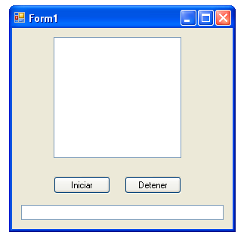
Imports System.Threading
Public Class Form1
Dim oHebra As Thread
Private Sub BtnIniciar_Click(ByVal sender As System.Object, ByVal e As System.EventArgs) Handles BtnIniciar.Click
Lstproceso.Items.Clear()
oHebra = New Thread(AddressOf llenarLista)
oHebra.Start()
End Sub
Private Sub llenarLista()
CheckForIllegalCrossThreadCalls = False
Dim iContador As Integer
Dim iCuentaBis As Integer
Lstproceso.Items.Add("ID Hebra: " & AppDomain.GetCurrentThreadId)
While True
iContador += 1
Lstproceso.Items.Add("Contador pasos: " & iContador)

Thread.CurrentThread.Sleep(500)

End While

oHebra.Abort()
End Sub

Private Sub BtnDetener_Click(ByVal sender As System.Object, ByVal e As System.EventArgs) Handles BtnDetener.Click
oHebra.Abort()
Lstproceso.Items.Add("Hebra Detenida")

End Sub
End Class

