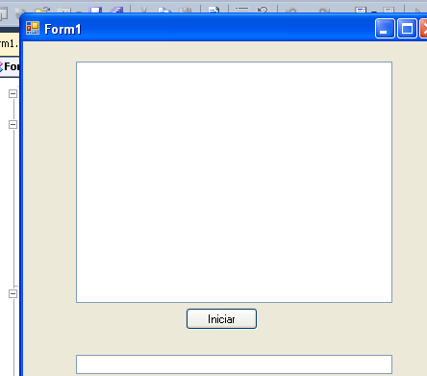

Imports System.Threading
Public Class Form1

Private Sub BtnIniciar_Click(ByVal sender As System.Object, ByVal e As System.EventArgs) Handles BtnIniciar.Click
Dim oHebra As Thread
Dim iContador As Integer
Lstproceso.Items.Clear()
For iContador = 1 To 10
oHebra = New Thread(AddressOf llenarLista)
oHebra.Start()

Next

End Sub
Private Sub llenarLista()
CheckForIllegalCrossThreadCalls = False
Dim iContador As Integer
Lstproceso.Items.Add("Sub Llenar Lista - ejecutandose en hebra: " & AppDomain.GetCurrentThreadId)

For iContador = 1 To 7
Lstproceso.Items.Add(ControlChars.Tab & AppDomain.GetCurrentThreadId & " Paso " & iContador)

Next

End Sub
End Class

