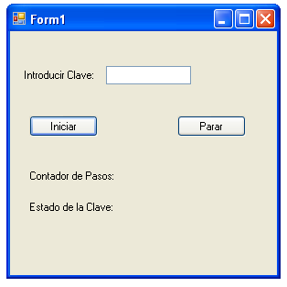
Imports System.Threading
Public Class Form1
Dim oHebra As Thread
Private Sub BtnIniciar_Click(ByVal sender As System.Object, ByVal e As System.EventArgs) Handles BtnIniciar.Click
oHebra = New Thread(AddressOf ComprobarClave)
oHebra.Start()
End Sub
Private Sub Comprobarclave()
CheckForIllegalCrossThreadCalls = False
Dim iContador As Integer
While True
iContador += 1
LblContador.Text = iContador
If TxtClave.Text = "778899" Then
Lblestado.Text = "CORRECTA"
Else
Lblestado.Text = "INCORRECTA"

End If
oHebra.Sleep(250)
End While
End Sub

Private Sub BtnParar_Click(ByVal sender As System.Object, ByVal e As System.EventArgs) Handles BtnParar.Click
oHebra.Abort()
LblContador.Text = ""
Lblestado.Text = ""
End Sub

Private Sub Form1_FormClosed(ByVal sender As Object, ByVal e As System.Windows.Forms.FormClosedEventArgs) Handles Me.FormClosed
If Not (oHebra Is Nothing) Then
If oHebra.IsAlive Then
oHebra.Abort()
End If
End If
End Sub
End Class

