s

The Experiment Report of Machine Learning

SCHOOL: SCHOOL OF SOFTWARE ENGINEERING

SUBJECT: SOFTWARE ENGINEERING

Author:  刘毅辉 | Supervisor:  Mingkui Tan
Student ID:  202430550999 | Grade:  Undergraduate

2020-10-24

Linear Regression for House Price Prediction

Abstract—This experiment studies linear regression on the Boston Housing dataset. After preprocessing the input features, a univariate model based on the average number of rooms was optimized with batch gradient descent. Three learning rates were compared over 1,000 epochs. The results show that the learning rate strongly affects convergence: α = 0.01 achieved the lowest validation mean squared error among the tested settings, whereas α = 0.001 converged too slowly. A multivariate least-squares model using all engineered features substantially improved validation performance.

INTRODUCTION
House price prediction is a regression problem in which a continuous target value is estimated from property and neighborhood attributes. This experiment uses the Boston Housing dataset to examine how a linear model maps housing features to the median value of owner occupied homes. The work also illustrates the effect of the learning rate on gradient descent in a single feature setting.

METHODS AND THEORY
For a single input feature x, the linear regression model is expressed as ŷ = wx + b, where w is the weight and b is the bias. Model quality is measured with the mean squared error (MSE), which averages the squared difference between the true target y and the prediction ŷ.
Batch gradient descent minimizes the MSE by repeatedly updating the parameters using the gradients with respect to w and b. For n training samples, ∂L/∂w = (2/n) Σ[(wxᵢ + b − yᵢ)xᵢ] and ∂L/∂b = (2/n) Σ(wxᵢ + b − yᵢ). The update rules are w ← w − α∂L/∂w and b ← b − α∂L/∂b, where α is the learning rate.

EXPERIMENT

Dataset and Preprocessing
The Boston Housing dataset contains 506 samples. Each original sample has 13 explanatory features and one target, MEDV. The data were split into 404 training samples and 102 validation samples. Missing values were handled using statistics fitted on the training set, and feature scaling was performed using training-set parameters. Logarithmic transformations were added for CRIM, ZN, and RAD, resulting in 16 input features after feature engineering.

Single Variable Gradient Descent
The RM feature, representing the average number of rooms per dwelling, was selected as the single input variable. Each configuration used batch gradient descent for 1,000 epochs. Table I summarizes the final parameters and MSE values. Lower validation MSE indicates better generalization.
SINGLE VARIABLE GRADIENT DESCENT RESULTS
α = 0.1: w = 22.9828; b = 22.8490; training MSE = 42.9966; validation MSE = 46.1448
α = 0.01: w = 18.6140; b = 22.8381; training MSE = 44.5821; validation MSE = 45.4441
α = 0.001: w = 3.4778; b = 19.7221; training MSE = 84.1000; validation MSE = 68.2930
The three settings reveal a clear trade off. With α = 0.001, the model remained far from convergence after 1,000 epochs and produced the highest errors. The setting α = 0.1 reduced training error more quickly, but α = 0.01 obtained the best validation MSE (45.4441) among the tested rates. Therefore, α = 0.01 is selected as the preferred setting for the single-variable experiment.

Loss Curve Analysis
Figures 1–3 show the training and validation MSE during gradient descent. With α = 0.001, both curves are still decreasing after 1,000 epochs, indicating slow convergence. With α = 0.1, the training curve decreases rapidly, but its final validation error is slightly worse than that of α = 0.01. The α = 0.01 curves decrease smoothly and give the lowest validation MSE among the three settings.
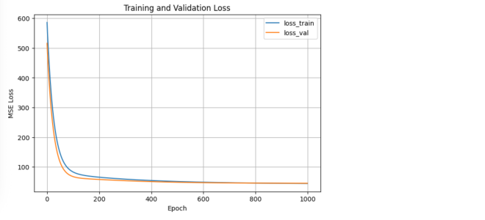
Figure 1. Training and validation loss curves for α = 0.01.
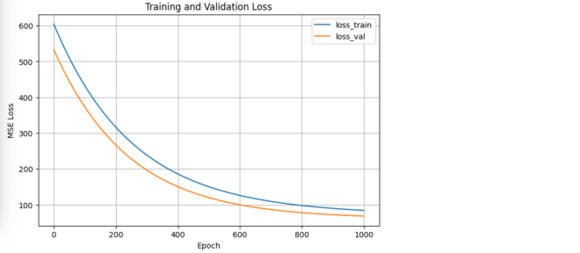
Figure 2. Training and validation loss curves for α = 0.001.
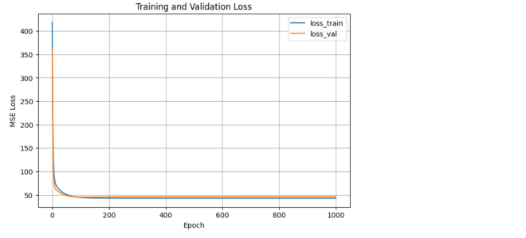
Figure 3. Training and validation loss curves for α = 0.1.

Multivariate Linear Regression Comparison
A multivariate LinearRegression model was then trained using all 16 preprocessed features. It used the ordinary least-squares solution. The training MSE was 21.3554 and the validation MSE was 24.2293. By comparison, the selected single-variable model (α = 0.01) obtained a training MSE of 44.5821 and a validation MSE of 45.4441.
Using all features reduced the validation MSE by 21.2148, or approximately 46.7%, relative to the single-variable model. This improvement is expected because house value is influenced by multiple attributes rather than the number of rooms alone.

Parameter Analysis and Selection Guidelines
The learning-rate experiments demonstrate the sensitivity of gradient descent to α. With α = 0.001, the loss curves decrease slowly throughout the 1,000 epochs, and the validation MSE remains high (68.2930); the step size is too small for efficient convergence. With α = 0.1, the training loss falls rapidly and reaches a lower training MSE (42.9966), but its validation MSE is 46.1448. The setting α = 0.01 gives the lowest validation MSE (45.4441) and a smooth loss curve, so it provides the best balance between convergence speed and generalization in this experiment.
Gradient descent minimizes a loss function by moving the parameters in the direction opposite to its gradient. At each iteration, the gradient identifies the local direction in which the loss increases most quickly; subtracting a scaled gradient therefore reduces the loss. The learning rate controls the size of this update. A very small learning rate is stable but slow, whereas an excessively large one can overshoot the minimum, oscillate, or become unstable.
In practice, input features should first be scaled so that a single learning rate works across all features. A useful starting strategy is to test learning rates on a logarithmic scale, for example 0.001, 0.01, and 0.1, while monitoring both training and validation loss. If the loss decreases too slowly, increase α or allow more epochs; if the curve rises, oscillates, or becomes unstable, decrease α. The selected setting should be based on validation loss rather than training loss alone, and training can stop once the validation loss no longer improves materially.

CONCLUSION
This experiment applied linear regression and gradient descent to house price prediction. The single-feature model based on RM demonstrates that a suitable learning rate is essential: an overly small rate slows convergence, while a larger rate does not necessarily produce the lowest validation error. The multivariate model achieved substantially lower training and validation MSE values, showing the value of combining multiple housing characteristics. The loss curves further show that α = 0.01 provides the most suitable trade off among the tested learning rates.

