# Line_Sensor

line sensor program for robocon 2016

According to my test(line_sensorPD), if the speed is less than 1m/s. The robot car could trace the white line to the top of the slope.

If the speed is faster, the robot car may rush out of the slope.

~~Currently, the simplest method to improve the performance I think is to use a faster controller.~~

~~If the state of the sensor changed(10degree) every 10ms, the servo motor may not be able to follow the controller.~~

~~Thus I think the performance of the system could reach maximum if each loop costs only 10ms. (currently each loop cost about 30ms)~~

19/01/2016

I tested the eco robot on the flat ground. It seems the robot tends to rush out of the track at certain point (see the following figure, highlighted by the blue circle.)

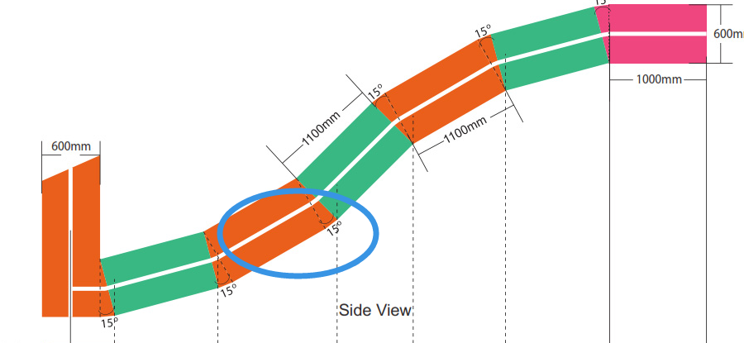

It proves that errors are caused by the control program.

Usually we start pushing the car at first slope (first green area). The first two turns are the same. The direction of the third turn changes so that it’s more difficult for it to turn. The speed of the car could be fast at the beginning. But the robot car need to be slowed down at the second slope.

Also I changed the baud rate so that each loop could finish within 2ms. It seems that the result stay the same.

As a result, I think there is only two ways to improve the performance if the speed of the car doesn’t change. 1. using PID to control. 2. Change the structure of the car.