**Introduction**

Suppose you own a company with six employees: Alice, Bob, Charlie, Dorothy, Evan, and Fred. To make managing easier, you decide to divide the six workers into two evenly sized teams. How many ways are there to do this?

As it turns out, there are ten ways to accomplish the division. Denoting the people by their initial, the ten ways are:

1. {A,B,C} {D,E,F}
2. {A,B,D} {C,E,F}
3. {A,B,E} {C,D,F}
4. {A,B,F} {C,D,E}
5. {A,C,D} {B,E,F}
6. {A,C,E} {B,D,F}
7. {A,C,F} {B,D,E}
8. {A,D,E} {B,C,F}
9. {A,D,F} {B,C,E}
10. {A,E,F} {B,C,D}

However, for problems on a larger scale, enumeration takes too long and it is necessary to formulate and generalize counting methods.

**COUNTING SETS**

Let A and B be two sets. Then |A∪B| = |A| + |B| − |A∩B|.

A, B and C are three sets. Then |A∪B∪C| = |A|+|B|+|C|−|A∩B|−|A∩C|−|B∩C|+|A∩B∩C|

**CARDINALITY**

If A is a finite set, then n(A), the number of elements A contains, is called the **cardinality of A**.

If A and B are finite sets, then n(A∪B) = n(A) + n(B) - n(A∩B).

In particular, if A and B are disjoint (that is, A∩B = https://www.zweigmedia.com/RealWorld/gf/empty.gif), then n(A∪B) = n(A) + n(B).

If S is a finite universal set and A $⊆$ S, then n(A') = n(S) - n(A) and n(A) = n(S) - n(A').

If A and B are finite sets, then n(A×B) = n(A).n(B)

**EXAMPLE:** Find the integer solutions for the equation a + b + c = 5, where a, b, c $≥$ 0.

**Solution:**

$$5=5+0+0=4+1+0=3+2+0=3+1+1=2+2+1$$

$$5=\left(5, 0, 0\right)=\left(4,1,0\right)=\left(3,2,0\right)=\left(3,1,1\right)=(2,2,1)$$

$\frac{3!}{2!1!}+\frac{3!}{1!1!1!}+\frac{3!}{1!1!1!}+\frac{3!}{21!!}+\frac{3!}{21!!}=3+6+6+3+3=21$

|  |  |  |  |  |
| --- | --- | --- | --- | --- |
| **Sl. No.** | **a** | **b** | **c** | **Total = 5** |
| 1 | **5** | **0** | **0** | 5 |
| 2 | 0 | 5 | 0 | 5 |
| 3 | 0 | 0 | 5 | 5 |
| 4 | **4** | **1** | **0** | 5 |
| 5 | 4 | 0 | 1 | 5 |
| 6 | 1 | 4 | 0 | 5 |
| 7 | 1 | 0 | 4 | 5 |
| 8 | 0 | 1 | 4 | 5 |
| 9 | 0 | 4 | 1 | 5 |
| **10** | **3** | **2** | **0** | 5 |
| 11 | 3 | 0 | 2 | 5 |
| 12 | 2 | 3 | 0 | 5 |
| 13 | 2 | 0 | 3 | 5 |
| 14 | 0 | 2 | 3 | 5 |
| 15 | 0 | 3 | 2 | 5 |
| **16** | **3** | **1** | **1** | 5 |
| 17 | 1 | 3 | 1 | 5 |
| 18 | 1 | 1 | 3 | 5 |
| **19** | **2** | **2** | **1** | 5 |
| 20 | 2 | 1 | 2 | 5 |
| 21 | 1 | 2 | 2 | 5 |

**EXAMPLE**: Find how many numbers from 1 to 1000 are divisible either by 7 or by 11.

Solution:

Let A be the set of numbers from 1 to 1000 that are divisibly by 7 and

let B be the set of numbers from 1 to 1000 that are divisible by 11.

Then the set of numbers divisible either by 7 or by 11 is the set A∪B.

The number of multiples of 7 from 1, 2, 3, . . . , 1000 = $\left[\frac{1000}{7}\right]$ =142.

The number of multiples of 11 from 1, 2, 3, . . . , 1000 = $\left[\frac{1000}{11}\right]$ = 90.

The number of multiples of 7 and 11 from 1, 2, 3, . . . , 1000 = $\left[\frac{1000}{7×11}\right]$ = 12.

Hence |A| = 142, |B| = 90 and |A∩B| = 12.

|A∪B| = |A| + |B| − |A∩B

= 142 + 90 $–$ 12 = 220.

**EXAMPLE**: Determine the number of integers between 1 and 250 (inclusive) that are divisible by 2, 3, or 5.

Solution: Set A = Set of integers between 1 and 250 (inclusive) are divisible by 2.

Set B = Set of integers between 1 and 250 (inclusive) are divisible by 3.

Set C = Set of integers between 1 and 250 (inclusive) are divisible by 5.

Set U = Set of integers between 1 and 250 (inclusive).

$\left|A\right|= \left|\frac{250}{2}\right|=125$

$\left|B\right|= \left|\frac{250}{3}\right|=83$

$\left|C\right|= \left|\frac{250}{5}\right|=50$

$\left|A∩B\right|=$ $\left|\frac{250}{2×3}\right|=41$

$\left|A∩C\right|=$ $\left|\frac{250}{2×5}\right|=25$

$\left|B∩C\right|=$ $\left|\frac{250}{3×5}\right|=16$

$\left|A∩B∩C\right|=$ $\left|\frac{250}{2×3×5}\right|=8$

$$\left|A∪B∪C\right|=\left|A\right|+\left|B\right|+\left|C\right|-\left|A∩B\right|-\left|A∩C\right|-\left|B∩C\right|+\left|A∩B∩C\right|.$$

= 125 + 83 + 50 – 41- 25 – 16 + 8

= 266 -82 =184.

The number of integers which are divisible by 2 or 3 or 5 =184

A **permutation of n items taken r at a time** is an ordered list of r items chosen from a set of n items. The number of permutations of n items taken r at a time is given by

P(n, r) = n × (n-1) × (n-2) × . . . × (n-r+1) = $\frac{n!}{\left(n-r\right)!}$.

A **combination** of n items taken r at a time is an unordered set of r items chosen from n. The number of combinations of n items taken r at a time is

C(n, r) = P(n, r)/r!

**FUNDAMENTAL PRINCIPLES OF COUNTING**

The Fundamental Counting Principle is a way to figure out the total number of ways different events can occur.

1. **Rule of sum.**

If the first task can be performed in *m* ways, while a second task can be performed in *n* ways, and the two tasks cannot be performed simultaneously, then performing either task can be accomplished in any one of *m + n* ways.

**Example 1**: A college library has 40 books on C++ and 50 books on Java. A student at this college can select 40+50=90 books to learn programming language.

**Example 2**: A class has 34 students. B class has 29 students. The two classes go to a computer demonstration together. Altogether there are 34 + 29 = 63 students.

1. **Rule of Product**

If a procedure can be broken into first and second stages, and if there are *m* possible outcomes for the first stage and if, for each of these outcomes, there are *n* possible outcomes for the second stage, then the total procedure can be carried out, in the designed order, in *mn* ways.

**Example 1:** A drama club with six men and eight can select male and female role in 6 x 8 = 48 ways.

**Example 2:** Suppose we throw a red die and a green die. How many possible outcomes?

*Solution*: Roll red die: 6 possibilities

Roll green die: 6 possibilities

So, total of 6 × 6 = 36 outcomes.

**Example 3:** How many positive divisors does 2000 have?

Any positive divisor of 2000 must have the form 2a5b (since 2000=2453), where *a* and *b* are integers satisfying $0≤a≤4, 0≤b≤3$. There are 5 possibilities for *a* and 4 possibilities for *b*, and hence there are 5x4=20 (rule of product) positive divisors of 2000 in all.

**Sum and product rules together:**

**Example 1:** Sathish have 13 Mathematics, 3 French and 7 History books. In how many ways can Sathish select two books not in the same area?

*Solution*: M & F: 13 × 3 = 39

M & H: 13 × 7 = 91

H & F: 3 × 7 = 21

Total: = 151

So, total of 151 selections.

**Example 2:** How many distinguishable nonempty collections can be formed from 7 identical red balls and 5 identical white balls?

*Solution*: Consider all collections, including empty one. Can have 0, 1, …, 7 red balls: 8 choices. Can have 0, 1, …, 5 white balls: 6 choices. So, altogether 8 × 6 = 48 collections, and 1 is empty, so 47 nonempty collections. (using the sum rule, empty + nonempty = total).

**Example 3:** Alabama car licence plates have a number between 1 and the number of counties in Alabama, followed by a two letters, followed by a sequence of digits, for a total of seven characters altogether. What is the maximum number of plates that can be made (ignoring considerations such as fact that some counties will run out before others in real life) if Alabama has 67 counties?

*Solution*:

Two cases: case(i) DLLDDDD 9x262x104

case(ii) DDLLDDD (67 − 9)x262x103 = 58x262x103

So total is (90 + 58)x262x103 = 100, 048, 000.

**Example 4:** In how many ways can 7 different books be arranged on a shelf?

*Solution*:

1st book 7 choices

2nd book 6 choices

.

.

.

7th book 1 choice

So, by the Product Rule, there are 7.6.5.4.3.2.1 = 7! = 5040 ways. This leads to Permutations (arrangements)

**Example 5:** Calvin wants to go to Chennai. He can choose from 3 bus services or 2 train services to head from home to Srinagar. From there, he can choose from 2 bus services or 3 train services to head to Chennai. How many ways are there for Calvin to get to Chennai?

He has $3+2=5$ ways to get to Srinagar. (Rule of sum)

From there, he has $2+3=5$ ways to get to Chennai. (Rule of sum)

Hence, he has $5×5=25$ ways to get to Chennai in total. (Rule of product)

**PARTITION OF A SET**

A **partition** of a set is a grouping of the set's elements into non-empty subsets, in such a way that every element is included in one and only one of the subsets.

Every equivalence relation on a set defines a partition of this set, and every partition defines an equivalence relation. A set equipped with an equivalence relation or a partition is sometimes called a **setoid**.

**Definition**

A partition of a set X is a set of nonempty subsets of X such that every element x in X is in exactly one of these subsets (i.e., X is a disjoint union of the subsets).

Equivalently, a family of sets P is a partition of X if and only if all of the following conditions hold:

* The family P does not contain the empty set.
* The union of the sets in P is equal to X.
* The intersection of any two distinct sets in P is empty (pair wise disjoint).

The sets in *P* are called the *blocks*, *parts* or *cells* of the partition.

The **rank** of *P* is |*X*| − |*P*|, if *X* is finite.

EXAMPLES:

* The **empty set** ∅ has exactly **one partition**, namely ∅.
* Every **singleton** set {x} has exactly **one partition**, namely { {x} }.
  + For any nonempty set *X*, *P* = {*X*} is a partition of *X*, called the **trivial partition**.
* Every set with two elements has two partitions. If X = {1, 2}, then P = {{1}, {2}} or P = {{1, 2}}.
* Every set with 3 elements has five partitions. If X = { 1, 2, 3 }, then
  + - P1 = { {1}, {2}, {3} }, sometimes written 1|2|3.
    - P2 = { {1, 2}, {3} }, or 12|3.
    - P3 = { {1, 3}, {2} }, or 13|2.
    - P4 = { {1}, {2, 3} }, or 1|23.
    - P5 = { {1, 2, 3} }, or 123.
* Every set with 4 elements has fifteen partitions. If X = { 1, 2, 3, 4 }, then
  + - P1 = { {1}, {2}, {3}, {4} }, or 1|2|3|4.
    - P2 = { {1, 2}, {3, 4} }, or 12|34.
    - P3 = { {1, 2}, {3}, {4} }, or 12|3|4.
    - P4 = { {1, 3}, {2, 4} }, or 13|24.
    - P5 = { {1, 3}, {2}, {4} }, or 13|2|4.
    - P6 = { {1, 4}, {2, 3} }, or 14|23.
    - P7 = { {1, 4}, {2} , {3} }, or 14|2|3.
    - P8 = { {2, 3}, {1}, {4} }, or 23|1|4.
    - P9 = { {2, 4}, {1}, {3} }, or 24|1|3.
    - P10 = { {3, 4}, {1}, {2} }, or 34|1|2.
    - P11 = { {1, 2, 3}, {4} }, or 123|4.
    - P12 = { {1, 2, 4}, {3} }, or 124|3.
    - P13 = { {1, 3, 4}, {2} }, or 134|2.
    - P14 = { {2, 3, 4}, {1} }, or 234|1.
    - P15 = { {1, 2, 3, 4} }, or 1234.
* For any non-empty proper subset A of a set U, the set A together with its complement form a partition of U, namely, {A, U \ A}.

**COUNTING PARTITIONS USING BELL NUMBERS**

The total number of partitions of an *n*-element set is the **Bell number *Bn***. The first several Bell numbers are *B*0 = 1, *B*1 = 1, *B*2 = 2, *B*3 = 5, *B*4 = 15, *B*5 = 52, and *B*6 = 203. Bell numbers satisfy the recursion

$$B_{n+1}=\sum_{k=0}^{n}{\left(\begin{matrix}n \\ k\end{matrix}\right)}B_{k}.$$

The Bell numbers may also be computed using the Bell triangle in which the first value in each row is copied from the end of the previous row, and subsequent values are computed by adding two numbers, the number to the left and the number to the above left of the position. The Bell numbers are repeated along both sides of this triangle. The numbers within the triangle count partitions in which a given element is the largest singleton.

The **Bell numbers** can easily be **calculated** by creating the so-called **Bell triangle**, also called **Aitken's** array or the **Peirce** triangle after Alexander Aitken and Charles Sanders Peirce.

1. Start with the number one. Put this on a row by itself. ( x 0 , 1 = 1 {\displaystyle x_{0,1}=1}*x*0,1=1)
2. Start a new row with the rightmost element from the previous row as the leftmost number ( x i , 1 ← x i − 1 , r {\displaystyle x_{i,1}\leftarrow x_{i-1,r}} *xi,*1 x i , 1 ← x i − 1 , r {\displaystyle x_{i,1}\leftarrow x_{i-1, *xi-*1*,r* where *r* is the last element of (*i*-1)-th row)
3. Determine the numbers not on the left column by taking the sum of the number to the left and the number above the number to the left, that is, the number diagonally up and left of the number we are calculating ( x i , j ← x i , j − 1 + x i − 1 , j − 1 ) {\displaystyle (x_{i,j}\leftarrow x_{i,j-1}+x_{i-1,j-1})}( x i , 1 ← x i − 1 , r {\displaystyle x_{i,1}\leftarrow x_{i-1,r}} *xi, j* x i , 1 ← x i − 1 , r {\displaystyle x_{i,1}\leftarrow x_{i-1, *xi, j-*1*+ xi-*1*, j-*1)
4. Repeat step three until there is a new row with one more number than the previous row (do step 3 until j = r + 1 {\displaystyle j=r+1}*j = r+1*)
5. The number on the left hand side of a given row is the *Bell number* for that row. ( B i ← x i , 1 {\displaystyle B_{i}\leftarrow x_{i,1}}B*i* x i , 1 ← x i − 1 , r {\displaystyle x_{i,1}\leftarrow x_{i-1,r}} *xi,* 1)

Here are the first five rows of the triangle constructed by these rules:

**1**

**1** 2

**2** 3 5

**5** 7 10 15

**15** 20 27 37 52

The Bell numbers appear on both the left and right sides of the triangle.

**STIRLING NUMBER**

**STIRLING NUMBER OF THE FIRST KIND**

Stirling numbers of the first kind arise in the study of permutations. In particular, the Stirling numbers of the first kind count permutations according to their number of cycles (counting fixed points as cycles of length one).

Below is a triangular array of unsigned values for the Stirling numbers of the first kind, similar in form to Pascal's triangle. These values are easy to generate using the recurrence relation in the previous section.

|  |  |  |  |  |  |  |  |  |  |  |
| --- | --- | --- | --- | --- | --- | --- | --- | --- | --- | --- |
| **n** \ *k* | *0* | *1* | *2* | *3* | *4* | *5* | *6* | *7* | *8* | *9* |
| **0** | 1 |  |  |  |  |  |  |  |  |  |
| **1** | 0 | 1 |  |  |  |  |  |  |  |  |
| **2** | 0 | 1 | 1 |  |  |  |  |  |  |  |
| **3** | 0 | 2 | 3 | 1 |  |  |  |  |  |  |
| **4** | 0 | 6 | 11 | 6 | 1 |  |  |  |  |  |
| **5** | 0 | 24 | 50 | 35 | 10 | 1 |  |  |  |  |
| **6** | 0 | 120 | 274 | 225 | 85 | 15 | 1 |  |  |  |
| **7** | 0 | 720 | 1764 | 1624 | 735 | 175 | 21 | 1 |  |  |
| **8** | 0 | 5040 | 13068 | 13132 | 6769 | 1960 | 322 | 28 | 1 |  |
| **9** | 0 | 40320 | 109584 | 118124 | 67284 | 22449 | 4536 | 546 | 36 | 1 |

**Identities involving Stirling numbers of the first kind**

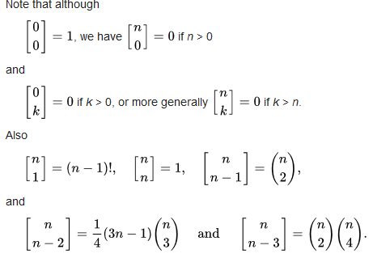

It is also notable that the sum of the Stirling numbers on any row is equal to the first non-zero entry on the next row:

.

**STIRLING NUMBER OF THE SECOND KIND**

The number of partitions of an n-element set into exactly k nonempty parts is the **Stirling** number of the **second kind** S(n, k).

Since the Stirling number { n k } {\displaystyle \left\{{n \atop k}\right\}} {}{{}kcvkcounts set partitions of an *n*-element set into *k* parts, the sum

$$B_{n}= \sum_{k=0}^{n}{\left\{{n \atop k}\right\}}$$

over all values of *k* is the total number of partitions of a set with *n* members. This number is known as the *n*th Bell number. Analogously, the ordered Bell numbers can be computed from the Stirling numbers of the second kind via a n = ∑ k = 0 n k ! { n k } . {\displaystyle a_{n}=\sum _{k=0}^{n}k!\left\{{n \atop k}\right\}.}

Below is a triangular array of values for the Stirling numbers of the second kind.

|  |  |  |  |  |  |  |  |  |  |  |  |
| --- | --- | --- | --- | --- | --- | --- | --- | --- | --- | --- | --- |
| **n** \ *k* | *0* | *1* | *2* | *3* | *4* | *5* | *6* | *7* | *8* | *9* | *10* |
| **0** | 1 |  |  |  |  |  |  |  |  |  |  |
| **1** | 0 | 1 |  |  |  |  |  |  |  |  |  |
| **2** | 0 | 1 | 1 |  |  |  |  |  |  |  |  |
| **3** | 0 | 1 | 3 | 1 |  |  |  |  |  |  |  |
| **4** | 0 | 1 | 7 | 6 | 1 |  |  |  |  |  |  |
| **5** | 0 | 1 | 15 | 25 | 10 | 1 |  |  |  |  |  |
| **6** | 0 | 1 | 31 | 90 | 65 | 15 | 1 |  |  |  |  |
| **7** | 0 | 1 | 63 | 301 | 350 | 140 | 21 | 1 |  |  |  |
| **8** | 0 | 1 | 127 | 966 | 1701 | 1050 | 266 | 28 | 1 |  |  |
| **9** | 0 | 1 | 255 | 3025 | 7770 | 6951 | 2646 | 462 | 36 | 1 |  |
| **10** | 0 | 1 | 511 | 9330 | 34105 | 42525 | 22827 | 5880 | 750 | 45 | 1 |

Stirling numbers of the second kind obey the recurrence relation

$\left\{{n+1 \atop k}\right\}=k \left\{{n \atop k}\right\}+\left\{{n \atop k-1}\right\}$ for k>0 with initial condition. $\left\{{0 \atop 0}\right\}=1$ and $\left\{{n \atop 0}\right\}=\left\{{0 \atop n}\right\}=0$ fro n>0.

The Stirling numbers of the second kind, written **S ( *n* , *k* )** or $\left\{{n \atop k}\right\}$ or with other notations, count the number of ways to partition a set of n labelled objects into *k* nonempty unlabelled subsets. Equivalently, they count the number of different **equivalence relations** with precisely *k* equivalence classes that can be defined on an *n* element set. In fact, there is a **bijection** between the set of partitions and the set of equivalence relations on a given set. Obviously,

$\left\{{n \atop n}\right\}=1$ and for $n≥1$, $\left\{{n \atop 1}\right\}=1$

as the only way to partition an n-element set into n parts is to put each element of the set into its own part, and the only way to partition a nonempty set into one part is to put all of the elements in the same part. They can be calculated using the following explicit formula:

$$\left\{{n \atop k}\right\}=\frac{1}{k!}\sum_{j=0}^{k}{{\left(-1\right)}^{k-j}}\left({k \atop j}\right)j^{n}$$

The Stirling numbers of the second kind may also be characterized as the numbers that arise when one expresses powers of an indeterminate x in terms of the falling factorials

**.** with, (*x*)0 = 1

**CATALAN NUMBER**

The number of noncrossing partitions of an n-element set is the **Catalan** number Cn, given by $c_{n}=\left(\begin{matrix}2n \\ n\end{matrix}\right)-\left(\begin{matrix}2n \\ n+1\end{matrix}\right)=\frac{1}{n+1}\left(\begin{matrix}2n \\ n\end{matrix}\right)$ for $n≥0.$

**The Catalan numbers** form a sequence of natural numbers that occur in various counting problems, often involving recursively-defined objects. They are named after the Belgian mathematician Eugène Charles Catalan. the nth Catalan number is given directly in terms of binomial coefficients by

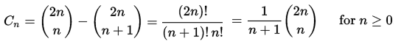

The first several Catalan numbers are listed as following:

|  |  |  |  |  |  |  |  |  |  |  |  |  |  |
| --- | --- | --- | --- | --- | --- | --- | --- | --- | --- | --- | --- | --- | --- |
| 0 | 1 | 2 | 3 | 4 | 5 | 6 | 7 | 8 | 9 | 10 | 11 | 12 | 13 |
| 1 | 1 | 2 | 5 | 14 | 42 | 132 | 429 | 1430 | 4862 | 16796 | 58786 | 208012 | 742900 |

**Applications of Catalan numbers**

**(i)Stacking Coins**

We are going to stack coins on a bottom row that consists of n consecutive coins. It is not allowed to put the coins on the two sides of the bottom coins. How many ways there are to stack coins on the n coins?

n: The number of ways to stack coins in the plane.

Solution: Cn.

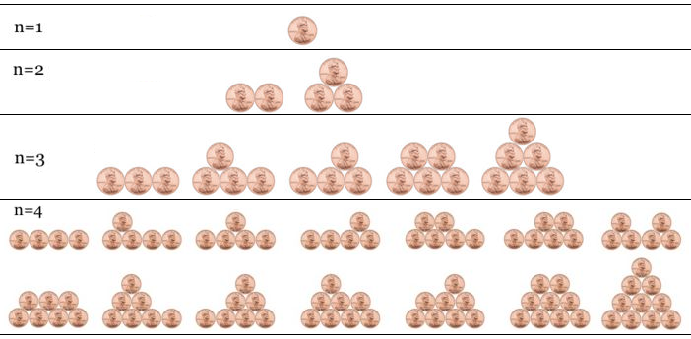

**(ii) Balanced Parentheses**

We want to group a string of parentheses. Each open parenthesis must have a matching closed parenthesis. Therefore, "(( )( ))" is valid, but ")( )) ((" and "())( ) (" are not. How many groupings are there to group n pairs of parentheses?

n : The number of pairs of parentheses.

Solution: Cn.

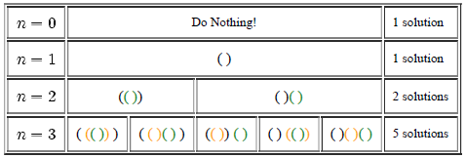



**(iii) Polygon Triangulation**

We want to cut convex polygons into triangles by connecting the vertices with straight, non-intersecting lines. How many different ways are there for a polygon with n+2 sides? This is the application Euler was interested in.

n: The number of sides of the polygon - 2.

Solution: Cn.

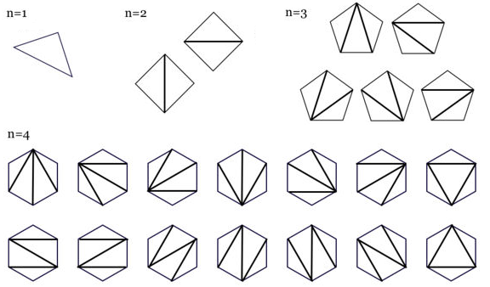

**(iv) Mountain Ranges**

We want to form mountain ranges on a line with n upstrokes and n downstrokes. Same as the matching rule of the parentheses grouping problem, each upstroke must have a matching downstroke. How many mountain ranges are there for each value of n?

n: The number of pairs of upstrokes and downstrokes.

Solution: Cn.

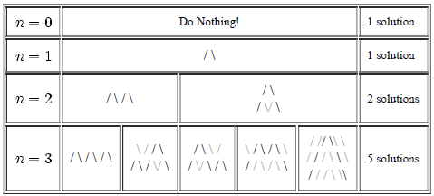

**(v) Number of full binary trees with n + 1 leaves**

Successive applications of a binary operator can be represented in terms of a full binary tree. (A rooted binary tree is *full* if every vertex has either two children or no children.) It follows that *Cn* is the number of full binary trees with *n* + 1 leaves:

[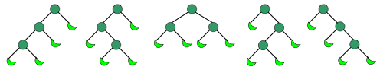](https://en.wikipedia.org/wiki/File:Catalan_number_binary_tree_example.png)

**(vi) xy-plane Move**

Consideran xy-plane with two kinds of moves: R: (x, y) => (x + 1, y) U: (x, y) => (x, y + 1).

We have to move from (0, 0) to (5, 5), using moves such as R and U. One unit to the right or one unit up. So we'll need five R's and five U's. Therefore, we have 10!/5!5! paths.

The number of paths (made up of n R's and n U's) going from (0, 0) to (n, n), without rising above the line y = x, is



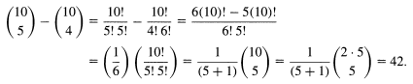

**EXERCISE**:

1. Show that .

2. Consider a "staircase'' as shown below. A path from A to B consists of a sequence of edges starting at A, ending at B, and proceeding only up or right; all paths are of length 6. One such path is indicated by arrows. The staircase shown is a "3×3'' staircase. How many paths are there in an n×n staircase?

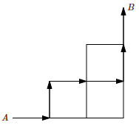

1. Determine the catalan number values for C7, C8, C9, and C10.
2. Find the number of total possible subsets from 8 elements set.
3. Find the number of integer solutions for a + b + c + d = 5, where a, b, c, d > 0.
4. In how many ways can one parenthesize the product *abcdef*?
5. How many ways can you portion of subset with 5 elements from 8 elements set?
6. Find the stirling first kind number for 6 out of 8.
7. Find the stirling Second kind number for 5 out of 10.
8. In how many ways can a particle move in the xy -plane from the origin to the point (7, 4)?